Unit 1 Hello Again!
课堂同步练习
Lesson 1 How Are You?
姓名： 班级：


要点图解秀

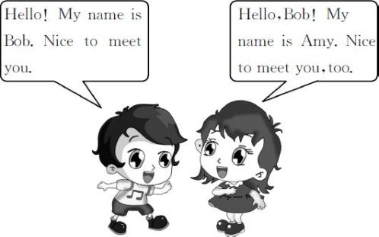

基础碰碰车

Ⅰ . 选出正确的字母或字母组合 , 将下列单词补充完整。
( )1.n me
A.a B.e C.o ( )2.m t
A.aa B.ae C.ee ( )3.f ne
A.e B.i C.u ( )4.t cher
A.ee B.ea C.ae ( )5.y
A.uor B.our C.rou ( )6.h llo
A.e B.o C.u ( )7.fr nd
A.ei B.ie C.ae ( )8.n ce
A.o B.i C.a
Ⅱ . 根据中文释义 , 选择对应的选项。
( )1. 欢迎回到学校 !
A.Wele to my home!
B.Wele back to school! ( )2. 你可以叫我吉姆。
A.You can call me Jim.
B.My name is Jim. ( )3. 很高兴见到你。
A.How are you?
B.Nice to meet you. ( )4. 他是一名新学生。
A.He is a new pupil.
B.He is a new teacher. ( )5. 这些是我的朋友。
A.These are my books.
B.These are my friends.

升级跷跷板

Ⅲ . 我会选择正确答案 , 并将序号填在题前的括号里。
( )1.—Hello,Jim!
— ,Li Lei.
A.Good morning B.Hello C.Goodbye ( )2.I your new teacher. My name
James Wood.
A.am;is B.are;is C.am;are ( )3.—Hi,Kate.How are you?
—
A.How are you,Jack?
B.Hi,I᾽m Jack.
C.Fine,thank you.

-1-

( )4.You can me Mr.Wood.
A.thank B.call C.take ( )5.—Nice to meet you.
— .
A.My name is Kim
B.Nice to meet you,too
C.Thank you
( )6.This is my friend. name is
Jenny.
A.Your B.His C.Her
Ⅳ . 补全对话 , 每空一词。Li Hua: 1 ! Tom. Tom:Hello! Li Hua.
Li Hua:Tom,this 2 Wang Lin.Wang Lin, 3 is
Tom Green.
Tom:Hello! Wang Lin! Nice to 4 you. Wang Lin:Hello! Tom! Nice 5 meet you,
6 .How 7 you? Tom: 8 ,thanks. 9 you?
Wang Lin:I᾽m very 10 ,thank you.
1. 2. 3. 4.
5. 6. 7. 8.
9. 10.

-2-

Unit 1 Hello Again! 课堂同步练习答案
Lesson 1 How Are You?

答案 :
Ⅰ .1.A | 2.C | 3.B | 4.B | 5.B 6.A 7.B 8.B
Ⅱ .1.B | 2.A | 3.B | 4.A | 5.B
Ⅲ .1.B | 2.A | 3.C | 4.B | 5.B 6.C
Ⅳ .1.Hello 2.is 3.this 4.meet 5.to 6.too 7.are 8.Fine 9.And 10.well

Unit 1 Hello Again!
课堂同步练习
Lesson 2 Is This Your Pencil?
姓名： 班级：

( )5.Is this your apple?
要点图解秀
( )6.What᾽s in your pencil box?
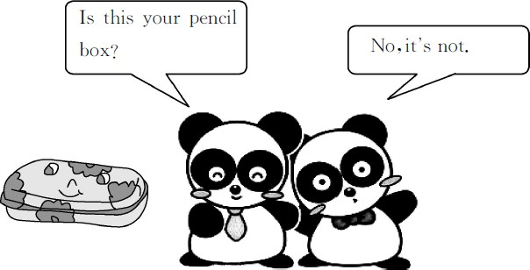
A.Fine,thank you.And you?
B.No,it isn᾽t. C.Hello,Li Lei!
D.A ruler and five pencils. E.Nice to meet you,too.
F.It᾽s Kate᾽s.

基础碰碰车
升级跷跷板

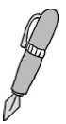Ⅰ . 看图片 , 写单词。
2.


1.


3. 4.


5.

- . 从方框中找出下列各句的最佳答语。
( )1.Hello,Jim!
( )2.How are you,Bill?
( )3.Whose book is this? ( )4.Nice to meet you.
Ⅲ . 我会选择正确答案 , 并将序号填在题前的括号里。
( )1.—Is this English book?
—Yes, is.
A.you;this B.your;this C.your;it ( )2.— pencil box is this?
—It᾽s Danny᾽s.
A.Where B.Whose C.What ( )3.—Is this Steven᾽s ruler?
—No.It isn᾽t ruler.
A.your B.her C.his

Ⅳ . 模仿例句用 Yes 或 No 回答以下问题。
Example:
Is this your book? √ Yes,it is.It᾽s my book. Is this Mike᾽s car?× No,it isn᾽t.It isn᾽t his
car.
  - Is this Danny᾽s ruler? √ 2.Is it Jenny᾽s dog?× 3.Is this your school? √
4.Is it Steven᾽s pencil box?× 5.Is it Kim᾽s pencil? √

Unit 1 Hello Again! 课堂同步练习答案
Lesson 2 Is This Your Pencil? 答案 :
Ⅰ .1.pencil 2.pen 3.ruler 4.crayons 5.pencil box Ⅱ .1.C 2.A 3.F 4.E 5.B 6.D
Ⅲ .1.C 2.B 3.C
Ⅳ .1.Yes,it is.It᾽s his ruler. 2.No,it isn᾽t.It isn᾽t her dog.
3.Yes,it is.It᾽s my school. 4.No,it isn᾽t.It isn᾽t his pencil box.
5.Yes,it is.It᾽s her pencil.

Unit 1 Hello Again!
课堂同步练习
Lesson 3 Where Are They?
姓名： 班级：

( )3.The panda is the ball.
要点图解秀


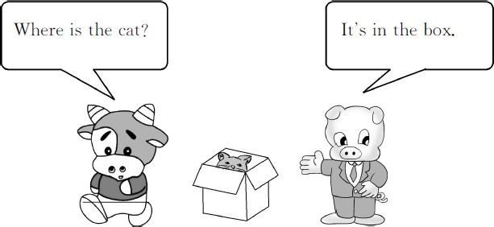
A.on B.under

( )4.Jenny is Li Ming and Mr.Wood.
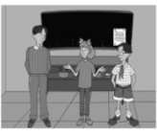
A.beside B.between

基础碰碰车
升级跷跷板

Ⅰ . 读单词 , 选择对应的图片。

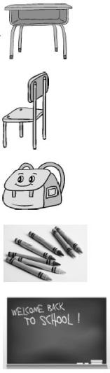
( )1. blackboard A. ( )2. crayons B.
( )3. desk C.

( )4. schoolbag D.

( )5. chair E.

Ⅱ . 看图 , 选择正确的方位词填空。
( )1.The pencils are the pencil box.

A.on B.in 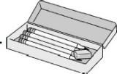
( )2.The cat is the chair.

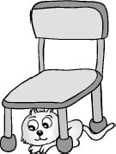
A.under B.beside

-1-
Ⅲ . 根据中文释义 , 选择对应的选项。
( )1. 在书桌上面
A.on the desk B.in the desk ( )2. 在盒子下面
A.under the box B.beside the box ( )3. 在书包里面
A.on the blackboard
B.in the schoolbag ( )4. 在课桌和椅子之间
A.between the desk and the chair
B.beside the desk and the chair

Ⅳ . 你来当导演 , 选择正确的对话给下面的图片配音。

A.—Where is the pencil?
—It᾽s in the box.

B.—Where is Amy?
—She᾽s under the desk.

C.—Where is the schoolbag?
—It᾽s beside the chair.

D.—Where is the apple?
—It᾽s on the books.

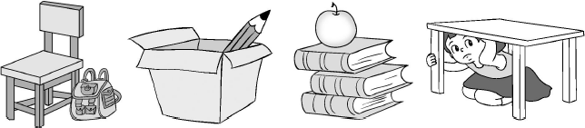
1.( ) 2.( ) 3.( ) 4.( )

-2-

Unit 1 Hello Again! 课堂同步练习Lesson 3 Where Are They?
答案
Ⅰ .1.E | 2.D | 3.A | 4.C 5.B
Ⅱ .1.B | 2.A | 3.A | 4.B
Ⅲ .1.A | 2.A | 3.B | 4.A
Ⅳ .1.C | 2.A | 3.D | 4.B

Unit 1 Hello Again!
课堂同步练习
Lesson 4 How Many Books Are There?
姓名： 班级：

( )4.eleven crayons
要点图解秀

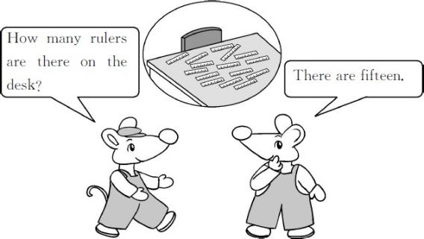

升级跷跷板

Ⅲ . 算一算 , 将相应的单词序号填入星星中。
A.thirty B.sixty-eight C.twelve D.seventy-one
基础碰碰车

Ⅰ . 将单词和相应的数字连线。

sixteen 50
twenty-nine 47
forty-seven 100 fifty 16
one hundred 29

Ⅱ . 数一数 , 选择正确的图片。
( )1.four birds


( )2.twelve books

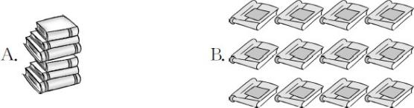

( )3.seven pupils

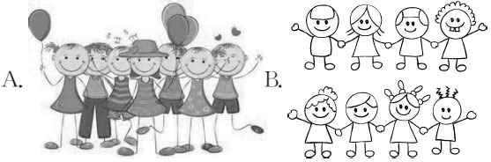

-1-
E.forty-nine F.thirteen


1.three+nine=

2.forty-five-thirty-two= 3.seventeen+thirteen=

4.one hundred-twenty-nine=

5.eleven+fifty-seven=

6.sixty-four-fifteen=

Ⅳ . 看图 , 数一数再回答问题。

( )1. 

—How many pencils do you have?
— .
A.Sixteen B.Fourteen


( )2.

—How many bananas can you see?
— .
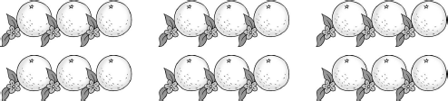
A.Twenty-five B.Twenty ( )3.

—How many oranges are there?
— .
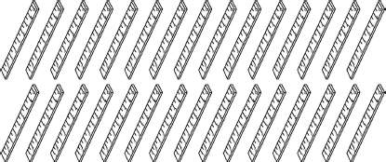
A.Eighteen B.Nineteen ( )4.

—How many rulers are there?
— .
A.Thirty B.Forty
Ⅴ . 阅读对话 , 完成后面的判断题。正确的打“√”, 错误的打“×”。
Lily:Look! I have some new pencils and new
crayons.
M i k e :Oh,how many new pencils do you have?
Lily:I have fifteen new pencils and twenty new
crayons.
Mike:But I can see twelve new crayons only.
Lily:The others( 其他的 )are in my schoolbag,under
the chair.
Mike:Oh,I see.
( )1.Lily has twelve new crayons.
( )2.The twelve new crayons are under the
chair.
( )3.Lily has fifteen new pencils.
( )4.Mike can see twenty new crayons.

-2-

Unit 1 Hello Again! 课堂同步练习答案
Lesson 4 How Many Books Are There? 答案 :
Ⅰ .(略)

Ⅱ .1.B | 2.B | 3.A | 4.B
Ⅲ .1.C | 2.F | 3.A | 4.D 5.B 6.E
Ⅳ .1.B | 2.B | 3.A | 4.A
Ⅴ .1.× 2.× 3. √ 4.×

Unit 1 Hello Again!
Lesson 5 Where Is Danny? 课堂同步练习
姓名： 班级：

要点图解秀

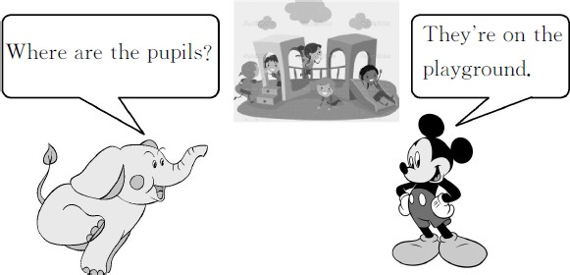

基础碰碰车

Ⅰ . 为下列短语选择正确的英文释义 , 将其序号填在题前的括号里。
( )1. 在教室里
( )2. 在操场上
( )3. 在树后面
( )4. 在黑板前面
( )5. 做游戏
( )6. 看书

A.in front of the blackboard B.play games
C.in the classroom D.behind the tree E.read books
F.on the playground

Ⅱ . 判断下面每组画线字母读音是否相同, 相同的打“√”, 不同的打“×”。
( )1.A. bread B. eat
( )2.A. meat B. teacher
( )3.A. read B. breakfast
( )4.A. zoo B. book ( )5.A.food B.school
( )6.A.look B.noodles

升级跷跷板

Ⅲ . 读句子 , 选择对应的图片。
( )1.—Where is the rabbit?
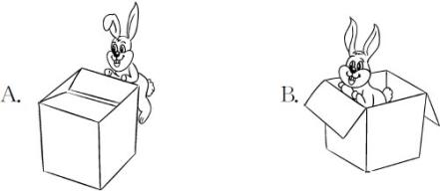
—It᾽s behind the box.

( )2.—Where is the ball?
—It᾽s beside the box.

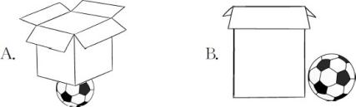

( )3.—Where is Mr.Lin?
—He is between the desk and the chair.

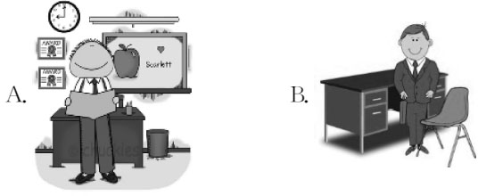

( )4.Look! They are on the playground.They᾽re
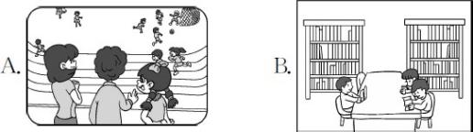
playing a game.

-1-

Ⅳ . 根据图片内容回答问题。

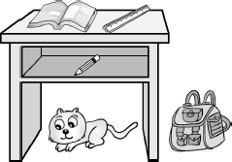

1.—Where is the book?
—It᾽s .
2.—Where is the ruler?
—It᾽s . 3.—Where is the pencil?
—It᾽s . 4.—Where is the schoolbag?
—It᾽s . 5.—Where is the cat?
—It᾽s .

-2-

Unit 1 Hello Again! 课堂同步练习答案
Lesson 5 Where Is Danny? 答案 :
Ⅰ .1.C 2.F 3.D 4.A 5.B 6.E
Ⅱ .1.× 2. √ 3.× 4.× 5. √ 6.×
Ⅲ .1.A 2.B 3.B 4.A
Ⅳ .1.on the desk 2.on the desk 3.in the desk 4.beside the desk 5.under the desk

Unit 1 Hello Again!
Lesson 6 Little Zeke 课堂同步练习
姓名： 班级：

( )2.—Where᾽s the mouse?
要点图解秀
—It᾽s in front of the box.

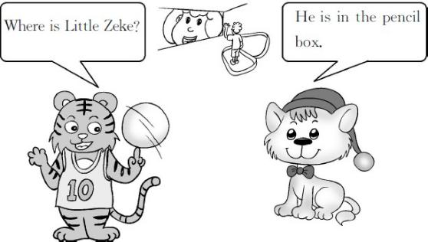

( )3.—Where᾽s the dog?
—It᾽s beside the boy.
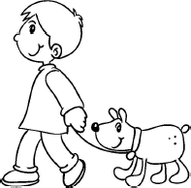
基础碰碰车

Ⅰ . 为下列英文句子选择正确的中文释义 , 将其序号填在题前的括号里。
( )1.Emma has many friends.
( )2.She puts the apples on the desk. ( )3.She hides behind the books.
( )4.I find it in my schoolbag. ( )5.I want to help him.
- 我想帮助他。
- 她把苹果放在桌子上。
- 我在我的书包里找到了它。
- 她躲在书后面。
- 埃玛有很多朋友。

- . 读句子 , 判断图片是否与之相符 , 相符的打“√”, 不相符的打“×”。
( )1.—Where are the apples?
—They are under the desk.

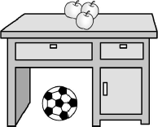
( )4.—Where᾽s the schoolbag?
—It᾽s on the chair.
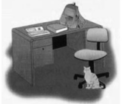

( )5.—Where is the pencil?
—It᾽s in the book.


升级跷跷板

Ⅲ . 我会选择正确答案 , 并将序号填在题前的括号里。
( )1.— is the pencil box?
—It᾽s under the schoolbag.
A.Where B.Who C.What ( )2.—Hello! name is Ann.
—Hello! am Jim.
A.I;I B.My;I C.My;my

-1-

( )3. is my friend. name is
Jack.
A.He;He B.He;His C.His;He
( )4.This is Mary᾽s book. name is on
it.
A.His B.My C.Her

Ⅳ . 按要求转换句型。
- This is my schoolbag.( 改成一般疑问句并作否定
回答 )

- Little Zeke has two friends.( 就画线部分提问 )
friends does Little Zeke
have?
- The apple is on the desk.( 同上 )
the apple? 4.This is Kim᾽s ruler.( 同上 )
ruler this? 5.My name is Emma.( 同上 )
?

-2-

Unit 1 Hello Again! 课堂同步练习答案
Lesson 6 Little Zeke 答案 :
Ⅰ .1.E 2.B 3.D 4.C 5.A
Ⅱ .1.× 2. √ 3.× 4.× 5. √
Ⅲ .1.A 2.B 3.B 4.C
Ⅳ .1.Is this your schoolbag? No,it isn᾽t(my schoolbag). 2.How many
3.Where is 4.Whose;is 5.What᾽s your name

Unit 1 Hello Again!
Again, Please! 课堂同步练习
姓名： 班级：
要点图解秀
升级跷跷板

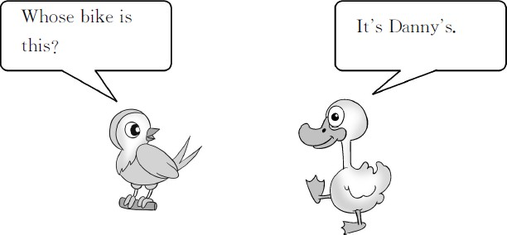

基础碰碰车

Ⅰ . 给数字选择对应的单词。
( )1. 50 A.fifteen B.fifty
( )2. 82 A.eighty-two B.sixty-two ( )3. 19 A.twelve B.nineteen
( )4. 21 A.forty-three B.twenty-one ( )5. 11 A.eleven B.twenty

Ⅱ . 选词填空 , 将词语的序号写在括号里。

A.Where B.What C.How D.Whose

( )1.— are my crayons?
—They᾽re in your schoolbag. ( )2.— are you?
—I᾽m fine,thank you. ( )3.— is this?
—It᾽s my pencil box.
( )4.— ruler is this?
—It᾽s Mike᾽s.
( )5.— is your name?
—My name is Amy.
( )6.— many apples are there in the

Ⅲ . 看图片 , 回答问题。每空一词。


1.—Where is the pen?

—It᾽s

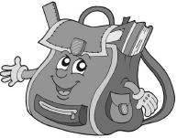
2.—Where is the ruler?

—It᾽s

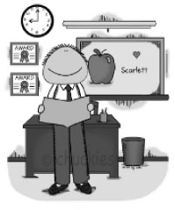
3.—Where is Mr.Black?

—He is the desk.

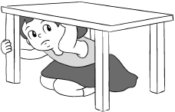
4.—Where is Mary?

—She is

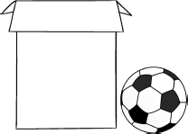
5.—Where is the ball?

—It᾽s the box.

Ⅳ . 根据对话内容, 在相应人物所属的物品下面打“√”。
A:Nancy.Is this your English book? B:Yes,it is.Thank you.

bag?
—Five.

-1-
A:And the schoolbag?

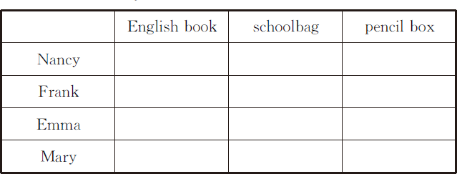
B:No,it isn᾽t.It᾽s Frank᾽s schoolbag.Oh,look! Is
this your pencil box,Emma? A:No,it᾽s my friend᾽s pencil box. B:What᾽s your friend᾽s name?
A:Her name is Mary.

-2-

Unit 1 Hello Again! 课堂同步练习答案
Again, Please! 答案 :
Ⅰ .1.B 2.A 3.B 4.B 5.A
Ⅱ .1.A 2.C 3.B 4.D 5.B 6.C
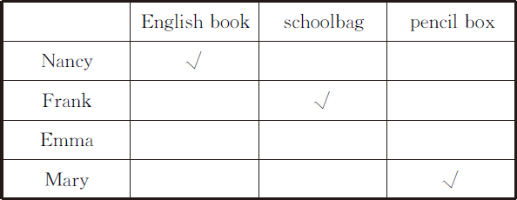
Ⅲ .1.on the book 2.in the schoolbag 3.in front of 4.under the desk 5.beside Ⅳ.

Unit 2 Days and Months
课堂同步练习
Lesson 7 Months of the Year
姓名： 班级：
要点图解秀
升级跷跷板

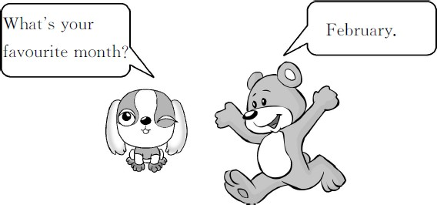

基础碰碰车

Ⅰ . 读一读 , 连一连 , 让小鸟找到自己的家。
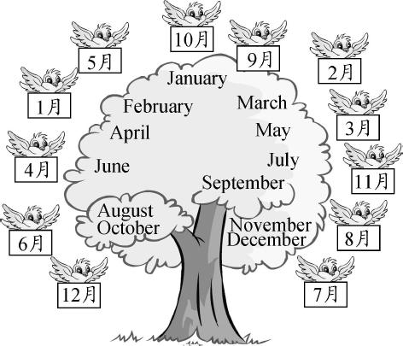

Ⅱ . 将各季节的图片与其对应的月份连线。

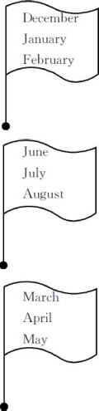
( )1. A.

( )2. B.

( )3. C.


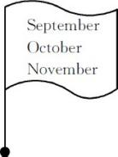
( )4. D.

Ⅲ . 写出十二个月份的缩写形式。

1. 一月 | 2. 二月
3. 三月 | 4. 四月
5. 五月 | 6. 六月
7. 七月 | 8. 八月
9. 九月 | 10. 十月
11. 十一月 | 12. 十二月

Ⅳ . 老师正在调查同学们的生日是什么时候。读句子 , 将人物和他生日所在的月份连线。

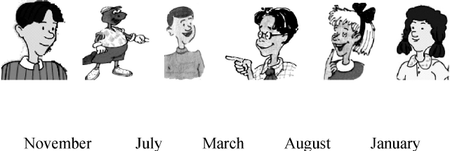

Mr.Wood:Hello,boys and girls.Let᾽s talk about your
birthday,OK? Students:OK.
Mr.Wood:Whose birthday is in January? Jenny:My birthday is in January.
Mr.Wood:Whose birthday is in March? Kim:My birthday is in March.
Mr.Wood:Whose birthday is in July? Danny:My birthday is in July.
Mr.Wood:Whose birthday is in November? Steven:My birthday is in November.
Li Ming:My birthday is in November,too.When is
your birthday,Mr.Wood? Mr.Wood:My birthday is in August.

Unit 2 Days and Months 课堂同步练习答案
Lesson 7 Months of the Year 答案 :
Ⅰ .(略)
Ⅱ .1.A 2.C 3.B 4.D
Ⅲ .1.Jan. 2.Feb. 3.Mar. 4.Apr. 5.May 6.Jun. 7.Jul. 8.Aug. 9.Sept. 10.Oct. 11.Nov. 12.Dec.
Ⅳ .(略)

Unit 2 Days and Months
课堂同步练习
Lesson 8 First, Second, Third
姓名： 班级：

要点图解秀
升级跷跷板

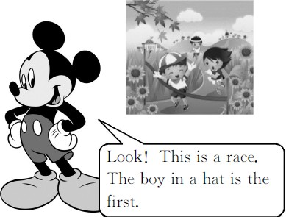

基础碰碰车

Ⅰ . 请将序数词和对应的基数词连线。
fourth 1
first 7
eighth 3
twelfth 8
sixth 4
fifth 12
tenth 6
third 10
seventh 5

- . 看图 , 用恰当的序数词完成句子。
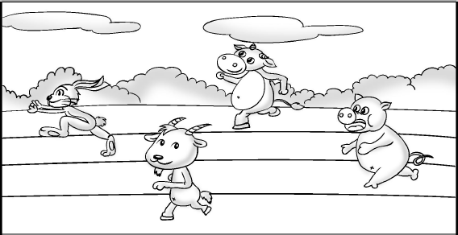

Look! This is a race.
The rabbit is the 1. .
The goat( 山羊 )is the 2. .
The cow is the 3. .
The pig is the 4. .

Ⅲ . 选词填空。
third, twelfth, fifth, ninth, first,
seventh, second, eleventh

  - January is the month of the year. 2.February is the month of the year. 3.March is the month of the year. 4.May is the month of the year. 5.July is the month of the year. 6.September is the month of the year. 7.November is the month of the year. 8.December is the month of the year.

Ⅳ . 我会选择正确答案 , 并将序号填在题前的括号里。
( )1.The boy white shorts is my
brother.
A.on B.of C.in
( )2. is the eighth month of the
year.
A.August B.July C.October
( )3.— your favourite month?
—January.
A.Where᾽s B.How᾽s C.What᾽s
( )4.My birthday is September.
A.on B.at C.in
( )5.There are months in a year.
December is the month of the
year.
A.twelve;twelve B.twelve;twelfth
C.twelfth;twelve

Unit 2 Days and Months 课堂同步练习答案
Lesson 8 First, Second, Third 答案 :
Ⅰ .(略)
Ⅱ .1.first 2.second 3.third 4.fourth
Ⅲ .1.first 2.second 3.third 4.fifth 5.seventh 6.ninth 7.eleventh 8.twelfth Ⅳ .1.C 2.A 3.C 4.C 5.B

Unit 2 Days and Months
课堂同步练习
Lesson 9 When Is It?
姓名： 班级：
要点图解秀
升级跷跷板

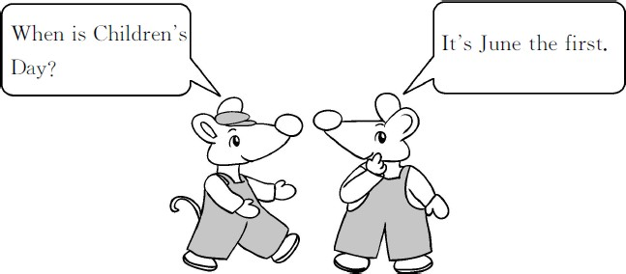

基础碰碰车

Ⅰ . 看图片, 选出与之对应的节日, 并将序号写在小花里。
A.New Year᾽s Day B.the Spring Festival
C.International Workers᾽ Day D.Children᾽s Day
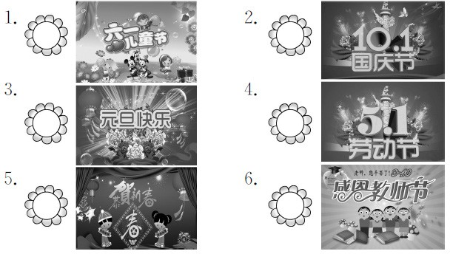E.Teachers᾽ Day F.National Day

Ⅲ . 补全对话 , 每空一词。
C=Chen Ling S=Sally
C:Hi,Sally.What᾽s your favourite 1. ?
S:October.My birthday is 2. October.
And National Day is in 3. ,too.4.
is your birthday?
C:5. birthday is May 20.

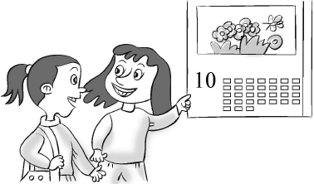

Ⅳ . 给下列日期排序 , 将日期前的字母序号按先后顺序写在横线上。
A.October 10 B.June 2 C.May 4 D.January 26 E.November 25 F.July 13 G.August 12 H.April 30

Ⅱ . 将节日和对应的日期连线。
( )1.New Year᾽s Day A.September the tenth
( )2.Christmas B.October the first ( )3.International C.June the first
Workers᾽ Day
( )4.Children᾽s Day D.December the twenty-
fifth
( )5.Teachers᾽ Day E.May the first
( )6.National Day F.January the first

Unit 2 Days and Months 课堂同步练习Lesson 9 When Is It?
答案
Ⅰ .1.D 2.F 3.A 4.C 5.B 6.E
Ⅱ .1.F 2.D 3.E 4.C 5.A 6.B
Ⅲ .1.month 2.in 3.October 4.When 5.My Ⅳ .DHCBFGAE

Unit 2 Days and Months
课堂同步练习
Lesson 10 Rain and Sun
姓名： 班级：

要点图解秀
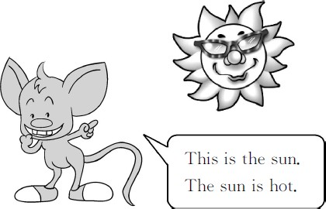

基础碰碰车

Ⅰ . 看图写单词。


1. 2.


3. 4.




5.

Ⅱ . 淘淘猫正在和迷你鼠玩连连看的游戏。你也来连一连吧 !

-1-
( )1. January A. 七月
( )2. September B. 十 一 月( )3. April C. 三 月
( )4. November D. 九 月( )5. July E. 四 月( )6. March F. 一 月

升级跷跷板

Ⅲ . 读句子 , 选择正确的图片。
( )1.It᾽s cold in Harbin.

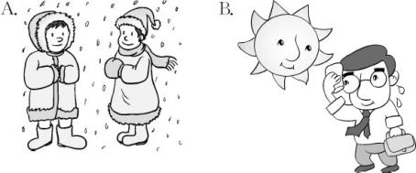

( )2.It᾽s hot in Guangzhou.
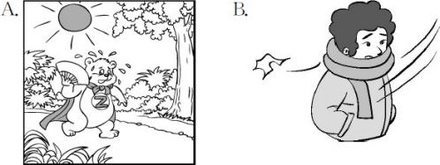

( )3.It᾽s raining.Close the door.

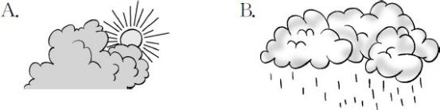

( )4.We go back to school in September.

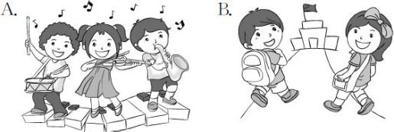
( )5.I like to play in the snow in December.
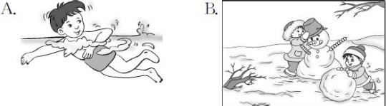

Ⅳ . 连词成句难不住我。
1.hot The is sun (.)

2.the at wind Look (.)

3.cold is white Snow and (.)

4.rain like I snow and (.)

5.you cloud the Do see (?)

-2-

Unit 2 Days and Months 课堂同步练习答案
Lesson 10 Rain and Sun 答案 :
Ⅰ .1.sun 2.rain 3.cloud 4.wind 5.snow Ⅱ .1.F 2.D 3.E 4.B 5.A 6.C
Ⅲ .1.A 2.A 3.B 4.B 5.B
Ⅳ .1.The sun is hot. 2.Look at the wind. 3.Snow is cold and white.
4.I like rain and snow. 5.Do you see the cloud?

Unit 2 Days and Months
Again, Please! 课堂同步练习
姓名： 班级：

要点图解秀

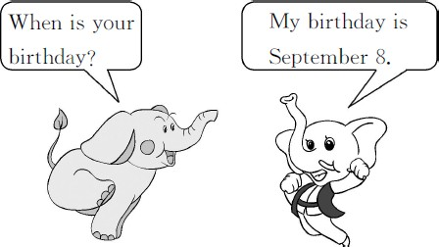

基础碰碰车

Ⅰ . 选出正确的字母组合 , 将下列单词补充完整。
( )1.M ( 五月 )
A.ay B.ey
( )2.Febr ry( 二月 )
A.ua B.ue
( )3.sn y( 下雪的 )
A.ow B.aw
( )4.cl dy( 多云的 )
A.oa B.ou ( )5. gust( 八月 )
A.Au B.Ao ( )6.w m( 温暖的 )
A.er B.ar

Ⅱ . 选词填空 , 将词语的序号写在括号里。
A.When B.What C.How D.Whose
( )4.— many months are there in a
year?
—Twelve.
( )5.— day is it today?
—It᾽s Thursday.
( )6.— is your favourite month?
—October.

升级跷跷板

Ⅲ . 请把下面的节日、日期 , 以及对应的中文进行匹配 , 并用线连起来。
New Year᾽s Day September 10th 国庆节International
Workers᾽Day October 1st 儿童节Children᾽s Day January 1st 教师节National Day May 1st 元旦Teachers᾽ Day June 1st 劳 动 节

Ⅳ . 连词成句难不住我。
1.your When is birthday (?)

2.weather March the How᾽s in (?)
3.sunny today It᾽s and hot (.)

( )1.— birthday is in May?
—My birthday is in May.
( )2.— is the weather today?
—It᾽s sunny.
( )3.— is Children᾽s Day?
—It᾽s June 1st.
4.is June Children᾽s in Day .
5.tenth the is October month

Unit 2 Days and Months 课堂同步练习答案
Again, Please! 答案 :
Ⅰ .1.A 2.A 3.A 4.B 5.A 6.B
Ⅱ .1.D 2.C 3.A 4.C 5.B 6.B
Ⅲ .(略)
Ⅳ .1.When is your birthday? 2.How᾽s the weather in March?
3.It᾽s sunny and hot today. 4.Children᾽s Day is in June.
5.October is the tenth month.

Unit 3 All about Me
课堂同步练习
Lesson 13 How Old Are You?
姓名： 班级：
要点图解秀
升级跷跷板

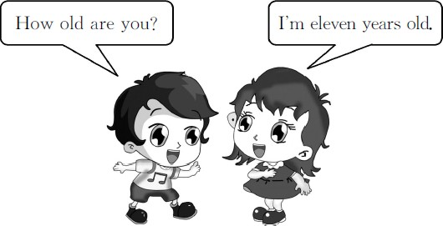

基础碰碰车

Ⅰ . 将年龄与对应的蛋糕连线。
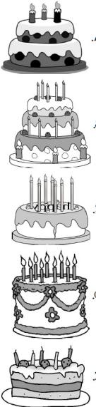
( )1.seven years old A.

( )2.three years old B.

( )3.nine years old C.

( )4.five years old D.

( )5.twelve years old E.

Ⅱ . 我会选择正确答案 , 并将序号填在题前的括号里。
( )1.How old you? A.is B.are
( )2.I᾽m eleven old.
A.year B.years
( )3.— is your birthday?
—January 22.
A.When B.Where
( )4.Steven is ten. birthday is
December 17.
A.Her B.His

Ⅲ . 读句子 , 将人物、年龄以及生日进行匹配 , 并用线连接起来。


My name is Lily.I᾽m 12 years old.My
birthday is November 25.


I᾽m Ms.White.I᾽m 32 years old.My
birthday is May 16.


My name is Sam Green.I᾽m 11 years
old.My birthday is June 28.



I᾽m Miss Cat.I᾽m 24 years old.My
birthday is March 10.

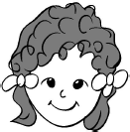

My name is Liu Hong.I᾽m 8 years
old.My birthday is February 14.



I᾽m Mr.Monkey.I᾽m 40 years old.My
birthday is September 3.

Name Age Birthday
Lily eight Feb.14
Ms.White twenty-four Mar.10
Sam Green twelve Sept.3
Miss Cat forty Nov.25

-1-

以上内容仅为本文档的试下载部分，为可阅读页数的一半内容。如要下载或阅读全文，请访问：https://d.book118.com/665140240124011114

