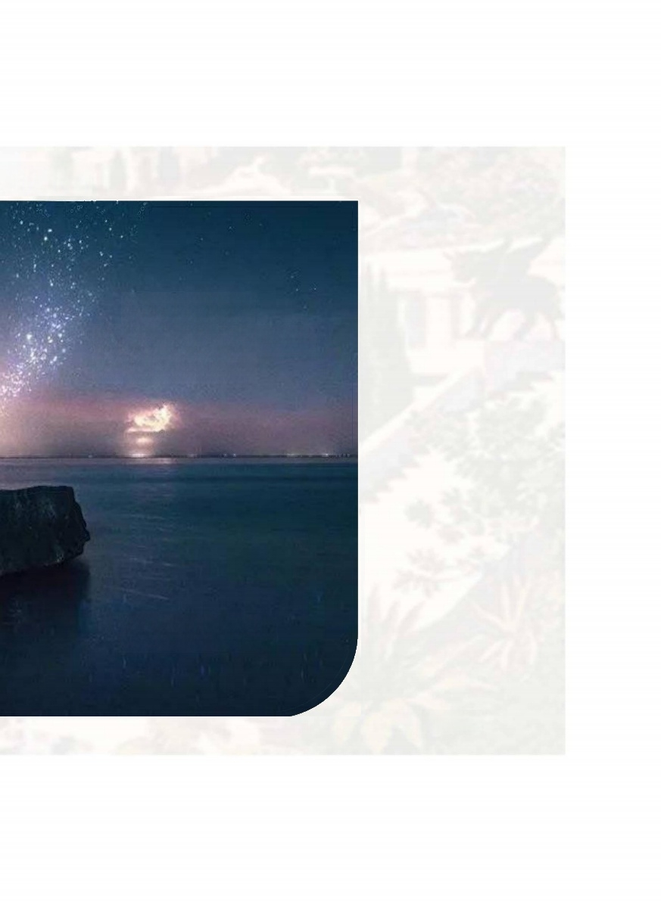
nknown

The longest
enfeirystbseip with

一轮复习

Sunshine

高中英语选择性必修四Unit5 Into the


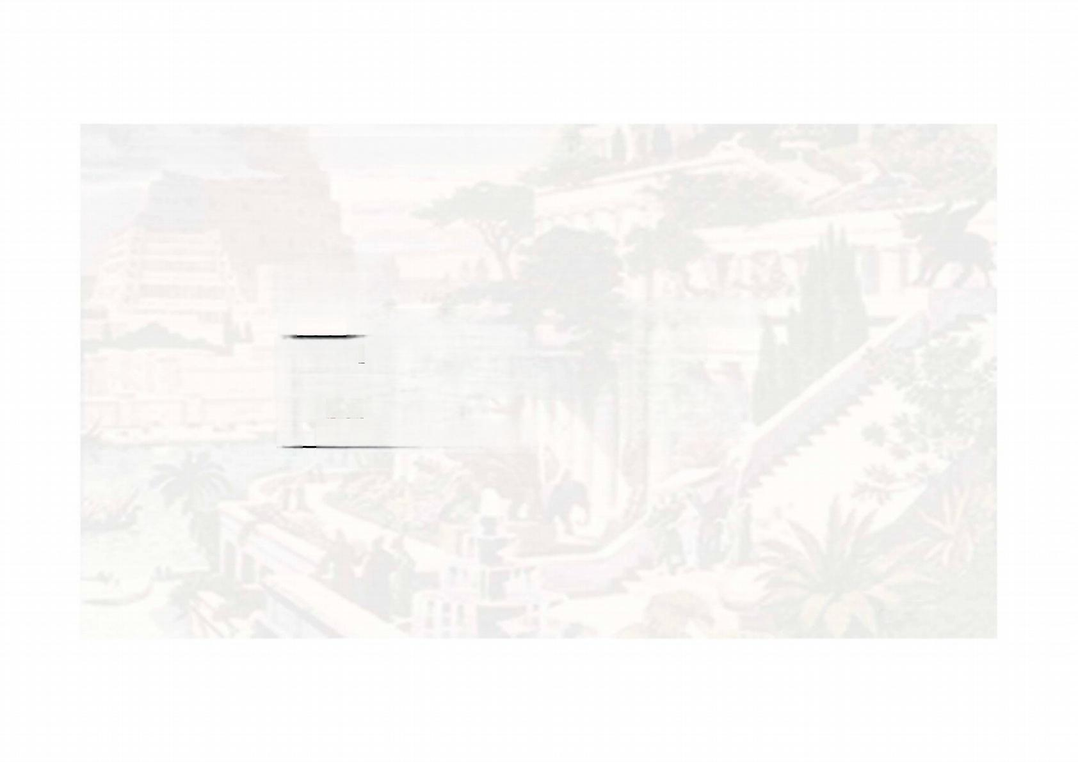
高中英语选择性必修四Unit5 Into the unknown

1.识记单词
(一)汉译英
1. _n. 文明(社会)  2._ _v.将……理在下面 | 1.civilisation 2.bury
3.__ _n. 残垣断壁，废墟 | 3.ruin
4. v. 离弃，逃离 | 4.abandon
5. __v. 拒绝考虑，否定 | 5.dismiss

Sunshine

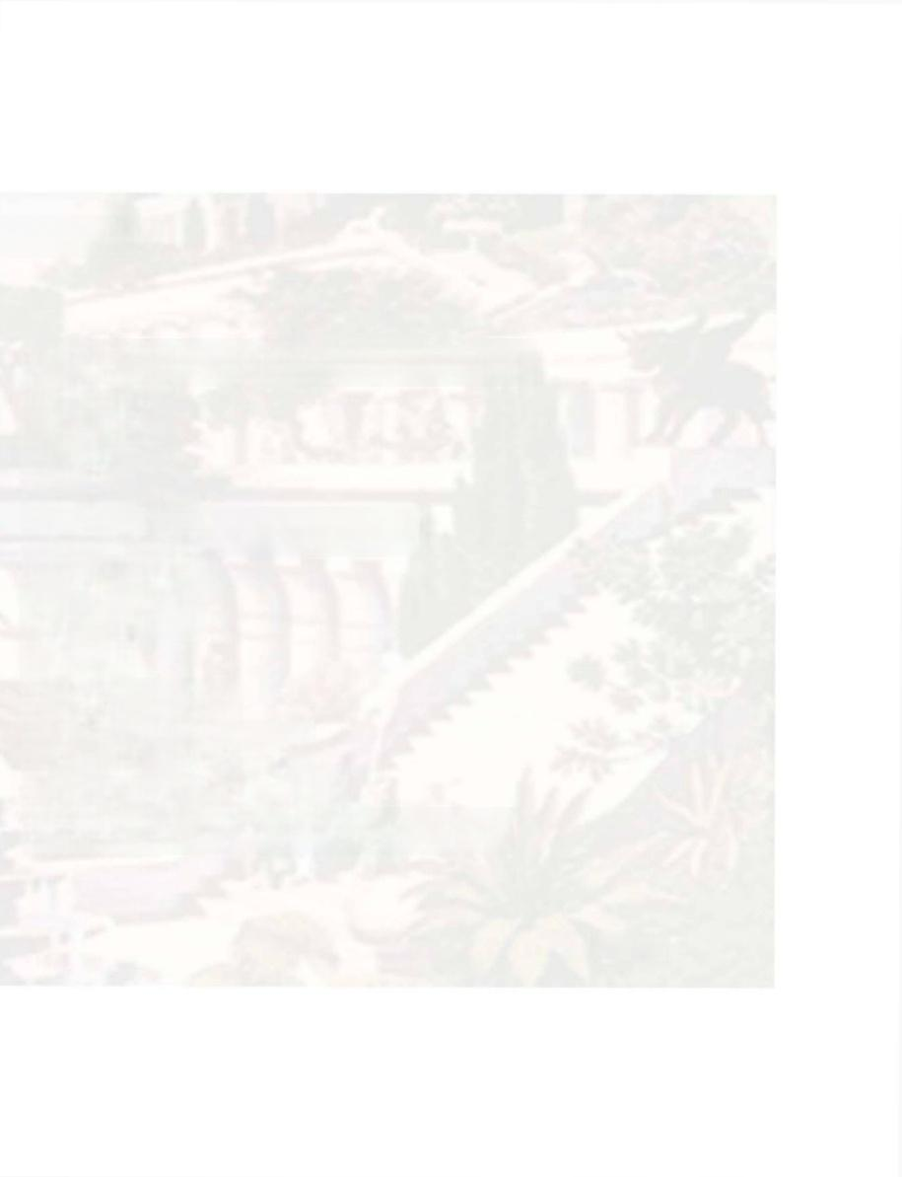
e unknown

1.激起…的兴的趣引起…的好奇心
2.金字塔
3.天文学
4.运河
5.来自热带的：产于热带的
6.气旋；旋风
7.超级干旱
8.衰败
9.逃跑，逃走
10.后退；离开；退避
11.克制，抑制(情绪)
12.地图上未标注的：尚未勘察的

Sunshine

高中英语选择性必修四Unit5 Into th

(二)英译汉
1.intrigue v. 2.pyramid n.

3.astronomy n.

4.canal n.
5.tropical adj.
6.cyclone n.
7.megadrought n.

8.downfall n.
9.getaway n.
10.retreat v.
11.subdue v.
12.uncharted adj.

known

13.探索，探究
14.退缩，畏缩
15.沉船，失事的船
16.珊瑚
17.毫米
18.管眼鱼
19.向上，朝上
20.海沟
21.等同的：等值的；相当的
22.(使)整齐地堆起；摞起
23.显要的；显著的；值得注意的
24.船；舰
25.(书的)卷，册

Sunshine

高中英语选择性必修四Unit5 Into the un

13.delve v.
14.shrink y.
15.shipwreck n.
16.coral n.
17.millimetre n.
18.barreleye n.
19.upwards adv.
20.trench n. _
21.equivalent adj.
22.stack y.
23.notable adj.
24.vessel n.
25.vol n.

高中英语选择性必修四Unit5 Into the unknown

2.拓展单词
1 n.扩大，增加 v. 扩张，使膨胀,展开
2. n.调查 v.调查
3. adj 考古学的；考古的 n. 考古学 n. 考古学家 4. n.钻探；勘探 v.钻孔， 训练

1.expansion;expand
2.investigation;investigate
3.archaeological;archaeology;
archaeologist
4.drilling;drill

Surshine

高中英语选择性必修四Unit5 Into the unknown
直击高考
1.Wang collected more than 7 million (abandon)bricks of different ages.
2. (dismiss)small talk a unimportant is easy,but we can't forget
that deep relationships wouldn't even exist if it weren't for casual
conversation.

3.Despite the celebrations,though,in the U.S.the jazz audience
continues (shrink)and grow older,and the music has failed to
connect with younger generations.
4.In fact,they were shot from 1914 through 1916,most of them
after disastrous shipwreck,by a cameraman who had no reasonable expectation of survival.
5.Perhaps,but some developmental psychologists(心理学家)have argued
that this"play"is more like a scientific (investigate)than one might
think. 1.abandoned 2.Dismissing 3.to shrink 4.a 5.investigation
Sunshine

高中英语选择性必修四Unit5 Into the unknown
6.When they returned to Rockaway the next day,they found their neighborhood ruins.
7.“From the infinity small to the infinity large,contraction and (expand)coming in and out of focus:amazing Flemish accuracy and the showy Baroque of old painting that he used in his museum-theatre in
Figueras,"explains the Pompidou Centre.
8.Mumbet's tombstone still stands in the Massachusetts cemetery where she (bury).
9.New (archaeologist)discoveries suggest that trade between Europe and Asia along the Silk Road probably began in some form many
centuries earlier than once thought.
10.One (note)case a few years ago involved an electrical device called the Relaxacisor,which had been sold for reducing the waistine.
6.in 7.expansion 8.was buried 9.archaeological 10.notable

Surshine

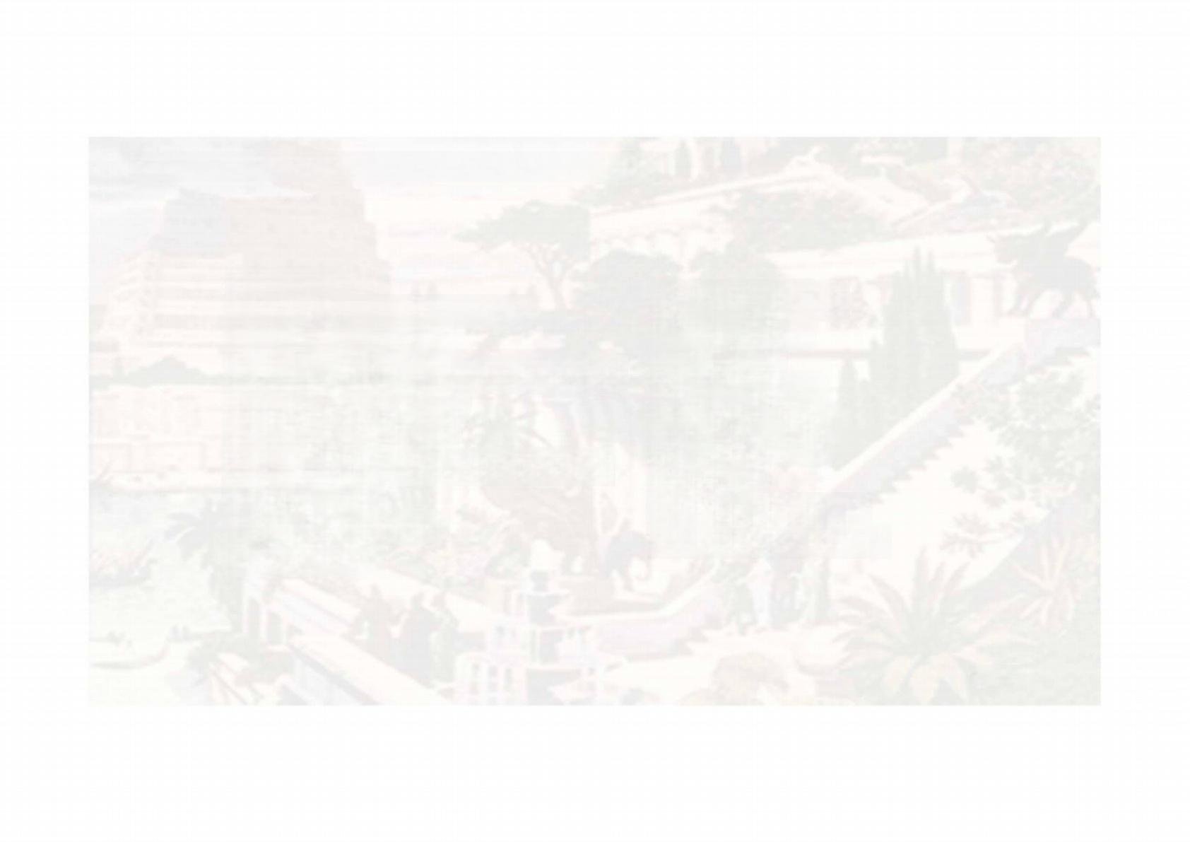
高中英语选择性必修四Unit5 Into the unknown

3短语巧练
1. 和.…相一致，相符合 | 1.correspond to
2._ 把….运用于  3. 除..…之外(还有其他问题) | 2.apply…to …  3.on top of
4. 多得多；更加 | 4.all the more
5 . 在全盛时期  6. (因无人照料而)衰落，败落 | 5.at sth.'s peak 6.fall into ruin 7.set sail
8. 逃跑，逃走  7. 起航  9. 逃命 | 8.make a getaway  9.run for one's life

Sunshine

10.check out
11.steer clear of
12.throw oneself into
13.think twice
14.shrink from
15.look into
16.set out

17.continue to do sth.
18.beyond the reach of

Sunshine

高中英语选择性必修四Unit5 Into the unknown

10. 调查，检查
11. 避开，从….处脱身
12 积极投入到...中去
13 _再三考虑，慎重考虑
14. .避免做，不愿做
15 调查，研究
16 动身踏上，开始做，着手进行 17 继续做某事
18 ….…够不到；超出…的能力之外

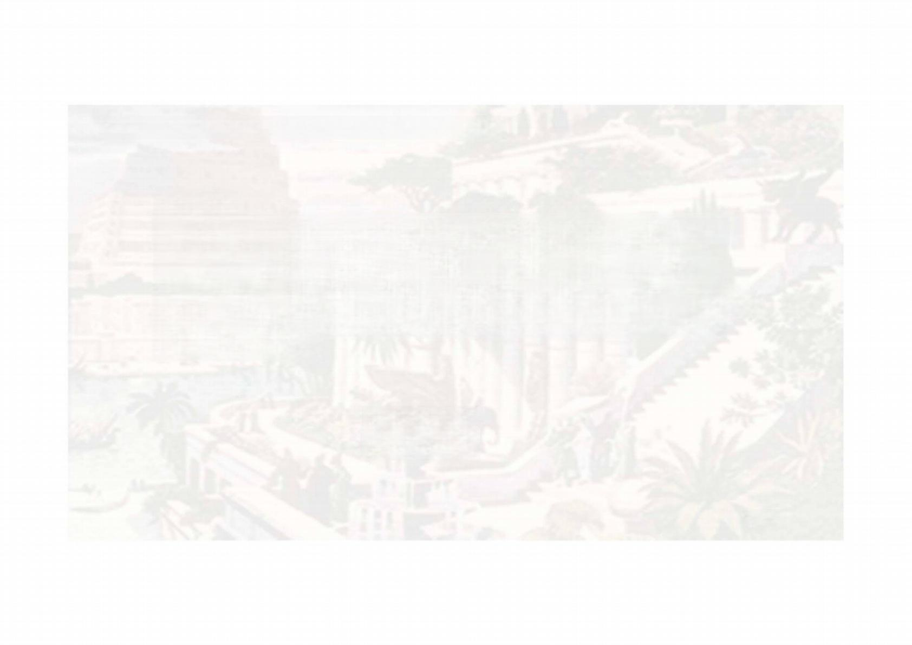
高中英语选择性必修四Unit5 Into the unknown

直击高考
1. (检查；借出)a book.While libraries sill loan out(出借
)books,you'll find it easier to get a copy of whatever you're
looking for,thanks to a cooperative network of area libraries.
2. _ (除.…….之外)that,most of the 3D food printers now are
restricted to dry ingredients,because meat and milk products
may easily go bad.

1.Check out
2.On top of

Sunshine

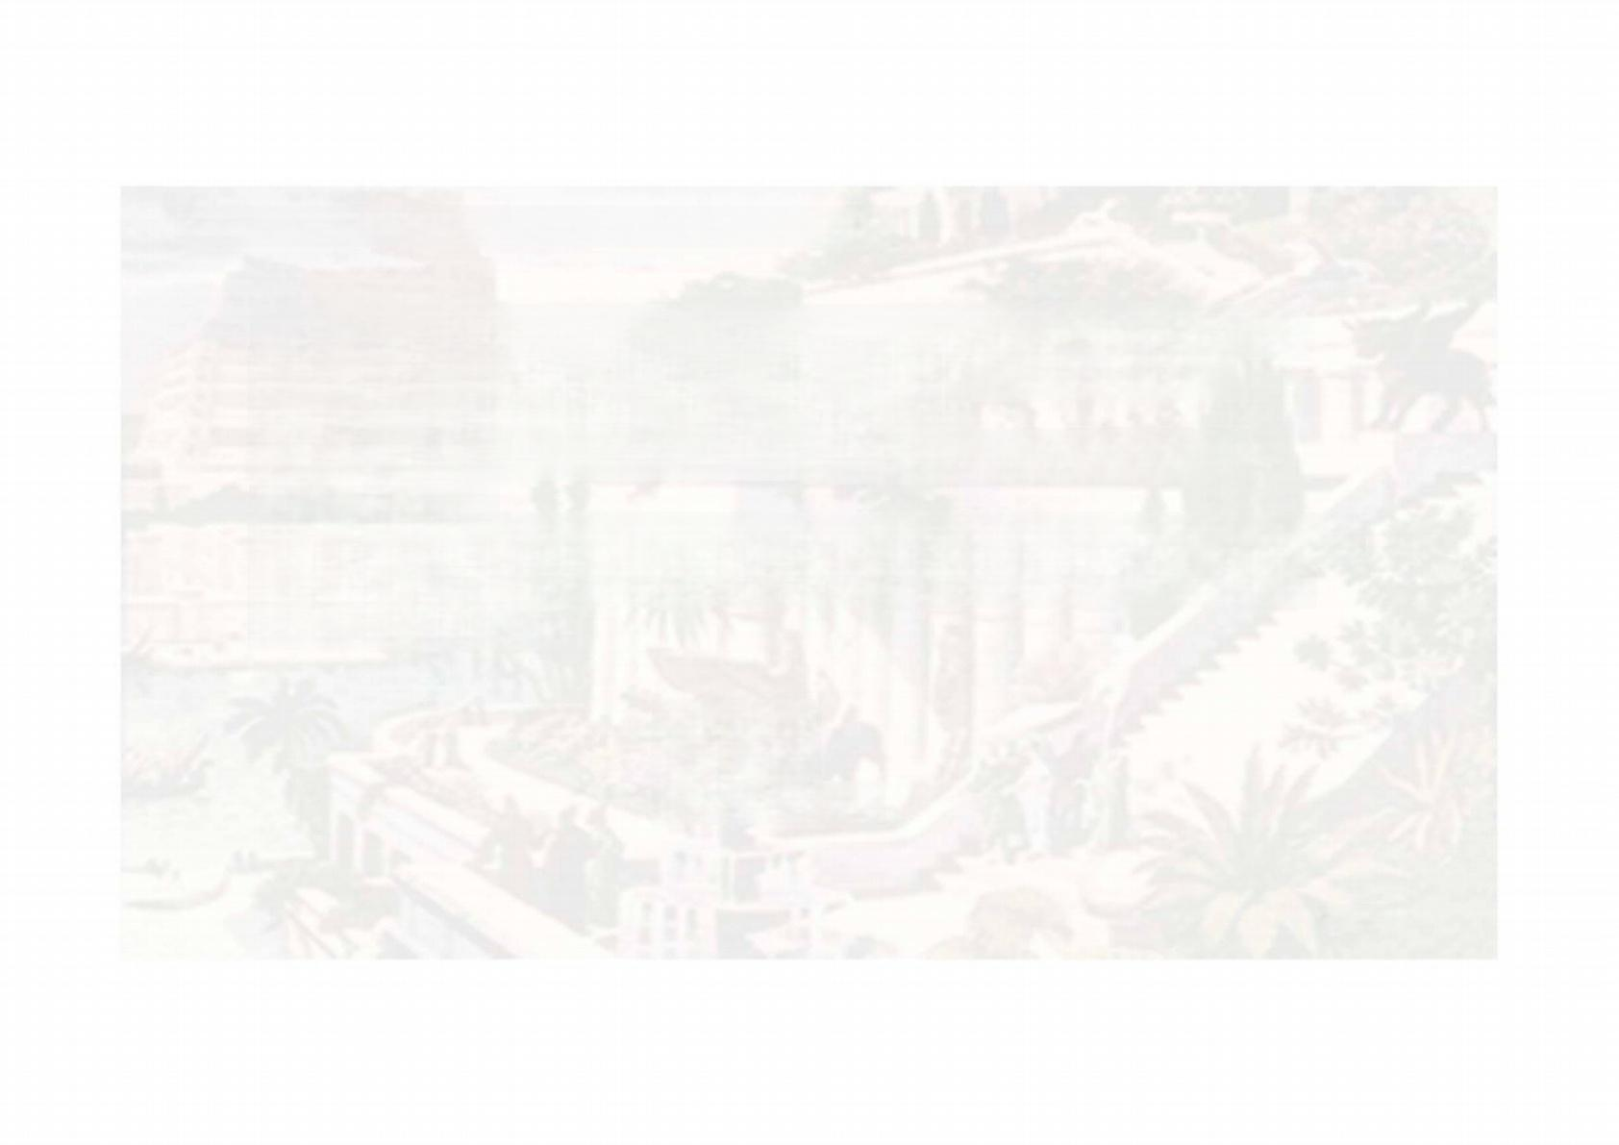
高中英语选择性必修四Unit5 Into the unknown

3.After that,I _ (开始做)to read widely for an inspiring
topic,wrote a speech,and practiced its delivery in beautiful
pronunciation with good public speech skills.
4.The last time Dad and I (起航) together is really
unforgettable,
5.A French tourist highly praised for rescuing a two-year-old girl in Manhattan said he didn't (再三考虑)before diving into the
freezing East River.

3.set out
4.set sail
5.think twice

Sunshine

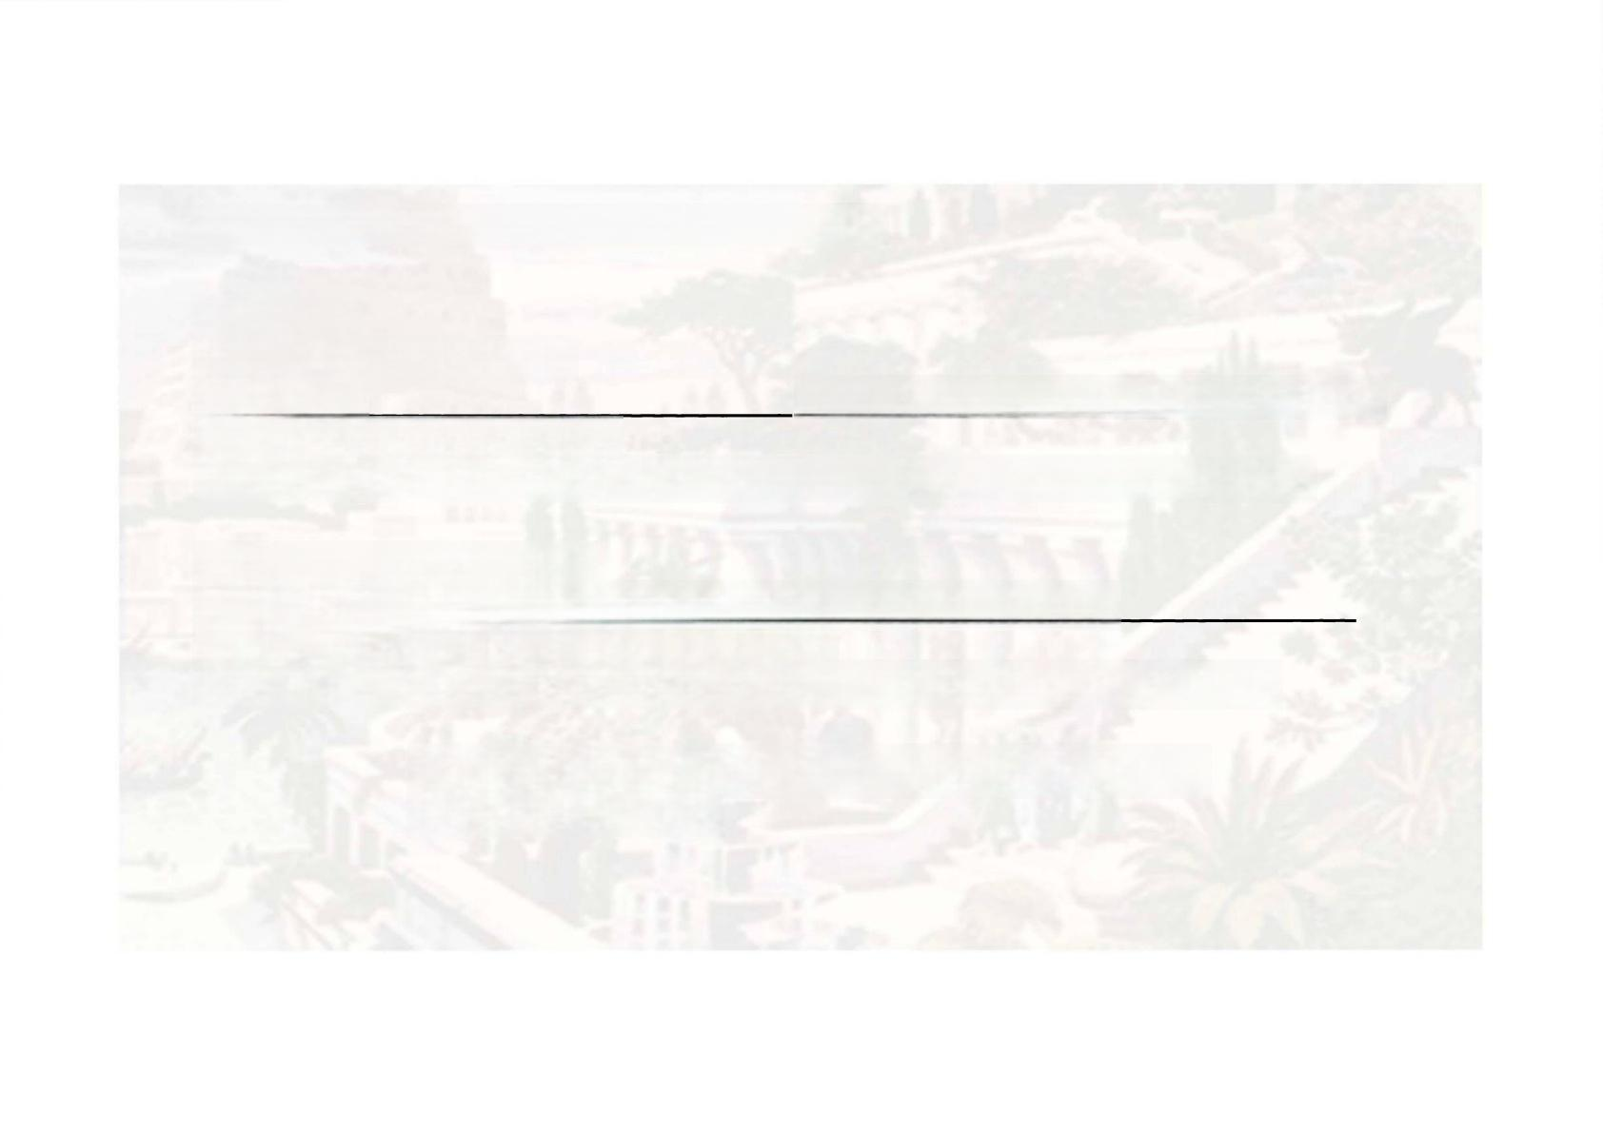
高中英语选择性必修四Unit5 Into the unknown

4 句式仿写
1.that 引导的同位语从句
The fact_ makes its achievements all the more
incredible and mysterious.
玛雅社会在技术上是原始的，这个事实使得它的成就更加难以置信和神秘。

2.leave+ 宾语+宾语补足语
Meanwhile,the rise and fall of this civilisation must also_
about our own past,present and future.
与此同时，这种文明的兴衰也必然让我们思考自己的过去、现在和未来。

1.that Maya society was technologically primitive
2.leave us thinking

以上内容仅为本文档的试下载部分，为可阅读页数的一半内容。如要下载或阅读全文，请访问：https://d.book118.com/667200061135006033

