Unit 1 Animals on the Farm
课堂同步练习
Lesson 1 On the Farm
姓名： 班级：


要点图解秀
升级跷跷板

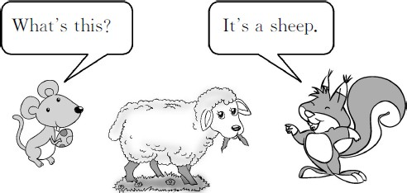

基础碰碰车

Ⅰ . 选出正确的字母组合 , 将下列单词补充完整。
A.ee B.ea
( )1.sh p( 绵 羊 ) A.ou B.ow
( )2.c ( 奶 牛 ) A.og B.ig
( )3.p ( 猪 ) A.ar B.or
( )4.f mer( 农 民 )

Ⅱ . 看图片 , 将对应单词的序号填在括号里。
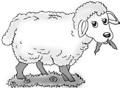
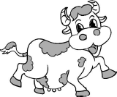
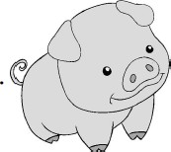
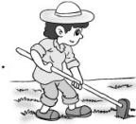
A.pig B.cow C.sheep D.farmer

( | )1. | ( | )2.
( | )3. | ( | )4.

-1-

Ⅲ . 小法官 , 巧判断。判断动物的叫声与实际是否相符 , 正确的打√ , 错误的打 ×。
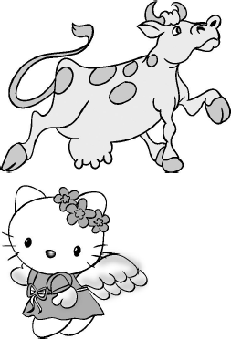
( )1.Moo! Moo!

( )2.Meow! Meow!

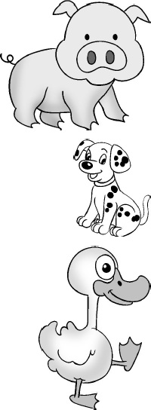
( )3.Woof! Woof!

( )4.Oink! Oink!

( )5.Quack! Quack!

Ⅳ . 读对话 , 选择对应的图片。
( )1.—What᾽s this?
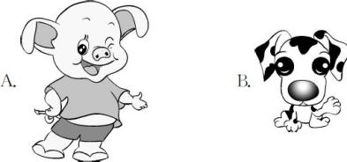
—It᾽s a pig.

( )2.—What᾽s this?
—It᾽s a sheep.
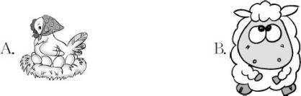

( )3.—What᾽s this?
—It᾽s a cat.

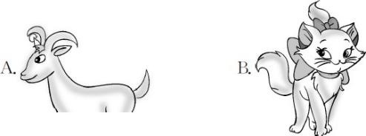

-2-
( )4.—What᾽s this?
—It᾽s a cow.
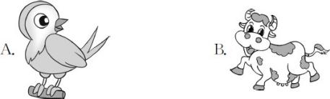

Unit 1 Animals on the Farm 课堂同步练习答案
Lesson 1 On the Farm 答案 :
Ⅰ .1.A 2.B 3.B 4.A
Ⅱ .1.C 2.B 3.A 4.D
Ⅲ .1. √ 2. √ 3.× 4.× 5. √
Ⅳ .1.A 2.B 3.B 4.B

Unit 1 Animals on the Farm
课堂同步练习
Lesson 3 Fish and Birds
姓名： 班级：

要点图解秀

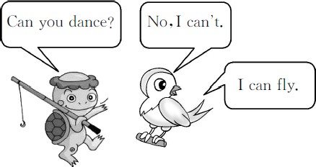

基础碰碰车

Ⅰ . 看图 , 选择与之相应的单词。

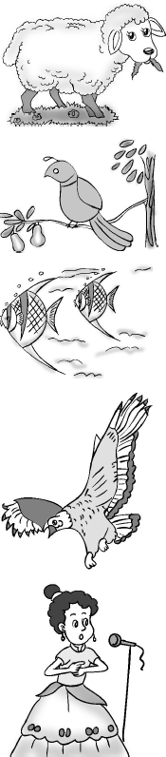
( )1. A.sheep B.cow

( )2. A.bird B.duck

( )3. A.chicken B.fish

( )4. A.swim B.fly

( )5. A.sing B.dance

- . 根据所给图片 , 选择对应的答案。( )1.Can you sing?
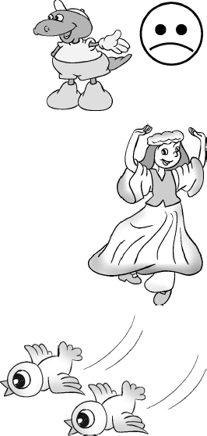
A.Yes,I can.
B.No,I can᾽t.

( )2.Can you dance?
A.Yes,I can.
B.No,I can᾽t.

( )3.Can you fly?
A.Yes,I can.
B.No,I can᾽t.

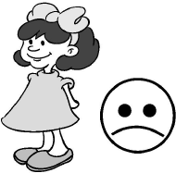
( )4.Can you swim?
A.Yes,I can.
B.No,I can᾽t.

升级跷跷板

Ⅲ . 读句子 , 选择正确的图片。
( )1.—Can you fly?
—Yes,I can.

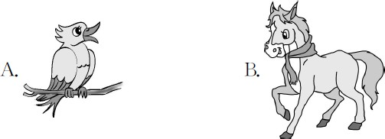

-1-

( )2.—Can you dance?
—No, I can᾽t.
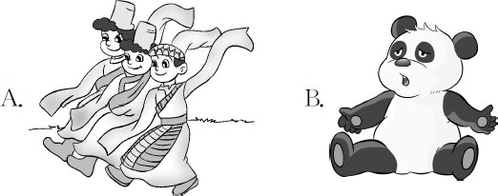

( )3.—Can you swim?
—Yes, I can.

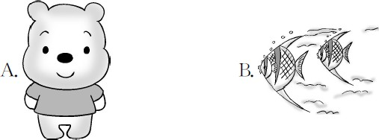

( )4.—Can you sing?
—No, I can᾽t.

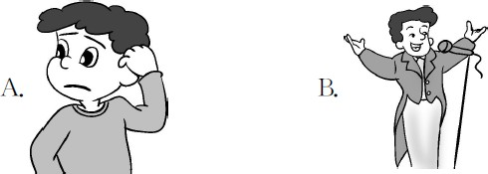

-2-
( )5.—What᾽s that?
—It᾽s a cat.
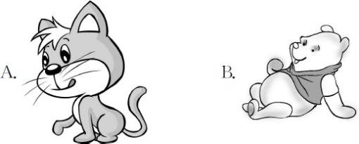

Ⅳ . 根据生活实际 , 圈出动物们会做的事情。
  - Fish can (swim,fly). 2.A cat can (fly,run). 3.A bird can (fly,swim). 4.A dog can (swim,fly).

Unit 1 Animals on the Farm 课堂同步练习答案
Lesson 3 Fish and Birds

答案 :
Ⅰ .1.A | 2.A | 3.B | 4.B 5.A
Ⅱ .1.B | 2.A | 3.A | 4.B
Ⅲ .1.A | 2.B | 3.B | 4.A 5.A
Ⅳ .1.swim 2.run 3.fly 4.swim

Unit 1 Animals on the Farm
课堂同步练习
Lesson 4 Horses and Rabbits
姓名： 班级：

要点图解秀

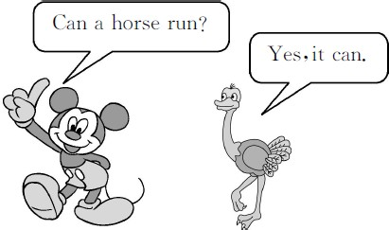

基础碰碰车

Ⅰ . 根据中文释义 , 选择对应的选项。
( )1. 什么动物会飞翔 ?
A.What animals can dance?
B.What animals can fly? ( )2. 鸭子和小狗会游泳。
A.Ducks and dogs can swim.
B.Cows and cats can run. ( )3. 兔子和马会跑。
A.Horses and rabbits can fly.
B.Rabbits and horses can run. ( )4. 绵羊会跳跃吗 ?
A.Can sheep jump?
B.Can pigs jump?

- . 选出正确的字母组合 , 将下列单词补充完整。
A.or B.ar
( )1.h se( 马 ) A.bb B.pp
( )2.ra it( 兔 子 ) A.am B.um
( )3.j p( 跳 跃 ) A.ur B.un
( )4.r ( 跑 )

升级跷跷板

Ⅲ . 读问句 , 选择与之对应的答句。
( )1.What animals can swim?
A.Birds can jump. B.Fish can swim. ( )2.Can a horse run?
A.Yes, it can. B.No, it can᾽t. ( )3.What᾽s this?
A.It᾽s a rabbit. B.Cows can run. ( )4.Is this a horse?
A.Yes, it can. B.Yes, it is. ( )5.Can rabbits fly?
A.No, it can᾽t. B.No, they can᾽t.

Ⅳ . 读句子 , 选择对应的图片。
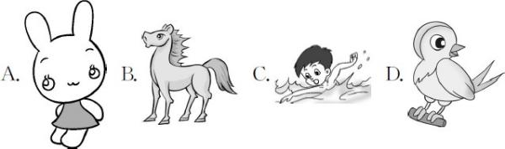

( )1.—What can you do?
—I can fly.
( )2.—What can you do?
—I can swim.
( )3.—What can you do?
—I can run.
( )4.—What can you do?
—I can jump.

Unit 1 Animals on the Farm 课堂同步练习答案
Lesson 4 Horses and Rabbits
答案 :
Ⅰ .1.B | 2.A | 3.B | 4.A
Ⅱ .1.A | 2.A | 3.B | 4.B
Ⅲ .1.B | 2.A | 3.A | 4.B 5.B
Ⅳ .1.D | 2.C | 3.B | 4.A

Unit 1 Animals on the Farm
Lesson 5 Where? 课堂同步练习
姓名： 班级：

要点图解秀

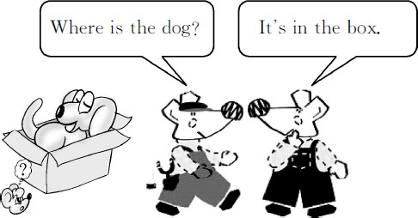

基础碰碰车

Ⅰ . 根据图片填写所缺字母。

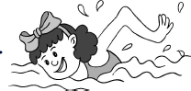
1. swi

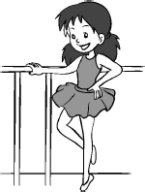
2. da ce


3. gir

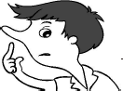
4. ose


5. f ve

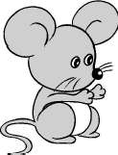
6. ouse

-1-
Ⅱ . 根据所给图片 , 选择对应的答案。
( )1.—Where is the pencil?
—

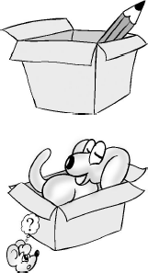
A.It᾽s in the box.
B.It᾽s under the box. ( )2.—Where is the cat?
—
A.It᾽s on the box.
B.It᾽s in the box.
( )3.—Where is the ruler?

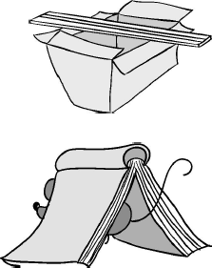 —

A.It᾽s on the box.
B.It᾽s under the box. ( )4.—Where is the mouse?
—
A.It᾽s on the box.
B.It᾽s under the box.

升级跷跷板

Ⅲ . 读问句 , 选择与之对应的答句。
( )1.What᾽s in the box?
A.Yes, it can. B.A cat. ( )2.Is it a rabbit?
A.No, it isn᾽t. B.No, it can᾽t. ( )3.Can it fly?
A.No, it can᾽t. B.It᾽s a horse. ( )4.Is this a horse?
A.No,I can᾽t. B.Yes,it is. ( )5.Where is the dog?
A.It can run. B.It᾽s in the box.

Ⅳ . 看图 , 选择正确的方位词填空。
( )1.The pencil is the book.
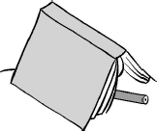
A.in B.under

( )2.The pencil is the box.

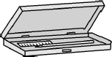
A.on B.in

-2-

( )3.The car is the watermelon.

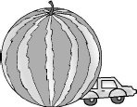
A.under B.on

( )4.The panda is the ball.

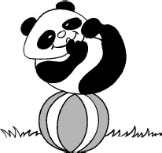
A.on B.under

Unit 1 Animals on the Farm 课堂同步练习答案
Lesson 5 Where?
答案 :
Ⅰ .1.m | 2.n | 3.l | 4.n | 5.i 6.m
Ⅱ .1.A | 2.B | 3.A | 4.B
Ⅲ .1.B | 2.A | 3.A | 4.B | 5.B
Ⅳ .1.B | 2.B | 3.A | 4.A

Unit 1 Animals on the Farm
Lesson 6 Can I Help You? 课堂同步练习
姓名： 班级：

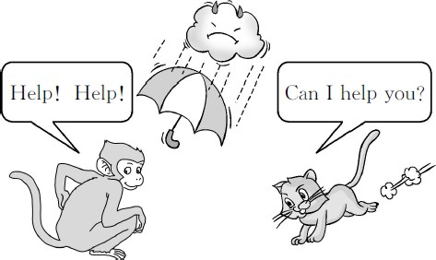
( )3.Look! A chicken and a duck.
要点图解秀
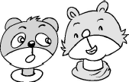

( )4.Look! A horse and a fish.
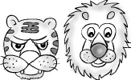

升级跷跷板

Ⅰ . 为下列单词选择正确的中文释义 , 将其序号填在题前的括号里。
基础碰碰车
( )1. help A. 卡住的 ; 不能动弹的
( )2. stuck B. 朋友
( )3. pull C. 帮助( )4. friend D. 发生
( )5. happen E. 拉 ; 扯

Ⅱ . 小法官 , 巧判断。判断图片与句子是否相符 , 相符的打“√”, 不相符的打“×”。
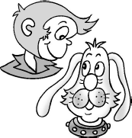
( )1.Look! A pig and a dog.

( )2.Look! A rabbit and a cat.

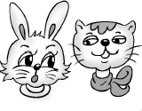

-1-
Ⅲ . 读句子 , 选一选。
( )1.—What᾽s this?
—It᾽s a duck.

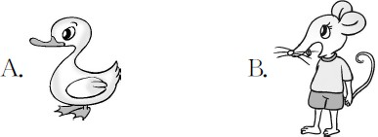

( )2.—Is this a cat?
—No, it isn᾽t.

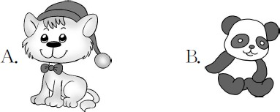

( )3.—Is this a book?
—Yes,it is.

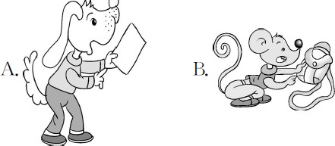

Ⅳ . 读句子 , 选择与之对应的答句。
( )1.What happened?
A.I᾽m stuck. B.I᾽m a pig. ( )2.Can I help you?
A.No, it isn᾽t. B.Yes, please. ( )3.Thank you!
A.No thank. B.You᾽re wele. ( )4.Can you help me?
A.Yes, of course. B.Yes, it is.
Ⅴ . 读句子 , 按句子意思给下面的小动物涂色。
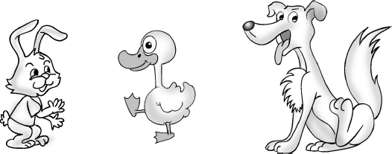

1.The duck is yellow and blue. 2.Look!The rabbit is blue and pink. 3.Look!The dog is purple and white.

-2-

Unit 1 Animals on the Farm 课堂同步练习答案
Lesson 6 Can I Help You? 答案 :
Ⅰ .1.C 2.A 3.E 4.B 5.D
Ⅱ .1.× 2. √ 3.× 4.×
Ⅲ .1.A 2.B 3.A
Ⅳ .1.A 2.B 3.B 4.A
Ⅴ .(略)

Unit 1 Animals on the Farm
Again,Please! 课堂同步练习
姓名： 班级：

Ⅱ . 读单词 , 选择对应的图片。
要点图解秀

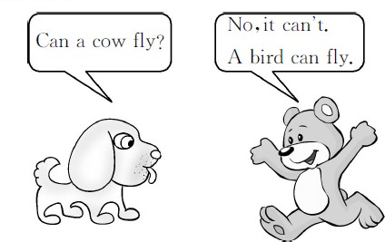
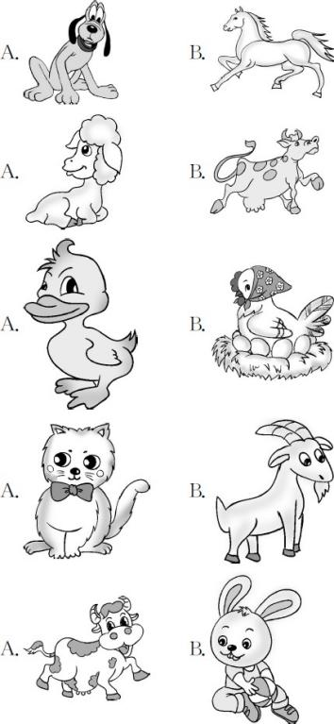
( )1.dog

( )2.sheep

( )3.chicken

( )4.cat
基础碰碰车

Ⅰ . 看图片 , 选出与之对应的单词。

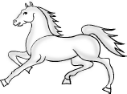
( )1. A.help B.horse

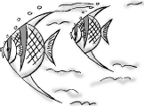
( )2.
A.five B.fish

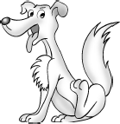
( )3.
A.dog B.bag


( )4. A.ruler B.rabbit

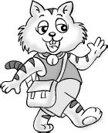
( )5.
A.ear B.cat

-1-
( )5.cow

Ⅲ . 将对应单词的序号标在图片旁边。
1.cow 2.rabbit 3.pig 4.cat
5.mouse 6.duck 7.chicken 8.dog
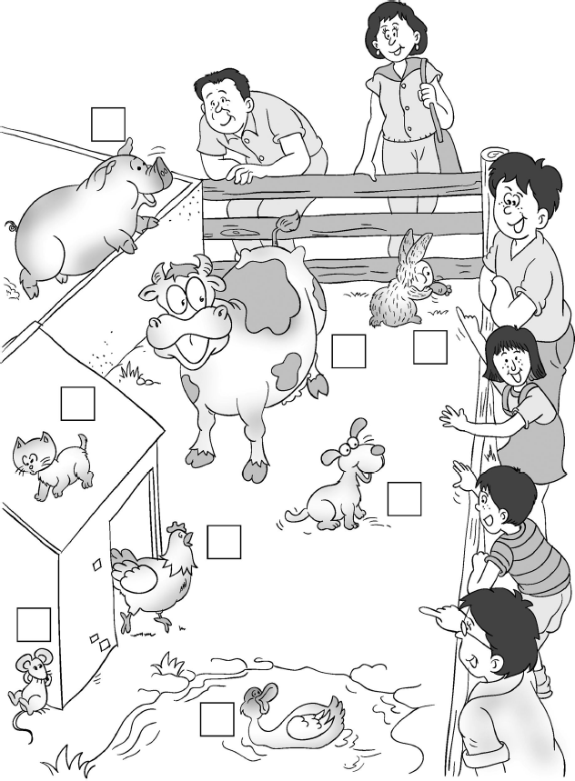

Ⅳ . 读句子 , 选择与之对应的答句。
( )1.What᾽s under the box?
A.It᾽s stuck. B.It᾽s a pig. ( )2.Can a chicken swim?
A.No,it can᾽t. B.Yes,please. ( )3.What᾽s this?
A.It᾽s a cow. B.It᾽s on the box. ( )4.Where is the duck?
A.It᾽s a sheep.
B.It᾽s under the chair. ( )5.Can I help you?
A.No,thanks. B.Yes,it can.

升级跷跷板

- . 看图片 , 选择正确的对话。
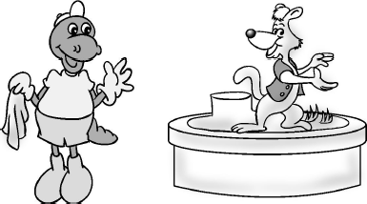
( )1.

A.—Can you sing,Cat?
—Yes,I can.
B.—Can you dance,Dog?
—Yes,I can.
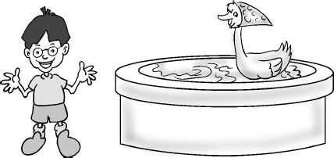
( )2.

A.—Can you swim,Duck?
—Yes,I can.
B.—Can you fly,Pig?
—Yes,I can.
( )3.

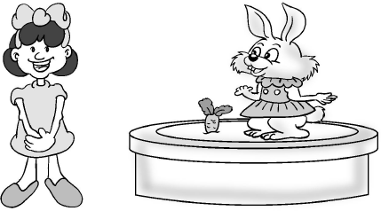

A.—Can you run,Horse?
—Yes,I can.
B.—Can you jump,Rabbit?
—Yes,I can.
Ⅵ . 选择填空。
( )1.I swim.
A.is B.can
( )2. happened?
A.What B.What᾽s ( )3.Can fly?
A.you B.your ( )4.This a rabbit.
A.are B.is ( )5.Can help you?
A.my B.I
Ⅶ . 根据所给图片 , 选词填空。( 每词限用一次 )

No dance fish sing Yes fly What can

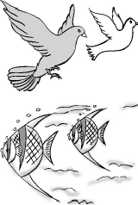
  - — can birds do?

—They can .

  - —Can swim?
— ,they can.

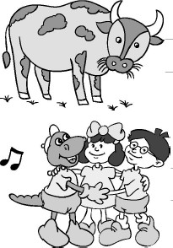
  - —Can cows ?
— ,they can᾽t.

  - —Danny sing.
—We can ,too.

-2-

Unit 1 Animals on the Farm 课堂同步练习答案
Again, Please! 答案 :
Ⅰ .1.B 2.B 3.A 4.B 5.B
Ⅱ .1.A 2.A 3.B 4.A 5.A
Ⅲ .(略)
Ⅳ .1.B 2.A 3.A 4.B 5.A Ⅴ .1.B 2.A 3.B
Ⅵ .1.B 2.A 3.A 4.B 5.B
Ⅶ .1.What; fly 2.fish; Yes 3.dance; No 4.can; sing

Unit 2 Animals at the Zoo
课堂同步练习
Lesson 7 At the Zoo
姓名： 班级：

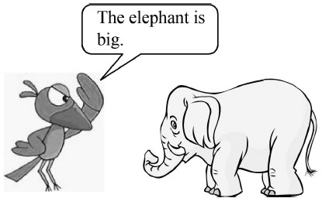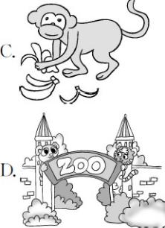( )3. zoo
要点图解秀

( )4. monkey

升级跷跷板

Ⅲ . 读句子 , 选择与之相符的图片。
( )1.The panda is fat.
基础碰碰车

Ⅰ . 根据中文释义 , 选择对应的句子。
( )1. 那只鸟很小。
A.The duck is big.
B.The bird is small. ( )2. 那头熊猫很胖。
A.The horse is fat.
B.The panda is fat. ( )3. 那只猴子很瘦。
A.The dog is small.
B.The monkey is thin. ( )4. 那头猪真大。
A.The pig is big.
B.The cat is fat.

- 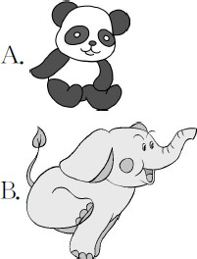. 读单词 , 选择对应的图片。

( )1. elephant ( )2. panda

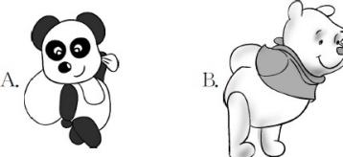

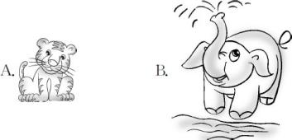( )2.Look at the elephant.It᾽s so big!

( )3.The cat is thin.

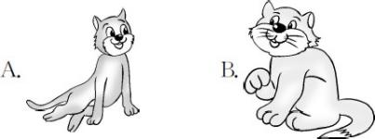

Ⅳ . 按要求画画。
  - The panda is fat. 2.The pig is big.

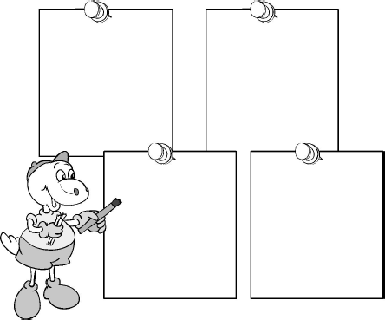
3.The cat is small. 4.The dog is thin.

Unit 2 Animals at the Zoo 课堂同步练习答案
Lesson 7 At the Zoo

答案 :
Ⅰ .1.B | 2.B | 3.B 4.A
Ⅱ .1.B | 2.A | 3.D 4.C
Ⅲ .1.A | 2.B | 3.A
Ⅳ .(略)

Unit 2 Animals at the Zoo
课堂同步练习
Lesson 8 Tigers and Bears
姓名： 班级：

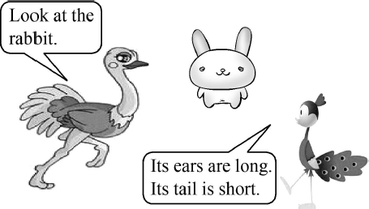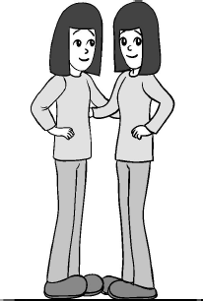( )3. The girls are .
要点图解秀

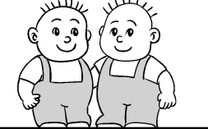( )4. The boys are .

基础碰碰车

Ⅰ . 将图片和对应的单词连线。

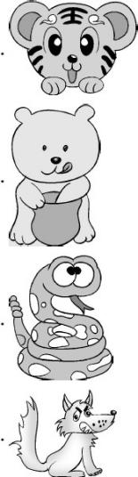1.
wolf

2. tiger

3. bear

4. snake

- . 选择与图片相符的形容词 , 每词限用一次。
A.long B.short C.fat D.thin ( )1. The bear is .

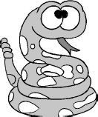( )2. The snake is .

Ⅲ . 选择下列单词的对应词。
( )1. big A.short B.small ( )2. long A.big B.short
( )3. thin A.fat B.long

升级跷跷板

Ⅲ . 读句子 , 选一选。
( )1.Look at my hair.It᾽s long.
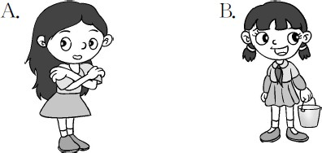
( )2.Look at the rabbit.It’s tail is short.
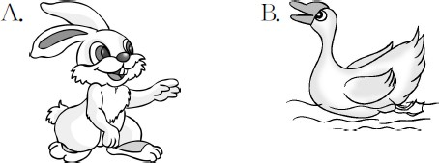

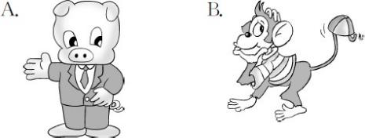( )3.Look at the monkey.It’s tail is long.

( )4.Look at the elephant.It’s nose is long.
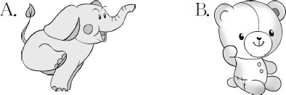
( )1.It᾽s white. It᾽s small. It’s ears are
long. Its tail is short.
( )2.It᾽s fat. It᾽s black and white.
( )3.It᾽s very big. It’s nose is so long. ( )4.It᾽s our friend.Its ears are big.

Ⅳ . 猜猜它是什么 ? 将答案的序号写在括号里。
A.rabbit B.elephant C.panda D.dog

Unit 2 Animals at the Zoo 课堂同步练习答案
Lesson 8 Tigers and Bears 答案 :
Ⅰ .(略)

Ⅱ .1.C | 2.A | 3.D | 4.B
Ⅲ .1.B | 2.B | 3.A
Ⅲ .1.A | 2.A | 3.B | 4.A
Ⅳ .1.A | 2.C | 3.B | 4.D

Unit 2 Animals at the Zoo
课堂同步练习
Lesson 9 How Many?
姓名： 班级：

( )3.
要点图解秀

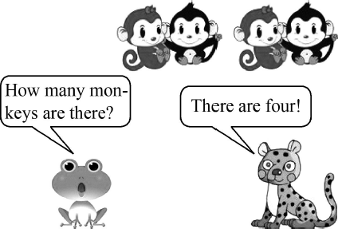 A.girl B.five ( )4.

A.six B.three

( )5.

A.one B.two
基础碰碰车

Ⅰ . 将单词和相应的数字连线。
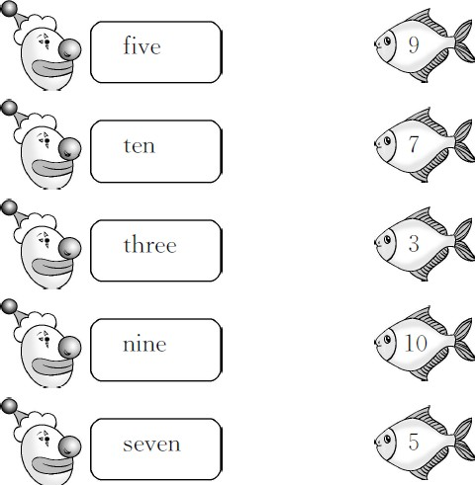

- . 数一数 , 选择正确的数量单词。

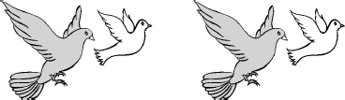( )1.

A.eight B.four

( )2.

A.two B.ten

升级跷跷板

Ⅲ . 算一算 , 将相应的单词序号填入星星中。

A.four B.eight C.one D.two E.six

  - four+two= 2.five-one=

3.one+one= 4.ten-two=

5.three-two=

Ⅳ . 读句子 , 选一选。
( )1.One, two, three. Three students.

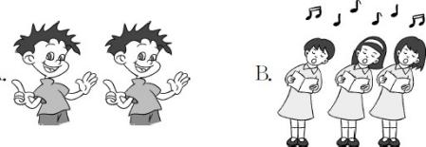

( )2.There are four bears.
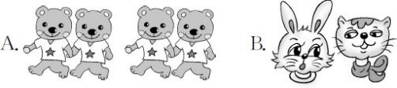

( )3.—How many tigers?
—Two.
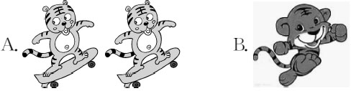
( )4.—How many ducks?
—Three.
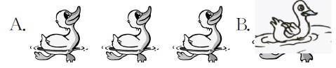

Unit 2 Animals at the Zoo 课堂同步练习答案
Lesson 9 How Many? 答案 :
Ⅰ .(略)

Ⅱ .1.B | 2.A | 3.B | 4.B | 5.A
Ⅲ .1.E | 2.A | 3.D | 4.B | 5.C
Ⅳ .1.B | 2.A | 3.A | 4.A

Unit 2 Animals at the Zoo
课堂同步练习
Lesson 10 Where Do They Live?
姓名： 班级：

要点图解秀
升级跷跷板

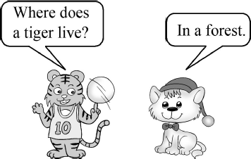

基础碰碰车

Ⅰ . 帮动物们找到家。连一连。
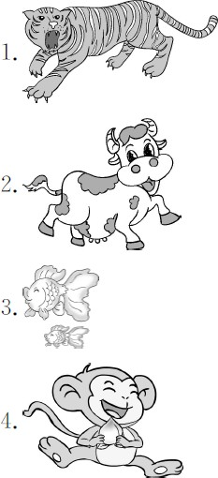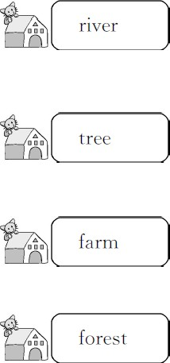

- . 选词填空。
forest river tree farm

  - Where does a panda live? In a . 2.Where does a bird live? In a . 3.Where does a fish live? In a . 4.Where does a sheep live? On a .

Ⅲ . 看图片 , 读问句 , 选择正确的回答。
( )1.Where does a panda live?

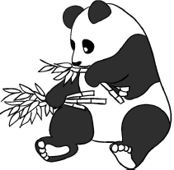

A.In a forest.
B.In a school.

( )2.Where does a fish live?

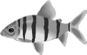
A.In a river.
B.In the grass.

( )3.Where does a tiger live?

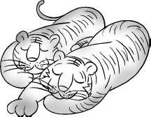
A.In a zoo.
B.On a farm.

( )4.Where does a bird live?

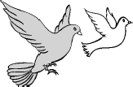
A.In a tree.
B.In a river.

( )5.Where does a snake live?
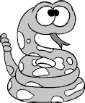

A.In the grass.
B.In the room.

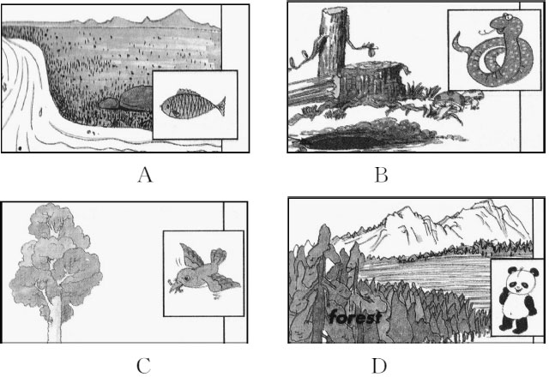Ⅳ . 读句子 , 选择对应的图片。
( )1.Where does a panda live? In a forest. ( )2.Where does a fish live? In a river.
( )3.Where does a snake live? In a hole. ( )4.Where does a bird live? In a tree.

Unit 2 Animals at the Zoo 课堂同步练习答案
Lesson 10 Where Do They Live? 答案 :
Ⅰ .(略)
Ⅱ .1.forest 2.tree 3.river 4.farm Ⅲ .1.A 2.A 3.A 4.A 5.A
Ⅳ .1.D 2.A 3.B 4.C

Unit 2 Animals at the Zoo
Lesson 11 What Do They Eat? 课堂同步练习
姓名： 班级：

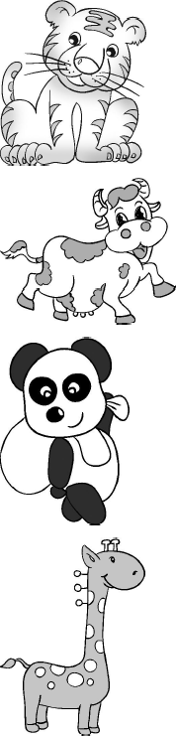2.
要点图解秀
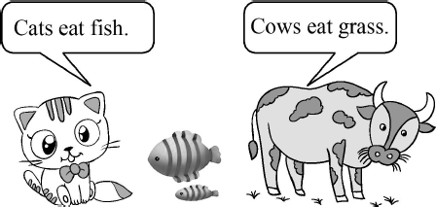 banana

3. bamboo

4. leaves

5. grass
基础碰碰车

Ⅰ . 选出正确的字母组合 , 将下列单词补充完整 , 将其序号填在题前的括号里。

A.na B.en
( )1.ba na( 香 蕉 )

A.ee B.ea ( )2.m t( 肉 )

A.ra B.la ( )3.g ss( 草 )

A.ch B.sh ( )4.fi ( 鱼 )

- . 动物们最喜欢吃什么 ? 连一连。
  - 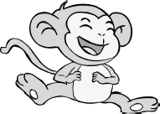meat
升级跷跷板

Ⅲ . 根据图片选词填空 , 使句子完整。

grass meat fish bananas

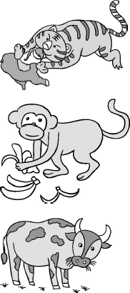1.
Tigers eat .

2.
Monkeys eat .

3.
Cows eat .

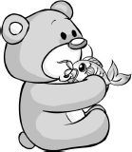4.
Bears eat .
Ⅳ . 读问句 , 选出与之相应的答语。
( )1.What can they do?
( )2.Where do they live? ( )3.What do they eat?
( )4.Where does a bear live?

A.A bear lives in a forest.
B.They live in the tree.
C.They can jump.
D.They eat fish.

以上内容仅为本文档的试下载部分，为可阅读页数的一半内容。如要下载或阅读全文，请访问：https://d.book118.com/668055076047006042

