2023-2024学年甘肃省白银市白银区八年级（上）期末英语试卷
听力理解 第一节 听句子，从题中所给的A、B、C三个选项中选出所包含的信息。每个句子读两遍。
1．（1分）A.mile.
B.meal.
C.mail.
2．（1分）A.March 20.
B.April 20.
C.May 20.
3．（1分）A.full of.
B.made of.
C.proud of.
4．（1分）A.1600s.
B.1700s.
C.1800s.
5．（1分）A.put on.
B.work on.
C.turn on.
第二节 听句子，选出该句的最佳答语。每个句子读两遍。
6．（1分）A.They're new.
B.Three.
C.In.class.
7．（1分）A.Sorry，I will.
B.OK，I will.
C.Sorry，I won't.
8．（1分）A.On foot.
B.With my friends.
C.In the morning.
9．（1分）A.Two years ago.
B.At night.
C.On weekends.
10．（1分）A.You are lucky.
B.Congratulations!
C.Have a good time!
第三节 听对话和问题，选择正确答案。每段对话读两遍。
11．（1分）What's wrong with the man？
A.He has a cough.
B.He has a fever.
C.His feet hurt.
12．（1分）Where does the woman want to go？
A.To the bookstore.
B.To the post office.
C.To the bank.
13．（1分）What does the girl's brother want to be？
A.A pilot.
B.An artist.
C.A policeman.
14．（1分）What colour is the boy's T﹣shirt？
A.Blue.
B.Red.
C.White.
15．（1分）How long has Mr.Zhou lived in Gansu？
A.For five years.
B.For ten years.
C.For fifteen years.
第四节 听短文填空，短文读两遍。
16．（5分）
Information Sheet
Name：Fred

Age：（1） years old.
Personality（性格）： （2）active and
Family members&jobs：18：father，an excellent（3） .
mother，a strict maths teacher
Hobbies：19：listen to pop music and play （4）
Want to do：20：learn （5）
语法与情景对话 阅读下列各题，从A、B、C、D四个选项中选择一个最佳答案。
17．（1分）The trip to the science museum was wonderful.We really had great time last Sunday.（ ）
A．a B．an C．the D．/
18．（1分）Can you give me some ________ on learning English？（ ）
A．advice B．news
C．suggestion D．secret
19．（1分）—The cake is really delicious.Could I have __________ one？
—Sure.Here you are.（ ）
A．another B．other C．the other D．others
20．（1分）—Would you like to attend a party with me？
—Sorry，my parents don't me to go out at night.（ ）
A．encourage B．advise C．allow D．lead
21．（1分）It often takes me two hours __________ playing the violin．（ ）
A．practice B．to practice
C．practicing D．practices
22．（1分）What can we know from the notice at the train station？
Notice
Sorry，everyone.It's 5：10 p.m
The train will arrive in ten minutes.
（ ）
A．The train will arrive at 5：00 p.m.
B．The train will arrive at 5：20 p.m.
C．The passengers can get off at 5：10 p.m.
D．The passengers can get on the train before 5：20 a.m
23．（1分）No matter you give up，never give up hope.（ ）
A．what B．where C．who D．when
24．（1分）In the past year，he many bad habits and made progress in math.（ ）
A．changes B．has changed
C．is changing D．will change
25．（1分）—I think children over ten should make their own decisions on what to wear every day.
— They are too young to do that.（ ）
A．Don't mention it. B．That's too bad.
C．I don't agree. D．I think so.
26．（1分）Which of the following underlined parts is different in pronunciation from the others？（ ）
A．whole B．who C．wheel D．whose
完形填空
27．（10分）Almost everyone has his own hobby.My hobby is reading.When I was young，I didn't have any hobbies.I used to watch TV at home all day and my parents were （1） about me.
One day，my father took me to my aunt's home.When I got there，I saw my cousin （2） in his room.I ran to him and said，"Reading books is so boring.Why not go out to play games？That's more （3） ."
"I don't think so.Reading is really interesting，and also I can get a lot of （4） from my books." Then my cousin asked me some questions，but I couldn't （5） most of them.He was two years younger than me，but he knew much more.My face turned red.
That day he told me many interesting stories.And I （6） myself in his stories.From then on，I became interested in reading.Now I have a room （7） books.In my free time，I'm glad to be （8） and read the books.I do well in my subjects because of all the books I've read，and I'm especially good at （9） .I have won many prizes in writing contests.That makes me feel very （10） .
（1） | A.tired | B.scared | C.worried | D.excited
（2） | A.read | B.reading | C.playing | D.play
（3） | A.important | B.enjoyable | C.surprising | D.comfortable

（4） | A.activities | B.programs | C.instructions | D.knowledge
（5） | A.receive | B.repeat | C.answer | D.follow
（6） | A.helped | B.taught | C.encouraged | D.lost
（7） | A.full of | B.short of | C.opposite of | D.fit for
（8） | A.special | B.early | C.different | D.alone
（9） | A.writing | B.English | C.P.E. | D.science
（10） | A.nervous | B.sick | C.proud | D.sorry
阅读理解
28．（10分）Gansu is a province in the northwest of China.The capital city is Lanzhou，which is passed through by the Yellow River.
Along the second longest river of China live so many people of different nations in Gansu Province.They are different in many aspects（方面） including foods，buildings（服装），festivals，customs，languages，cultures and so on.But all the people live together
How can they work as a team？First of all，people in Gansu Province are hard﹣working and brave.As we all know，the climate（气候）（资源） is poor.However，people work hard to get over the difficulties.Now，the resource，the environment，people in Gansu Province can respect and accept one another and help each other.It's all the differences that make Gansu Province be a lively place to live in.
Although Gansu Province has a long way to catch with the developed provinces，people are still willing to work hard to make a better living.

根据短文内容，判断下列句子的正误。正确的选（A），错误的选（B）。
（1）Gansu Province is in the southwest of China.
（2）Yellow River is the longest river in China.
（3）All the nations in Gansu look forward to living a peaceful life.
（4）The climate and the resource in Gansu are better than other places in China.
（5）The writer believes Gansu Province will have a brighter future.
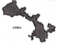
29．（10分）If you are riding a bike in foreign countries，you need to know what these traffic signs mean.
1 |  | This sign means"walk".You can cross the street with other people.
2 |  | This sign is the"don't walk"sign.It means you should stop to wait for a while until the sign of"walk"is showing.
3 |  | This sign means that there is a bike lane（车道）.If bike riders see such a sign，they must use the bike lane.
4 |  | Car drivers and bike riders must come to a complete stop at"stop"signs.
5 | 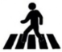 | This sign means you are coming to a zebra crossing.You must slow down to allow people on the zebra crossing to cross the street first.
（1）Which of the following signs means"walk"？
A.
B.
C.
D.
（2）What should bike riders do when they see the sign？
A.Ride against traffic.
B.Ride on the left side of the road.
C.Ride in the bike lane.
D.Ride on the right side of the road.
（3）Which of the following signs has the same meaning as this sign？
A.
B.
C.
D.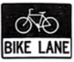
（4）According to the passage，which of the following is NOT right？
A.You should stop to wait when you see the"don't walk"sign.
B.If there is a bike lane，bike riders can choose the bike lane or the sidewalk.
C.The"STOP"sign means a complete stop for car drivers and bike riders.
D.Before people on the zebra crossing cross the street，bike riders should slow down.
（5）The passage is mainly talking about .
A.traffic rules
B.traffic lights
C.traffic signs
D.traffic accidents

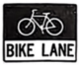
任务型填空：用方框中所给词的适当形式填空
30．（10分）
us，give up，beginning，any，home，kilometer，confident
My classmates and I went hiking last weekend.It was a challenge for us because none of（1） have ever experienced such a long journey.It was almost forty （2） long.At the （3） we all felt very excited.We talked to each other and sang songs happily.
About two hours later，we became so thirsty and tired that we almost wanted to （4） .
But we also wanted to challenge ourselves.The sun was burning like a fire.Each step seemed to become heavier and
（5） ，but no one ever thought to stop.We kept （6） .
At noon，we made it.We were so glad that we couldn't help shouting and laughing.After an hour，we started to go back （7） .When there was only 1.500 meters left，a pain（疼痛）（8） went through my whole body.At that moment，I really wanted to stop.But my classmates gave me their full support.With their help.I finally reached the end.I felt the strong satisfaction of overcoming difficulties.
Through this hiking experience，I feel energetic and more（9） to meet challenges in the future，and I realize we are our own enemies.There's no doubt that we will overcome（10） difficulty if we have a brave heart and a strong will.
任务型阅读理解 阅读下面短文，并按要求完成问题。
31．（10分）Paper，as one of the four great inventions in China，is used everywhere in our daily life.It is very common
People developed writing in ancient times，they mainly made ropes to record things.At first，ancient people wrote something on oracle bones（甲骨），wood and silk were also discovered and used during the Spring and Autumn Period.Paper was made because it was cheaper and lighter.
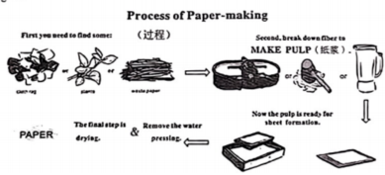
Nowadays，paper is quite helpful and necessary in our life.A large amount（数量） of ancient information was kept because of this invention.It is the carrier of writing and painting.Painters use it to describe the beauty of the world，printing paper，toilet paper and so on.

阅读短文，根据其内容完成以下任务：
任务一：根据短文补全下面句子。
（1）Paper，as one of the in China， is very common in our daily life.
任务二：回答问题。
（2）What did ancient people use for writing at first？
（3）What can we learn from these pictures？
任务三：阅读第三段，再列举一条paper的用途。
（4）Students use it to .
（5）The last paragraph is mainly about .
A.The development of paper.
B.The use of paper in our life.
C.The development of writing.
D.The introduction（介绍） of paper.
口语交际 阅读下面的对话，根据上下文，从方框内选择恰当的选项补全对话，使句意完整、符合逻辑。（其中有两项为多余选项）
32．（10分）A：Hello？
B：Hi，Lily.How's everything going？
A：Pretty well.
B：Tomorrow is Sunday.Do you have any plans？
A：（1） What about you？
B：I am going to work as a volunteer at the train station.（2）
A：Sure，I'd love to.（3）
B：We can help people buy tickets.If there is someone smoking，we can tell him to stop doing it.
A：That's what I'm good at.
B：（4） I've done volunteer work many times and every time I could learn something new.
A：I can't wait!（5）
B：You can take the No.4 bus.It's fast and cheap.
A：OK.See you tomorrow.
B：See you tomorrow.

A How can I get there？
B.How is your weekend？
C.J have no idea.
D.Would you like to go with me？
E.I'm glad that you can do that.
F.What can we help to do there？
G.They can tell people how to get there.
词汇考查：用所给词的适当形式填空。
33．（1分）Anna had a fever yesterday，so she was （able） to go to school．
34．（1分）He solved all the problems by （he） this time.
35．（1分）The problem won't （appear） by itself.We must solve it.
36．（1分） （learn） a language well，we should use it every day.
37．（1分）As you （probable） know，I'm going to change my job soon.
38．（1分）I didn't see Mr.Wang in the office.He might （go） back home.
39．（1分）Our Chinese teacher always encourages us （read） more books.
40．（1分）I'll talk to him when he （come） back．
41．（1分）Try to use your （imagine） to think of something special.
42．（1分）You are （suppose） to write to him as soon as possible.
根据汉语意思完成句子。（每空限填一词）
43．（2分）去年夏天因为天气太炎热，我们只好待在家里。
the hot weather，we had to stay at home last summer.
44．（2分）这部卡通电影使许多男孩梦想成为警察。
This cartoon movie makes many boys being policemen.
45．（2分）王军家就在图书馆对面，他每天都会在那里看两个小时书。
Wang Jun's home is the library，and he reads books there for two hours every day.
46．（2分）刘老师已经教了我们一年多英语了。
Ms.Liu has taught us English for a year.
47．（2分）我经常提醒自己要保持真诚和善良。
I often myself keep sincere and kind.
书面表达
48．（10分）习近平总书记在中国国际友好大会暨中国人民对外友好协会成立60周年纪念活动中讲到，"有梦想，有追求，一切都有可能"，作为中学生，写一篇短文。
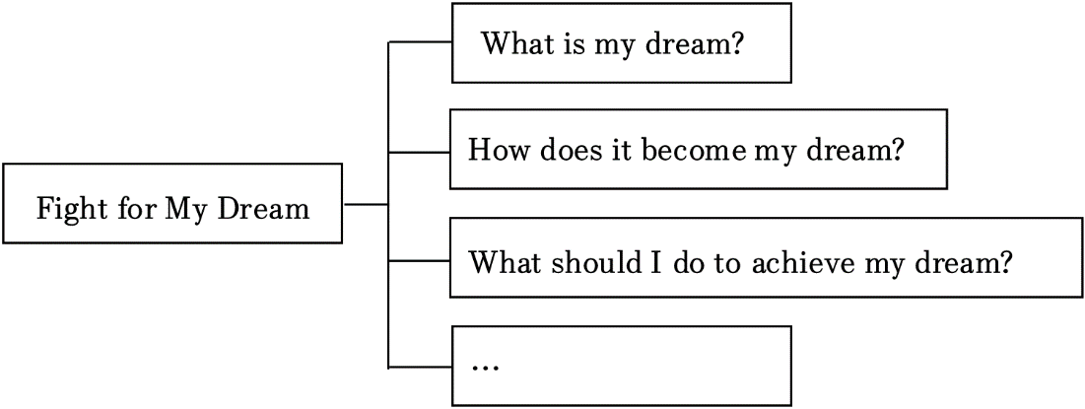
（1）文中须包括所有提示内容，可适当发挥。
（2）文中不要出现真实的地名，校名和人名。
（3）词数80 左右。 （开头已给出，不计入总词数）
______
以上内容仅为本文档的试下载部分，为可阅读页数的一半内容。如要下载或阅读全文，请访问：https://d.book118.com/678033075102006026

