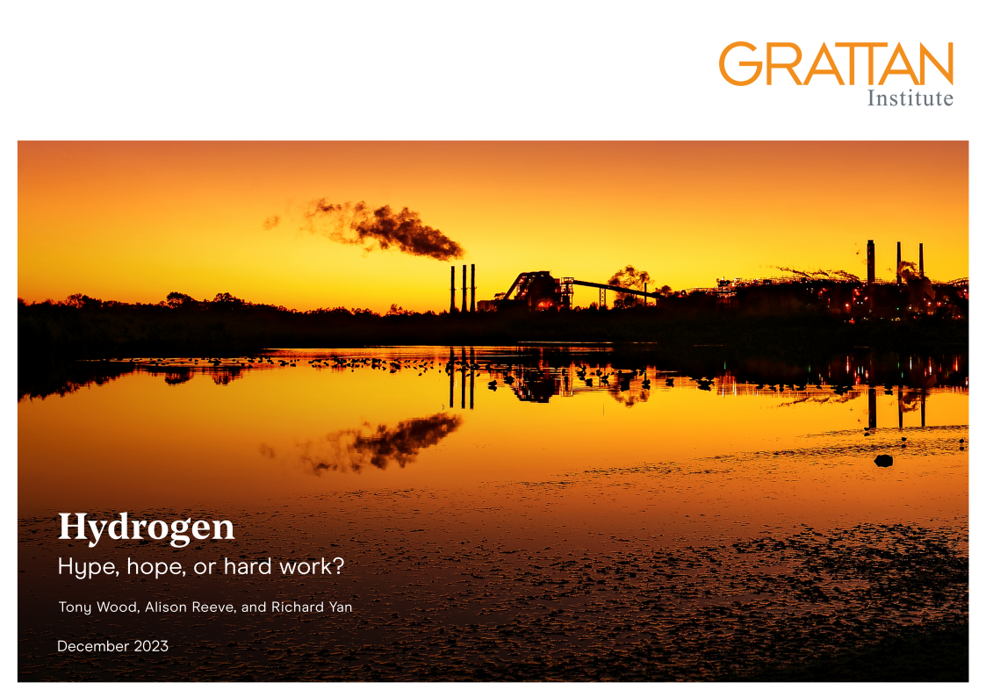



Grattan Institute Support

Founding members (2009)





BHP

Endowment Supporters
The Myer Foundation
National Australia Bank
Scanlon Foundation
Susan McKinnon Foundation
Affiliate Partners
Origin Energy Foundation
Scanlon Foundation
Susan McKinnon Foundation
Third Link Growth Fund
Senior Affiliates
Cuffe Family Foundation
Medibank Private
Trawalla Foundation
Wesfarmers
Affiliates
Allens
Ashurst
Boston Consulting Group
Maddocks
McKinsey & Company
PEXA
Urbis
Westpac

Grattan Institute Report No. 2023-13, December 2023

This report was written by Tony Wood, Alison Reeve, and Richard
Yan. Tarun Chowdhary, Bronwyn See, and Christina Grant contributed early research.
We would like to thank the members of Grattan Institute’s Energy and
Climate Change Program Reference Group for their helpful comments, as well as numerous government and industry participants and officials for their input.
The opinions in this report are those of the authors and do not
necessarily represent the views of Grattan Institute’s founding
members, affiliates, individual board members, reference group
members, or reviewers. The authors are responsible for any errors or omissions.
Grattan Institute is an independent think tank focused on Australian public policy. Our work is independent, practical, and rigorous. We aim to improve policy by engaging with decision makers and the
broader community.
We acknowledge and celebrate the First Nations people on whose traditional lands we meet and work, and whose cultures are among the oldest in human history.
For further information on Grattan’s programs, or to join our mailing list, please go to: www.grattan.edu.au. You can donate to support future Grattan reports here: www.grattan.edu.au/donate.
This report may be cited as: Wood, T., Reeve, A., and Yan, R. (2023). Hydrogen: hype, hope, or hard work?. Grattan Institute.
ISBN: 978-0-6457978-5-5
All material published or otherwise created by Grattan Institute is licensed under a Creative Commons Attribution-NonCommercial-ShareAlike 3.0 Unported License.

Overview

Hydrogen can help meet Australia’s emissions reduction targets and underpin economic growth opportunities. But to date, governments have seemed more concerned with hyping Australia’s hydrogen
prospects and hoping for the best, rather than doing the hard work
to establish integrated industry policy for proportionate, targeted, and timely support.
The best way to seize the hydrogen opportunity is to make strategic choices about its industrial applications that can leverage Australia’s comparative advantage in renewable energy resources and minerals, and build on existing export industries.
The most promising uses of hydrogen are in the production of
ammonia, alumina, and iron. These applications could use hydrogen efficiently and cost-effectively at a scale that could support a viable, long-term hydrogen industry that won’t require subsidies.
But in each of these cases, hydrogen still faces a ‘green premium’ – the gap between the cost of using hydrogen for zero-emissions production, and the cost of conventional production.
Three things can close that gap. First is cheaper electricity. Hydrogen costs are driven by electricity costs, and each hydrogen producer
will need to understand its specific electricity supply chain, including potential links to development of Australia’s renewable electricity
transmission grid.
Second is higher carbon prices. Heavy industry is covered by the
Safeguard Mechanism, which imposes a carbon price to drive down

emissions. But under the Safeguard’s current settings, this price isn’t likely to be high enough to close the cost gap before 2040.
Third is support for ‘green’ versions of these commodities. The best support would be an industry policy that evolves from the federal government’s Hydrogen Headstart program and uses
contracts-for-difference – contracts designed to support investment by underwriting part of the additional cost of production – to help industry grow.
This program should be broadened to form part of a comprehensive
Australian green industry policy. It should also support green commodity production using technology beyond hydrogen.
The cost to the government would probably be between $600 million and $2 billion per year. The prize would be reduced emissions from
domestic production of green ammonia, alumina, and iron, and export industries with a robust future for all three commodities.
Other uses of hydrogen, where the opportunities are less certain, tend to have complex supply chain logistics or face competing technologies, or both. These uses should be supported through policies that remove barriers to both hydrogen and competitor technologies.
It’s time to get serious about hydrogen. The reforms recommended in this report would give Australia the best chance to build a viable hydrogen industry that leverages our comparative advantages, is proportionate to our fiscal capacity, and won’t lead to inefficient
subsidies and trade distortions.

Recommendations

Be strategic about the hydrogen opportunity
. Set a clear objective to develop a hydrogen industry capable of supplying reliable low-cost hydrogen for the Australian industries where it would add greatest economic value.

. Focus first on producing green ammonia, green alumina, and
green iron as the most promising hydrogen uses.

Use neutral contracts-for-difference to close the green premium gap
. Transform the Hydrogen Headstart program into a contract-for- difference program, to support the growth of green commodity production in Australia. Conduct reverse auctions every year for 10 years.

Deliver cheap, green, reliable electricity
. Embed green hydrogen production and use more fully in
electricity-system planning, including the role of hydrogen as fuel for back-up power in the electricity grid.

. Continue to reduce the cost of renewable electricity in Australia, through new renewable energy generation, storage, and
transmission.

Unblock construction constraints
. State governments should co-ordinate and sequence major construction projects to avoid labour, material, and equipment constraints.

Use carbon pricing appropriately
. The 2026-27 review of the Safeguard Mechanism should consider how steeper baseline declines, higher price caps, and a lower
threshold could reduce green premiums.
. The Carbon Leakage Review should consider the role a Carbon Border Adjustment Mechanism (CBAM) could play in developing viable green commodity production.

Remove barriers to hydrogen use in other sectors
. Use sector-wide policy to encourage decarbonisation of industrial heat, sustainable aviation fuel, methanol, back-up electricity
generation, and long-distance road freight.

Rule out further government investment in uses that appear less likely to prove viable
. Do not invest further in hydrogen for homes and commercial buildings, light vehicles, and oil refining.

Table of contents

Overview 3
Recommendations 4
1 Why hydrogen matters 6
2 Hydrogen needs policy support to succeed 10
3 Assessing the opportunities 15
4 Start with ammonia, alumina, and iron 21
5 What governments should do 33
6 Other potential uses of hydrogen 46
A Uses of hydrogen 54
B Scenario assumptions 59

1 Why hydrogen matters

Hydrogen is a molecule that can help the world to decarbonise. It is
a light-weight, and energy-dense (by weight) molecule that can be
produced and burned with zero emissions. Like traditional fuels, it can be stored and transported for use at a different time and location. It
is also an irreplaceable component of important chemicals, including nitrogen fertilisers that help feed the world.
These advantages must be set against the current high cost of
hydrogen production and supply. Hydrogen should be used where it makes the most sense technically and economically. Those uses are likely to be fewer than had been hoped.
Where hydrogen will play a role in global decarbonisation, it is likely
Australian hydrogen will play an outsized role. Australia is endowed
with a significant, but untapped, clean-energy comparative advantage – that is, we have a larger endowment of renewable energy resources but smaller domestic demand than many other countries. Our significant
mineral reserves and proximity to large Asian markets are also
important factors. In a future decarbonised world economy, some
energy-intensive processes could shift to Australia, and hydrogen will be key to some of these opportunities.
The initial hype around hydrogen is settling into realism. Since
Australia’s first National Hydrogen Strategy was published in
2019, understanding of the role that hydrogen is likely to play in
decarbonisation has improved.

1.1 Hydrogen is one tool in the decarbonisation toolkit
The interaction between the technical and economic characteristics of hydrogen and its derivatives will determine the role it plays in the future decarbonised economy (see Box 1 on the following page).

Often, this means that decarbonising through electrification is cheaper than using hydrogen, for several reasons:
. Hydrogen-based processes often involve multiple energy
conversion steps along the chain. Energy losses at conversion mean that hydrogen-based processes will be less efficient and hence more costly.
. Green hydrogen production requires renewable electricity as
an input. In many cases, it may make more sense to use the
renewable electricity directly, given energy conversion penalties.
. Electricity can take advantage of significant existing infrastructure in the form of the grid, which can be made bigger to meet
future demands. Hydrogen often requires an entirely new and specialisedinfrastructure.
. Renewable electricity technologies have become cheaper through research,development, and deployment, whereas low-emissions hydrogen production technologies have barely started on this
journey.
Given these realities, the best decarbonisation decision will usually be ‘electrify everything we can and use hydrogen where we can’t’ .
But it is likely that hydrogen will play a part in decarbonising some activities, because:
. Hydrogen is needed as a molecule or feedstock in some industrial processes. In these cases, there is no alternative.
. Hydrogen may be able to replace fossil fuels in some applications to achieve high-temperature industrial heat at lower cost than
electricity.

Box 1: What is hydrogen?  Hydrogen is the lightest element in the periodic table. Compared  with fossil fuels such as natural gas, petrol, and diesel, it is more  energy-dense by weight, but less so by volume. Burning hydrogen  releases energy in the form of heat, while leaving nothing but water as a byproduct.  The world produced about 95 million tonnes (Mt) of hydrogen in 2022 – overwhelmingly using carbon-emitting production processes with  natural gas and coal as the feedstock – leading to more than 900Mt CO2-e (carbon dioxide-equivalent) in emissions.a Australia produces about 0.5Mt of hydrogen a year using natural gas, creating about 5Mt CO2-e in emissions.b  Hydrogen is currently used for the production of ammonia (used in  fertiliser and commercial explosives), methanol, and other chemicals; and to refine crude oil for transport fuels.  Hydrogen can contribute to decarbonisation in two ways:  . Decarbonising the production of hydrogen intended for its current uses.  . Using zero-emissions hydrogen to replace fossil fuels in other energy-intensive processes. Hydrogen can be: | – burned to create heat for manufacturing  – burned to generate electricity using a steam turbine;  – used in hydrogen fuel cells to generate electricity;  – combined with other elements to produce chemicals such as ammonia and methanol. These can then be burned as fuels;  – synthesised with carbon to create synthetic hydrocarbons (such as kerosene, which is used as jet fuel).  For more information on these use cases of hydrogen, see Appendix A.  Currently, the most common method for producing hydrogen uses  natural gas as a feedstock, a process which creates CO2 emissions – this is often called ‘grey hydrogen’. Low-emissions hydrogen can  be produced by capturing and storing CO2 (CCS) – this is often  called ‘blue hydrogen’ – but this process is not in widespread use.  Zero-emissions hydrogen can be produced through electrolysis, using water and 100 per cent renewable electricity – this is commonly called

 |  | ‘green hydrogen’ .
a.  b. | IEA (2023a, p. 13).  DCCEEW (2023a). | ‘green hydrogen’ .

. Hydrogen may be able to cost-effectively replace fossil fuels in some transport applications, and as a way to store energy to balance a grid that has a high proportion of variable renewable energy generation.
. Hydrogen and its derivatives are a way to transport energy. Where there are severe imbalances in energy availability, it could make
economic sense for countries to trade energy using hydrogen as the vector.

1.2 Hydrogen can help Australia decarbonise
Australia’s commitment under the 2015 Paris Agreement to reach net- zero carbon emissions by 2050 will requires a wide range of actions
across all of the sectors that contribute to our domestic emissions.
Zero-emissions processes using hydrogen will play a role in Australia’s decarbonisation. We estimate that hydrogen could help reduce
Australia’s emissions by up to 8.6 per cent (see Figure 1.1).

1.3 Hydrogen will help the world decarbonise, and Australia can play an outsized role
Australia is well-placed to prosper in a decarbonised world. In future, Australia could host more energy-intensive economic activity, because we have significant, but latent, clean-energy comparative advantages. They include:
. a higher ratio of renewable energy resources to domestic demand than many other countries;1

1. Wood et al (2020, p. 15). Our renewable energy resources include large amounts of land that are high in solar photovoltaic and wind potential. Our domestic
demand is a function of population and energy-intensive exports, noting that both may increase in the future.

以上内容仅为本文档的试下载部分，为可阅读页数的一半内容。如要下载或阅读全文，请访问：https://d.book118.com/685324024112011101

