Unit 1 Sports
课堂同步练习
Lesson 1: Ping-pong and Basketball
姓名： 班级：


要点图解秀

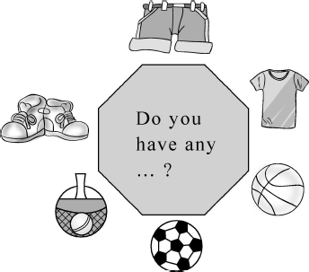

基础碰碰车

Ⅰ . 字母宝宝迷路了 , 请你把他们送回家。
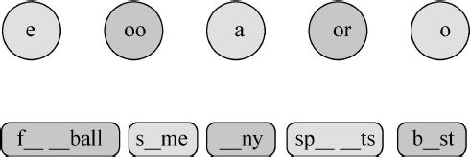

Ⅱ . 快帮淘淘猫写出这些图片的名称吧。
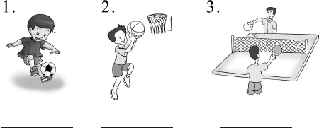

Ⅲ . 单项选择。
( )1.I have apples.
A.some B.any
( )2.I don᾽t have ping-pong balls.
A.some B.any ( )3.—I like red.
—I like red, .
A.too B.either
( )4.I don᾽t have a pen a book.
A.and B.or
( )5.—Would you like oranges?
—Yes,I would.
A.some B.any

Ⅳ . 仿照例句写句子 , 看谁写得又对又快。
Model: ping-pong sport
I like ping-pong best.
My favourite sport is ping-pong.
1.basketball sport
I like best.
My favourite is
2.pink colour
I like pink .
My is
3.circle shape
I the circle best.
My is a
4.fish food
I .
My
5.melon fruit
.

.

升级跷跷板

- . 淘淘猫邀请你来用单词的适当形式填空 , 相信你一定能行 , 加油 !
  - What (sport)do you play?
  - Ping-pong,football and basketball (be)
sports.
  - Can you teach me (play)basketball?

-1-

4.Would you like (learn)to play ping-  pong?  Ⅵ . 仿照例子完成对话。  Model: Do you have any shorts?  Yes,I do.  Do you have a soccer ball?  No,I don᾽t.  1. Do you have ?  , . .  2. Do you ?  . .  3. Do you any balls?  . . | Ⅷ .Taotao 和 Mini 把这些单词的顺序打乱了 , 请你帮他  们整理一下 ,Thank you!  1.is,sport,my,favourite,ping-pong (.)  2 . a l w ays,wear,I,shorts (.)  3.go,to,let᾽s,the,shop (.)  4.get,balls,let᾽s,ping-pong,some (.)  5.sport,what,does,she,play (?)  Ⅸ . 我知道哪儿生病了。
Ⅶ .Taotao 和 Mini 在玩找朋友的游戏 , 你也来参加吧。 | ( )1.You need one ball play ping pong.
( )1.Do you have a T-shirt?  ( )2.What᾽s your favourite sport? | ( )2.Do you has any ping pong balls?
( )3.Would you like to learn English?
( )4.Can you teach me to swim? | ( )3.Basketball and football is my favourite
( )5.What sports do you play? | sports.
A.Ping-pong.  B.No,I don᾽t. | ( )4.Do you have any basketball?
C.Sure.
D.Yes,I would.
E.I play ping-pong and football.





-2-

Unit 1 Sports 课堂同步练习答案Lesson 1:Ping-pong and Basketball 答案 :
Ⅰ .football some any sports best
Ⅱ .1.football 2.basketball 3.ping-pong Ⅲ .1—5 ABABA
Ⅳ .1.basketball;sport;basketball 2.best;favourite colour;pink
3.like;favourite shape;circle 4.like fish best;favourite food is fish
5.I like melon best My favourite fruit is melon Ⅴ .1.sports 2.are 3.to play 4.to learn
Ⅵ .1.a T-shirt Yes,I do 2.have a basketball No,I don᾽t
3.have ping-pong Yes,I do Ⅶ .1—5 BADCE
Ⅷ .1.Ping-pong is my favourite sport 2.I always wear shorts
3.Let᾽s go to the shop 4.Let᾽s get some ping-pong balls
5.What sport does she play
Ⅸ .1.C to play ping-pong 2.B have 3.B are 4.C basketballs

Unit 1 Sports
课堂同步练习
Lesson 2: At the Sports Shop
姓名： 班级：

A. 我要那个。 B. 我想要这个。
要点图解秀
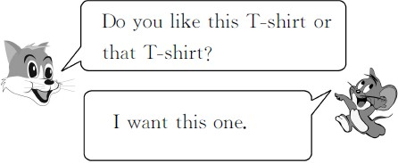
C. 我不要了。 D. 我还想要。

Ⅲ . 我会选出每组中不同类的一项。
( )1.A.some B.any C.thirty
( )2.A.need B.football C.basketball ( )3.A.coach B.teacher C.ask
( )4.A.these B.those C.want ( )5.A.they B.him C.we
基础碰碰车

Ⅳ . 词语对对碰。

Ⅰ . 淘淘猫正在和迷你鼠玩连连看的游戏。你也来连一连吧 !
1. o A.doll
2. ee B.n d
3. ir C.exc se
4. u D.sh p
5. uy E.sh t
6. ar F.b

- . 快来给迷你鼠当老师 , 帮他选出答案。
( )1.some T-shirts
A. 一些鞋 B. 一些运动员
C. 一些 T 恤衫 D. 一些拖鞋( )2.I᾽ll show you.
A. 我看你。 B. 我带你。
C. 我展示你。 D. 我带你看看。( )3.Excuse me!
A. 打扰一下 ! B. 看我 !
C. 你 好 ! D. 给 我 ! ( )4.Here they are!
A. 它们在这儿 ! B. 给你 !
C. 拿 走 ! D. 这 是 他 们 。( )5.I want this one.

-1-
  - near( 反义词 ) A.old 2.new( 反义词 ) B.far
3.big( 反义词 ) C.that 4.this( 对应词 ) D.those 5.these( 对 应 词 ) E.small

升级跷跷板

Ⅴ . 用所给单词的适当形式填空。
- I want these (ball).
- She is going to (buy)a gift. 3.Jenny (need)a hat.
4.There (be)a book on the desk. 5.Those are five (dollar).

Ⅵ . 请你根据句意选择单词补全句子吧。
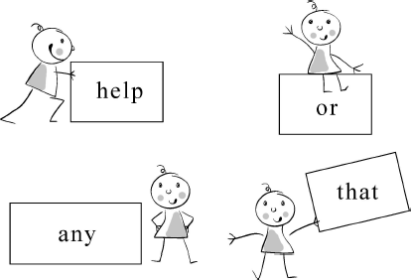

- Do you have T-shirts? 2.Let᾽s ask him for some . 3.Is the ball heavy light? 4.Do you like this pen or pen?
A.Yes, I do. B.Yes. I᾽ll show you.
C.OK. D.Thank you.
E.Ping-pong.

Ⅶ . 句子大变身。
Model:I need this T-shirt. → I need these
T-shirts.
I don᾽t need that hat. → I don᾽t need
those hats.
1.I need this skirt.
→
- I don᾽t need that coat.
→
3.I need these hamburgers.
→
4.I don᾽t need those basketballs.
→

Ⅷ . 找朋友。
( )1.Excuse me! Do you have any ping-pong
balls?
( )2.Here you are!
( )3.Do you like these gifts?
( )4.What᾽s your favourite sport? ( )5.Let᾽s go to the shop.
Ⅸ . 调皮的淘淘猫将下面的对话弄掉了几句 , 快来将缺失的补上去吧 !
A.You᾽re wele. B.How much is it?
C.I want this T-shirt. D.I᾽ll show you.
D.How tall is he?

A:Excuse me! Do you have any T-shirts? B:Yes! 1 Do you like this T-shirt or that T-shirt?
A: 2 B:OK.
A: 3
B:Forty-two dollars. A:Thank you.
B: 4
1. 2. 3. 4.

-2-

Unit 1 Sports 课堂同步练习答案
Lesson 2:At the Sports Shop 答案 :
Ⅰ .1—6 DBECFA
Ⅱ .1—5 CDAAB
Ⅲ .1—5 CACCB
Ⅳ .1—5 BAECD
Ⅴ .1.balls 2.to buy 3.needs 4.is 5.dollars Ⅵ .1.any 2.help 3.or 4.that
Ⅶ .1.I need these skirts. 2.I don᾽t need those coats.
3.I need this hamburger. 4.I don᾽t need that basketball.
Ⅷ .1—5 BDAEC
Ⅸ .1—4 DCBA

Unit 1 Sports
课堂同步练习
Lesson 3:Let᾽s Play!
姓名： 班级：

Ⅳ . 根据图片完成句子。
要点图解秀
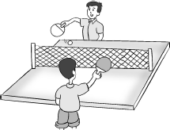
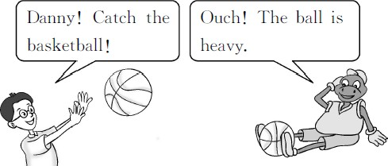
( )1.Li Ming is the ball to Jim.

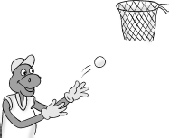
A.hitting B.throwing ( )2.I can the ball easily.

基础碰碰车
A.throw B.hit

Ⅰ . 淘淘猫正在和迷你鼠 玩连连看的游戏。你也来连一连吧 !
- 重的 A.easily
2. 容 易 地 B.difficult
3. 困 难 的 C.poor
4. 尝试 D.heavy
5. 可 怜 的 E.try

Ⅱ . 淘淘猫正在和迷你鼠做问答游戏。你也来参加吧。( 看要求写单词 )
heavy( 反义词 ) learn( 反义词 ) hit( 现在分词 ) easy( 反义词 )
catch( 第三人称单数形式 )

Ⅲ . 我会选出每组中不同类的一项。
( )1.A.basketball B.football C.doll
( )2.A.easy B.easily C.quietly ( )3.A.ball B.throw C.catch
( )4.A.ready B.hand C.arm
( )3.Tom is football.

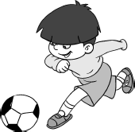

A.playing B.hitting

升级跷跷板

Ⅴ . 火眼金睛 , 读一读 , 选一选。
( )1.A.heavy B.ready C.teacher ( )2.A.throw B.now C.snow
( )3.A.light B.hit C.in
( )4.A.basketball B.catch C.hand ( )5.A.think B.throw C.these

Ⅵ . 选什么最合适。
( )1.What do you want ? A.learn B.learning
C.to learn D.learns
( )2.You hit the ping-pong ball the

( )5.A.gym B.heavy C.shop

-1-
paddle.
A.with B.in C.to D.at

( )3.Li Ming is the basketball.  A.throws B.throw | Ⅷ . 我知道哪儿生病了。  1.I am hit the ball to Jenny.
C.throwing D.throwes  ( )4.Are you ready basketball?  A.learn B.to learn | 2.Here I goes!
C.learning D.learns | 3.I can hitting the ball).
( )5.Throw the basketball the net.  A.in B.with C.at D.on | 4.This is for me too hardly.

Ⅶ . 根据提示 , 完成句子。
- I have some ping-pong balls.( 改为一般疑问句 )

5.Do Danny catch the ball)?

- I think I can.( 改为否定句 )

- This ball is heavy. ( 写出同义句 )
Ⅸ . 用英语介绍你最喜欢的体育运动 , 语言简练 , 表达清楚 , 三四句话即可。

- I am throwing the basketball.( 对画线部分提问)

-2-

Unit 1 Sports 课堂同步练习Lesson 3:Let᾽s Play!
答案
Ⅰ .1—5 DABEC
Ⅱ .light teach hitting difficult catches Ⅲ .1—5 CAAAB
Ⅳ .1—3 AAA
Ⅴ .1—5 CBAAC
Ⅵ .1—5 CACBA
Ⅶ .1.Do you have any ping-pong balls? 2.I don᾽t think I can.
3.This ball isn᾽t light. 4.What are you doing?
Ⅷ .1.A hitting 2.C go 3.B hit 4.C hard 5.A Does Ⅸ . 参考例文 :
My favourite sport is basketball.I can throw and catch the ball.I can throw the ball in the net.I am
happy.

Unit 1 Sports
课堂同步练习
Lesson 4: Did You Have Fun?
姓名： 班级：

要点图解秀

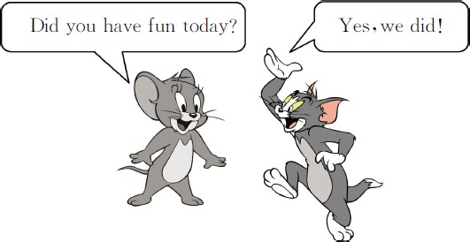

基础碰碰车

Ⅰ . 我来帮它们找到自己的家。
1. om A.h t( 打 )
2. an B.th ( 事 情 )
3. ing C.alw s( 总 是 )
4. i D.w t( 想 )
5. ay E.h e( 家 )

- . 淘淘猫正在和迷你鼠玩连连看的游戏。你也来连一连吧 !
  - each other A. 打了他的手
2.have fun B. 一个篮球队员
3.this morning C. 玩得愉快
4.a basketball player D. 今天上午
5.hit his hand E. 互相 ; 彼此

Ⅲ . 我会写这些单词的过去式。
teach → ( )
think → ( )
buy → ( )
hit → ( )
do → ( )

Ⅳ . 单项选择。
( )1.I a gift for my mother yesterday. A.buy B.bought
C.buys D.is buying
( )2.He is a good basketball .
A.play B.played
C.playing D.player
( )3.They usually each other a
sport.
A.teach B.teaches
C.taught D.will teach
( )4.I taught Jenny the ball.
A.hits B.hitting
C.to hit D.hit
( )5.I often go to the shop Danny.
A.in B.with C.and D.or

升级跷跷板

Ⅴ . 请你找出每组中画线部分发音不同的一个单词。
( )1.A.bought B.thought C.could ( )2.A.fun B.put C.sun
( )3.A.visited B.wanted C.played ( )4.A.school B.catch C.teach ( )5.A.there B.here C.where

Ⅵ . 用所给单词的适当形式填空。
- Where (do)you go yesterday?
- Danny thought he (can)hit the ball. 3.I taught Li Ming (hit)the ball. 4.Jenny and Li Ming often (buy)some
things at the shop.
5.Did you (have)fun last week?

-1-

Ⅶ . 调皮的淘淘猫将下面句子中的单词顺序弄乱了 , 快来按正确顺序排列好。1.the/catch/basketball/he/can (?)

2.ball/a/ping-pong/he/played/basketball/with
(.)

3.player/a/he/good/is/basketball (.)

4.go/where/did/you/yesterday (?)

5.hit/his/Danny/hand (.)

Ⅷ . 调皮的 Mini 将下面的短文弄丢了几个单词 , 快来将缺失的补上去吧 !
I wanted a 1 of runners( 运动鞋 ).I 2 to a shop this morning and 3 a pair of
red runners.Red is my favourite 4 .In the afternoon I 5 football with my friends.We 6 fun.
( )1.A.pair B./ C.pairs ( )2.A.go B.goes C.went ( )3.A.buy B.buying C.bought ( )4.A.sport B.colour C.day
( )5.A.play B.played C.playing ( )6.A.is B.are C.had

Ⅸ . 实话实说 ( 根据实际情况回答问题 )。
1.Did you have fun yesterday?
.
2.Where did you go yesterday?
. 3.What did you do yesterday?
.

-2-

Unit 1 Sports 课堂同步练习答案
Lesson 4:Did You Have Fun? 答案 :
Ⅰ .1—5 EDBAC
Ⅱ .1—5 ECDBA
Ⅲ .taught thought bought hit did Ⅳ .1—5 BDACB
Ⅴ .CBCAB
Ⅵ .1.did 2.could 3.to hit 4.buy 5.have
Ⅶ .1.Can he catch the basketball 2.He played basketball with a ping-pong ball
3.He is a good basketball player 4.Where did you go yesterday
5.Danny hit his hand Ⅷ .1-6 ACCBBC
Ⅸ .(略)

Unit 1 Sports
Lesson 5: A Basketball Game 课堂同步练习
姓名： 班级：


( )3.
要点图解秀

基础碰碰车

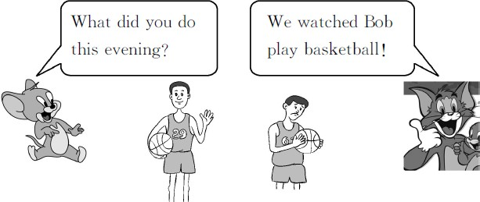
Ⅰ . 快来给淘淘猫当老师 , 帮它选出答案。
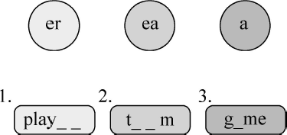

- . 请你根据图片提示 , 选择合适的答案。

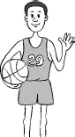
( )1.

A.a football player
B.a ping-pong player
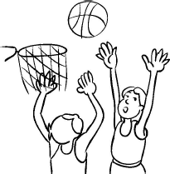
C.a basketball player ( )2.

A.basketball B.football
C.ping-pong
A.water B.juice C.milk ( )4.

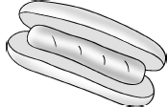
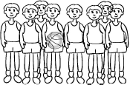
A.hot dog B.banana C.apple ( )5.

A.gym B.team C.people

Ⅲ . 淘淘猫正在和迷你鼠玩连连看的游戏。你也来连一连吧 !
  - Go!Bob. A. 吃的东西
2.this evening B. 加油 ! 鲍勃。
3.Who won? C. 玩得高兴
4.have fun D. 今天晚上
5.something to eat E. 谁赢了 ?

Ⅳ . 选词填空。

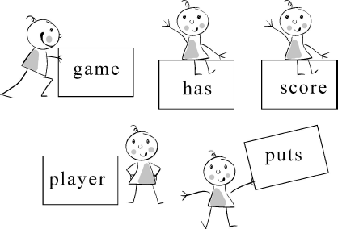

1.Yao Ming is a basketball . 2.A team many players. 3.This is a basketball . 4.He the ball in the net. 5.The is 2 ∶ 0.

-1-

升级跷跷板

Ⅴ . 单项选择。
( )1.Bob the ball.
A.catches B.catch C.catching ( )2.Bob is twenty old.
A.year B.years C.year᾽s ( )3.Li Ming plays a team.
A.in B.at C.on
( )4.Jenny and Li Ming are going to watch
Bob this evening.
A.playing basketball
B.play basketball
C.played basketball
( )5.One is the blue team, and team
is the orange team.
A.another B.other C.the other
( )6.He plays basketball Saturdays.
Ⅶ . 根据汉语提示完成句子。
- 鲍勃的球队比赛了吗 ?
Did Bob᾽s team ?
- 比赛时珍妮和李明玩得很高兴。
J e nny and Li Ming at the
game.
- 你想买些吃的东西吗 ?
Did you want to buy
?
- 鲍勃的队穿蓝 T 恤和蓝短裤。
Bob᾽s team blue T-shirts and
blue .
- 我们为鲍勃的球队呐喊。
We Bob᾽s team.

Ⅷ . 我知道哪儿生病了。选出来并改正。
( )1.We watched the Blue Team played
basketball.

A.in B.at C.on

Ⅵ . 为下列问句找出合适的答语。
( )1.Who is Bob?
( )2.What did you do?
( )3.Would you like to go to the shop? ( )4.What᾽s a team?
( )5.Who can win?
( )6.Is this Bob᾽s team?
A.I played basketball. B.Sure! Let᾽s go.
C.Bob is Jenny᾽s brother. D.The blue team can win. E.A team has many players.
F.Yes,it is.
( )2.Where did you played the game?
( )3.Everyone play basketball on the
playground after school.
( )4.Bob is Jenny brother.
( )5.Bob run down the floor.

( )6.We buy many things at the shop
yesterday.

-2-

Unit 1 Sports 课堂同步练习答案
Lesson 5: A Basketball Game 答案 :
Ⅰ .player team game Ⅱ .1—5 CABAB
Ⅲ .1—5 BDECA
Ⅳ .1.player 2.has 3.game 4.puts 5.score Ⅴ .1—6 ABCBCC
Ⅵ .1—6 CABEDF
Ⅶ .1.play a game 2.have fun 3.something to eat 4.wear;shorts 5.yelled for
Ⅷ .1.B play 2.B play 3.A plays 4.C Jenny᾽s brother 5.A runs 6.A bought

Unit 1 Sports
Lesson 6:A Famous Football Player 课堂同步练习
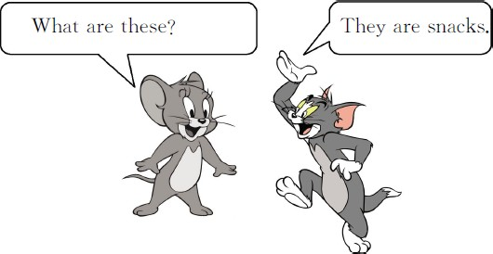
姓名： 班级：

要点图解秀 | ( )5. 你知道这个男孩是谁吗 ?  A.Do you know who is the boy?  B.Do you know who the boy is?  Ⅲ . 写出下列单词的过去式。
 | 1.watch | 2.lose
 | 3.win | 4.are
 | 5.play | 6.buy
基础碰碰车 | 7.do  9.yell | 8.have  10.teach
Ⅰ . 淘淘猫正在和迷你鼠玩连连看的游戏。你也来连一连

吧 !
1.family A. 世界
2.cup B. 教练
3.coach C. 著 名 的
4.famous D. 房 子
5.house E. 奖 杯
6.world F. 家 庭

Ⅱ . 淘淘猫要学英文了 , 快来帮它选一选。
( )1. 珍妮 , 今天晚上你去干什么了 ?
A.What do you do this evening,Jenny?
B.What did you do this evening,Jenny? ( )2. 大家都很努力。
A.Everyone played hard.
B.Everyone play hard.
( )3. 看比赛时你们玩得高兴吗 ?
A.Did you have fun watching the game?
B.Did you have fun watch the game? ( )4. 这是一些其他的小吃。
A.Here are some other snacks.
B.Here are some another snacks.
Ⅳ . 用所给单词的适当形式填空。
1.We watch Bob (play)basketball. 2.What game (do)you play?
3.Many years ago,there (be)a boy. 4. (this)ping-pong balls are five
dollars.
- Let᾽s (go)to the shop.
- (be)you ready for a quiz( 小测验 )?

升级跷跷板

Ⅴ . 单词大变身 ( 改变单词中的一个字母使这个单词变成一个新单词 )。
1.look 2.ball 3.say 4.year
- game 6.good

Ⅵ . 单项选择。
( )1.Yesterday I to the shop.
A.go B.goes C.went

-1-

( )2.Jenny is her homework now.
A.doing B.do C.did ( )3.Next week I Beijing.
A.am going B.am going to
C.be going
( )4.We yelled Bob᾽s team.
A.on B.in C.for ( )5.The blue and orange teams
played .
A.easy B.hard C.good
( )6.Did you have fun kites?
A.flying B.fly C.to fly

Ⅶ . 按要求完成句子。
  - We bought many things. ( 对画线部分提问 )

2.lost,team,the,orange(.)( 连词成句 )
3.Bob᾽s team played a game.( 改为一般疑问句 )

4.Go! Blue Team!( 译成汉语 )
5.a,good,it,was,game(.)( 连词成句 )

Ⅷ . 调皮的淘淘猫将下面的对话弄丢了几句 , 快来将缺失的补上去吧 !
A.What did you do last night,Jim? B.Did Bob᾽s team play a game?
C . D i d you have fun? D.Who won?
Mary: 1
Jim:We watched Bob play basketball. Mary: 2
Jim:Yes,his team played with the Orange team. Mary: 3
Jim:Bob᾽s team. Mary: 4
Jim:Yes.We yelled for Bob᾽s team.
1.
2.
3.
4.

-2-

Unit 1 Sports 课堂同步练习答案Lesson 6:A Famous Football Player 答案 :
Ⅰ .1—6 FEBCDA
Ⅱ .1—5 BAAAB
Ⅲ .1.watched 2.lost 3.won 4.were 5.played 6.bought 7.did 8.had 9.yelled 10.taught Ⅳ .1.play 2.did 3.was 4.These 5.go 6.Are
Ⅴ .(略)
Ⅵ .1—6 CABCBA
Ⅶ .1.What did you buy? 2.The orange team lost. 3.Did Bob᾽s team play a game?
4. 蓝队加油 ! 5.It was a good game.
Ⅷ .1—4 ABDC

Unit 1 Sports
Again, Please! 课堂同步练习
姓名： 班级：

Ⅰ . 淘淘猫正在和迷你鼠玩连连看的游戏。你也来连一连吧 !
1.f tball A.ir
2.cat B.ch
3.s ort C.p
4.T-sh t D.gh
5.li t E.oo

Ⅱ . 选出每组中画线部分发音不同的一项。
( )1. A.orange B.great C.game ( )2. A.it B.arrive C.win ( )3. A.meat B.heavy C.team ( )4. A.throw B.thought C.that
( )5. A.short B.for C.sport

Ⅲ . 单项选择。
( )1.I don᾽t want the soup, .
A.too B.either C.also D.both ( )2.The basketball is heavy.I can᾽t
throw it.
A.to B.two C.for D.too ( )3.My favourite sports ping-pong
and basketball.
A.be B.is C.are D.has ( )4.A team has many .
A.player B.play
2.these,balls,are,dollars,twenty
. 3.ball,is,ping-pong,the,light
. 4.like,or,this,sweater,that,do,you,sweater
? 5.hit,to,can,you,the,ball,Jenny
?

故事连连看

根据故事情景和汉语提示 , 填入适当的单词将故事补充完整。
1.One day a duck invited Jerry to watch Bob
① ( 打篮球 ).
2.Jerry met( 遇到 )Tom.So they went to watch the
② ( 比赛 )together.
3.There were two teams.One was the orange team.
The other team was Bob᾽s team.It was the
blue team.Tom yelled for the orange team.
Jerry yelled for the blue team.
4.At last,the blue ③ ( 赢了 ). The orange ④
( 输了 ).Jerry was very happy.Tom was angry.He
wanted to ⑤ ( 捉住 )Jerry and eat it.

C.players D.played
( )5.I often play ping-pong.
A./ B.a C.an D.the ( )6.I can throw the ball .
A.easily B.easy C.happy D.light

Ⅳ . 快来给下列单词排排队吧 , 注意标点呦 !
1.bought,I,yesterday,a,football
①
②
③
④
⑤

.

Unit 1 Sports 课堂同步练习答案
Again, Please! 答案 :
Ⅰ .1—5 EBCAD
Ⅱ .1—5 ABBCB
Ⅲ .1—6 BDCCAA
Ⅳ .1.I bought a football yesterday 2.These balls are twenty dollars 3.The ping-pong ball is light
4.Do you like this sweater or that sweater 5.Can you hit the ball to Jenny
故事连连看 :
1.play basketball 2.game 3.won 4.lost 5.catch

Unit 2 Good Health to You!
课堂同步练习
Lesson 7: Always Have Breakfast!
姓名： 班级：


( )2.
要点图解秀

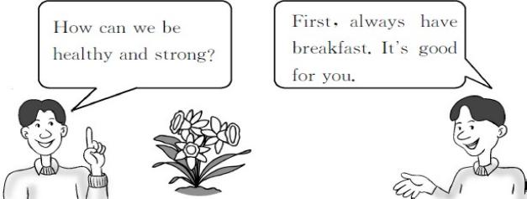
A.This flower is weak.

B.This flower is strong. ( )3.

基础碰碰车

Ⅰ . 请帮它们找到自己的家。
1. es A.br kfast
2. ay B.alw_ s
3. ea C.w k
4. ce D.on
5. ee E.Wedn day

Ⅱ . 单词大变身。
- one( 表倍数或次数的词 )


A.Today is Monday. B.Today is Sunday. ( )4.

A.I usually eat bread.
B.I usually eat soup.

Ⅳ . 选出每组中不同类的一项。
( )1.A.once B.twice C.three ( )2.A.usually B.week C.often ( )3.A.Monday B.breakfast C.lunch

- egg( 复数形式 ) 3.health( 形容词 ) 4.have( 过去式 ) 5.eat( 过去式 )
( )4.A.healthy B.flower C.strong

Ⅲ . 根据图片 , 选择答案。
升级跷跷板

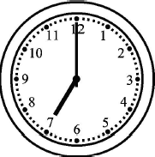
( )1.

A.Danny ate breakfast at seven yesterday.
B.Danny ate breakfast at seven thirty
yesterday.
Ⅴ . 选择难不住我。
( )1.Milk is good you.
A.for B.to C.in D.of ( )2.Everyone wants strong.
A.is B.to is C.be D.to be
( )3.— did you eat breakfast last week?
—Six times.
A.How often B.How much
C.How many D.How

-1-

( )4.What do you usually eat breakfast?
A.on B.with C.of D.for
( )5.We are going to learn what .
A.do B.did C.to do D.does

Ⅵ . 根据汉语提示完成句子。
- 什么是健康强壮 ?
What᾽s and ?
- 她通常在七点十五吃早饭。
She usually at 7:15.
- 金 , 做得好。
,Kim.
- 这盆花是强壮的。
This flower is .
- 她什么时候吃的早饭 ?
did she have breakfast?

Ⅶ . 找朋友。
( )1.Why do you always eat breakfast?
( )2.Do you want to be healthy and strong? ( )3.Is the flower strong?
( )4.What do you usually have for breakfast? ( )5.How often do you watch TV?
Ⅷ . 看表格 , 填空。
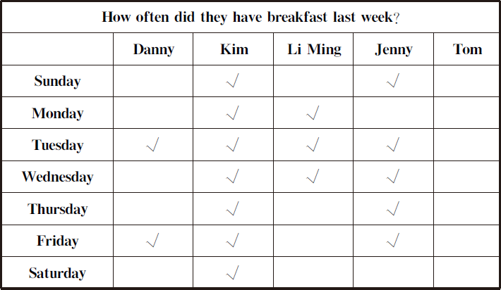

1.Danny has breakfast. 2.Kim has breakfast. 3.Li Ming has breakfast. 4.Jenny has breakfast. 5.Tom has breakfast.

always usually sometimes never

A.Because it is good for me.
B.Yes,it is.
C.Five times a week.
D.Yes,I do.
E.I eat a donut and drink a glass of milk.

-2-

Unit 2 Good Health to You! 课堂同步练习答案
Lesson 7:Always Have Breakfast! 答案 :
Ⅰ .1—5 EBADC
Ⅱ .1.once 2.eggs 3.healthy 4.had 5.ate Ⅲ .1—4 ABBA
Ⅳ .1—4 CBAB
Ⅴ .1—5 ADADC
Ⅵ .1.healthy;strong 2.has breakfast 3.Good work 4.strong 5.When Ⅶ .1—5 ADBEC
Ⅷ .1.sometimes 2.always 3.sometimes 4.usually 5.never

Unit 2 Good Health to You!
课堂同步练习
Lesson 8: Always Brush Your Teeth!
姓名： 班级：

要点图解秀

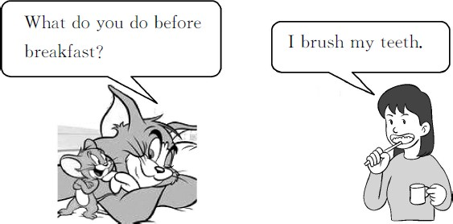

基础碰碰车


Ⅰ . 看图补充单词。

- brush your

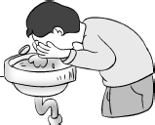
- wash your


- your clothes

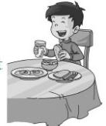
- breakfast

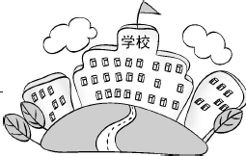
- go to

Ⅱ . 单词大变身。
- wake( 现在分词 )
- brush( 第三人称单数形式 )
Ⅲ . 淘淘猫正在和迷你鼠玩连连看的游戏。你也来连一连吧 !
  - 穿上 A.after supper
2. 吃 早 饭 B.get up
3. 回家 C.work hard
4. 起床 D.put on
5. 努力学习 E.eat breakfast
6. 晚 饭 后 F.go home

Ⅳ . 这儿填什么最恰当 ?
( )1.Jenny,please answer questions.
A.me B.my C.I D.mine
( )2.Jenny to school five times a
week.
A.goes B.go C.went D.going
( )3.Saturday and Sunday different.
A.is B.be C.are D.do ( )4.— do you go to school?
—Five times a week.
A.How B.How many
C.How much D.How often ( )5.— ?
—Because I want to have strong,healthy
teeth.
A.Why B.Where C.What D.Who

升级跷跷板

Ⅴ . 选词填空难不倒我。
on in for at from to

- tooth( 复数形式 ) 4.after( 反义词 )

-1-
- Jenny works hard school.
- She puts her clothes and goes out.

- Jenny goes to school Monday
Friday.
- She gets up at 7:00 the morning. 5.What do you eat breakfast?

Ⅵ . 用所给单词的适当形式填空。
- Jenny is (wash)her hands.
- He brushes his (tooth)after breakfast. 3.Jenny always (do)her homework before
supper.
4.Danny brushes his teeth (two)a day. 5.Look! Jenny is (get)up.

Ⅶ . 根据汉语提示完成句子。
- 李明在早饭前洗手。
Li Ming before
breakfast.
- 詹妮从星期一到星期五上学。
Jenny goes to school
.
- 早饭后你做什么 ?
_do you do ? 4.——你多长时间打一次篮球 ?
——一周三次。
— do you play basketball?
— a week.

Ⅷ . 连词成句。
1.face, she, her, hands, washes, and (.)

2.do, do, breakfast, what, you, before (?)

3.at, Li Ming, eats, in, the, breakfast, 7:00,
morning (.)

- is, bad, teeth, that, for your (.)

- to, go, Jenny, doesn᾽t, on, days, school,
those (.)

Ⅸ . 阅读对话 , 判断正 (T) 误 (F)。
Mr.Wood:Jenny,please answer my questions.What
do you do before supper? Jenny:I do my homework.
Mr.Wood:Why?
Jenny:Because I want to watch TV after supper. Mr.Wood:How often do you watch TV?
Jenny:Once a day.
Mr.Wood:What time do you go to bed? Jenny:At about 9:00.
( )1.Jenny does her homework after supper. ( )2.She watches TV once a day.
( )3.She goes to bed at about 9:00. ( )4.Jenny isn᾽t a good girl.

-2-

Unit 2 Good Health to You! 课堂同步练习答案
Lesson 8:Always Brush Your Teeth! 答案 :
Ⅰ .1.teeth 2.face 3.put on 4.have 5.school Ⅱ .1.waking 2.brushes 3.teeth 4.before
Ⅲ .1—6 DEFBCA
Ⅳ .1—5 BACDA
Ⅴ .1.at 2.on 3.from;to 4.in 5.for
Ⅵ .1.washing 2.teeth 3.does 4.twice 5.getting
Ⅶ .1.washes his hands 2.from Monday to Friday 3.What;after breakfast 4.How often;Three times Ⅷ .1.She washes her hands and face 2.What do you do before breakfast
3.Li Ming eats breakfast at 7:00 in the morning
4.That is bad for your teeth
5.Jenny doesn᾽t go to school on those days Ⅸ .1.F 2.T 3.T 4.F

Unit 2 Good Health to You!
课堂同步练习
Lesson 9: Eat More Vegetables and Fruit!
姓名： 班级：

要点图解秀

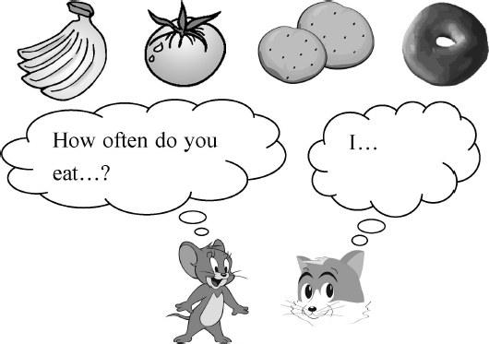

基础碰碰车

Ⅰ . 看图片写单词。

1. 2.


3. 4.

- . 淘淘猫 正在和迷你鼠 玩连连看的游戏。你也来连一连吧 !
1.on A.k _p( 使保持在 )
2.ee B.m th( 月 )
3.i C.th k( 感 谢 )
4.o D.tw ce( 两次 )
5.an E.m re( 更多的 )

Ⅲ . 选择正确答案。
( )1.eat vegetables
A. 吃蔬菜 B. 吃水果 C. 吃苹果

-1-
( )2.twice a week
A. 一周两次 B. 一周一次
C. 一周三次( )3.be good for
A. 对……有用 B. 对……有利
C. 对……有害( )4.how often
A. 多 长 B. 经常 C. 多长时间一次( )5.after lunch
A. 午饭前 B. 午饭后 C. 午饭中( )6.play sports
A. 进行体育活动 B. 运动员
C. 运动会

Ⅳ . 这儿填什么最恰当 ?
( )1.— is the cabbage?
—It᾽s green.
A.What B.What colour
C.What sport D.How
( )2.Here᾽s the chart I for Danny.
A.maked B.making
C.makes D.made
( )3.Onions can make you .
A.cry B.to cry
C.crying D.cryed
( )4.I like tomatoes than potatoes.
A.many B.much C.any D.more ( )5.—Do you like noodles?
—
A.Yes,I do. B.Yes,I don᾽t.
C.No,I do. D.No,I am not.

升级跷跷板

Ⅴ . 根据汉语提示完成句子。
- 你需要多吃蔬菜。
You eat more vegetables.
- 你多久吃一次蔬菜 ?
do you eat vegetables?
- 我从来不吃土豆。
I eat .
- 伍德老师一个月吃两次豌豆。
Mr.Wood eats peas
.
- 你最喜欢什么食物 ?
What᾽s your ?

Ⅵ . 调皮的迷你鼠将下面句子中的单词顺序弄乱了 , 快来帮忙排排吧。
1.like /vegetables /I /much /very
. 2.do /like /eat /what /you /to
? 3.body /you /healthy /need /for /to /vegetables
/eat /a
- I usually eat donuts two a day.

- They are good at you.

4 . Y o u can to ask many other questions.
5.Make a chart to one of your friends.

Ⅷ . 根据表格回答问题。
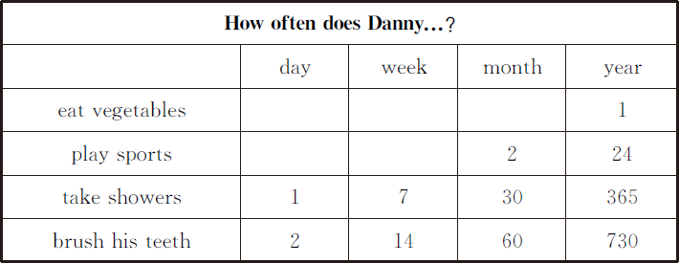
1.How often does Danny eat vegetables a year?

2.How often does Danny take showers a week?

3.Does Danny play sports twice a week?

4.Does Danny brush his teeth twice a day?

. 4.meat /I /like /don᾽t
. 5.often /you /wash /how /face /your /do
5.How often does Danny brush his teeth a year?

?

Ⅶ . 我知道哪儿出错了。
1.Let᾽s see how often Danny eat
vegetables.

-2-

Unit 2 Good Health to You! 课堂同步练习Lesson 9:Eat More Vegetables and Fruit! 答案
Ⅰ .1.potatoes 2.tomato 3.donut 4.apple Ⅱ .1—5 BADEC
Ⅲ .1—6 AABCBA
Ⅳ .1—5 BDADA
Ⅴ .1.need to 2.How often 3.never;potatoes 4.twice a month 5.favourite food Ⅵ .1.I like vegetables very much
2.What do you like to eat
3.You need to eat vegetables for a healthy body
4.I don᾽t like meat
5.How often do you wash your face
Ⅶ .1.C eats 2.C twice 3.C good for 4.A ask 5.B for
Ⅷ .1.Once a year. 2.Seven times a week. 3.No,he doesn't. 4.Yes,he does.
5.Seven hundred and thirty times a year.

Unit 2 Good Health to You!
课堂同步练习
Lesson 10: Exercise
姓名： 班级：

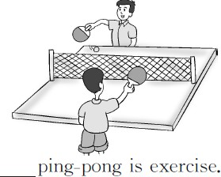
4.
要点图解秀

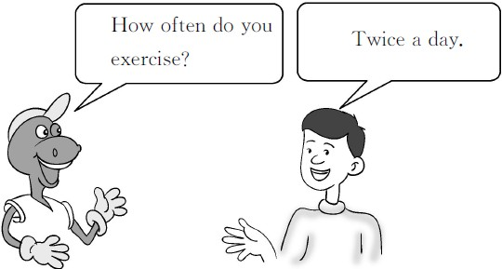
- . 单词大变身。
  - run( 现在分词 ) 2.health( 形容词 ) 3.hour( 同音词 )
基础碰碰车

Ⅰ . 看图片写单词。
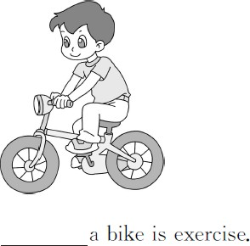
1.

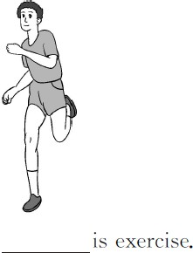
2.

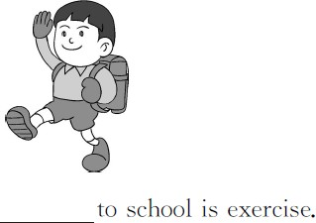
3.
4.minute( 复数形式 ) 5.ride( 现在分词 ) 6.much( 比较级 )

Ⅲ . 淘淘猫 正在和迷你鼠 玩连连看的游戏。你也来连一连吧 !
- walk home A. 骑自行车2.after school B. 六十分钟3.ride a bike C. 必须4.sixty minutes D. 放学后5.have to E. 步 行 回 家6.walk to school F. 步 行 上 学

Ⅳ . 这儿填什么最恰当 ?
( )1.Exercise helps your body healthy
and strong.
A.makes B.make C.making D.made ( )2.How many a day do you clean the
house?
A.minute B.time
C.minutes D.a minute

-1-
( )3.Running exercise.
A.be B.are C.am D.is

( )4.You have to sports for exercise.
A.played B.playing
C.play D.are playing ( )5.Sixty minutes make hour.
A.an B.a C.the D./
5.I /you /need /more /get /think /to /exercise
.
Ⅷ . 找朋友。
( )1.What᾽s a minute?
( )2.How many minutes do you exercise? ( )3.How much exercise do you need?
( )4.How often do you exercise? ( )5.Is running exercise?

Ⅴ . 火眼金睛。下面每组单词中画线部分有一个与其他的读音不一样 , 请你将它选出来。
升级跷跷板
( )1.A.minute B.hit C.win D.light ( )2.A.breakfast B.heavy
C.team D.healthy
( )3.A.about B.make C.game D.name ( )4.A.short B.work
C.sport D.morning ( )5.A.have B.cabbage
C.catch D.after

Ⅵ . 连线。
1.sixty minutes A.a week 2.twenty-four hours B.a month 3.seven days C.a year 4.four more weeks D.a day 5.twelve months E.an hour

Ⅶ . 连词成句。
1.exercise /is /to /school /walking
. 2.have /play /for /you /to /sports /exercise
!
3.does /minutes /how /exercise /many /Danny
?
4.is /twice /a /that /day

A.Yes,it is.
B.About ten minutes.
C.I need about 2 hours of exercise a week. D.Sixty minutes make an hour.
E.Twice a day.

Ⅸ . 填写正确的动词形式填空
1.Exercise (help)make your body healthy. 2.I᾽m going to (watch)more sports on TV. 3.That᾽s ten (minute)of exercise a day. 4.How much (exercise)do you need?

Ⅹ . 我知道哪儿出错了。
( )1.Play ping-pong is exercise.
A B C
( )2.How many minute does Danny exercise?
A B C
( )3.I walk school in the morning.
A B C
( )4.What is exercises?
A B C

.

-2-

Unit 2 Good Health to You! 课堂同步练习答案
Lesson 10:Exercise
答案 :
Ⅰ .1.Riding 2.Running 3.Walking 4.Playing
Ⅱ .1.running 2.healthy 3.our 4.minutes 5.riding 6.more Ⅲ .1—6 EDABCF
Ⅳ .1—5 BCDCA
Ⅴ .1—5 DCABD
Ⅵ .1—5 EDABC
Ⅶ .1.Walking to school is exercise
2.You have to play sports for exercise
3.How many minutes does Danny exercise
4.That is twice a day
5.I think you need to get more exercise
Ⅷ .1.D 2.B 3.C 4.E 5.A
Ⅸ .1.helps 2.watch 3.minutes 4.exercise
Ⅹ .1.A Playing 2.B minutes 3.B to school 4.C exercise

Unit 2 Good Health to You!
Lesson 11:Work Hard! 课堂同步练习
姓名： 班级：

要点图解秀

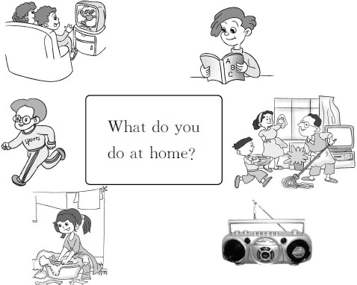

基础碰碰车

Ⅰ . 连一连
1.l A.h gh( 高 的 )
2.sh B.di ( 盘 子 )
3.ow C.d ( 擦 干 )
4.ry D.c ean( 打扫 )
5.i E.l ( 低 的 )

Ⅱ . 选出正确答案。
( )1. 努力学习
A.work hard B.play hard ( )2. 晚饭后
A.before supper B.after supper

Ⅲ . 按要求写单词。
dish( 复数形式 ) high( 反义词 ) dry( 反义词 ) we( 宾格 )

Ⅳ . 火眼金睛。
( )1.Work hard home.
A.at B.on C.in D.with ( )2.Help the house.
A.cleans B.cleaned
C.clean D.cleaning ( )3. Kim work hard?
A.Do B.Is C.Has D.Does ( )4. minutes do you read books?
A.How many B.How much
C.How often D.How
( )5.I clean my bedroom Saturdays.
A.in B.on C.at D.with

升级跷跷板

Ⅴ . 情景交际。
( )1. 当你想说“听老师的话。”时 , 用英语表达

( )3. 玩得愉快A.have fun B.be sad ( )4. 做午饭
A.eat lunch B.make lunch
是
A.Listen to your teacher.
B.Listen to your mother.
C.Hear your teacher.

( )5. 打扫房子
A.clean the house B.clean the bedroom
( )2. 当你想说“坚持锻炼身体。”时 , 用英语表
达是

A.Work hard at home.
B.Work hard at sports.
C.Work hard at school.

-1-

( )3. 当你称赞别人“做得好 !”时 , 用英语表达
Li Ming 1 hard at school.He 2 to his

是
A.Do well. B.Have a good time.
C.Good work!
teacher and always 3 his homework.At home,he listens to his mother and father.He often 4 his bedroom and helps his mother make 5 on

( )4. 当你想说“你洗衣服用多少分钟 ?”时 , 用
英语表达是
A.How many minutes do you play sports?
B.How many minutes do you read books?
C.How many minutes do you wash clothes?

Ⅵ . 调皮的淘淘猫将下面句子中的单词顺序弄乱了 , 快来按正确顺序排列好。
1.fun /with /your /have /friends
. 2.it /you /can /do
. 3.at /what /do /else /you /do /home
? 4.help /do /family /you /your
? 5.dry /the /I /always /supper /dishes /after
.

Ⅶ . 请你根据文意 , 选择单词补全短文吧。

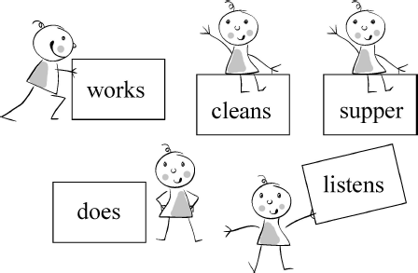

-2-
S a t u r days.He works hard at sports.He has fun with his friends.He is a good boy.
1. 2. 3.
4. 5.

Ⅷ . 我知道哪儿出错了。
1.I clean my bedroom on Saturdays to about
thirty minutes.
2.You can to make a chart.

3.After I go to school,I always make my lunch.
4.Work hard at sport.
5.How much minutes do you dry the dishes?

Unit 2 Good Health to You! 课堂同步练习答案
Lesson 11:Work Hard! 答案 :
Ⅰ .1—5 DBECA
Ⅱ .1—5 ABABA
Ⅲ .1.dishes 2.low 3.wet 4.us Ⅳ .1—5 ACDAB
Ⅴ .1—4 ABCC
Ⅵ .1.Have fun with your friends 2.You can do it 3.What else do you do at home
4.Do you help your family 5.I always dry the dishes after supper
Ⅶ .1.works 2.listens 3.does 4.cleans 5.supper
Ⅷ .1.C for 2.C make 3.A Before 4.C sports 5.A How many

Unit 2 Good Health to You!
Lesson 12: Helen Keller 课堂同步练习
姓名： 班级：


3.Is he strong?
要点图解秀

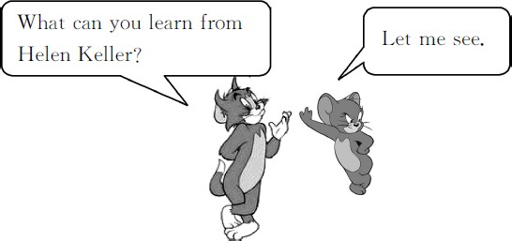

4.Can you name these vegetables?


基础碰碰车

Ⅰ . 淘淘猫正在和迷你鼠玩连连看的游戏。你也来连一连吧 !
1.ea A.b n 出 生
2.ou B.d f 聋 的
3.in C.bl d 瞎 的
4.er D. gry 生 气
5.an E.univ sity 大 学
6.or F.fam s 著 名 的

Ⅱ . 选出每组中不同类的一项。

( )1.A.blue | B.score | C.orange
( )2.A.hand | B.blind | C.deaf
( )3.A.pear | B.donut | C.apple
( )4.A.hour | B.minute | C.fish
( )5.A.melon B.bananas C.apples

Ⅲ . 根据图片回答问题。

1.Are these fruit or vegetables?
Ⅳ . 连词成句。
1.learnt/new/each/day/words/many/she

2.did/often/angry/why/Helen/get

3.wanted/teach/words/she/to/Helen

4.fell/and/deaf/blind/she/ill/became/and

5.threw/food/from/table/she/her/the

升级跷跷板

- . 火眼金睛 , 我会选。
( )1.Here the right answers.
A.is B.are C.be D./ ( )2.Are you ready a quiz?
A.to B.for C.of D./ ( )3.Supper is lunch.


2.Are Jenny᾽s hands high or low?

-1-
A.at B.have C.before D.after ( )4.Helen᾽s story everyone hope.
A.giving B.gives C.give D.gave ( )5.I watch sports TV.
A.in B.at C.on D.with

以上内容仅为本文档的试下载部分，为可阅读页数的一半内容。如要下载或阅读全文，请访问：https://d.book118.com/695140313124011114

