ICS 13.020.99

北京市大兴区建设协会团体标准

P00 T/DXJSXH 0001-2021

北京市大兴区工程建设

环境保护标准

Protection standards for engineering construction

environment in daxing district, beijing

2021-04-15 发布 2021-05-01 实施

北 京 市 大 兴 区 建 设 协 会 发 布

北京市大兴区建设协会

关于发布北京市大兴区建设协会团体标准

《北京市大兴区工程建设环境保护标准》的公告

京大建协[2021]05 号

现批准《北京市大兴区工程建设环境保护标准》为北京市大兴区建设协会团体标准，编号
为 T/DXJSXH 0001-2021，自 2021 年 05 月 01 日实施。

本标准公开出版发行。

北京市大兴区建设协会

2021 年 4 月 13 日

前 言

为落实习近平总书记在全国生态环境保护大会上的重要讲话精神，大兴区坚决贯彻落实党中央、
国务院和北京市政府关于加强生态文明建设和生态环境保护的决策部署，举全区之力持续深化“一微
克”行动，坚决打好“蓝天”“碧水”“净土”保卫战。
随着《北京城市总体规划（2016 年-2035 年）》的批复，大兴区的城乡建设掀开了新的一页。落
实环境保护与环境治理的工作任重道远、责任重大。为了深入贯彻绿色发展理念，推进生态文明建设，
提升工程建设行业环境保护成效，促进绿色低碳循环发展，提出了“三保两避一开展”的工作要求，
即“保护大气、保护水体、保护周边环境；避免噪音污染，避免光污染；开展新时代爱国卫生运动”。
通过加强对项目生产、生活的有效管理，最大限度地减少工程建设对环境造成的影响，努力走向社会
主义生态文明新时代。
为此北京市大兴区住房和城乡建设委员会、北京市大兴区生态环境局、北京市大兴区建设协会组
织相关单位编制了《北京市大兴区工程建设环境保护标准》，进一步梳理总结行业环保工作亮点，鼓
励环保工作技术创新，加强大兴区工程建设环境保护工作成效，提高项目环境保护标准化水平，实现
环境保护工作的制度化、规范化、标准化。
本标准在执行过程中如发现有需要修改和补充之处，请将意见和有关资料寄送北京市大兴区建设
协会（地址：北京市大兴区观音寺街道大兴区建设协会 203 室，邮政编码：102600）。
本 标 准 编 制 单 位：北京市大兴区住房和城乡建设委员会
北京市大兴区生态环境局
北京市大兴区建设协会
本 标 准 主 编：张青松 赵景海
本 标 准 副 主 编：王 颖 刘国红 李明珠 赵 斌 罗保忠 王 军
本 标 准 编 写 成 员：（排名不分先后）
张 骏 任书华 王 亮 杨 顺 尤树华 朱 丹
王晓芳 恩宇翔 赵梦雨 刘 微 胡振平 吴 昊
张 晶 李春涛 王朋朋 王 松 陈 帅 李金舫
崔永谦 李 辉 罗 昊 聂春雷 王伟俊
本 标 准主 要 审 查 人 员：赵 静 李从笑 黄玉虎 吉祖友 安兰慧

目 次

1 总 则...............................................................................................................................................................1
2 术 语...............................................................................................................................................................2
3 基 本 规 定...................................................................................................................................................3
4 工程建设环境保护组织机构.........................................................................................................................4
4.1 成立环境保护领导小组.........................................................................................................................4
4.2 环境保护组织机构主要管理人员职责.................................................................................................5
4.3 项目各部门环境保护管理职责.............................................................................................................5
5 施 工 准 备 阶 段.......................................................................................................................................6
5.1 施工现场公示标牌.................................................................................................................................6
5.2 办公用房及宿舍.....................................................................................................................................6
5.3 围挡及围挡喷淋系统.............................................................................................................................6
5.4 车辆冲洗设施.........................................................................................................................................7
5.5 沉淀池.....................................................................................................................................................8
5.6 场内道路清扫降尘.................................................................................................................................9
5.7 密闭式垃圾站.........................................................................................................................................9
5.8 密闭式木工加工防护棚.......................................................................................................................10
5.9 危废库房...............................................................................................................................................11
5.10 预拌砂浆罐防护棚.............................................................................................................................11
5.11 生活区办公区闲置地面绿化.............................................................................................................12
5.12 场内道路硬化.....................................................................................................................................12
5.13 “门前三包”管理.............................................................................................................................13
5.14 扬尘监测系统.....................................................................................................................................13
5.15 噪声监测系统.....................................................................................................................................14
5.16 扬尘远程视频监控系统.....................................................................................................................15
5.17 食堂.....................................................................................................................................................15
5.18 厕所.....................................................................................................................................................16
5.19 垃圾分类.............................................................................................................................................16
5.20 健康教育与控烟工作.........................................................................................................................17
6 基 坑 施 工 阶 段.....................................................................................................................................18
6.1 基坑施工降水.......................................................................................................................................18
6.2 桩基工程...............................................................................................................................................18

6.3 土石方工程...........................................................................................................................................18
6.4 地基处理工程.......................................................................................................................................19
6.5 土方、砂石运输车辆...........................................................................................................................20
6.6 基坑临边喷淋系统...............................................................................................................................20
6.7 裸露土方扬尘覆盖...............................................................................................................................21
6.8 建筑垃圾消纳管理...............................................................................................................................21
7 主 体 施 工 阶 段.....................................................................................................................................23
7.1 大型设备降噪.......................................................................................................................................23
7.2 易生烟尘设备除尘...............................................................................................................................23
7.3 楼内垃圾清运.......................................................................................................................................24
7.4 排水设施及雨水回收再利用系统.......................................................................................................24
7.5 光污染...................................................................................................................................................25
7.6 露天材料堆放.......................................................................................................................................25
7.7 钢筋工程...............................................................................................................................................25
7.8 模板工程...............................................................................................................................................26
7.9 混凝土工程...........................................................................................................................................26
7.10 砖体结构工程.....................................................................................................................................26
7.11 钢结构工程.........................................................................................................................................26
8 装 修 阶 段.................................................................................................................................................27
8.1 一般规定...............................................................................................................................................27
8.2 VOCs 控制措施......................................................................................................................................27
8.3 地面工程...............................................................................................................................................28
8.4 隔墙及内墙面工程...............................................................................................................................28
8.5 保温工程...............................................................................................................................................28
8.6 防水工程...............................................................................................................................................28
8.7 机电安装工程.......................................................................................................................................29
9 市 政 施 工 工 程.....................................................................................................................................30
9.1 道路施工...............................................................................................................................................30
9.2 非道路移动机械...................................................................................................................................30
9.3 顶管工程...............................................................................................................................................31
10 拆 除 工 程...............................................................................................................................................32
10.1 一般规定.............................................................................................................................................32
10.2 拆除施工准备.....................................................................................................................................32
10.3 拆除施工.............................................................................................................................................32
规范性引用文件................................................................................................................................................. 34

contents
1 General Rules.................................................................................................................................................. 1
2 Professional Term........................................................................................................................................... 2
3 The Basic Regulations......................................................................................................................................3
4 The Organization for Environmental Protection of Engineering Construction.............................................. 4
4.1 Establish The Leading Group for Environmental Protection.................................................................. 4
4.2 Manager Responsibilities of Environmental Protection Organization................................................... 5
4.3 Project departments Management Responsibilities for Environmental Protection.............................. 5
5 Construction Preparation Stage......................................................................................................................6
5.1 The Sign of Construction Site.................................................................................................................. 6
5.2 The Office Building & Dormitory House..................................................................................................6
5.3 Construction Fence & Spray System....................................................................................................... 6
5.4 Vehicle Cleaning Infrastructure.............................................................................................................. 7
5.5 Water Precipitation Pool.........................................................................................................................8
5.6 Road Cleaning & Dust Removal of Construction Site............................................................................. 9
5.7 Enclosed Garbage Station....................................................................................................................... 9
5.8 Enclosed Protective Shed for Wood processing................................................................................... 10
5.9 Warehouse by Hazardous & Obsoleting............................................................................................... 11
5.10 Protective Shed for Ready-mixed Mortar Operation......................................................................... 11
5.11 Afforestation of Living Quarters & Office Area Idle Ground.............................................................. 12
5.12 Road Hardening at Construction Site..................................................................................................12
5.13 Following by“Three Responsibilities” Management........................................................................ 13
5.14 Dust Monitoring System..................................................................................................................... 13
5.15 Noise Monitoring System....................................................................................................................14
5.16 Dust Monitoring by Remote Video System.........................................................................................15
5.17 Dining Hal............................................................................................................................................ 15
5.18 Washroom...........................................................................................................................................16
5.19 Garbage classification......................................................................................................................... 16
5.20 Healthy Education & Smoking Controlling..........................................................................................17
6 Construction Period of Foundation Pit......................................................................................................... 18
6.1 Precipitation Construction on Foundation Pit...................................................................................... 18
6.2 Foundation Pile Engineering................................................................................................................. 18

6.3 Earthwork Engineering..........................................................................................................................18
6.4 Foundation Treatment Engineering......................................................................................................19
6.5 The Transport Vehicles for Earthwork Concrete Materials & Sandstone.............................................20
6.6 Spray System for Foundation Pit Sides................................................................................................. 20
6.7 Dust Management for Uncovered Earthwork Materials...................................................................... 21
6.8 Construction Garbage Dissolve Work Management............................................................................ 21
7 Main Building Construction Period............................................................................................................... 23
7.1 Large Noise Elimination Device.............................................................................................................23
7.2 Dust Removing Equipment for Ordinary Dust...................................................................................... 23
7.3 Garbage Disposal & Transportation of The Building............................................................................ 24
7.4 Drainage Facilities & Rainwater Recycle System.................................................................................. 24
7.5 Light Pollution....................................................................................................................................... 25
7.6 Materials by Outdoor Storage Stacking................................................................................................ 25
7.7 Reinforcement Works Engineering....................................................................................................... 25
7.8 Building Formwork Engineering............................................................................................................26
7.9 Cement Concrete Engineering.............................................................................................................. 26
7.10 Brick Masonry Structure Engineering................................................................................................. 26
7.11 Steel Structure Engineering................................................................................................................ 26
8 Decoration Period......................................................................................................................................... 27
8.1 Common Regulations............................................................................................................................27
8.2 Regulatory Measure for VOCs...............................................................................................................27
8.3 Ground Engineering.............................................................................................................................. 28
8.4 Wall Surface Disposal Engineering for Partition Wall or Interior Wall................................................. 28
8.5 External Thermal Insulation Engineering..............................................................................................28
8.6 Waterproof Engineering....................................................................................................................... 28
8.7 Electrical Installing Engineering............................................................................................................ 29
9 Municipal Construction Engineering.............................................................................................................30
9.1 Urban Road Construction......................................................................................................................30
9.2 Mechanical Equipment Moving by Non-road.......................................................................................30
9.3 Pipe Jacking Engineering....................................................................................................................... 31
10 Demolition Work Engineering.....................................................................................................................32
10.1 General Regulations............................................................................................................................32
10.2 Demolition Work Preparing................................................................................................................ 32
10.3 Demolition Working............................................................................................................................32
Normative Reference File................................................................................................................................... 34

1 总 则

1.1 为贯彻落实绿色发展理念，推进生态文明建设，提升工程建设行业环境保护成效，促进大兴区工
程建设行业绿色低碳循环发展，实现环境保护工作的制度化、规范化、标准化，制定本标准。
1.2 本标准适用于大兴区域内新建、扩建、改建、拆除等建设工程的环境保护管理。
1.3 施工现场环境保护管理除应符合本标准的规定外，还应符合现行国家、北京市、大兴区相关法规
和标准的规定。

第 1 页

2 术 语

2.1 工程建设环境保护 Environmental protection of engineering construction
指工程项目施工周期内严格进行过程管理，“保护大气、保护水体、保护周边环境；避免噪音污
染，避免光污染；开展新时代爱国卫生运动”，简称“三保两避一开展”。
2.2 施工现场 Construction site
进行建设工程施工活动时，经批准占用的施工场地。
2.3 垃圾分类 Garbage classification
一般是指按一定规定或标准将垃圾分类储存、投放和搬运，从而转变成公共资源的一系列活动的
总称。分类的目的是提高垃圾的资源价值和经济价值，力争物尽其用，减少垃圾处理量和处理设备的
使用，降低处理成本，减少土地资源的消耗，具有社会、经济、生态等几方面的效益。
2.4 光污染 light pollution
过度使用照明系统而产生的问题。

第 2 页

3 基 本 规 定

3.1 建设单位应提供包括场地、环境、工期、资金等方面的环境保护实施保障。协调参建各方做好施
工现场环境保护工作，并接受有关部门对环境保护的监督检查。
3.2 设计单位应在满足设计标准的前提下，优先选择节能环保材料及设备。协助、支持、配合施工单
位做好环境保护的有关工作。
3.3 监理单位应审查环境保护管理措施及环境保护实施方案，并在实施过程中做好监督检查工作。
3.4 施工单位是工程建设环境保护的实施主体，应组织环境保护工作的全面实施。应明确环境保护管
理目标，建立环境保护管理体系，制定环境保护管理制度。
3.5 施工单位项目部应成立项目环境保护领导小组，统一领导项目环境保护相关工作，研究、决策施
工过程中环境保护的重大问题。应编制环境保护相关方案，经项目安全总监或技术总工审核 、项目经
理审批，并对相关人员进行方案交底后，方可实施。
3.6 各参建单位应根据实际情况做好本单位管理范围内的环境保护工作。
3.7 本标准执行单位无特别说明的，均指建设项目的施工总承包单位。

第 3 页

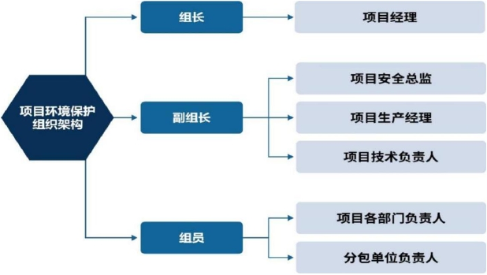4 工程建设环境保护组织机构

4.1 成立环境保护领导小组

施工总承包单位项目经理部应成立项目环境保护领导小组，统一领导项目环境保护相关工作，研
究、决策施工过程中环境保护的重大问题。
4.1.1 环境保护组织机构框架：

图 4.1.1 环境保护组织机构框架

4.1.2 环境保护组织机构职责如下：
a) 执行国家、地方政府、企业等有关环境保护的法律法规、标准和规章制度，开展环境保护工作；
b) 开工前完成环境影响评价或备案；
c) 制定项目环境保护费用计划，并在施工作业中组织实施，确保环境保护费用的有效使用；
d) 施工过程中根据各个施工阶段特点，采取不同的环境保护措施；
e) 建立施工人员环境保护培训制度，编制培训计划，并组织教育培训，增强施工人员环境保护意
识。定期对施工现场环境保护实施情况进行检查，并做好检查记录。

第 4 页

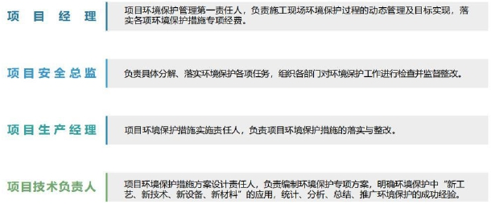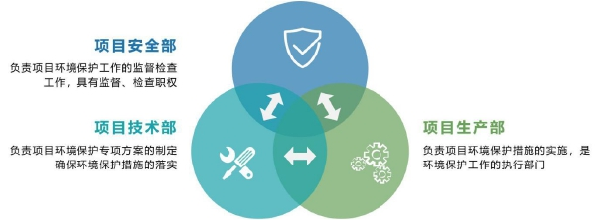4.2 环境保护组织机构主要管理人员职责

图 4.2 环境保护组织机构主要管理人员职责

4.3 项目各部门环境保护管理职责

图 4.3 项目各部门环境保护管理职责

第 5 页

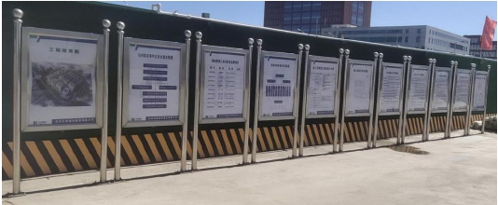5 施工准备阶段

5.1 施工现场公示标牌

5.1.1 在施工现场大门内侧明显位置公示《施工现场绿色施工管理制度》、《施工现场环境保护管理
制度》标牌。
5.1.2 在施工现场大门口外侧明显位置设置“建设工程参建单位、监督机构及负责人公示牌”、“土
方施工工程参建单位及负责人公示牌（土方施工阶段）”、“扬尘治理和建筑垃圾处置责任公示牌”、
“建筑节能公示牌”、“建筑垃圾消纳备案表公示牌”、“空气重污染预警应急措施公示”。
5.1.3 公示牌宜采用不锈钢材加工，柱体直径 63mm，高 1800mm；四框尺寸不小于 600mm×800mm；安装
后确保美观、牢靠。

图 5.1.3 现场标识牌安装实例

5.2 办公用房及宿舍

5.2.1 应采用箱式模块化集成房或充分利用既有建筑物，配备符合要求的防暑降温、冬季采暖设施。
5.2.2 设置可开启式窗户,保持室内通风。
5.2.3 宿舍建筑层数不应超过 3 层，每层建筑面积不应大于 300 ㎡，设置防雷装置。
5.2.4 宿舍应设置烟感报警器，地面铺设耐火地板，使用 36V 以下安全电压照明。

5.3 围挡及围挡喷淋系统

5.3.1 施工现场围挡（墙）应封闭、完整、牢固、美观，高度不得低于 2.5m，围墙材质应采用专用金
属定型材料或砌块砌筑。

第 6 页

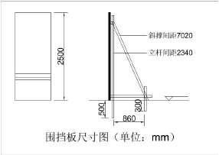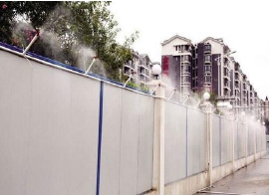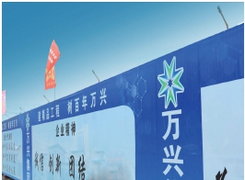5.3.2 施工现场围挡尺寸如下图所示，且每隔 6m 设置型钢固定点，围挡钢板厚度不小于 0.6mm。

图 5.3.2 围挡板尺寸图
5.3.3 施工现场围挡（墙）临近道路、居民区等人员、车辆密集区域，宜设置围挡降尘喷淋系统，选
用节水型喷雾喷头，喷头间距不大于 4 米，距离围挡（墙）的高度宜为 75~150mm。
5.3.4 土方施工阶段、空气重污染预警、大风预警天气、现场扬尘监测系统超过预警值时降尘喷淋系
统应保证持续开启喷淋，此外可根据现场实际情况间隔开启。
5.3.5 现场围挡及大门每半年进行清洗，出现严重破损应及时替换。

图 5.3.5 围挡降尘喷淋系统

5.4 车辆冲洗设施

5.4.1 施工现场出入口必须设置车辆冲洗设施，保持进出现场车辆清洁。车辆冲洗装置除能够冲洗车
辆轮胎外，还应能冲洗槽帮，保证车辆轮胎、槽帮等各部位均冲洗干净。
5.4.2 车辆冲洗过程不应小于 3 分钟，并应设置专人检视车辆冲洗情况，对仍有泥沙存留部位应采用
人工冲洗，确保车辆出场不带泥沙。
5.4.3 洗车池处或大门口应设置吸湿垫。
5.4.4 设专人管理车辆冲洗设施，定期进行维修保养，留存维修保养记录。

第 7 页

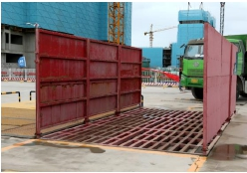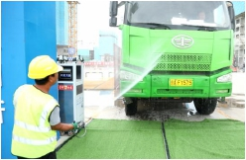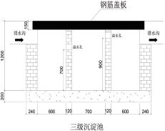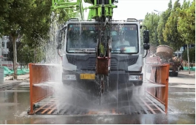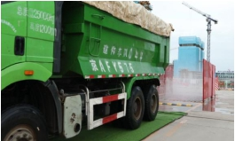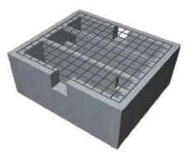图 5.4.4-1 车辆冲洗设施 图 5.4.4-2 机械冲洗作业

图 5.4.4-3 人工冲洗作业 图 5.4.4-4 吸湿垫沥水

5.5 沉淀池

5.5.1 混凝土输送泵及运输车辆冲洗设施处需设置沉淀池，用水经二次沉淀后循环使用或用于洒水降
尘，废水不得直接排入市政污水管网。
5.5.2 沉淀池应设置防护盖板，周围宜加装钢制防护拦杆，护身栏高度不小于 1.2m。

图 5.5.2-1 三级沉淀池

第 8 页

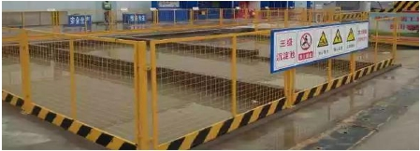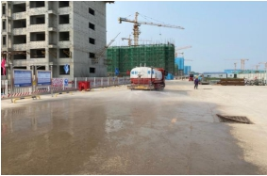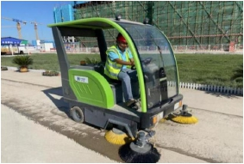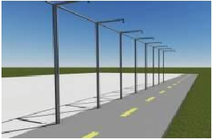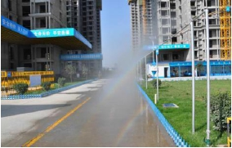图 5.5.2-2 三级沉淀池防护

5.6 场内道路清扫降尘

5.6.1 场内道路需配备新能源清扫车定时清扫，其他部位配合人工洒水，清扫。每天洒水、清扫的次
数不少于 6 次。
5.6.2 可设置场内道路降尘喷淋系统，喷淋嘴设置间距 4 米。
5.6.3 施工现场进出口周边 100m 以内的道路不得有泥土和建筑垃圾，及时进行清扫和洒水降尘。

图 5.6.3-1 洒水车洒水作业 图 5.6.3-2 新能源扫地车

图 5.6.3-3 道路喷淋系统示意图 图 5.6.3-4 场内道路降尘喷淋系统

5.7 密闭式垃圾站

5.7.1 施工现场应设置密闭式垃圾站，建筑垃圾和生活垃圾应分类存放，及时清运；建筑垃圾宜进行
资源化利用。
第 9 页

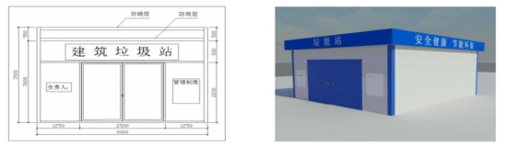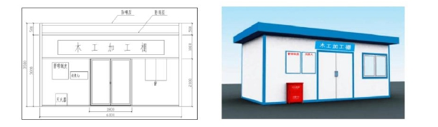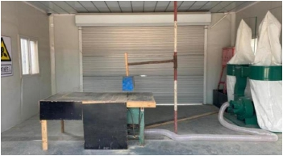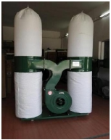5.7.2 密闭式垃圾站外需悬挂负责人标识牌。

图 5.7.2 密闭式垃圾站

5.8 密闭式木工加工防护棚

5.8.1 木工加工防护棚应独立设置，在塔吊范围内的防护棚，应设防雨防砸层，防砸层满铺 50mm 厚
的脚手板，棚顶立面喷涂安全标识。除顶部防砸层外，应采用燃烧性能等级为 A 级的材料搭建，设门
窗和防爆灯具，地面硬化。
5.8.2 木工加工防护棚内应增设防尘降噪措施，门外应配备灭火器材。
5.8.3 木工加工防护棚内应设置木屑吸尘设备，并设置专人管理，及时清理、清扫，清理出的木屑粉
尘应装袋运输。

图 5.8.3-1 密闭式木工加工棚效果图

图 5.8.3-2 木屑吸尘设备实例 图 5.8.3-3 双桶布袋吸尘器

第 10 页

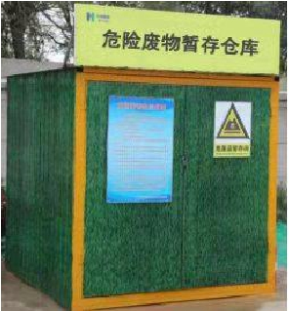5.9 危废库房

5.9.1 施工中用的油漆稀料、油质脱模剂及其他有毒、有害材料，应单独设危废库房存放，设专人负
责保管。
5.9.2 危废库房地面硬化后应采取抹防渗漏砂浆或者铺贴防水卷材的抗渗措施，并在四周墙面上返
20cm，形成挡渗墙。
5.9.3 危废库房应设置在施工现场畅通处，远离办公区、生活区，距离不应少于 30m，危废库房门口
明显处悬挂警示标识。
5.9.4 危废库房照明应为防爆灯，开关设置在库房外，设置通风排风口，并配置灭火器。
5.9.5 危废清运应交由具有相应资质的公司处置，并与其签订合同或协议。

图 5.9.5 危险废物暂存仓库实例图

5.10 预拌砂浆罐防护棚

5.10.1 施工现场禁止搅拌砂浆及混凝土，应按要求使用预拌砂浆及预拌混凝土，并采取相应的防止
扬尘措施。
5.10.2 防扬尘及防砸棚高度不低于 3.5m，宽度不小于 2m，棚上方铺设防砸防雨设施。

第 11 页

以上内容仅为本文档的试下载部分，为可阅读页数的一半内容。如要下载或阅读全文，请访问：https://d.book118.com/698050135074006045

