浙江省杭州市临平区2022-2023学年五年级上学期英语期末试卷（音频暂未更新）
阅卷人 |  | 一、听句子，选择听到的单词。
得分 |  | 一、听句子，选择听到的单词。
听句子，选择听到的单词。
1．
A．clock B．clever
2．
A．hungry B．thirsty
3．
A．sing B．song
4．
A．Tuesdays B．Thursdays
5．
A．boating B．building
6．
A．drink B．cat
7．
A．forest B．fresh
8．
A．wash B．watch
9．
A．plant B．polite
10．
A．beside B．behind
阅卷人 |  | 二、听对话，选出与内容相符的图片。
得分 |  | 二、听对话，选出与内容相符的图片。
听对话，选出与内容相符的图片。
11．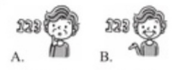
12．
13．
14．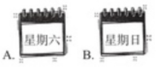
15．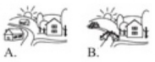
16．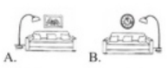
17．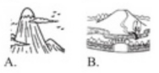
18．
19．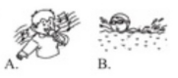
20．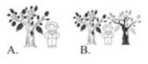
阅卷人 |  | 三、听问句，选择相应的答语。

得分
听问句，选择相应的答语。
21．
A．We have art. B．I often draw cartoons.
22．
A．She likes English. B．She is strict.
23．
A．Yes, there is. B．No, there aren't.
24．
A．Hamburgers. They're delicious. B．I'd like some hamburgers.
25．
A．Yes, I do. B．No, I can't.
阅卷人 |  | 四、听录音，完成相应的任务。听较长对话，选择相符的图片。
得分 |  | 四、听录音，完成相应的任务。听较长对话，选择相符的图片。
听录音，完成相应的任务。听较长对话，选择相符的图片。
26．What's the village like?
A．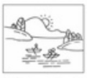 B．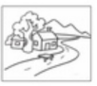
27．What can David do?
A．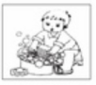 B．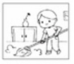
听短文，判断正误。
28．In Sunny School there are no tall buildings. There is a big playground.
29．Peter is helpful. He often helps David with science.
30．David likes beef and milk.
阅卷人 |  | 五、读句子，判断画线部分发音是否相同。
得分 |  | 五、读句子，判断画线部分发音是否相同。
读句子，判断画线部分发音是否相同。
31．It's my mum's birthday today. I paint a picture for her.
32．Wow, it's snowy! Dad, be slow, please.
33． I'd like to eat some beef. It's yummy and healthy.
34． My grandma cooks yummy food for afternoon tea.
35．Let's count. One, two... There are 12 flowers in the house.
阅卷人 |  | 六、读一读，选择合适的选项。
得分 |  | 六、读一读，选择合适的选项。
36． — What can you do? 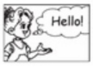
—____
A．I can speak English, B．I can sing English songs.
37．—Are there any trees in the village?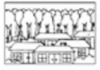
—____
A．Yes, there are. B．No, there aren't.
38．—What's your friend Kevin like?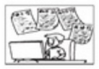
—____
A．He's shy. B．He's clever.
39．—____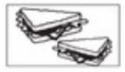
—Sandwiches.
A．What's your favourite drink? B．What's your favourite food?
40．—Where is the ball?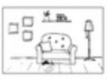
—____
A．It's in front of the sofa. B．It's behind the sofa.
阅卷人 |  | 七、读思维导图，选择合适的选项，将单词归类。
得分 |  | 七、读思维导图，选择合适的选项，将单词归类。
读思维导图，选择合适的选项，将单词归类。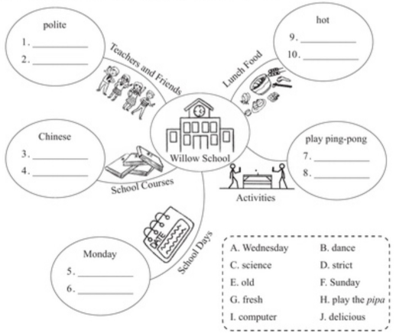
41． 42． 43． 44． 45．
46． 47． 48． 49． 50．
阅卷人 |  | 八、读一读，根据图片及上下文提示写单词。
得分 |  | 八、读一读，根据图片及上下文提示写单词。
读一读，根据图片及上下文提示写单词。
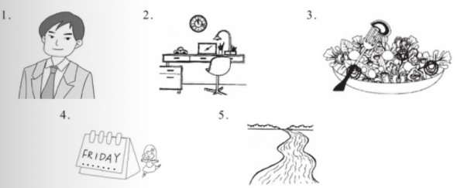
51． Our music teacher is very . He is only 24 years old.
52．There is a clock in my room. It's the desk.
53． is my favourite food. It's fresh and delicious.
54．I have a dancing class on .I want to be a good dancer.
55．—Is there a in the park? —Yes, there is.
阅卷人 |  | 九、补全对话，把编号写在横线上(有一项为多余选项）。
得分 |  | 九、补全对话，把编号写在横线上(有一项为多余选项）。
补全对话，把编号写在横线上(有一项为多余选项）。
A. What's he like?
B. Do you often play football here?
C.He's a good boy.
D. Do you often read books in this park?
E. Who is he?
F.Is there a library near the park?
(It's Sunday afternoon. Zhang Peng meets Sarah at the park.）
Zhang Peng:Hi, Sarah. 56．
Sarah: No, I don't. 57．
Zhang Peng: Yes. I like this park very much. And I often come here with Carl. Sarah:Carl? 58．
Zhang Peng: He's my cousin. He likes sports, too.
Sarah: 59． Is he strong?
Zhang Peng: Yes, he is. And he is very funny. Look, he's coming
Sarah： 60． I want to borrow a new book.
Zhang Peng: Yes,there is. Let's go together.
阅卷人 |  | 十、阅读理解。
得分 |  | 十、阅读理解。
阅读短文，选择合适的答案。
How do you keep good eyesight(视力）? Wantang Primary School in Yunnan has good ways. There are 536 students in the school. None of the students are short-sighted. Students there have a good schedule. It keeps them healthy.
They play sports for three hours( 小时）every day.
They get 10.5 hours of sleep from every day.
They can't take phones to school.
They have a healthy diet(饮食）.They eat more vegetables and fruits.
There are green plants all around the school.
61． How many students in Wantang Primary are short-sighted?
A．536 students. B．No students. C．We don't know.
62．How many hours do they get for sports and sleep every day?
A．3 hours. B．10.5 hours. C．13.5 hours.
63．Are there any green plants around the school?
A．Yes, they are. B．No, there aren't. C．Yes, there are.
64．Which one in NOT true to keep good eyesight?
A．Eat healthy food.
B．Use your phone a lot.
C．Do sports every day.
阅读短文，填空或回答问题。
Nature in cities
Cities can be lovely homes for plants and animals. Many cities around the world want to make their cities more livable(宜居的） for animals and plants.Let's see how they do that! Forests in Milan
In Milan, Italy, there are two special tall buildings. Green plants cover them. They look like forests in the air. The "forests" have 800 trees, 15,000 small plants and 5,000 shrubs(灌木）.People plant them on balconies(阳台）.
Wuhan, the "sponge(海绵）city"
Wuhan in Hubei is rich in water. But it is often troubled by flooding(洪水）.In 2015,Wuhan started to build itself as a "sponge city". It built many gardens,ponds(池塘） and wetlands(湿地） around the city. When it rains, they can take in water like a sponge.
Curridabat, the "sweet city"
Curridabat is a wonderful place. It grows flowers along every sidewalk(人行道）,so bees and butterflies have their favourite food. It also builds"bee hotels"around the city. These are nice houses for bees to live and have babies.
65． Cities can be lovely homes for and
66．Curridabat grows lots of . Bees and butterflies like them.
67．In Milan, the two tall buildings look like in the air.
68．There are many , ponds and wetlands in Wuhan. They can take in when it rains.
69．—Are there any houses for bees in Curridabat?
—
阅卷人 |  | 十一、书面表达。
得分 |  | 十一、书面表达。
70．假设你是Bob或者Amy(在文中圈出），根据表格内的信息及问题提示，完成短文。
 | Bob | Amy
What's your favourite day? | 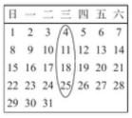 | 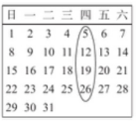
What do you have on that day? | 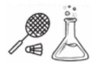 | 
What do you have for lunch? | 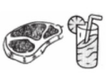 | 
And what's your favourite food? | …… | ……
What do you often do on the weekend? | …… | ……
Hello, my name is Bob/Amy. My favourite day is
▲ .We ▲ .We ▲ for lunch.My favourite food ▲ .On the weekend, ▲ .
答案解析部分
【答案】1．A
2．A
3．A
4．B
5．B
6．A
7．A
8．B
9．B
10．B
【知识点】句子型听力
【解析】【听力原文】1 There is a nice clock on the wall.
2 I'm hungry. What's for dinner?
3 I can sing for the party.
4 What do you have on Thursdays?
5 Are there any tall buildings in the village?
6 What would you like to drink?
7 Let's go to the forest.
8 I often watch TV on the weekend.
9 He's a polite boy.
10 There is a bike behind the door.
【点评】考查听力，先看选项，特别注意选项单词发音区别，仔细听录音，在听力原文找出听到的单词。
1．听力原文：墙上有一个漂亮的钟。A：时钟，B：聪明的。出现单词clock，故答案为A。
2．听力原文：我饿了。晚餐吃什么？A：饿的，B：渴的。出现单词hungry，故答案为A。
3．听力原文：我可以在晚会上唱歌。A：唱歌，B：歌曲。出现单词sing，故答案为A。
4．听力原文：星期四你们有什么课？A：周二，B：周四。出现单词Thursdays，故答案为B。
5．听力原文：村子里有高楼吗？A：划船，B：建筑。出现单词buildings，故答案为B。
6．听力原文：您想喝点什么？A：喝，B：猫。出现单词drink，故答案为A。
7．听力原文：我们去森林吧。A：森林，B：新鲜的。出现单词forest，故答案为A。
以上内容仅为本文档的试下载部分，为可阅读页数的一半内容。如要下载或阅读全文，请访问：https://d.book118.com/698061105013006050

