安徽财贸职业学院单招《英语》考试复习题库（含答案）
1.My pen friend knows a lot about China ________ she has never been here.
A、although
B、if
C、because
D、Until
答案：A
2.Now fill in this _______, please.
A、from
B、form
C、inform
D、force
答案：B
3.- you the Chinese Culture Festival in the Central Square?-Yes. It was really a great success.
A、Are; attending
B、Will; attend
C、Do; attend
D、Did; attend
答案：D
4.--Excuse me, sir. Can you tell me how to get to the nearest bank?--_______
A、You are welcome.
B、Sorry. I’m new here.
C、You can’t miss it.
D、That’s right.
答案：B
5.The old woman doesn’t feel _______ though she lives _______.
A、alone; lonely
B、alone; alone
C、lonely; lonely
D、lonely; alone
答案：D
6._______ your help, I passed the English exam.
A、Thanks
B、Thanks to
C、Thank you
D、Thank to
答案：B
7.The pen _______ me. It is hers.
A、isn’t belong to
B、wasn’t belong to
C、doesn’t belong to
D、didn’t belong to
答案：C
8.Exit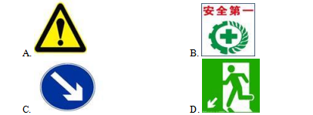
A、A
B、B
C、C
D、D
答案：D
9.--Is this book yours?--No, mine _______.
A、is borrowing
B、has been borrowed
C、borrows
D、has borrowed
答案：B
10.We prefer _______ at the party rather than _______.
A、to sing; dance
B、to sing; dancing
C、sing; to dance
D、sing; dance
答案：A
11.--Shall we meet at 3 at the gate of the school?________
A、That’s right.
B、I’d love to.
C、All right.
D、That’s wrong.
答案：C
12.The book on the desk isn’t mine. Is it __________?
A、yours
B、yourself
C、you
D、Your
答案：A
13._______ play football here. It’s too dangerous.
A、Please
B、To
C、Don’t
D、Let’s
答案：C
14.--The mooncake is really delicious. Can I have another piece?--_______
A、You can.
B、Behave yourself.
C、Go ahead.
D、Never mind.
答案：C
15.--Have a nice weekend!_______
A、That’s all right.
B、Thank you. You, too.
C、See you next week.
D、I’m glad to hear that.
答案：B
16.I want to buy _______.
A、two bottles of orange juice
B、two bottle of orange juice
C、two bottle of orange juices
D、two bottles of orange juices
答案：A
17.--Don’t touch it. It’s dangerous.________
A、Are you all right?
B、Don’t mention it.
C、Sorry, I won’t.
D、Yes, please do.
答案：C
18.Women’s Room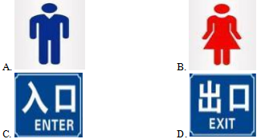
A、A
B、B
C、C
D、D
答案：B
19.The classroom is full _______ desks and chairs.
A、of
B、in
C、to
D、at
答案：A
20.--Your watch is so beautiful.________
A、Don’t say that.
B、Thank you.
C、That’s all right.
D、You’re right.
答案：B
21.It’s still early. You _______.
A、mustn’t hurry
B、wouldn’t hurry
C、may not hurry
D、don’t have to hurry
答案：D
22.--Why was Yu Gong trying to move the mountains?--Because it was _______ for his family to get to the other side of the mountains.
A、difficulty
B、difficulties
C、difficult
D、most difficult
答案：C
23.More than two trees are planted in our neighborhood every year. ( )
A、hundred
B、hundreds
C、hundreds of
D、hundred of
答案：A
24.--The pan(平底锅) is on fire.--_______
A、That’s good.
以上内容仅为本文档的试下载部分，为可阅读页数的一半内容。如要下载或阅读全文，请访问：https://d.book118.com/705334141122011123

