
2023-2024学年河南省安阳市林州市八年级（上）期中英语试卷（B卷）
听力理解 第一节 听下面5段对话。每段对话后有一个小题，从题中所给的 A、B、C三个选项中选出最佳答案。每段对话读两遍。
1．（1分）Where did the boy go on vacation？
A.To the mountains.
B.To the beach.
C.To the park.
2．（1分）What did Jenny do last weekend？
A.She visited her grandparents.
B.She went shopping with her parents.
C.She studied for the exam.
3．（1分）Who is the youngest？
A.Bill.
B.Sue.
C.Tara.
4．（1分）Who taught Mary to dance？
A.Her aunt.
B.Her teacher.
C.Her mother.
5．（1分）When did the man get his food？
A.At 11：00.
B.At 11：30.
C.At 12：00.
第二节 听下面几段对话或独白。每段对话或独白后有几个小题，从题中所给的 A、B、C三个选项中选出最佳答案。每段对话或独白读两遍。
6．（2分）（1）What is Sam like？
A.He is tall and outgoing.
B.He is short but outgoing.
C.He is short but hard﹣working.
（2）When do Larry and Sam play ping﹣pong？
A.After work.
B.After arriving home.
C.After finishing their homework.
7．（2分）（1）What does Bob's brother think of the TV show？
A.He thinks it is interesting.
B.He thinks it is exciting.
C.He thinks it is boring.
（2）What does the girl think of the actress with blonde hair？
A.She thinks she is careful.
B.She thinks she is funny.
C.She thinks she is kind.
8．（3分）（1）Who has a farm？
A.Jane's sister.
B.Jane's uncle.
C.Carol.
（2）How does Jane usually go to the farm？
A.By car.
B.By train.
C.By bike.
（3）What does Jane like helping to do best？
A.To feed the baby pigs.
B.To clean the farm.
C.To walk the dogs.
9．（3分）（1）What are those？
A.They are film tickets.
B.They are football tickets.
C.They are basketball tickets.
（2）How does Sally like football？
A.She likes it very much.
B.She doesn't like it.
C.She thinks it's exciting.
（3）Who may want the tickets？
A.Lucy.
B.Lily.
C.Both A and B.
第三节 听下面一篇短文。按照你所听内容的先后顺序将下列图片排序。短文读两遍。
10．（5分）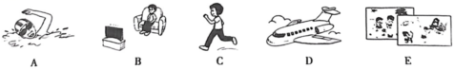

（1） （2） （3） （4） （5）
阅读理解
11．（10分）Topic：Should kids join talent shows？
Discussion：
The talent shows shouldn't set a limit on the age.If the parents want their kids to join talent shows，they should say "Yes".
﹣Ben
Talent shows can help children become more confident.And no matter how young you are，you can have talents.
﹣Laura
I think it's wrong for kids to join big talent shows.They have other things，like schoolwork，to worry about.And they will be sad if they can't win.
﹣Robert
The judges of the big talent shows are too strict.There should be Kids Have Got Talent.So they don't need to compete with adults.
﹣James
阅读上面的信息，选择正确答案。
（1）Ben thinks if want the kids to join talent shows，the talent shows should say "Yes".
A．the kids' parents
B．the kids' teachers
C．the kids' friends
D．the judges
（2）Laura thinks talent shows can help kids become .
A．more talented
B．more outgoing
C．more confident
D．more hard﹣working
（3）Robert thinks kids should worry about .
A．talent shows
B．their parents
C．their studies
D．their friends
（4）James thinks .
A．kids should not watch talent shows
B．kids mustn't join talent shows
C．there should be some young judges
D．there should be talent shows for kids only
（5）What can we learn from the discussion？
A．Laura thinks kids can be talented，too.
B．Kids always win in talent shows.
C．Kids feel excited in talent shows.
D．All kids should join talent shows.
12．（10分）①Susan was a smart girl，but she hardly talked to her classmates.She couldn't see clearly，so she wore glasses.Her classmates always laughed at her big glasses.
②Lewis started calling her "Four Eyes".That was the worst thing.Lewis was very popular
among the students.Now everyone called her"Suzy Four Eyes".She acted like she didn't care，but in fact，Susan was quite sad.
③One day，the class went on a school trip.The children were having a great time when suddenly Lewis fell into a hole（掉进洞里）.Lewis grabbed（抓）
④It was so dark in the hole.Susan and Lewis felt scared and they shouted for help，but no one came.After some time，they found some sunlight.Susan took a piece of wood（木头），using her glasses as a magnifying glass（放大镜）.Now they had a torch（火把）
⑤Finally，they found a way out.Lewis gave Susan his heartfelt thanks.It was her glasses that had saved them both.He hoped he had never called her"Four Eyes".

根据材料内容选择最佳答案。
（1）What was Susan like？
A.Shy.
B.Fun.
C.Outgoing.
D.Hard﹣working.
（2）Why did Susan's classmates laugh at her？
A.Because she was too short.
B.Because she wore glasses.
C.Because she got bad grades.
D.Because she was new in the class.
（3）Lewis and Susan during the school trip .
A.fought with each other
B.left the group
C.found a new forest
D.fell into a hole
（4）How did Susan get the fire？
A.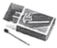
B.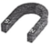
C.
D.
（5）Which paragraphs tell us Lewis and Susan's experience（经历） in the hole？
A.①②
B.②③
C.③④
D.②④
13．（10分）China has four satellite launch bases（卫星发射基地）.They are Jiuquan in Gansu，Xichang in Sichuan
Jiuquan Satellite Launch Center which was founded （建立） in 1958 is one of the four famous satellite launch bases in China.The center has created eight proud firsts for China's space industry.On April 21，1970manned spacecraft blasted off （发射） from Jiuquan Satellite Launch Center in June，2021.
Xichang Satellite Launch Center，also known as Xichang Satellite City，was founded in 1970.After 37 years of development（设备）.It is known as the "Oriental Houston（东方休斯顿）".
Taiyuan Satellite Launch Center was founded in 1967.The center has launched China's first weather satellite "Fengyun﹣1"，making nine firsts in the history of China's satellite launches.
Wenchang Space Launch Center （founded in 2009）is now the fourth satellite launch center of China.Because it is only 19 degrees away from the equator （赤道），more rocket loads （负载），making it the center of China's space development in the future.
（1）How many satellite launch bases are there in China according to the passage？
A．There are three.
B．There are four.
C．There are five.
D．There are six.
（2）What does the underlined words "manned spacecraft" mean in Chinese？
A．载人飞船
B．宇宙空间站
C．航空航天器
D．人造地球卫星
（3）Which center is known as the "Oriental Houston"？
A．Jiuquan Satellite Launch Center.
B．Xichang Satellite Launch Center.
C．Taiyuan Satellite Launch Center.
D．Wenhang Space Launch Center.
（4）Choose the order of the foundation（成立） time of the four centers according to the following.
①Jiuquan ②Xichang ③Taiyuan ④Wenchang
A．①②③④
B．③①④②
C．③④②①
D．①③②④
（5）Which of the following is NOT right？
A．The center of Taiyuan has made nine firsts since 1967.
B．The Shenzhou XⅡ manned spacecraft blasted off in June，2021.
C．The center of Jiuquan has created eight proud firsts since 1968.
D．The center of Wenchang will be the center of China's space development.

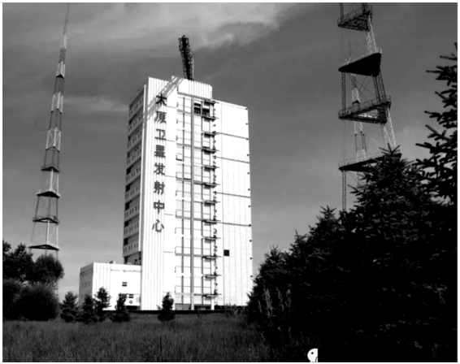
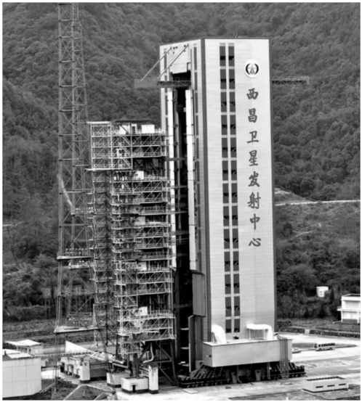
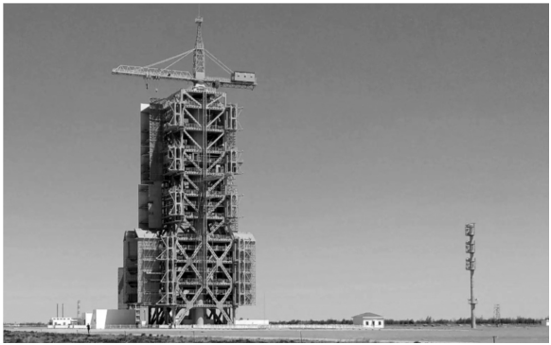
14．（10分）Disneyland Park is one of the most popular places for people to go，especially for children.There are six Disneyland Parks in the world.（1） As for Chinese visitors，they probably want to go to Shanghai Disneyland Park the most.
The park brings people happiness and laugh，no matter how old you are.Children are able to meet many cartoon characters and play with them.（2） Old people can watch shows，take a walk and have a rest in the park.
In the park，there are all kinds of interesting programs.（3） During the daytime，you can ride a much taller and longer roller coaster（过山车），go to the Sleeping Beauty Castle and so on.（4） In the evening，you can watch firework shows and some other shows.They are all fantastic.
However，the ticket here isn't very cheap，from 399 RMB to 665 RMB.So don't go to the park on weekends or holidays.You can choose to come here on common days.（5）
Welcome to Shanghai Disneyland Park.There is always something for everyone in the park.

A.Because tickets on these days are cheaper.
B.Shanghai Disneyland Park is the second Disneyland Park in China，and the sixth one in the world.
C.If you get to the park late，you can also have fun.
D.Young people can take part in lots of exciting activities.
E.It's fun for people to play during the daytime and in the evening.
完形填空 先通读短文，掌握其大意，然后从 A、B、C、D四个选项中选出一个可以填入相应空白处的最佳答案。
15．（15分）A little girl thought she was not as beautiful as other girls，and nobody liked her.So she was （1） happy.She always stayed at home by herself and didn't talk to （2） .
One day，her mother gave her a beautiful hair clip（发夹）.When she （3） it，she looked much more beautiful than before.She decided to go to school in the beautiful hair clip.
On her way to （4） ，she found that everyone who saw her smiled at her.Most of her schoolmates said "Hello" to her，（5） this never happened before.She thought that the beautiful hair clip（6） them all to her.She was so happy （7） all of the wonderful things.
Although all her classmates wanted to know （8） happened to her，she didn't want to tell（9） about her beautiful hair clip.
When she went back home after school，her mother asked her， "Did you know you （10） your hair clip at home？I found it by the door this morning."
She was （11） to hear what her mother said.She knew that she didn't wear the hair clip to school （12） .
It's not important what we wear or how we （13） .The most（14） thing is how we think about ourselves. （15） we want to do a thing successfully，first try to
be confident.If we think we can，we can.

（1） | A．often | B．usually | C．hardly | D．always
（2） | A．anyone | B．someone | C．no one | D．everyone
（3） | A．made | B．chose | C．wore | D．lost
（4） | A．work | B．school | C．class | D．house
（5） | A．so | B．because | C．and | D．but
（6） | A．took | B．brought | C．got | D．bought
（7） | A．to | B．of | C．in | D．about
（8） | A．what | B．when | C．why | D．how
（9） | A．us | B．him | C．them | D．he
（10） | A．left | B．forgot | C．put | D．missed
（11） | A．angry | B．surprised | C．lucky | D．meaningless
（12） | A．at last | B．at least | C．in all | D．at all
（13） | A．look | B．feel | C．think | D．act
（14） | A．difficult | B．important | C．interesting | D．comfortable
（15） | A．Although | B．Until | C．If | D．So
语篇填空 阅读短文，从方框中选择适当的词并用其正确形式填空，使短文通顺、意思完整。 每空限填一词，每词限用一次。
16．（10分）
part hard hardly interest educational remember although expect start with
Chinese Character（汉字） Dictation Contest，a（n）（1） program in China，is becoming popular among people.The program is very successful and it makes people all over China （2） in writing Chinese characters.
In fact，mainly using computers and smartphones makes most young people be（3） able to write correctly by hand.Many of them even cannot （4） the 10，000
characters in everyday life without help from computers or smartphones.
CCTV （5） Chinese Character Dictation Contest to improve the people's handwriting in 2013.（6） the contestants（参与者） on the show are students，it may be even（7） for some older audiences（观众） to write every word right than those on the show.
People like to type（打字） characters by using pinyin.They don't need to remember how to write them and it has to do （8） computers and smartphones.So people are（9） to take up a hobby like writing Chinese characters by hand and consider it as a（n）（10） of Chinese culture because of the program.
Learning Chinese characters goes on throughout（贯穿） the life.If you stop using them for a long time，you will forget them quickly.
阅读短文，根据语篇要求填空，使短文通顺、意思完整。每空限填一词。
17．（5分）Dear Nancy，
You asked about places to go and things（1） do in our town.The Downtown Mall is always fun.It's a shopping place in （2） oldest part of town and you can buy whatever you like in it.My favorite restaurant in town is Nick's Restaurant.The food is cheap and the hamburgers there are great.I also like Dragon City Restaurant，You can eat wonderful noodles there and the beef noodles are the （3） delicious!You must try the tasty dumplings there，too!But the food is more expensive （4） that of Nick's Restaurant.
Anyway，（5） are lots of things to do and to see here.Come for a visit soon!
Yours，
Daisy
补全对话 根据下面的对话情景，在每个空白处填上一个适当的句子，使对话的意思连贯、完整。
18．（10分）A：Hello，David!Do you like watching TV？
B：Yes.My parents and I all like watching TV.
A：（1） ？
B：I like talent shows best.I think they are interesting.
A：（2） ？
B：I watch them twice a week.Do you like watching talent shows？
A：No，I don't like them.（3） .
B：Oh，I like watching movies，too.
A：Then how about watching a movie this weekend？
B：Good idea!There are a few cinemas in our city.（4） ？
A：I think Redstar Cinema is the best one.It has the most comfortable seats and the cheapest tickets.
B：All right.Let's go to Redstar Cinema.By the way，does the cinema sell student tickets？
A：Yes.
B： （5） ？
A：20 yuan.
B：Oh，I see.
书面表达
19．（20分）假如你有一个外国笔友 Sue，请根据下面表格中的提示向你的同学介绍她的情况。
生活方式 | 每星期锻炼三次；几乎不吃垃圾食品
爱好与特长 | 爱看游戏类节目；擅长唱歌，有音乐天赋
与你比较 | 共同点：都擅长网球  差异：她更努力
你喜欢她的原因 | 她关心你，帮助你
要求：
（1）内容必须包括表格中的信息，可适当发挥；
（2）词数80左右，开头已给出，不计入总词数。
Hi，everyone!I am going to tell you something about my pen friend Sue.______
2023-2024学年河南省安阳市林州市八年级（上）期中英语试卷（B卷）
参考答案与试题解析
听力理解 第一节 听下面5段对话。每段对话后有一个小题，从题中所给的 A、B、C三个选项中选出最佳答案。每段对话读两遍。
1．（1分）Where did the boy go on vacation？
A.To the mountains.
B.To the beach.
C.To the park.
【分析】略
【解答】B
【点评】略
2．（1分）What did Jenny do last weekend？
A.She visited her grandparents.
B.She went shopping with her parents.
C.She studied for the exam.
【分析】略
【解答】C
【点评】略
3．（1分）Who is the youngest？
A.Bill.
B.Sue.
C.Tara.
【分析】略
【解答】C
【点评】略
4．（1分）Who taught Mary to dance？
A.Her aunt.
B.Her teacher.
以上内容仅为本文档的试下载部分，为可阅读页数的一半内容。如要下载或阅读全文，请访问：https://d.book118.com/715243141220011033

