Unit 1 Food matters Section Ⅰ Welcome to the unit & Reading
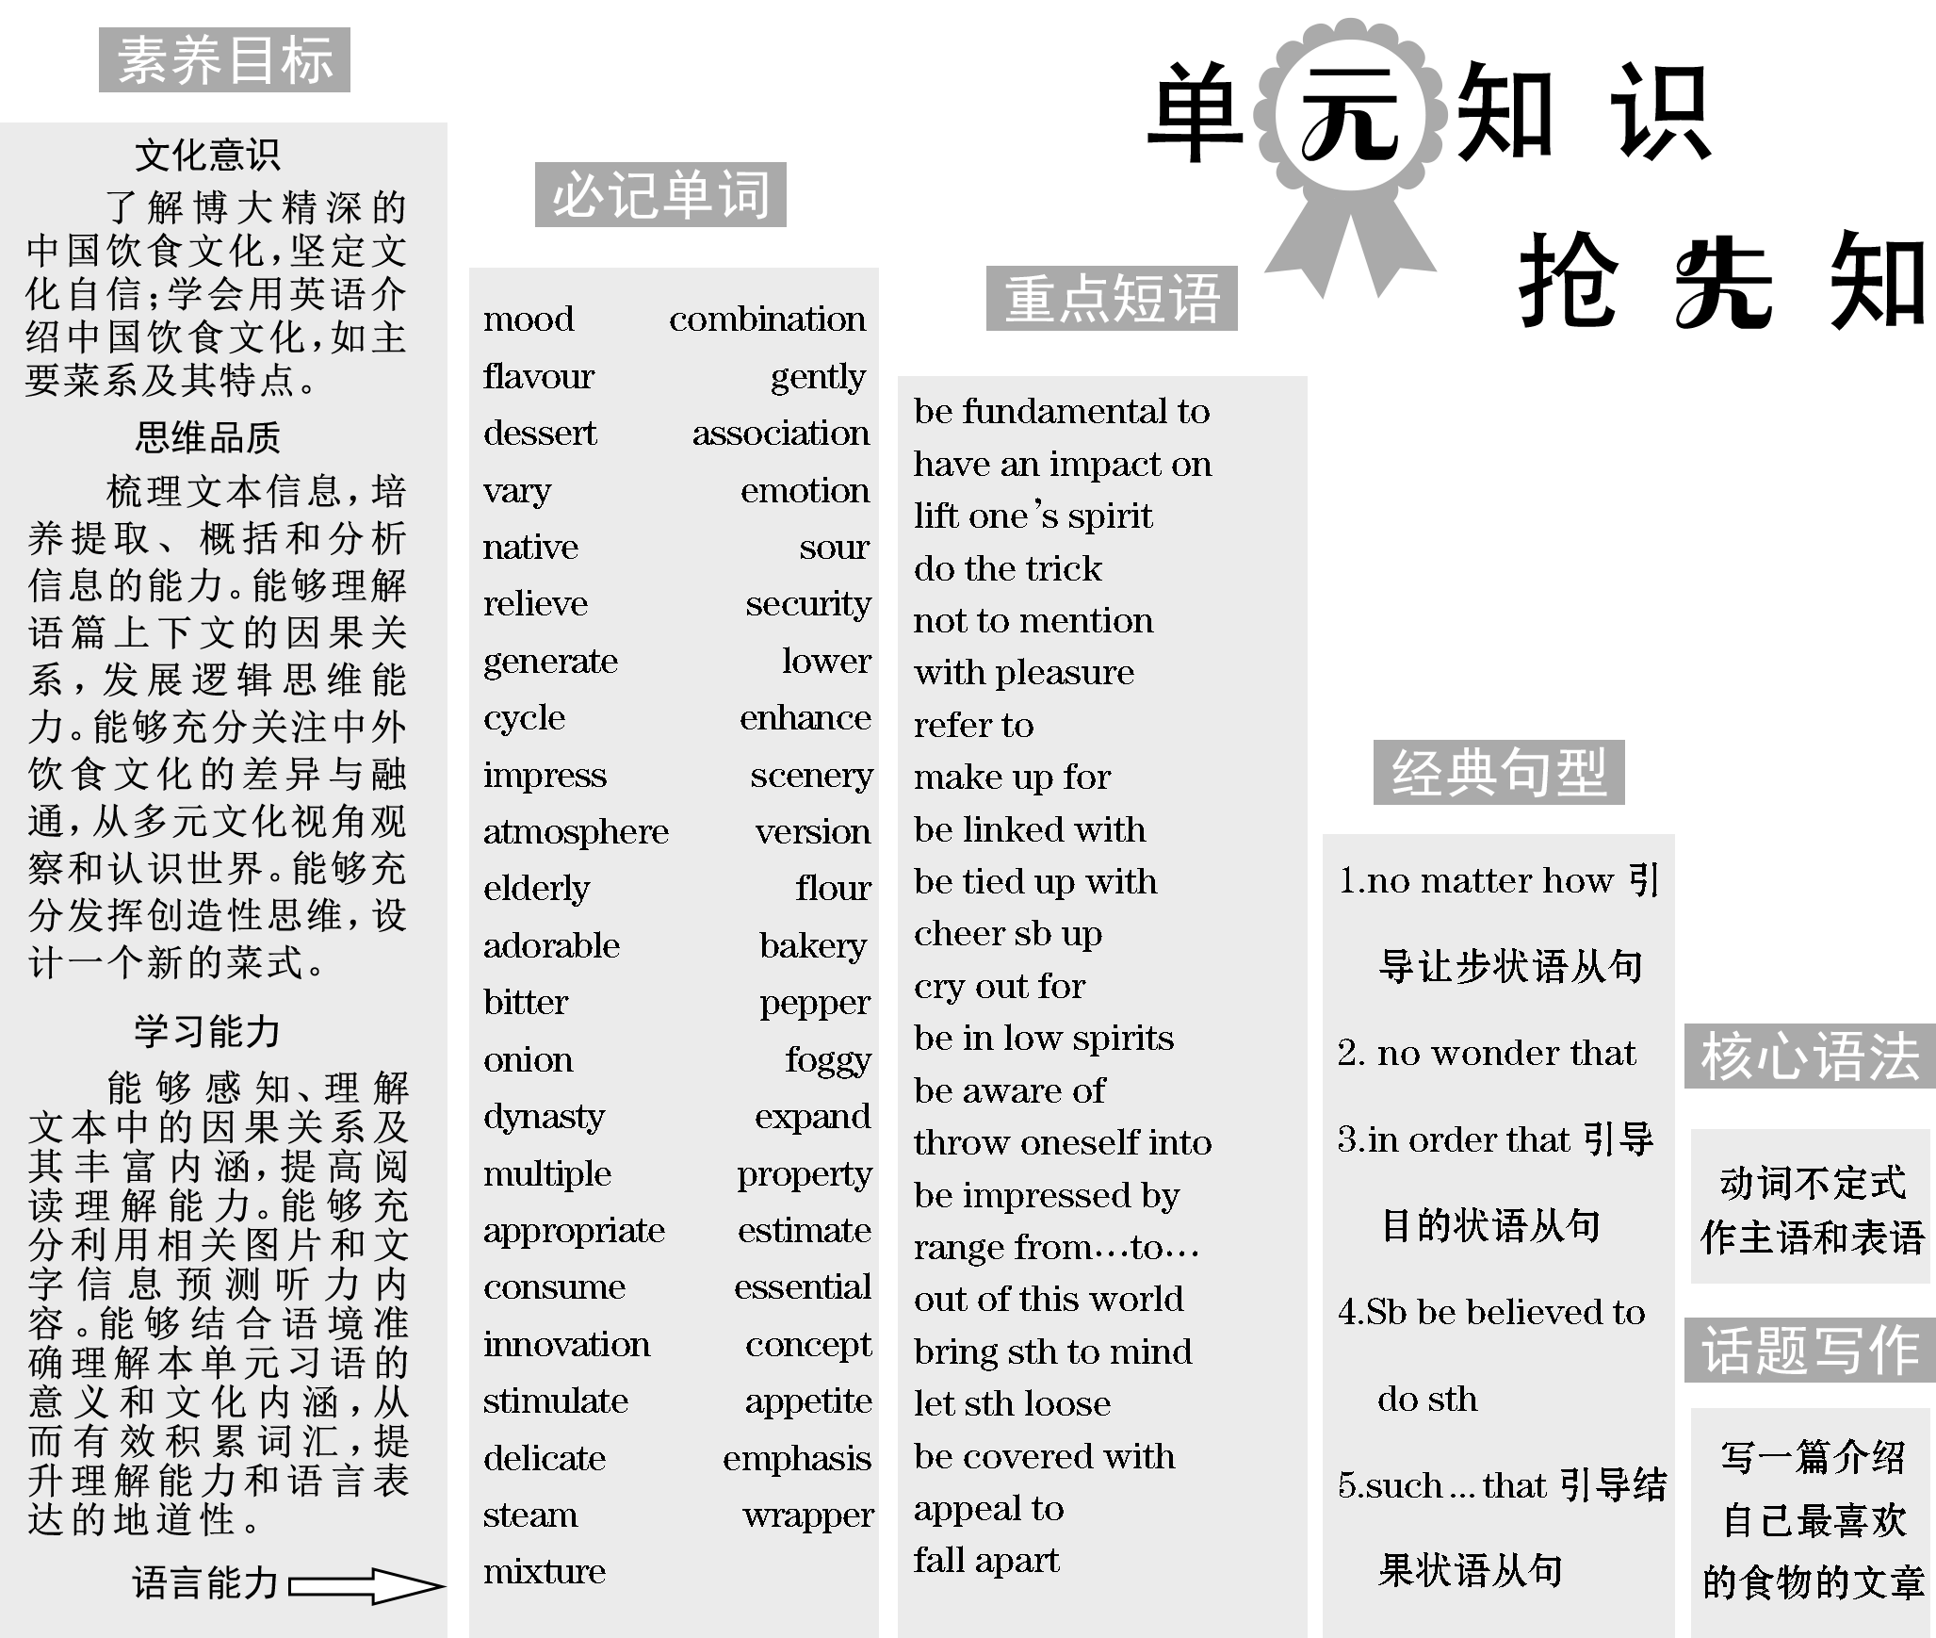
中国人特别重视食物中的“色”“香”“味”，下面让我们一起来了解这三原则以及八大菜系中的湘菜。
3 Requirements in Cookery
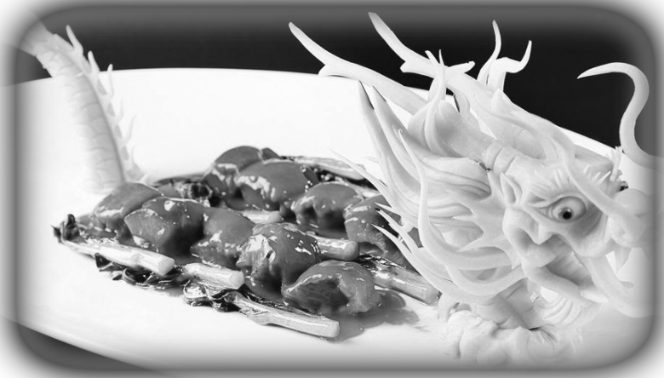Chinese people attach particular importance to a triple­principle (三原则) of their food, namely, color, aroma (香气) and taste：
•Color refers not only to the hue (色彩) of a dish, but also its modeling.Food is often decorated by carving in a specific appearance, which actually requires more than a few years' hard training by chefs.
•Aroma involves the appetizing smell of the dishes making one's mouth water.
•Taste refers to utilizing (利用) suitable condiments (调味品) and perfect food match to create a unique flavor.
To achieve this standard, every exquisite (精致的) culinary dish involves a long
and complicated process from selecting the ingredients to finally serving it to diners.The superb skills of Chinese chefs make a great contribution to the development of Chinese food industry.Sometimes, watching their work is like enjoying a splendid acrobatic (有关杂技的) show.
[阅读理解]
阅读文章，判断正(T)误(F)。
1．Chinese people think a triple­principle of their food which refers to color, aroma and taste is very important.(T)
2．Food is often decorated by carving in a specific appearance, which actually requires no more than a few years' hard training by chefs.(F)
3．The cooking styles of Hunan and Sichuan are the similar.(T)
Hunan Cuisine (湘菜)—Spicy and Sour
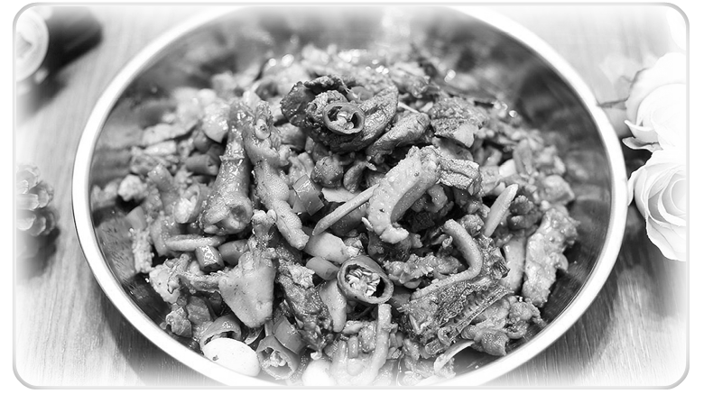Hunan Province provides a menu rich with a potent punch of chili (辣椒), so the uninitiated may easily mix up the cooking styles of Hunan and Sichuan.
Yet the special characteristics of Hunan Cuisine focus on pickled chilies and vegetables, sour relish and a heavier use of a kind of fatty preserved meat called larou in Chinese, tasting a bit like smoky bacon.
Recommended Hunan Food | Corresponding Chinese Name | Hunan Cuisine Characteristics
Tasty Crawfish | 口味虾 | pickled chilies and vegetables, sour relish, larou
Steamed Fish Head with Diced Red Peppers | 剁椒鱼头 | pickled chilies and vegetables, sour relish, larou
Steamed Ham | 腊味合蒸 | pickled chilies and vegetables, sour relish, larou
[词汇积累]
1．attach importance to 认为……很重要
2．namely adv. 即；也就是
3．specific adj. 特定的
4．make a great contribution to 对……有巨大贡献
5．splendid adj. 壮丽的
Section Ⅰ  Welcome to the unit & Reading

$\begin{matrix}[读文清障]\end{matrix}$
①mood n． 情绪，心情；气氛，氛围
②combination n. 结合体，联合体；联合，混合
③do the trick 奏效，起作用，达到目的
④not to mention 更不用提，更别说……
⑤creamy adj. 含奶油的；像奶油的，光滑细腻的；淡黄色的
⑥flavour (AmE flavor) n. 味，味道；特点，特色
vt. 给……调味，加味于
⑦with pleasure 很乐意，很高兴
⑧greedily adv. 贪婪地，贪心地
⑨take one's time over 慢慢做，从容不迫地做
⑩gently adv. 轻柔地，温和地
⑪dessert n. (饭后)甜点，甜食
$\begin{matrix}[原文呈现]\end{matrix}$
Comfort food
Whenever I feel lonely, I have a secret recipe that never fails: rice, milk and sugar, cooked low and slow.[1]No matter how bad my mood^{①} is, that perfect combination^{②} is always enough to lift my spirits.[2]Sometimes the smell alone can do the trick^{③}， not to mention^{④} the lovely creamy^{⑤} flavour^{⑥}， which works like a time machine immediately transporting me back to my sunny childhood.[3]With pleasure^{⑦}， I remember the lazy Sunday afternoons I used to spend in the warmth of my grandma's flat, listening to her wonderful stories and greedily^{⑧} eating bowl after bowl of her delicious rice pudding.[4]I take my time over^{⑨} every spoonful, gentlyB10 rolling the silky dessert^{⑪} around my mouth and enjoying the perfect
marriage of rice and milk.Before I know it, I'm happy again.
[1]本句为主从复合句。whenever引导让步状语从句，表示“无论……时候”。
[2]本句为主从复合句。其中no matter how引导让步状语从句，表示“无论……样”，相当于however bad my mood is。
[3]本句为主从复合句。not to mention 是固定结构，表示“更不用提……”；which引导非限制性定语从句，修饰先行词the lovely creamy flavour。
[4]本句为主从复合句。主句部分是I remember the lazy Sunday afternoons；I used to spend in the warmth of my grandma's flat为定语从句，修饰先行词the lazy Sunday afternoons; listening to her wonderful stories和greedily eating bowl after bowl of her delicious rice pudding为现在分词作伴随状语。
$\begin{matrix}[译文参考]\end{matrix}$
治愈系食物
每当我感到孤独的时候，我有一个屡试不爽的秘方：米饭、牛奶和糖，小火慢煮。不管我的心情有多糟，这种完美的组合总是足以让我振奋。有时只是闻到气味就有这种效果，更不用说那美妙的奶油的味道了，这种味道就像一台时光机，立刻把我带回阳光灿烂的童年。我愉快地回忆起那些慵懒的星期天下午，我常常在奶奶温暖的公寓里度过，听她讲精彩的故事，贪婪地吃着一碗又一碗她美味的米饭布丁。我细细品尝每一勺，让丝滑的甜点在我的口中轻轻转动，享受米糊和牛奶的完美融合。不知不觉，我又高兴起来了。
⑫illustrate v. 显示，展示
⑬association n. 联想，联系；
协会，社团；
联合，交往
⑭make up for 弥补……，
补上……
⑮vary vi. (根据情况)变化，变更；相异，不同
vt. 变更，改变
vary from ...to ... 从……到……变化/不等
⑯depend on 视……情况而定
⑰grow up 成长，长大
⑱link vt. 联系，相关联；把……连接起来
n. 联系，连接；关系，纽带；链接
be linked with 与……有联系
⑲emotion n. 情感，强烈的感情，激情，情绪
positive emotions 积极的情感
⑳connect ...with 把……与……联系起来
tie up with 把……与……联系起来
cheer sb up 使某人振作起来
move away from
离开……，搬离……
saucer n. 碟状物，茶碟，茶托
a saucer of vinegar
一碟醋
native n. 出生于某国(或某地)的人；本地人
adj. 出生地的；本地的；土著的；土产的
salty adj. 咸的，含盐的
sour adj. 酸的，有酸味的；馊的
vi.& vt. (使)变坏；变味，酸腐
cry out for 迫切需要
relieve vt. 解除，减轻；缓和，缓解
bond n. 纽带，联系；连接，结合
My experience with rice pudding illustrates^{⑫} the unique power of “comfort food”．In its broadest sense, comfort food refers to any food that makes us feel better.In this article, we will talk about a particular type of comfort food whose power mainly lies in the associations^{⑬} it calls to mind.[5]It often makes up for^{⑭} bad feelings by helping us recall happy memories of the people, things or places we love.
[5]本句为主从复合句。we will talk about a particular type of comfort food为主句； whose引导定语从句，修饰先行词a particular type of comfort food; 在该从句中it calls to mind也为定语从句，修饰先行词the associations。
Our comfort foods are highly individual.They vary^{⑮} from person to person, depending on^{⑯} our own unique experiences that have shaped our lives.[6]If we grow up^{⑰} eating certain foods in our family, then those foods tend to be linked^{⑱} with positive emotions^{⑲}.For example, we often connect chicken soup with^{⑳} a happy childhood and its flavour becomes tied up with the feeling of being taken care of.When we eat it again, we unlock memories of a time when we were loved and looked after, and this cheers us up.[7]
[6]本句为主从复合句。depending on our own unique experiences为现在分词作状语；that引导定语从句，修饰先行词our own unique experiences。
[7]本句为主从复合句。第一个when引导时间状语从句；第二个when引导定语从句，修饰先行词a time。
The feeling of happiness and sense of belonging can become particularly important for people who move away from their home country.[8]According to some food experts, there are some aspects of culture that people will lose right away, but with food, there are more opportunities to connect to memory, family and place.[9]It is hardest to give up the food that you grow up with.[10]Of course, each person's comfort food largely depends on where they come from — for a Chinese it might be a plate of dumplings with a saucer of vinegar, and for a native of the UK it might be the classic fish and chips, served hot, salty and sour.One mouthful of comfort food takes us back to our cultural roots, giving us the “taste of home” that we cry out for and relieving feelings of homesickness.[11]
[8]本句为主从复合句。who引导定语从句，修饰先行词people。
[9]本句为主从复合句。there are some aspects of culture ...but ...there are more opportunities to ...为并列there be句型；that people will lose right away为定语从句，修饰先行词some aspects of culture。
[10]本句为主从复合句。其中It is hardest to ...为it作形式主语的句型，真正主语是to后的不定式；同时that you grow up with是定语从句，修饰先行词the food。
[11]本句为主从复合句。One mouthful of comfort food takes us back to our cultural roots为主句部分； giving us the “taste of home” ...and relieving feelings of homesickness为and并列结构中现在分词作状语； that we cry out for为定语从句，修饰先行词the “taste of home”。
That's certainly true for me.Comfort food tastes good and by building an emotional bond with our happy memories, always makes us feel good.It isn't just a bowl of noodles or chicken soup.It's food for the soul.
我吃米饭布丁的经历说明了“治愈系食物”的独特功效。从最广泛的意义上讲，治愈系食物是指任何能让我们感觉更好的食物。在这篇文章中，我们将讨论一种特殊类型的治愈系食物，它的力量主要在于它唤起人们的联想。它常常通过帮助我们回忆我们所爱的人、事或地方的美好回忆来弥补不好的感觉。
我们的治愈系食物是高度个性化的。他们因人而异，这取决于我们独特的经历，这些经历塑造了我们的生活。如果我们吃家里的某些食物长大，那么这些食物往往与积极的情感联系起来。例如，我们经常把鸡汤和快乐的童年联系在一起，鸡汤的味道和被照顾的感觉联系在一起。当我们再次吃它时，我们打开了被爱和照顾的记忆，这让我们振奋起来。
对于离开祖国的人来说，幸福感和归属感变得尤为重要。根据一些食品专家的说法，人们会丢失某些方面的文化，但有了食物，人们就有更多的机会将记忆、家庭和地方联系起来。放弃从小吃到大的食物是最难的。当然，每个人的治愈系食物在很大程度上取决于他们来自哪里——对于中国人来说，它可能是一盘饺子，配上一碟醋，而对于土生土长的英国人来说，就可能是一份经典的炸鱼薯条，热腾腾地端上来，吃起来咸中带酸。吃一口治愈系食物让我们回到自己的文化根源，带来我们迫切需要的“家的味道”，以解思乡之情。
对我来说确实如此。治愈系食物味道很好，通过与我们快乐的记忆建立情感纽带，总是让我们感觉很好。这不仅仅是一碗面条或鸡汤。它是慰藉心灵的食物。
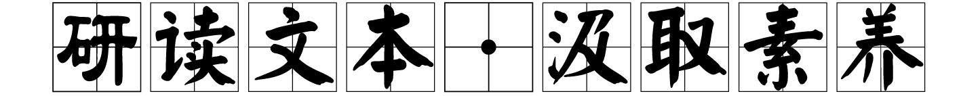
Step One：Pre­reading
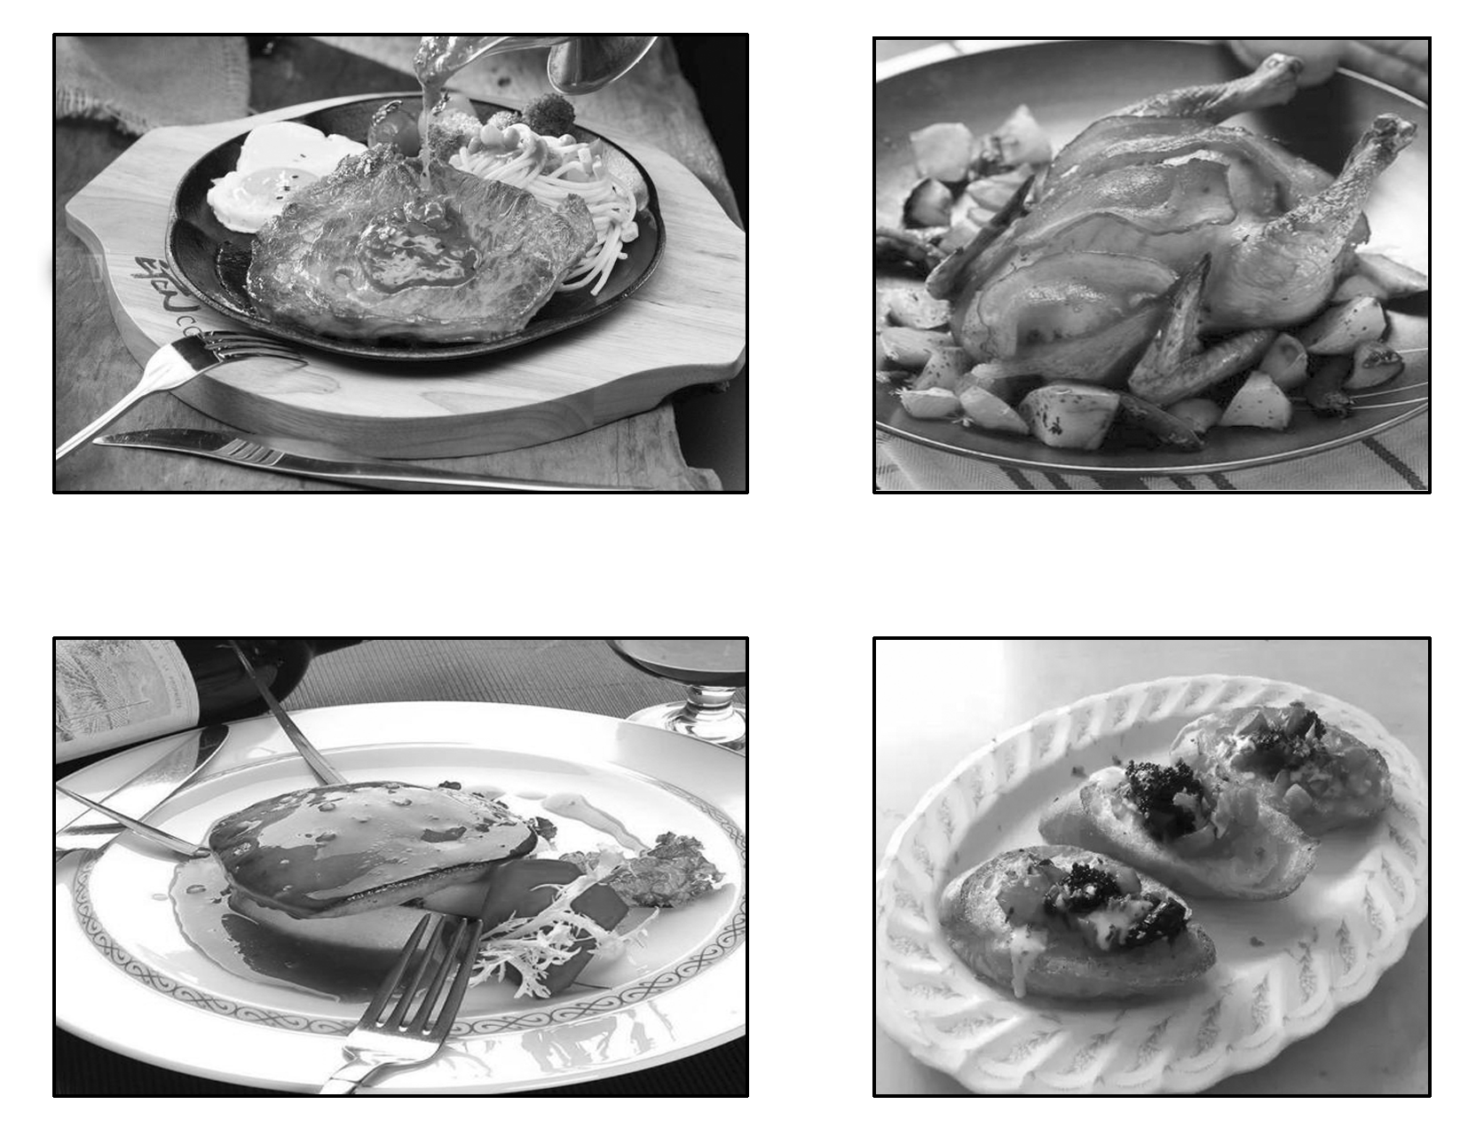
1．Have you ever been to foreign countries? What country do you like best? Why？(Answers may vary.)

2．What kind of food in these countries do you like to eat? Can you list some of the food？(Answers may vary.)

3．Today, we will read an article from a food magazine.Now, read the title and predict what the passage will be about and what food will have an effect on your feelings.(Answers may vary.)

Step Two: While­reading
Ⅰ.Read for the main idea
Read the passage quickly and choose the best answer.
Part 1(Para.1) A．The comfort foods bring bond with happy memories.
Part 2(Para.2) B．Rice pudding cheers me up when I feel unhappy.
Part 3(Paras.3～4) C．The meaning of the comfort food.
Part 4(Para.5) D．The comfort foods are very individual and vary from person to person.
答案：Parts 1～4 BCDA
Ⅱ.Read for details
Read Part 1 and answer the following questions.
1．What's the author's secret recipe?
Rice, milk and sugar, cooked low and slow.
2．Why does the secret recipe light the author up?
Because its perfect combination always enough to lift his spirits, and the smell and the lovely creamy flavour also do the trick.
3．What does the author compare the flavour of the rice pudding to?
The flavour of the rice pudding works like a time machine bringing the author to his happy childhood.
Read Part 2 and give a definition to the comfort food.
4．In its broadest sense, it refers to any food making us feel better.
Read Part 3 and choose the best answer.
5．What will be connected with the positive emotions?
A．The happy childhood.
B．The foods in the family.
C．The feeling of being taken care of.
D．The unlocked memories.
6．How does the comfort food like the chicken soup cheers us up?
A．By relating it to a happy childhood.
B．By creating a tight bond with family members.
C．By providing a mouth­watering food to the family members.
D．By shaping our lives with our own unique experiences.
7．For people who move away from their home country, what will largely determine their comfort food?
A．Some aspects of their own culture.
B．The food that they grow up with.
C．The feeling of relieving from their homesickness.
D．The feeling of happiness and sense of belonging.
答案：5～7 BAD
Read Part 4 and discuss the following question
8．What does the author mean by saying “It isn't just a bowl of noodles or chicken soup.”？
It is not only the food that tastes good but the food for the soul.
Ⅲ.Read for the structure
Read the passage again and fill in the blanks.
Part 1 | •When I am lonely, I have a secret recipe to 1.lift my spirits, which is a combination of foods.The smell and the creamy flavour can function, which often brings me back to 2.my childhood in my grandmother's house.
Part 2 | •My experience with rice pudding illustrates 3.the definition of “comfort food”．In its broadest sense, comfort food refers to any food that makes us 4.feel better, which mainly lies in the 5.associations it calls to mind.
Part 3 | •In fact, comfort foods are highly individual and it varies from person to person, depending on people's experiences.  •What's more, the feeling of happiness and 6.sense of belonging is important for people moving away from their home

以上内容仅为本文档的试下载部分，为可阅读页数的一半内容。如要下载或阅读全文，请访问：https://d.book118.com/728053002037006023

