第一章

1-2-1
幺值。

对例 1-2，取U
B 2

= 110kV ， S
B

= 30MVA ,用准确和近似计算法计算参数标

解：①准确计算法：

选取第二段为基本段，取U = 110kV ， S = 30MVA ，则其余两段的电压基准值分
B 2 B

别为：

U = k U
B1 1 B 2

U

= 10.5 ×110kV = 9.5kV 121
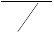110
110
6.6

U = B 2
B3 k
= = 6.6kV

2

电流基准值：

I = S
3U
B
B1
B1

I = S
3U
B
B 2
B 2

I = S
3U
B
B3
B3
= 30 = 1.8kA

= 30 = 0.16kA
3 × 9.5
3 ×110

30
= = 2.62kA
3 × 6.6

各元件的电抗标幺值分别为：

x

= 0.26 × 10.52 × 30

= 0.32

发电机：
1∗ 30 9.52

变压器T ：
1212 30
x = 0.105 × ×

= 0.121

1

输电线路：
2∗ 1102 31.52
x = 0.4 × 80 × 30 = 0.079
3∗1102

变压器T ：
2
1102
x = 0.105 ×
4∗ 152
30
× 1102
= 0.21

电抗器：
x = 0.05 × 6
× 2.62
= 0.4

5∗ 6.6 0.3

电缆线路： x
6∗
= 0.08 × 2.5 ×
30 = 0.14
6.62

电源电动势标幺值：

②近似算法：
E = 11 = 1.16
∗ 9.5

取 S = 30MVA ，各段电压电流基准值分别为：
B

U = 10.5kV ， I =
30
3 ×10.5
B1 B1
= 1.65kA

U = 115kV ， I = 30
3 ×115
B 2 B 2
= 0.15kA

U = 6.3kV ， I = 30
3 × 6.3
B3 B3
= 2.75kA

各元件电抗标幺值：

发电机：

x = 0.26 × 10.52 1∗30
× 30
10.52

= 0.26

变压器T ：
1
x = 0.105 ×
2∗
30

31.5
= 0.1

输电线路：
x = 0.4 × 80 × 30
3∗ 1152
= 0.073

变压器T ：
2
x = 0.105 × 30
4∗15
= 0.21

电抗器：
x = 0.05 × 6
5∗ 6.3
× 2.75
0.3
= 0.44

电缆线路：
x = 0.08 × 2.5 × 30
6∗ 6.32
= 0.151

电源电动势标幺值：

习题 2
E = 11
∗ 10.5
= 1.05

解：（1）准确计算：

U = U = 115kV
B 3 B (110)

U
U =
B3
= 115 ×
220

= 209.1kV

B 2 k
2
121

U
U =
B3
B1 k k
2 1
220 10.5
= 115 × 121 × 242 = 9.1kV

各段的电流基准值为：

I = S
3U
B
B1
B1

I = S
3U
B
B 2
B 2

I = S
3U
B
220
= = 14.0kA
3 × 9.1

220
= = 0.6kA
3 × 209.1

220
= = 1.1kA
3 ×115

B3
B3

各元件的电抗标幺值分别为：

发电机：
x = 0.30×
1∗
10.52
220
×
240 0.8
9.12
= 0.29

变压器T ：
1
10.52
x = 0.14 ×
2∗ 3002
220
×
9.12
= 0.14

输电线路：
220
x = 0.42 × 230 × = 0.49
3∗209.12

变压器T ：
2
2202
x = 0.14 × ×
4∗2802
220

209.12
= 0.12

(2) 近似算法：

U = 10.5kV ， I
B1 B1

220
= = 12.10kA
3 ×10.5

U = 231kV ， I =
B 2 B 2
220
= 0.55kA
3 × 231

U = 121kV ， I =
B 3 B3
220
= 1.05kA
3 ×121

各元件电抗标幺值：

发电机： x
1∗

= 0.30 ×

220
240 / 0.8 = 0.22
220

变压器T ：
1
x = 0.14 ×
2∗

300
= 0.10

输电线路：
x = 0.42 × 230 ×
3∗
220
220 = 0.40
2312

变压器T2：
x = 0.14 ×
4∗

280
= 0.11

习题 3

要点：

以下摘自《国家电网公司电力系统安全稳定计算规定》：

暂态稳定是指电力系统受到大扰动后，各同步电机保持同步运行并过渡到新的或恢复到原来稳态运行方式的能力，通常指保持第一、第二摇摆不失步的功角稳定，是电力系统功角稳定的一种形式。
动态稳定是指电力系统受到小的或大的扰动后，在自动调节和控制装置的作用下，保持较长过程的运行稳定性的能力，通常指电力系统受到扰动后不发生发散振荡或持续的振 荡，是电力系统功角稳定的另一种形式。
两者均是系统受扰动后恢复的能力，均属于功角的稳定，暂态是偏移正常运行状态很 小的暂时的状态，能很快达到正常状态，而动态稳定更多依靠于自动调节和控制装置的作用， 时间较长，波动较大。

U
- I = m
x 0.797
9.45KA ϕ arctan arctan
2 * 6.3
= = ==
= 57.64o

m z 0.943 r 0.505

T = L =

0.797
= 0.005

- a
R 314 * 0.505

I = 0
m|0|

i = 9.45cos(ω t − 27.64o ) − 9.45cos 27.64o e−200t
a
i = 9.45cos(ω t − 27.64o ) − 8.37e−200t
或
a
i = 9.45cos(ω t −147.64o ) − 9.45cos147.64o e−200t
b

i = 9.45cos(ωt + 92.36o ) − 9.45cos92.36o e−200t
c

或：将u 改写成u =
2
a a
* 6.3sin(ωt + α + 90o ) _{，带入公式得}

i = 9.45sin(ωt + 62.36o ) − 9.45sin 62.36o e−200t
a
i = 9.45sin(ωt − 57.64o ) + 9.45sin 57.64o e−200t
b
i = 9.45sin(ωt + 182.36o ) − 9.45sin182.36o e−200t
c
（3）a,b,c 相初始相角分别| α −ϕ |为o , o ， o ，故 a 相瞬时电流最大

i = I
M m
−0.01
I * e0.005
+
m
= 10.73KA

_{由}| α + 90 −ϕ |= 90得α =或

C = I
相

m|0|
sin(α −ϕ
|0|
) − I
m
sin(α −ϕ)

= * 0.18sin(30 + 90 − 30) − 9.45sin(30 + 90 − 57.64) = −8.12KA
2

B 相 c 相

_{取基准值} U = 13.8kV , S = 240MVA ，则
B B
3 *13.8

I = S
3 *U
B
B
B

= 240 = 10.04kA

发电机次暂态电抗标幺值 x''
U 2
= x'' N
S

* B = 0.216

d* d
S / cosϕ U 2
N B

U (%) U 2 S

变压器的电抗标幺值 x = S
* TN
* B = 0.13

T * 100 S U 2
N B

1

电流标幺值 I ''
m*

= 0.13 + 0.216
= 2.89

第二章
    - 一发电机、变压器组的高压侧断路器处于断开状态，发电机空载运行，其端

电压为额定电压。试计算变压器高压侧突然三相短路后短路电流交流分量初始值I ′ 。
m

发电机：S
N
= 200MW ，U
N
= 13.8kV ，cosϕ
N
= 0.9 ，x
d
= 0.92 ，x′ = 0.32 ，x ′
d d
= 0.2

变压器： S
N
= 240MVA ， 220kV /13.8kV ，U
S
(%) = 13

解： 取基准值U
B
= 13.8kV ， S
B
= 240MVA

电流基准值 I =
B
S = 240 = 10.04kA
B
B
3U
3 ×13.8

U % U 2 S 13 13.82 240

则变压器电抗标幺值 x = S
× TN ×
B = × × = 0.13

T ∗ 100 S
N
U 2 100 240 13.82
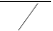B
200
0.9

发电机次暂态电抗标幺值 x ′
= x ′ × U 2
- SB
= 0.2 × 13.82 × 2402 = 0.216

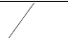次暂态电流标幺值I ′ =
N
S
^{N} cosϕ
N
∗
d∗

1
x + x ′
T ∗ d ∗
d

= 1
0.13 + 0.22
U 2
B

= 2.86
13.82

有名值 I ′ =
2
m

× 2.86×10.04 = 38.05kA

2-3-1
例 2-1 的发电机在短路前处于额定运行状态。
- 分别用 E ′ ， E′ 和 E′ 计算短路电流交流分量I ′， I ′和 I ′ ；
q d

- 计算稳态短路电流I ∞。
•

•
解：（1）U
0
= 1∠0□ ， I
= 1∠ − cos−1 0.85 = 1∠ − 32□

短路前的电动势： E ′ •
=
0
U
0 0

•
•
jx I
+ ′
d 0

•
= 1 + j 0 .167 ∠ − 32 □ = 1 .097 ∠ 7 .4 □

E′ = U
0
- jx′ I
0 d 0
= 1 + j0.269∠ − 32□ = 1.166∠11.3□

I = 1× sin(41.1□
d 0
+ 32□ ) = 0.957

U = 1 × cos 41 .1□ = 0 .754
q 0

E′ = U
q 0 q 0
- x′ I
d d 0

= 0.754 + 0.269× 0.957 = 1.01

E = U
q 0 q 0

x I
d d 0

= 0.754 + 2.26× 0.957 = 2.92

所以有：

I ′ = E′
0

x ′ = 1.097 / 0.167 = 6.57
d

I ′ = E′ x′ = 1.166 / 0.269 = 4.33
0 d

I ′ = E′ x′ = 1.01/ 0.269 = 3.75
d q 0 d

（2） I = E
∞ q 0

/ x = 2.92 / 2.26 = 1.29
d

2-4-1
解:对不计阻尼绕组的情形

⎧U = −r ⋅ i +ψ −ψ

⎪ d = −r ⋅
U
⎪
q
d d q
i + +
ψ ψ
q q d

⎪ U
⎨ψ f
= r ⋅ i +ψ
f f f

= −x ⋅ i + x ⋅ i
⎪
d d d ad f

⎪ ψ
⎪ψ q
= −x ⋅ i
q q

⎪⎩

由定子三相开路：i = i =0 得：
d q
= −x ⋅ i + x ⋅ i
f ad d f f

U =ψ −ψ = x
- dif

d d q

U =ψ +ψ
q q d
ad dt

= x ⋅ i
ad f

U = r ⋅ i +ψ
f0 f f
= r ⋅ i
f f f
- x ⋅ dif
f dt

可以解得： i
f
= − U f
r
0
f
r
- f ⋅t x
⋅ e
f
U
- f0
r
f

带入得：U
d
= x ⋅ U f ad r
f
0
r

- f ⋅t x
⋅ e
f

可得：
U = x
q ad
⋅ (− U f
r
0
f
r
- f ⋅t x
⋅ e
f
U
+ f0 ) = x r ad
f
U
- f0
r
f
⋅ (1− e
r
- f ⋅t x
)
f

⎡U ⎤ ⎡
cosθ −sinθ 1⎤ ⎡U ⎤

⎢Ua ⎥ = ⎢cos(θ −120 ) −sin(θ −120 ) 1⎥ ⎢Ud ⎥
⎢ ⎥ ⎢ ⎥ ⎢ ⎥
b q
0

⎢U
⎣
c
⎥⎦ ⎢⎣cos(θ +120 ) −sin(θ +120 ) 1⎥⎦ ⎢⎣U ⎥⎦

⎡ U ⋅ cos ωt −U ⋅ sin ωt ⎤
⎢ ⋅ cos(ωt −120 ) − U ⋅ sin(ωt −120 ⎥
=
d
q
)
⎢U
⎥
⎢Ud ⋅ cos(ωt +120 ) −Uq ⋅ sin(ωt +120 )⎥
⎣ _{d} _{q} ⎦

U = x
- ad
U
  - f0
x
f

r
- f ⋅t x
⋅ e
f
⋅ cos ωt − x
ad
U
  - f0
r
f
⋅ sin ωt ⋅ (1− e

r
- f ⋅t x
)
f

U = x
- ad
U
  - f0
x
f

U
r
- f ⋅t x
⋅ e
f

r
- f ⋅t
⋅ cos(ωt −120 ) − x
ad
U
  - f0
r
f

U
⋅ sin(ωt −120 ) ⋅ (1− e
r
- f ⋅t x
)
f

r
- f ⋅t

U = x ⋅
- ad
f0 ⋅ e x f
x
f
⋅ cos(ωt + 120 ) − x ⋅
ad
f0 ⋅ sin(ωt + 120 ) ⋅ (1− e
r
f
x f )

2-5,6-1

Δi = ΔEqm (1− e⁻ ^{t}T ′ )
d x + x d
- L
Δ i = 0
q

Δu = x
Gd L

Δu = x
* Δ i
q

* Δi
= 0
= ΔEqm * xL

(1− e⁻ ^{t}

T ′ )

Gq L d
x + x d
d L

2-5,6-2

励磁突增前：

I = UG = 1.31∠7.5
|0| jx
L

E = U
Q G
- Jx
q
I
|0|
= 1.35∠50.3

I = 1.31cos(50.3 − 7.5 )∠50.3 = 0.96∠50.3
q|0|
I = 1.31sin(50.3 − 7.5 )∠(50.3 − 90 ) = 0.89∠ − 39.3
q|0|

而 E =U
q|0| G
+jx I
d d

jx I
q q
= 1.84∠50.3

由ΔU f |0| = 0.1U f |0| 得： ΔEqm= 0.184

Δi = ΔE (1− e⁻ ^{t}T ′ ) = 0.136(1− e− t )
qm
0.26
d x + x d
d q
Δi = 0
q
Δi = 0.136(1− e− t 0.26 )cos t

a

Δu =
ΔE * x
qm L

(1− e⁻

^{t}T ′ ) = 0.027(1− e− t 0.26 )

Gq x + x d
d L
Δu = 0
Gd
Δu = −0.027(1− e− t 0.26 )sin t
Ga

设励磁突增前:
U =
Ga|0|
i =
2
cos(t+15 )
*1.31cos(t+ 7.5 )
2

i
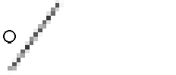
则有： ª
2

= i
a|0|
a|0|

+ Δi =
a

*1.31cos(t+ 7.5 ) + 0.136(1− e− t 0.26 )cos t

U = cos(t+15 ) − 0.027(1− e− t 0.26 )sin t
2
Ga

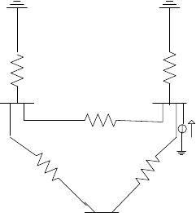
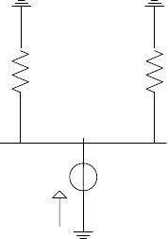
第三章3-1-1

j0.15

j0.1
j0.075 x1

j0.075

-1

j0.1 j0.1 -1

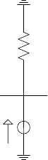
x2
-1

X 1 = 1 1
1
+
+ j0.15 = j
13 ;
60

j0.2 j0.1
X =
1
+ j0.15 = j
39 ;

2 1 + 1

700

j 13 j0.075
60

- 1

I =

Δ I •
39 j 700

= •
= − j17.9487

j0.075

= − j4.6154;

I
G1 f
13 j + j0.075
60
13
j

Δ I •
G 2
= Δ I •
G3
= 0.5 •
f
I
60
13 j + j0.075
60
= − j6.6667;

I ''
G1
= 4.6154 × 60
= 15.2268

I ''
3 *10.5
G 2
= 6.6667 × 60 = 21.9944

3-1-2
3 *10.5

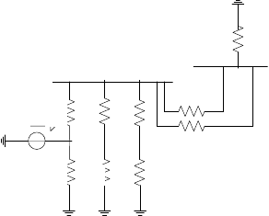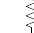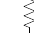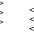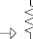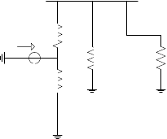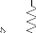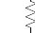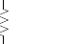
x7
X3+x4+x6
-1
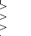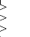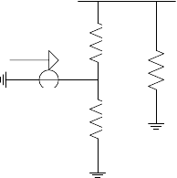

X 8 = 1 1
1
+
= 0.17826;

0.5( X
1
- X )
2
1
X + 0.5( X + X
7 3 4
- X )
6

X 9 = 1 1
+
= 0.2565; I
f
= 1 = 3.89856
X

X X + X
1 2 8

X + X
9

1000

I = I ⋅ 8 2 ⋅ = 57.758
3 × 21

G1 f
X + X + X
1 2 2

X

+ 0.5( X + X

  - X ) X

1000
3 × 21

I = I
G 2 G 3
= 0.5I
f
⋅
0.5( X
1
7 3 4
+ X ) + 0.5( X + X
2 3
6 ⋅ 1
+ X ) X + X + X
4 6 1 2 2
- = 10.34

3-1-3

(1)

E­
l

气

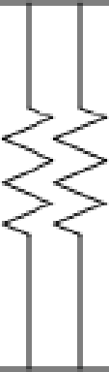
X2 X2

x3
X3

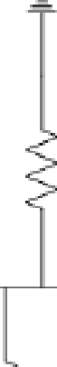
骂 E3'

屯

- 1 屯 令亨 X , 2

500kV

35kV


斗i 及 －1

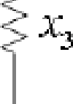， 》上厂 三
夕 r －－ 气
<乌

lI|
- 1


口马 上上 还 ？
丙 , X

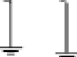
＿

S = 1000MVA, 平均额定电压为基准值；
B
1000

X = 250 × 0.302 ×
1
1000

5252
= 0.274;

X = 0.14 ×
2

720
= 0.194

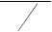
X = 0.217 × 1000 = 0.3255
3 600
0.9
1000
X = 0.12 × = 1
4 120
X = 1 = 0.1794
5 1 1
+
X X + X
1 2 3

X = X + X
8 5 2
= 0.3734

X 6 = 1
+
X
3
1
1
X + X
2 5
= 0.174

i'' =
1 1000
5.75;i'' 5.75 158.084；
3 × 21
= = × =

f X f
6
X

1000
3 × 21

Δi'' = i''
8 = 3.072; Δi''
= 3.072 × = 84.46

2

Δi''
3
f

= i''
f
X + X
3 8

X
3
X + X
3 8
2 f

- X 1
X + X + X
1 2 3

= 0.9247; Δi''
3 f

= 0.9247 × 1000 = 25.423;

Δi''
= i''
X 3 ⋅
X + X
2 3
3 × 21
= 1.7533; Δi''
= 1.7533 × 1000 = 48.203;

系 f X + X
3 8
X + X + X 系
1 2 3

- f2点短路
3 × 21

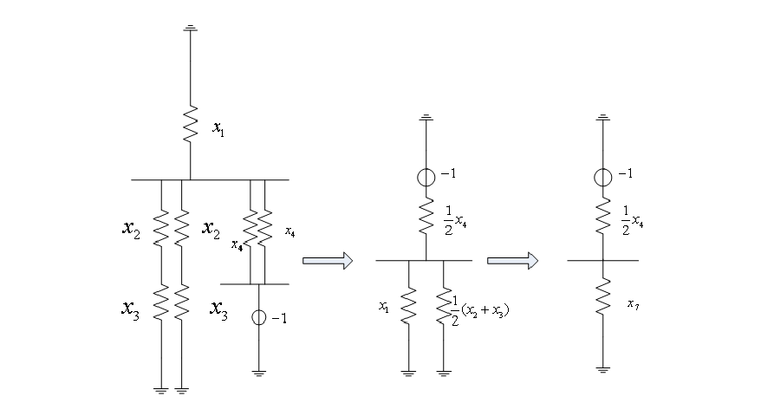
X = 1 = 0.1333

7 1 +
X
1
1
0.（5 X
2

+ X ）
3

i'' =
1 1000
1.579;i'' 1.579 24.639；
3 × 21
= = × =

f X + 0.5X f
7 4

X

1000
3 × 21

i'' = i''
= 0.5i''
1 = 0.4053; Δi''
= 0.4053 × = 6.324

2 3 f
X + 0.5( X
1 2

X
+ X )
3
G 2

1000
3 × 21

i''
B
= 0.5i''
f
1
X + 0.5( X
1 2
+ X )
3
= 0.7684; Δi''
G 3
= 0.7684 × = 11.99

3-2-1
应用例 3-4 已求得Y 矩阵因子计算 3-1-1,并与已有的计算结果比较。

⎡− j26.6666 j10 j10 ⎤
解： Y = ⎢ j10 − j33.3333 j10 ⎥
⎢ ⎥
⎣⎢ j10 j10 − j20.0⎥⎦
_{因子表中内容为}[j0.0375 − 0.375 − 0.375 j0.033803 − 0.464791 j0.101420]

以上内容仅为本文档的试下载部分，为可阅读页数的一半内容。如要下载或阅读全文，请访问：https://d.book118.com/746044010032010102

