外研版七年级下册英语期中综合素质评价试卷
(120分钟 120分)
第一部分 听力(共20 分)

一、听句子，选择与所听句子相符的图片。每个句子读一遍(每小题1 分，共5 分)
1. A.  B. 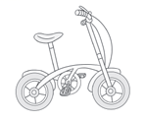 C. 
2. A. 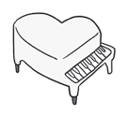 B.  C. 
3. A.  B. 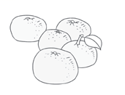 C. 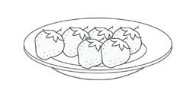
4. A. 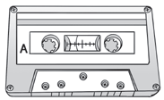 B. 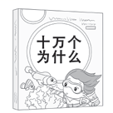 C. 
5. A. 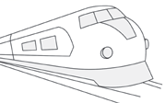 B. 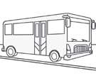 C. 
答案 | 1—5
二、听句子，选择恰当的答语。每个句子读一遍(每小题1 分，共5 分)
6. A. They are 100 yuan. B. In my father’s car. C. It is red.
7. A. It’s a book. B. It’s yellow. C. It’s Lingling’s.
8. A. Yes, I am. B. No, I can’t. C. Yes, I do.
9. A. No, it isn’t. B. Yes, it is. C. Yes, it will.
10. A. It’s seven. B. It’s next to the post office.
C. She is a doctor.
答案 | 6—10
三、听两段长对话，选择正确答案，每段对话读两遍(每小题1 分，共5 分)
听第一段对话，完成第11-12 小题
11. What are they going to do this evening?
A. See a movie. B. Play tennis. C. Do their homework.
12. What time will they meet at the gate of the theatre?
A. At 6:45. B. At 7:00. C. At 6:30.
听第二段对话，完成第13-15 小题
13. Where is Lucy from?
A. New York. B. London. C. Canada.
14. Who can swim?
A. Lucy. B. Lucy’s father. C. Lucy’s mother.
15. What does Lucy’s mother do?
A. A doctor. B. A worker. C. A teacher.
答案 | 11—15

四、听短文，选择正确答案，短文读两遍(每小题1 分，共5 分)
16. Where are they?
A. At the bus station. B. At the train station.
C. At the supermarket
17. What are they going to do?
A. See a film. B. Do shopping. C. Do some sightseeing.
18. Which place are the Greens going to visit?
A. Sanya. B. Mount Tai. C. Disneyland.
19. Who will go to Sanya?
A. Mr. Zhao and his wife. B. Mr. Liu. C. The Greens.
20. What does Mr. Liu’s daughter like?
A. Monkeys. B. Animals. C. Mickey Mouse.
答案 | 16—20
第二部分 笔试 (共100 分)

五、单项选择(每小题1 分，共10 分)
21. Tom can play __________ piano, but he can’t play __________ football.
A. the; the B. /; / C. the; / D. /; the
22. New York is a modern city. It is famous __________ its large shopping centres and beautiful night views.
A. of B. as C. for D. from
23.— My pen is lost. May I use __________?
— Sure.
A. you B. your C. yours D. yourself
24. This T-shirt is nice and the price is not too __________.
A. expensive B. high C. cheap D. low
25. After I finish __________ my homework, I can go out to play football.
A. write B. to write C. writing D. writes
26.—__________ do you take?
— Size M.
A. What size B. How much C. How many D. What colour
27. — Do you like the pink dress?
— Yes, I do. But I need to __________ first before I take it.
A. try it on B. pick it up C. look it up D. turn it on
28. I don’t know how to talk with the foreigners (外国人) because I can speak only __________ English.
A. little B. a little C. few D. a few
29. Linda goes to school early, __________ she’s never late for school.
A. because B. but C. so D. or
30. — Will you join in the discussion (讨论) tomorrow?
—__________. Maybe I’ll have a meeting.
A. Well, I’m not sure B. That’ll be great
C. Sure, I will D. Don’t be silly
答案 | 21—25 26—30
六、完形填空(每小题1 分，共10 分)
Peter is a middle school student. He lives in a big city. There is an old people’s home next to his 31 . At weekends he always goes there with his 32 — Alice, Sam, Tony, Betty and Henry. They try to 33 the old people happy.
Peter and Alice like 34 . Peter can play the piano and Alice can sing for the old people. Tony and Sam are 35 telling stories. They often tell stories to the old
people. Sometimes Tony and Sam 36 some storybooks to the old people. Betty and Henry enjoy sports. They like 37 table tennis with the old people. They also talk to the old people and watch films 38 them. The old people look very happy.
When people ask Peter and his friends, “ 39 do you always go to the old people’s home?” They always say, “It is 40 and meaningful (有意义的).”
31. A. shop B. home C. classroom D. library
32. A. teachers B. cousins C. customers D. friends
33. A. make B. want C. call D. see
34. A. history B. PE C. music D. science
35. A. good at B. busy with C. careful with D. different from
36. A. spell B. take C. write D. watch
37. A. finding B. sending C. drawing D. playing
38. A. with B. on C. for D. from
39. A. What B. When C. Why D. How
40. A. traditional B. interesting C. difficult D. dangerous
答案 | 31—35 36—40
七、阅读理解(每小题1 分，共20 分)

A
Swimmers Wanted (招聘)
Can you swim? Do you like kids? Can you help them with swimming on weekends? Come and join us. Call Mr. White at 530-6342.
Chess Club
Do you like to play chess (下棋)? Do you want to play chess well? Mr. Smith can teach you. You can come here every Sunday evening.
Tel:828-4940
Add: Room 102 in School Building
Let’s Learn French (法语)
Can you speak French? Do you want to learn French? Join the French

Club now.
Time: 8:00 a.m-11:00 a.m. from Monday to Friday. Call Peter at 569-5348.
Musicians (音乐家) Wanted
Boys and girls, are you music lovers? Can you sing or dance? Can you play the drums? Welcome to our Star Rock Band!
Please call Victor at 758-4612 or send an e-mail to music@126. com.
41. What can Mr. Smith teach you to do?
A. To swim. B. To play chess.
C. To sing. D. To speak French.
42. Mary can swim well and she wants to find a job. Who can she call?
A. Mr. Smith. B. Peter. C. Mr. White. D. Victor.
43. Jerry joins the Chess Club. When does he go to the club?
A. Every day. B. From Monday to Friday.
C. Every Sunday morning. D. Every Sunday evening.
44. You love music and you want to join the Star Rock Band. How can you contact (联系) with them?
A. Call them at 828-4940.
B. Go to the Room 102 in School Building.
C. Call Peter at 569-5348.
D. Send an e-mail to music@126. com.
45. Sandra can speak French well. She is good with kids and teaches them French. She works from Monday to Friday. Where does she work?
A. In the Star Rock Band. B. In the French Club.
C. In the Chess Club. D. In the Swimming Club.
答案 | 41—45
B
Today is Sunday. Jenny is making a plan for her birthday next week.

Tuesday
On Tuesday, I want to have breakfast with my family. My father plans to take us to Feast by car to have pizza and pasta. Yes, it is my favorite Italian restaurant.

Wednesday
I plan to go shopping with my friend Lily. She can help me look for a birthday dress and a present. I want to go to a lot of stores.

Thursday
On Thursday, we want to make a birthday cake, and some cookies, too. I plan to put the cookies into some colorful boxes. So my friends can eat them at my party.

Friday
It is a big day. I invite some good friends to come to my house to join in the party. We have lunch first. Then in the afternoon, I plan to take them to watch a great movie.
46. Feast is the name of a ________.
A. man B. car C. restaurant D. movie
47. What does Jenny plan to do on Wednesday?
A. Buy things. B. Make cookies.
C. Watch a movie. D. Have pizza and pasta.
48. When is Jenny’s birthday party?
A. On Tuesday. B. On Thursday.
C. On Friday. D. On Sunday.
49. What does the underlined word “invite” mean in Chinese?
A. 想念 B. 邀请 C. 想象 D. 支持
50. What’s the best title of the passage?
A. A Nice Sunday B. A Very Happy Month
C. Jenny’s Big Birthday Party D. Jenny’s Birthday Week Plan
答案 | 46—50
C
Welcome to Jiefang Street. It’s a very busy street. On the right of the street is the History Museum. That is a very big building. It is a great place to learn Chinese
history. Opposite the museum is the Bank of China. Every day lots of people come here and save their money or get their money. Next to the bank is a post office. There is a bus stop behind the post office.
A big supermarket is on the left of Jiefang Street. It is Huaxia Supermarket. There are all kinds of nice things in it. If you want to buy something to eat, you can go to the first floor. On the second floor, there are some TV sets, and CD players. If you want to buy nice clothes, you can go to the third floor. And on the fourth floor is some furniture (家具).
If you are tired, you can go to the Queen Coffee House and have a rest. The coffee house is between the supermarket and the bookstore.
51. The underlined word “It” in Paragraph 1 refers to (指的是) _________.
A. Jiefang Street B. Chinese history
C. the History Museum D. the Bank of China
52. Where is the Bank of China?
A. It’s next to the bus stop. B. It’s next to the post office.
C. It’s opposite the supermarket. D. It’s behind Jiefang Street.
53. What can’t you buy from Huaxia Supermarket?
A. Delicious food. B. Nice furniture.
C. Beautiful clothes. D. Interesting books.
54. If Susan needs a rest, which place can she go to?
A. Huaxia Supermarket. B. The bookstore.
C. Jiefang Street. D. The Queen Coffee House.
55. You may read this passage in .
A. a guidebook B. a science report
C. a storybook D. a cartoon book
答案 | 41—45
D
Life in the future will be different from life today. Many changes will happen. But what will the changes be?
The population (人口) is growing fast. There will be more people in the world and most of them will live longer than people live now.
Computers will be much smaller and more useful, and there will be at least one in every home. And computer studies will be one of the important subjects in school then. People will work fewer hours than they do now and they will have more free time for sports, watching TV and travelling. Travelling will be much cheaper and easier.
There will be changes in our food, too. More land will be used for building new towns and houses for all the people. Then there will be less room for cows and sheep, so meat will be more expensive. Maybe no one will eat it every day. Instead (相反), they will eat more fruit and vegetables. Maybe people will be healthier. Work in the future will be different, too. Robots will do dangerous and hard work. Because of this, many people will not have enough (足够的) work to do. This will be a problem.
56. In the future there will be _________.
A. no fruit B. more people
C. less vegetables D. more meat
57. Every family will have at least a ________ in the future.
A.  B. 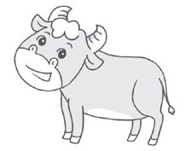 C.  D. 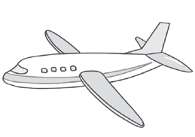
58. In the future people won’t have to ________.
A. work long hours B. work fast
C. walk on foot D. sleep
59. What is the correct structure of the passage? (P1=Paragraph 1)
A. 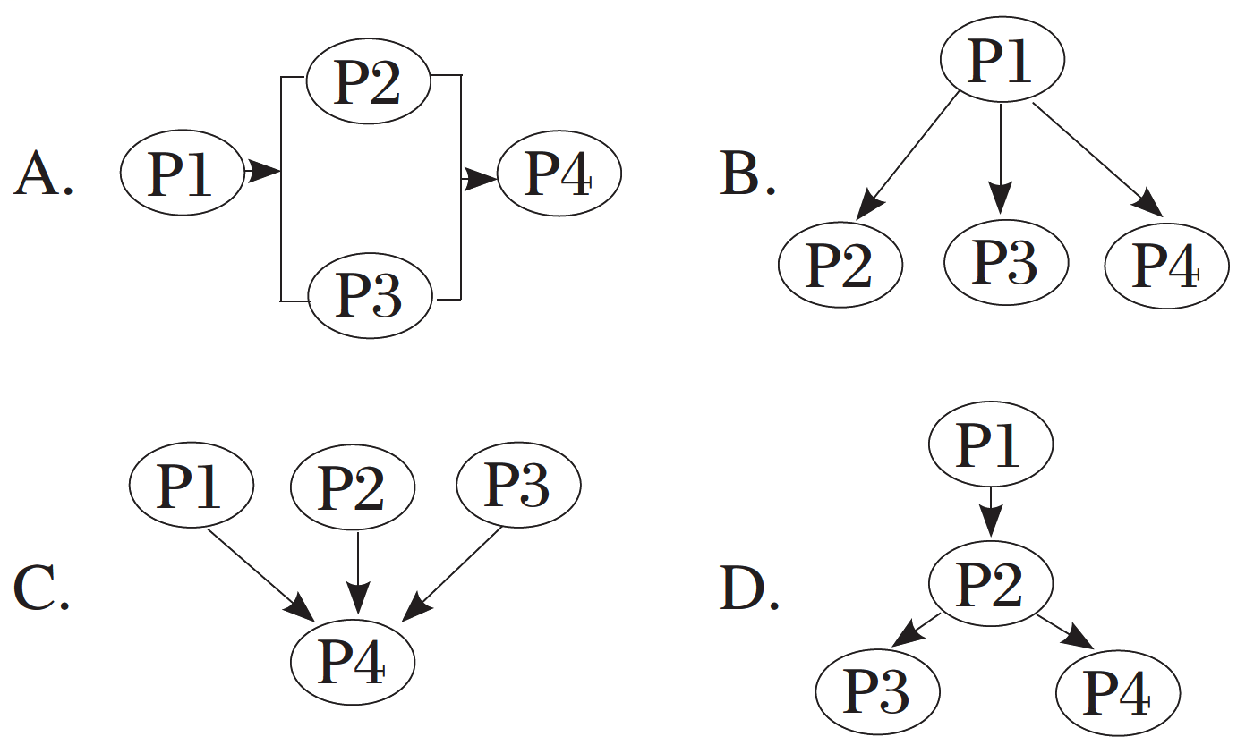 B.
C. D.
60. According to (根据) the passage, one big problem in the future is that ________.
A. many people won’t have to work
B. many people will not be able to find work
C. people will have to work hard
D. people will have to work for a long time
答案 | 56—60

八、词汇运用 (每小题1 分，共10 分)
A) 根据句意及汉语提示完成句子。
61. We will _____________ (收到) an important letter in ten days.
62. This weekend, we will volunteer to collect _____________ (垃圾) in the park.
63. David, don’t put your things _____________ (到处).
64. This suitcase is one of the _____________ (游客). Maybe he is looking for it everywhere.
65. Tests can check the students’ _____________ (水平) and we must correct the mistakes.
B）用括号内所给单词的适当形式填空。
66. I can’t find my eraser. Can I use _____________ (you), Mike?
67. There are _____________ (hundred) of books in our school library.
68. The fans are looking forward to _____________ (see) their favourite stars.
69. Tom is a clever boy. He always answers the teacher’s questions _____________ (easy).
70. Come and buy fruit and vegetables at our great _____________ (sell).

九、情景交际(每小题2 分，共10 分)
根据对话内容，从方框内选择恰当的句子将对话补充完整(选项中有两项是多余的)。
A: Come and look in the lost and found box. 71
以上内容仅为本文档的试下载部分，为可阅读页数的一半内容。如要下载或阅读全文，请访问：https://d.book118.com/756120123021010054

