2008年南通市初中毕业、升学考试
英 语
共140分。考试时间120分钟。考试结束，将本试卷和答题卡一并交回。
第I卷(选择题共85分)
注意事项：
1．答第1卷前，考生务必将自己的姓名、考试号、科目名称用2B铅笔涂写在答题卡上．
2．每小题选出答案后，用2B铅笔把答题卡上对应题目的答案标号涂黑。如需改动，
用橡皮擦干净后，再选涂其它答案。不能答在试卷上。
一、单项选择(本题共20小题；每小题1分，共20分)
1. Tom has _______ honest face, and, in fact, he never tells lies or plays tricks on others.
A. a B. an C. the D. 不填
2. Come on, children. Help yourselves to some _______ if you like.
A. fish and chicken B. fishes and chicken
C. fish and chickens D. fishes and chickens
3. In my class some students love music, ____ are fond of drawing and ____ enjoy reading.
A. some; the other B. others; the other C. others; the others D. some; others
4. --How about seeing the film Roman Holiday tonight?
--_______.
A. Thank you B. Never mind C. Good idea D. Not at all
5. -- I'd like some... Er,...excuse me, how is the word "j-u-i-c-e" pronounced?
-- It's_______.
--Thanks. I'd like some juice, please.
A. /dʒu:s/ B. /dʒu:zs/ C. /ju:s/ D. / ju:rs/
6. --How soon shall we start the bicycle trip?
--_______.
A. In three day's B. After three days
C. In three days' time D. After three day's time
7. --_______day it is!
-- Let's go out and have a picnic!
A. How cold B. How nice C. What a cloudy D. What a lovely
8. -- Bob, we are moving this weekend.
-- Congratulations! I _______ you happiness in your new flat.
A. wish B. hope C. expect D. send
9. -- Can I help you?
-- Well, I'm afraid the bag is _______heavy for you, but thanks all the same.
A. so B. too C. quite D. very
10. All my favourite story books _______ by my mother before my last exams.
A. hid B. have hidden C. were hiding D. were hidden
11. I can_______ swim _______ skate. I'm going to have some training next year.
A. either; or B. neither; nor C. both; and D. not only; but also
12. -- Can you tell me _______?
-- Two weeks ago.
A. when you bought the toys B. who did you buy the toys for
C. how much the toys cost D. how many toys did you buy
13. --Tomorrow will be Father's Day. What will you do for your father?
-- I will say "I love you, Daddy" as soon as he _______ up.
A. will wake B. is waking C. wakes D. woke
14. -- Will you please show me how to do the role-play exercise?
-- Sure. Now let me tell you _______ first.
A. which to do B. how to do C. when to do D. what to do
15. Do you believe some special dogs can do things _______ man?
A. as good as B. as well as C. as soon as D. as careful as
16. Don't_______ while the bus is moving, or you may hurt yourself and even someone outside.
A. get on B. get up C. get off D. get in
17. Yesterday morning Tom hurried to class ____ his schoolbooks, so he had to share Mary's.
A. without B. for C. with D: past
18. -- I came to your home yesterday afternoon, but nobody was in.
-- Oh, we _______ some shopping in the supermarket.
A. have done B. did C. were doing D. are doing
19. Ann's house is ten miles away from the school and nobody else in her class lives _____.
A. far B. farther C. farthest D. the furthest
20. -- May I park my car here, Sir?
-- _______ . You may park it over there.
A. Yes, you may B. Yes, you can C. No, you needn't D. No, you mustn't
二、完形填空(本题共25小题；每小题1分，满分25分)
请认真阅读下列短文，从短文后各题所给的A、B、C、D四个选项中，选出最佳选项，并在答题卡上将该项涂黑。
A
You must have hobbies of your own. Are you interested in our hobbies? OK, now let me tell you something about my 21 hobbies.
My hobby is collecting stamps. When I began, I tried to collect the stamps of all 22 ,but there were too many, so now I collect only US and Chinese ones. I 23 a lot of friends in the US, so I often get letters from them. Some of my stamps are very pretty and some are unusual. We can 24 a lot from stamps, such as the history of the countries.
My younger brother, Peter, likes 25 trains. He often goes to the station nearby and watches them carefully. 26 a train goes through the station, he writes down its name and number.
My sister's hobby is sewing. She has no sewing machine, 27 she doesn't have to
worry about it -- she can use my mother's. She makes most of her 28 herself, and when
I tear (撕坏) my shirt or my trousers, I always ask her for 29 .
My father has a hobby, too. It is walking the 30. Every morning and afternoon he
goes walking with his handsome dog.
21. A. classmates' B. teachers' C. friends' D. family's
22. A. countries B. colours C. prices D. sizes
23. A. miss B. have C. meet D. remember
24. A. choose B. make C. learn D. take
25. A. collecting B. taking C. making D. watching
26. A. When B. Although C. Until D. Because
27. A. and B. so C. but D. or
28. A. decisions B. plans C. cakes D. clothes
29. A. money B. help C. pity D. advice
30. A. cat B. sheep C. dog D. horse
B
One day, a poor boy, who was selling newspapers from door to door in order to pay for his schooling, found he had only ten cents left, and he was 31 . He decided to ask for a meal at the next house. However, he changed his mind when a young woman opened the door.
Instead of a 32 he asked for a drink of water. But as he looked so hungry, she 33 him a large glass of milk. He drank it, and then asked, "How much do I owe (欠) you?"
"My mother teaches me never to accept money for any 34 ," she replied, "so you
don't owe me anything."
Many years later, the 35 became seriously ill. Then she was sent to a famous 36
in London.
Dr Kelly was called in to study her illness. When he 37 the name of the town which
she came 38 a strange light filled his eyes,
As soon as he walked into her room, he recognized (认出) her at once.
He did his best to 39 her. Then he gave special attention to her. After some time she
got 40 .
Dr Kelly asked for her final bill 41 she left hospital. He looked at it, then 42 something on it before it was sent to her. She was 43 to open it, for she believed it would take the rest of her life to 44 for it all. But finally she opened it, and read these words on it:
Paid in full with one glass of, 45.
31. A. thirsty B. hungry C. tired D. excited
32. A. tomato B. sweet C. meal D. banana
33. A. ordered B. brought C. sold D. found
34. A. business B. fitness C. illness D. kindness
35. A, woman B. boy C. man D. mother
36. A. college B. hotel C. dentist's D. hospital
37. A. called B. asked C. heard D. told
38. A. to B. from C. by D. through
39. A. save B. examine C. feed D. protect
40. A. back B. away C. well D. worse
41. A. before B. after C. when D. because
42. A. remembered B. said C. noticed D. wrote
43. A. excited B. surprised C. afraid D. ready
44. A. wait B. care C. search D. pay
45. A. water B. milk C. coffee D. juice
三、阅读理解(本题共20小题；每小题2分，满分40分)
请认真阅读下列短文，从短文后各题所给的A、B、C、D
四个选项中，选出最佳选项，并在答题卡上将该项涂黑。
A
The Guinness(吉尼斯)World Records Museum
Address ： 329 Alamo Plaza,San Antonio，TX 78205
Open Hours： From September to May 10 am to 7 pm Sunday through Thursday
10 am to 10 pm Friday and Saturday
From June to August 10 am to 10 pm Sunday through Thursday
10 am to Midnight Friday and Saturday
Adult Single(成人单票)：$14．95 for 2 attractions(吸引人的展览)，$18．95 for any 4
attractions，$22．95 for all attractions
Child(4-12)Single：$8．95 for 2 attractions，$11．95 for any 4 attractions，$14．95 for all attractions
In the museum you can enter the different exhibition halls you see below．In each of these halls you can see the world records of different kinds．Sometimes you may get a chance to do something so that you can know better how a record was set(创造)．
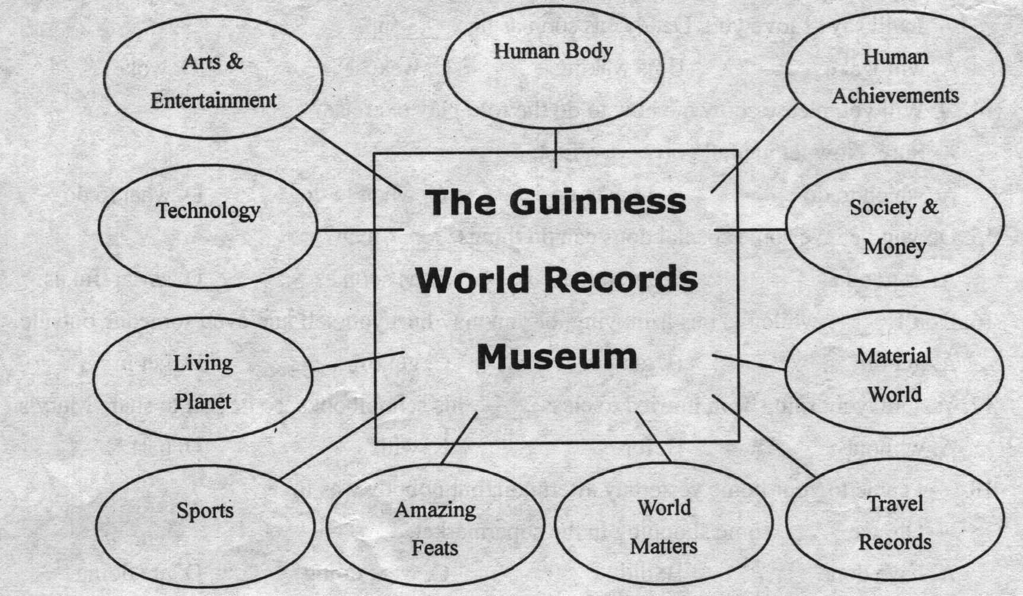
46. On a Sunday in October, you may stay in the museum until _______.
A. 7.00 pm B. 8.00 pm C. 9.00 pm D. 10.00 pm
47. From the advertisement we can learn that there are ____visitors to the museum on Fridays
and Saturdays in summer.
A. no B. some C. fewer D. more
48. A 10-year-old girl and her mother will visit two attractions. How much will they pay?
A. $14.95. B. $17.90. C. $23.90. D. $29.90.
49. If you want to see the smallest picture in the world, which exhibition hall will you visit?
A. Society & Money. B. Arts & Entertainment.
C. World Matters. D. Material World.
50. According to (根据) the advertisement, sometimes visitors to the museum _______.
A. will surely meet one who set a record B. may set a world record of their own
C. can experience how a record was set D. may see someone setting a record
B
Your junior high school years are coming to an end. After the big exam, most of you will go on to study in a senior (高级) high school. What are you expecting from senior high? Let's hear some Teens readers talk about it.
Zhou Zhijie, 15, from Shanghai:
I have heard that although Senior 3 is a hard year, Senior I and Senior 2 are less stressful. I hope there'll be time then to enjoy sports. There will be plenty to see: the Tennis Masters Cup will be held in Shanghai, and of course there is the 2008 Beijing Olympics. I am going to do something for it and I'm sure I'll really enjoy it.
Jin Xin, 16, from Harbin, Heilongjiang:
I really enjoy science. I visit many science exhibitions. I am interested in UFOs too. I'm crazy about making model planes, although I'm not very good at it because I don't really have enough scientific knowledge. I'll be learning more science in senior high. In a word, sometime in the future I'm going to build an excellent model plane!
Wang Yaling, 15, from Xiamen, Fujian:
I hope I can be taller in senior high school. I am only 155 cm. Many people grow faster in senior high and I hope I will too. I want to be 162 cm. But I'm not so sure about that, since most girls in my family don't grow any taller than 160 cm. I hope I'm different.
Zhang Fang, 15, from Puyang, Henan:
I expect that I'll make more friends in senior high. I study in a middle school in the country. Most of my classmates live nearby. In senior high, I'll meet different people from different areas.
I hope I can learn new things from them.
51. It seems that ________has a special interest in sports.
A. Zhou Zhijie B. Jin Xin C. Wang Yaling D. Zhang Fang
52. Jin Xin believes that it needs ______to make an excellent model plane.
A. a quite long time B. a lot of scientific knowledge
C. knowledge of UFOs D. help from senior high teachers
53. Wang Yaling and Zhang Fang_______.
A. are from one city B. have a similar dream
C. are the same age D. have a similar problem
54. The underlined word "stressful" in the first talk probably means "making one feel _______.
A. busy and nervous B. free and easy
C. unsuccessful and sad D. safe and happy
55. The students in the passage are talking about_______.
A. their hobbies B. their experiences C. their schools D. their wishes
C
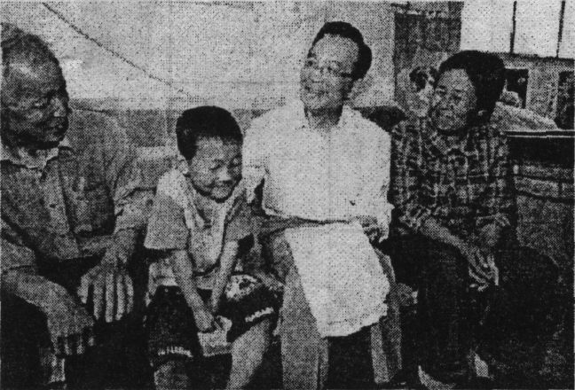
BEIJING -- Chinese Premier Wen Jiabao has visited
the "left-behind" (留守) children whose parents are
working in cities before Children's Day.
During a visit to northwest China's Shaanxi
Province, Wen visited the home of Yang Saike, a
primary school boy in a village of Xingping City.
Yang, whose parents were working in Fujian,
以上内容仅为本文档的试下载部分，为可阅读页数的一半内容。如要下载或阅读全文，请访问：https://d.book118.com/778012030115006041

