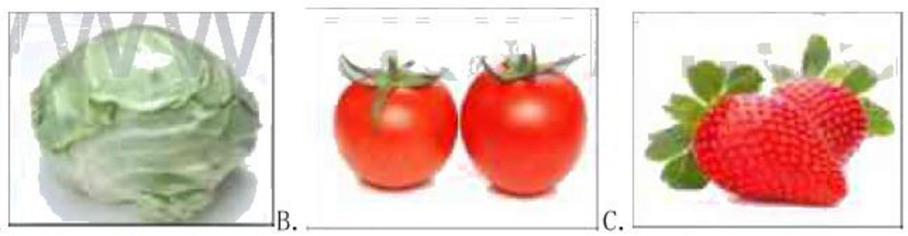
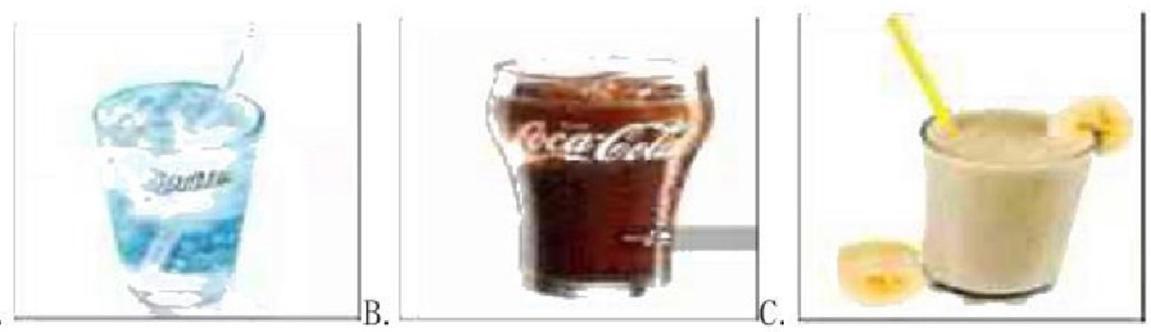
祥城中学2022-2023 学年度第一学期期末教学质量调研
八年级英语试题

注意事项：

1.本试卷分第 I 卷和第Ⅱ卷两部分，第 I 卷为选择题，60 分；第Ⅱ卷为非选择题，
60分；共120分。考试时间为120分钟(含听力20分钟)。共12页。

2.答题前，考生务必用0.5毫米黑色墨水签字笔将本人的姓名、考号写在答题卡要求
的相应位置。

3.答第Ⅱ卷时，必须使用0.5毫米黑色墨水签字笔书写。若需改动，先划掉原来的答
案，然后再写上新的答案。不准使用涂改液、胶带纸、修正带，否则，答案无效。

第 I 卷 (选择题 共60分)

一、听力选择 (共15小题，计15分)

(一)请听下面五个句子，然后从每小题所给的A 、B 、C 三个选项中选出一张正确图片。
听完每个句子后，你有10秒钟的时间来回答有关小题和阅读下一小题。每个句子听一遍。

1.A.

2.A.

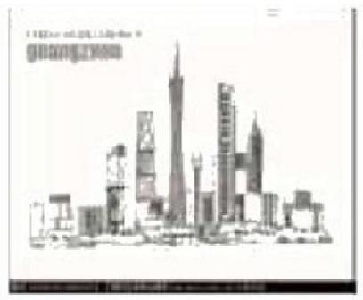
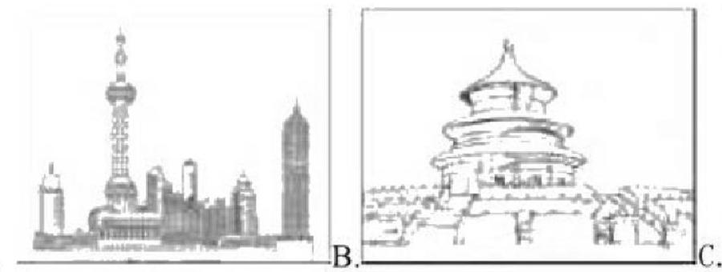
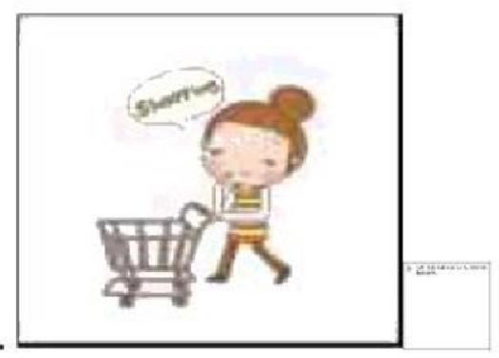
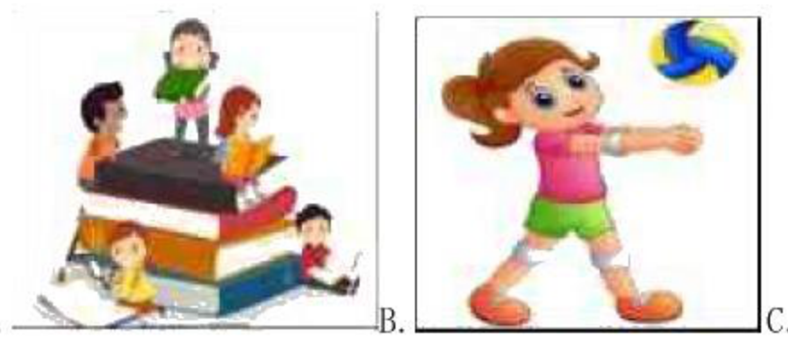
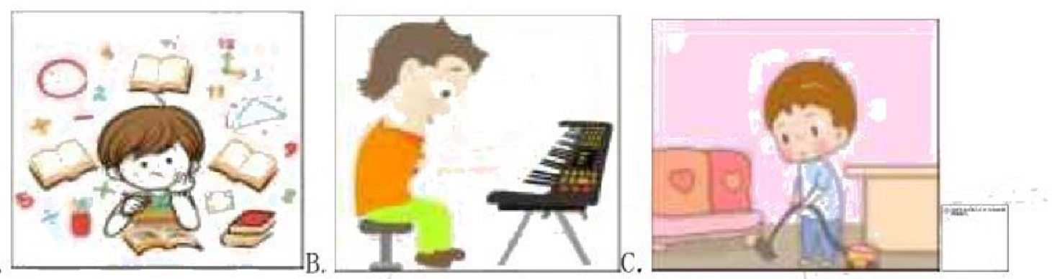

3.A.

4.A.

5..A.

(二)请听录音中五段对话。每段对话后有一个小题，从题中所给的A、B、C三个选项中，
选出能回答所给问题的最佳答案。 (每段对话读两遍)

6.Why does the woman have sore eyes?

A.Because she reads a lot of books.

B.Because she watches TV too much.

C.Because she often looks at her mobile phone.

7.Who is going to watch the videos next weekend?

A.Bob's sister. B.Bob's father C.Bob's mother

8.What does the boy give his mother for New Year's Day?

A.A card. B.Some flowers. C.A handbag.
9.How long does it take the boy to go to school?

A.Five minutes. B.Ten minutes C.Fifteen minutes.

10.Which one(哪一个)is the heaviest of the three schoolbags?

A.The green one. B.The red one. C.The black one.

(三)请听录音中两段较长的对话。每段对话后有几个小题，从题中所给的A、B、C 三个
选项中，选出能回答所给问题的最佳答案。 (每段对话读两遍)

听第一段对话，回答第11至第12两个小题。
11.How many days will the snow last ?

A.2 days.B.3 days C.4 days.

12.What is Laura going to do this Saturday?

A.Watch movies. B.Do homework.C.Meet friends.

听第二段对话，回答第13至第15三个小题。

13.Where does Kelly want to live in the future?
A.In Beijing.B.In Shanghai. C.In Changsha.

14.What's Kelly going to be in the future?
A.A doctor. B.A reporter. C.A writer. 
15.What will Kelly do if she has time and money in the future?

A.Eat delicious food. B.Make more friends.C.Travel around China.
二、阅读理解(共15 小题，计45分)

阅读下面短文，从每小题A、B、C、D四个选项中，选出能回答所提问题或完成所给句
子的最佳答案。

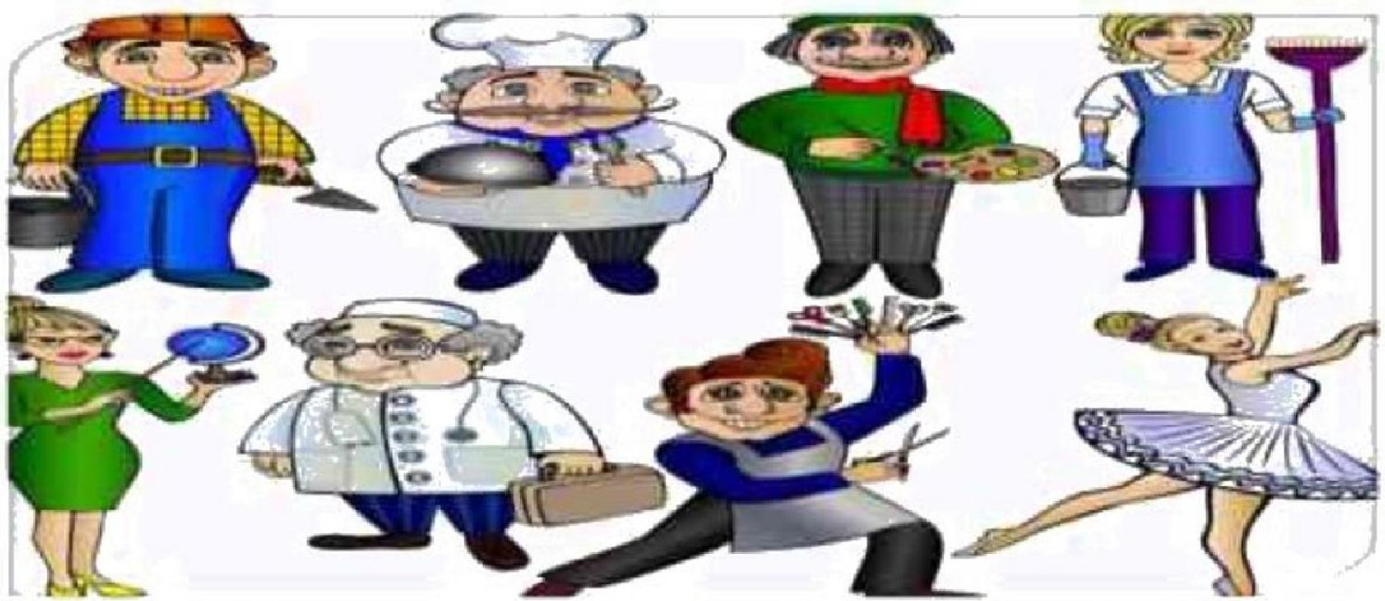

Suhjext: The finire
Date: 0s/117P PM
Tat Ae16Zcn
Fmm: Toly whoecamn
Hrlo,Je!
At school thit week,we tlked aboun our goab and ambitians Same tiudenn didn't imrw whs they wadrd tn be in the furune But 1 wrote thut I wanted tin be an Englnh techer 1 lmpe io le t ped tacher,like Mr Wu He make ui wuk wrp hind.but he t nee.Hi does ae sle of fun!He like tling joke after das
Do ywu know whe you are ging ao ke when you're oldet.Jue?Muyhe yiu'l be budrhilpiyer.Jmny told me tha you are a wery goud player.

Suhjext: The umme
Date: 08/12 E19 PM
Te:Tidyeuhes.camcn
Fromm: w162m
Hi.Toby
Jmry is nghr!I'm much taller this year,and 1 love piarng bakethall.Bur I don't think
I'm ming tn be a baukethall pltyer when I'm older.
Tin wrrl I wrotr a lrio to Hdlon.She evn alvre ro pouple in the newpaper.I aked her wtat I wrill he when I grow up.She sad thur I mmghr be a pod actur.Mayhe I will bea famou morie sar someday.Or mayhe I'l be:TV actot in the furure.I will be famous wben
I'm oder,but I wil always be your fnend!

16.What does Toby want to be in the future?

A.A basketball player.
B.A singer.

C.A famous writer.

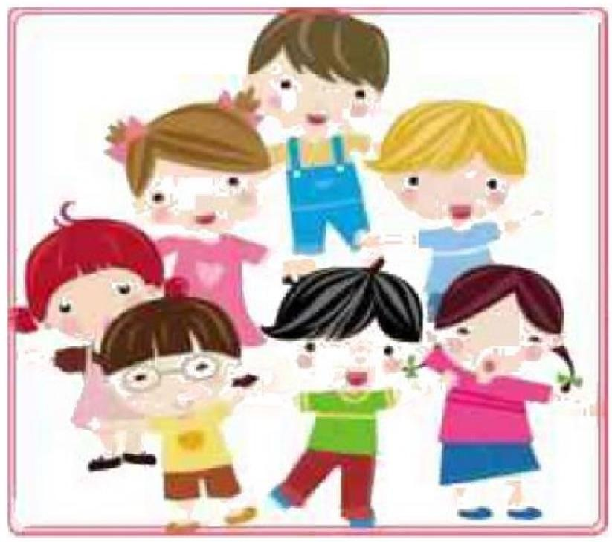

D.A teacher.

17.What does Mr.Wu like doing after class?
A.Playing basketball.

B.Telling jokes.

C.Reading books.
D.Drinking tea

18.Joe is much this year.

A.heavier.B.stronger.C.taller.D.healthier.

19.Helen said that Joe would be a/an in the future.

A.actor.

B.basketball
C.teacher.

D.cook.

player

B

Bill wondered why he didn't have many friends.The reason was that he was always taking,
never giving.

One day Bill told Peter,"Td like to give a party on Saturday.I'dlike you to come and bring Martha.Too.""Thanks,Bill.We'd be happy to come.""Perhaps you'd like to bring your violin. You and Martha sing well together.I'm sure everyone will want you to sing for us."That was
how Bill began to plan his party.Next,he

asked another friend,Betty,to bring a cake.
"You make the best cake in the world,Betty,

and I like to eat your cake better than have

one from the bakery."Bill invited a few other

friends to come to his party.He didn't forget

to ask something from each one of them.He

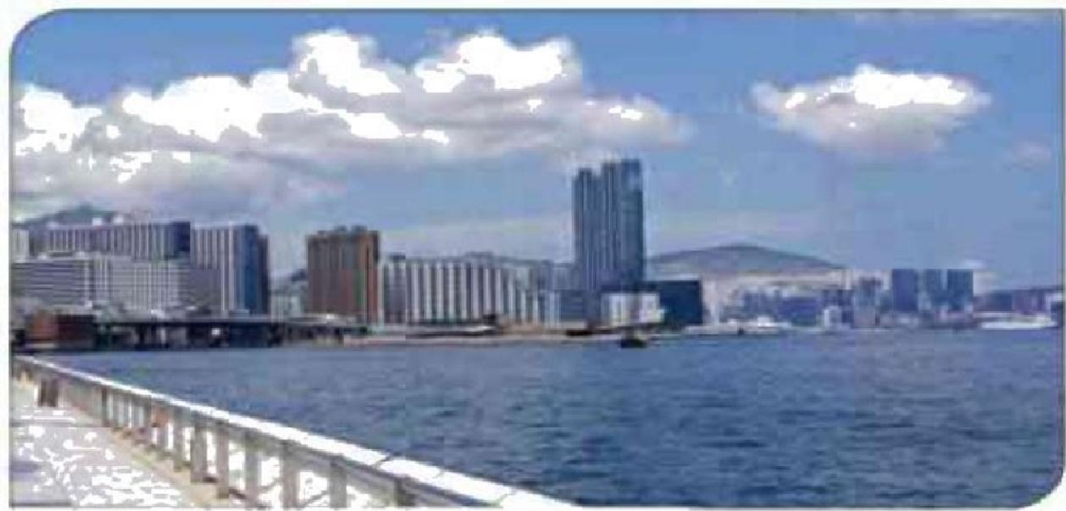

even asked Jim and Mary Smith to let him give the party at their house!They agreed.The party was a big success.However,as the guests were leaving,they said "Thank you."to Peter and Martha for the music,Betty for the cake,the Smiths for the use of the house and to others for
their hard work.To Bill they just said,"Thanks for the invitation."

20.The party was held

A.at Peter's house B.at Bill's house

C.at Betty's house D.at Jim and Mary's house
21.Which of the following is NOT true?

A.Mary Smith sang well.

B.Betty made the best cake.

C.Peter played the violin well.

D.The others did hard work for the party.
22.Bill to give the party.

A.tried his best B.only invited some friends

C.did nothingD.did everything

23.From the story,we can see Bill was

A.a warm-hearted man B.good at making friends
C.a welcomed friendD.a selfish man

C

If you go to Hong Kong by air,you will arrive at Hong Kong International Airport.Because there was not enough land,this was built(被建造)out into the sea.It is in the part of Hong Kong
called Kowloon.Kowloon is one of the two big cities in Hong Kong.

The other city
is Hong Kong itself.

It is on an island.

You can get there by

ship or through a tunnel under the sea.Much of Hong Kong is farmland and mountains.

The population of Hong Kong is over six million.Chinese and English are spoken by many people.Clothes,computers,radios and TVs are made in Hong Kong.Yon can buy all kinds of
things,such as watches and computers there.

People from all over the world travel to Hong Kong every year.You can watch dog-racing or motor-racing.Some places are quiet and beautiful.When you are hot and tired,there are small cool gardens to rest in.There are also a lot of hotels to live in.Hong Kong is also a good place for wonderful Chinese food.You can enjoy many kinds of food,for example,fish,vegetables
and the famous Beijing duck.There is certainly a lot to see and to do in Hong Kong.

24.The airport was built out into the sea because
A.it's near the sea

B.there was not enough land
C.planes arrive safely

D.it would be good

25.Kowloon is
A.the name of an airport
B.the name of a country

C.a big city under the sea

D.one of the two big cities in HongKong

26.What's the Chinese meaning of the underlined word"tunnel"in Para.2?

A. 岔路 B. 山道 C. 隧道 D. 栈道

27.What's the main idea of Para.4?

A.Hong Kong is a good place for traveling.
B.Beijing Duck is famous.

C.Dog-racing is interesting
D.Chinese food is famous.

D

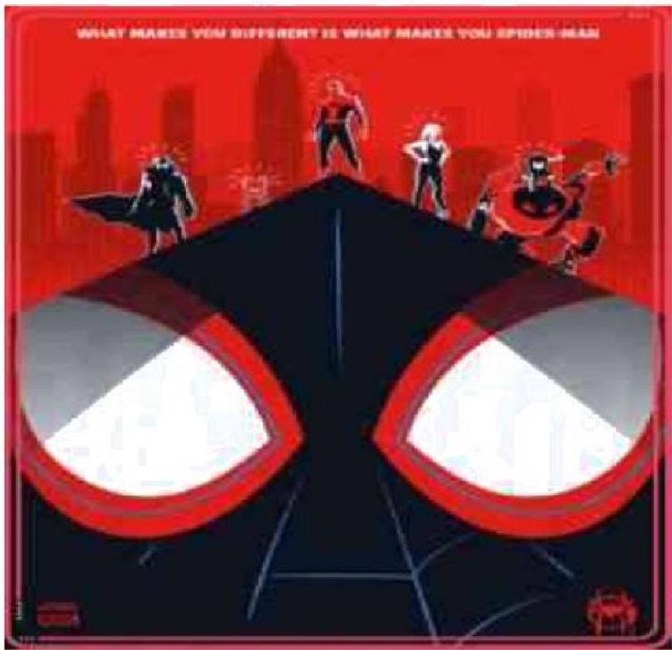

Do you think you know all about Spider-man?The movie Spider—man:Into he
Spider-Verse(《 蜘蛛侠：平行宇宙》)

came out in Chinese mainland
theaters on Dec.21 in 2018.It

shows us a different side of this

superhero.

One highlight(亮点)of the film
is that there is more than one

Spider-Man.In addition to Peter
Parker,there is another younger

Spider—man.

He is a high school student who Parker trains to be a superhero.There is also
Spider-Gwen,a female(女性的)superhero,as well as Spider-Ham,he's a pig.

These characters live in different parallel universes(平行宇宙)and experience different
things.For example,Peter Parker is in his 40s in this film.He is divorced(离婚的)and

suffers from depression(抑郁).Miles Morales finds it hard to fit in at school because he has an African-American father and a Puerto Rican mother.People treat him like an outcast(被
排斥的人).However,no matter how different these characters are,they have the same

purpose-to work together and fight against Kingpin,the movie's villain.They travel to each
other's universe by using a special machine.

Variety said that the movie creates "an inclusive (包容的)world where pretty much

anybody can be the superhero…even you".The movie has a very inspiring message—all of
us can be superheroes in our own lives if we are brave enough.

28.What do we know about the movie Spider-man:Into the Spider-verse?
A.It will come out on Dec.21 in the US.

B.It will come out in Chinese mainland first.

C.The movie has attracted many people.

D.There is more than one Spider-man in the movie.
29.Paragraph 4 is written to

A.describe how different characters live different lives in the film
B.introduce new characters in the movie

C.describe how Spider-Ham lived a hard life

D.describe how the characters meet each other

30.What can we learn from the movie?

A.The spider heroes don't like to work together.

B.Everyone can be superheroes in their own lives as long as they are brave enough.
C.People in Miles Morales'school don't like him because of his ability.

D.Miles Morales is a primary school student.

2020-2021 学年度第一学期期末教学质量调研
八年级英语试题

第 I 卷选择题答案(60分 )

题号 | 1 | 2 | 3 | 4 | 5 | 6 | 7 | 8 | 9 | 10
答案
题号 | 11 | 12 | 13 | 14 | 15 | 16 | 17 | 18 | 19 | 20
答案
题号 | 21 | 22 | 23 | 24 | 25 | 26 | 27 | 28 | 29 | 30
答案

第Ⅱ卷 (非选择题 共60分)

三、听力填词(共5小题，计10分)

请听下面一段短文。根据所听到的内容，写出可以填入下表1~5空格处的适当单词，每

空限填一词。 (短文读两遍)

*The man's wife's birthday is on1.10th.
*The man washed the vegetables,cut them up,and 2. them in a bowl
*It was 3.to make the fish gravy.
*The man bought a chocolate cake at the 4._.
*The man found that cooking wasn't the hardest part,but doingthe 5.was!
四、 单词拼写与运用(共8小题，计8分)

根据句意完成已给出首字母或汉语提示的单词，使补全后的句子意思通顺，语法正确。

1.It's raining now.Tom,don't forget to take anu with you.

2.Andy's home is c to his office,so heoften goes to work on foot.
3.Christmas Day is a t festival in westerncountries.

4.The air in the countryside is very f .I like living there.
3.Miss White waited Ben for a long time,but he didn't (出现).
6.To plant trees,we (挖土)some holes first yesterday.
7.Mark asked Sue to play ping-pong,but Sue (拒绝).
8.Be careful!Don't make (错误)when you have the math test.
五、 语法填空 ( 共10 小题，计10分)
阅读下面短文，在空白处填1 个适当的单词或括号内单词的正确形式(请将答案写在题后
的横线上)。

Tara and Nelly were 1. (good 的最高级) friends.They sat next to each other in
class.They were both tall,2. long dark hair.Everyone thought they were sisters.

One day,Tara couldn't go to school because she had a bad cold.So Nelly had to
3. (sit)on her own in class,but not for long.

"Good morning,everybody.Today we 4. (have)a new pupil.Her name is Sarah." said theteacher,Mr.Brown."Sit next to Nelly,Sarah.Nelly can 5. (tell)you all about
your new school."

Nelly and Sarah soon became friends.They were both very good at dancing and Mr Brown

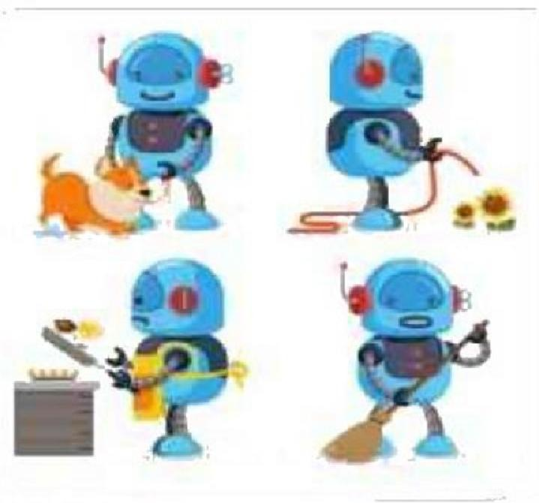

asked them 6. (make)up a dance for the school show.

After a few days,Tara was 7. (good
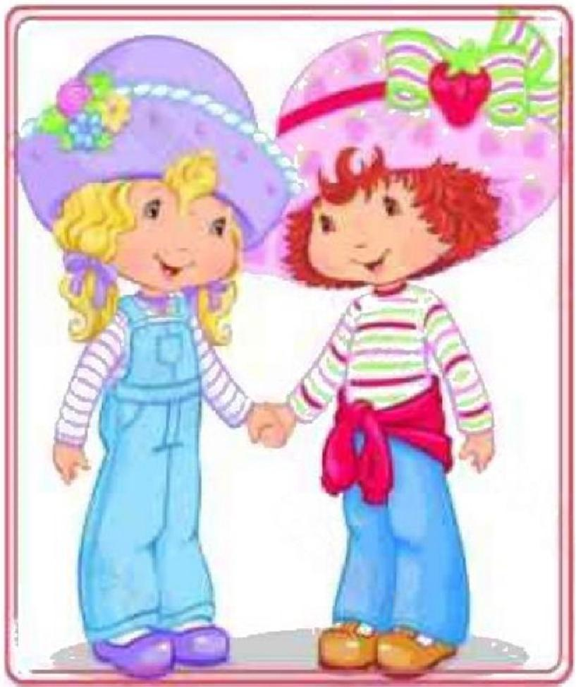

"Sarah has a great idea,"said Tara.

的比较级)and came back to school.

"So what are we going to 8. (do)for the school show,Nelly?"
asked Tara.

Nellywent very red."Well,I'm dancing
with Sarah."said Nelly.

Tara walked off and 9. (give) Sarah a nasty look.Tara and Nelly didn't talk
toeach other all morning.

Later that day, Nelly found Tara10. (talk) to Sarah in the
playground.They were bothSmiling.

"She wants to ask Mr Brown if the three of us can make up a dance for the school show."
"So are we friends again?"asked Nelly happily.

“Sure!”said Tara smiling.

六 、完型填空 (共7小题，计7分)

阅读短文，从方框中选择适当的词填空，每空一词。方框中有两个词为多余选项。

solve, move, more, hundred,same,computers ,animals,learn,smarter
People began to make robots about several 1. years ago.In the past,some of the early ones looked like 2. or humans.However,they couldn't talk and were pretty dumb.They worked like clocks and did the 3. things over
and over again.

Now modern robots don't always look like people.Some are like big machines,others are nothing but long arms attached to boxy bodies.However,modern robots are smart.Some can 4. problems on their own.Their brains are 5. and their eyes are sensors(传
感器).Motors (发动机)help them6. .

In the future,robots will learn from their mistakes more than they do now.They will be 7. .It's possible that we will have robot judges,robot household workers,and robot
factory workers.Robots will help people to do more things.

七、阅读表达 (共5小题，计10分)
阅读短文，根据要求回答所给问题。

Life in the future will be different from life today.Between then and now many changes
will happen.But what will the changes be?

The population is growing fast.There will be many people in the world and most of them
will live longer than people live now.

Computers will be much smaller and more useful,and there will be at least one in every home.And computer studies will be one of theimportant subjects in schools then.People will work fewer hours than they do now and they will have more free time for sports,watching TV and traveling. Traveling will be much cheaper and easier. And many more people will go to
other countries for holidays.

There will be changes in our food,too.More land will be used for building new towns and houses for all the people.Then there will be less room for cows and sheep,so meat will be moreexpensive.Maybe no one will eat it every day.Instead,they eat more fruits and vegetables. Maybe people will be healthier.Work in the future will be different,too.Robots will do dangerous and hard work.Because of this,many people will not have enough work to do.This
will be a problem.

1.How many computers will there be in every home in the future?
2.What will more land be used for in the future?

以上内容仅为本文档的试下载部分，为可阅读页数的一半内容。如要下载或阅读全文，请访问：https://d.book118.com/785240040203011111

