

常用法兰规格尺寸表

Document number【980KGB-6898YT-769T8CB-246UT-18GG08】

常用法兰规格尺寸表(国标、美标、日标)

GB9119，2—88 GB9119，2—88
10kg=

16kg=

公称 螺 螺 公称 法 螺

in
通径法兰 栓 栓 螺栓 法兰通径
兰 螺栓 螺栓 栓

法兰厚度

㎡㎏
 | 外径 | 孔  距 | 直  径 | 孔数 | 厚度 | 外  径 | 孔距 | 直径 | 孔  数
3/
8 | DN10 50 | 60 | 14 | 4 | 14 | DN10 90 | 60 | 14 | 4 | 14
1/
 | DN15 59 | 65 | 14 | 4 | 14 | DN15 95 | 65 | 14 | 4 | 14
2
3/
 | DN20 105 | 75 | 14 | 4 | 16 | DN20 105 | 75 | 14 | 4 | 16
4
1 | DN25 115 | 85 | 14 | 4 | 16 | DN25 115 | 85 | 14 | 4 | 16
11/
 | DN32 140 | 100 | 18 | 4 | 18 | DN32 140 | 100 | 18 | 4 | 18
4
11/
 | DN40 150 | 110 | 18 | 4 | 18 | DN40 150 | 110 | 18 | 4 | 18
2
2 | DN50 165 | 125 | 18 | 4 | 20 | DN50 165 | 125 | 18 | 4 | 20

21/ | DN65 | 185 | 145 | 18 | 4 | 20 | DN65 | 185 | 145 | 18 | 4 | 20
2
3 | DN80 | 200 | 160 | 18 | 8 | 20 | DN80 | 200 | 160 | 18 | 8 | 20
31/ | DN10 |  |  |  |  |  | DN10
 |  | 220 | 180 | 18 | 8 | 22 |  | 220 | 180 | 18 | 8 | 22
2 | 0 |  |  |  |  |  | 0
 | DN12 |  |  |  |  |  | DN12
4 |  | 250 | 210 | 18 | 8 | 22 |  | 250 | 210 | 18 | 8 | 22
 | 5 |  |  |  |  |  | 5
 | DN15 |  |  |  |  |  | DN15
5 |  | 285 | 240 | 22 | 8 | 24 |  | 285 | 240 | 22 | 8 | 24
 | 0 |  |  |  |  |  | 0
 | DN20 |  |  |  |  |  | DN20
6 |  | 340 | 295 | 22 | 8 | 24 |  | 340 | 295 | 22 | 8 | 26
 | 0 |  |  |  |  |  | 0
 | DN25 |  |  |  |  |  | DN25
8 |  | 395 | 350 | 22 | 12 | 26 |  | 405 | 355 | 26 | 12 | 29
 | 0 |  |  |  |  |  | 0
 | DN30 |  |  |  |  |  | DN30
10 |  | 445 | 400 | 22 | 12 | 28 |  | 460 | 410 | 26 | 12 | 32
 | 0 |  |  |  |  |  | 0
 | DN35 |  |  |  |  |  | DN35
12 |  | 505 | 460 | 22 | 16 | 30 |  | 520 | 470 | 26 | 16 | 35
 | 0 |  |  |  |  |  | 0
 | DN40 |  |  |  |  |  | DN40
14 |  | 565 | 515 | 26 | 16 | 32 |  | 580 | 525 | 30 | 16 | 38
 | 0 |  |  |  |  |  | 0

 | DN45 |  |  |  |  |  | DN45
16 |  | 615 | 565 | 26 | 20 | 35 |  | 640 | 585 | 30 | 20 | 42
 | 0 |  |  |  |  |  | 0
 | DN50 |  |  |  |  |  | DN50
18 |  | 670 | 620 | 26 | 20 | 38 |  | 715 | 650 | 33 | 20 | 46
 | 0 |  |  |  |  |  | 0
20 | DN60 | 780 | 725 | 26 | 20 | 42 | DN60 | 840 | 770 | 36 | 20 | 52
 | 0 |  |  |  |  |  | 0
24

JIS 标准 JIS 标准

10kg= 16kg=
JIS 标准

20kg=

公称 螺 螺 公称 法 螺
公称 法
螺 螺 螺

in 法兰 栓 栓 螺栓 法兰 兰 螺栓 螺栓 栓通径 通径
外径 孔 直 孔数 厚度 外 孔距 直径 孔距 径 径 数
兰
法兰厚度 通径
外

径
栓 栓 栓
法兰厚度
孔 直 孔

距 径 数

3/
DN10 DN10
8

1/
DN15 DN15
2

3/
DN20 DN20
4

DN10

DN15

DN20

1 | DN25 |  |  |  |  |  | DN25 |  |  |  |  |  | DN25
11/ | DN32 |  |  |  |  |  | DN32 |  |  |  |  |  | DN32
4
11/
 | DN40 | 140 | 105 | 19 | 4 | 16 | DN40 | 140 | 105 | 19 | 4 | 16 | DN40 | 140 | 105 | 19 | 4 | 18
2
2 | DN50 | 155 | 120 | 19 | 4 | 16 | DN50 | 155 | 120 | 19 | 8 | 16 | DN50 | 155 | 120 | 19 | 8 | 18
21/
 | DN65 | 175 | 140 | 19 | 4 | 18 | DN65 | 175 | 140 | 19 | 8 | 18 | DN65 | 175 | 140 | 19 | 8 | 20
2
3 | DN80 | 185 | 150 | 19 | 8 | 18 | DN80 | 200 | , | 22 | 8 | 20 | DN80 | 200 | 160 | 23 | 8 | 22
 |  |  |  |  |  |  |  |  | 160
31/
 | DN90 | 195 | 160 | 19 | 8 | 18 | DN90 | 210 | 170 | 22 | 8 | 20 | DN90 | 210 | 170 | 23 | 8 | 24
2
 | DN10 |  |  |  |  |  | DN10

4
210 | 175 | 19 | 8 | 18
250 | 210 | 23 | 8 | 20
280 | 240 | 23 | 8 | 22

0

DN12
5
5

DN15
6
0

8 DN20 330 290 23 12

0

DN12 5
225 | 185 | 22 | 8 | 22 | DN100 225 | 185 | 23 | 8 | 24
270 | 225 | 25 | 8 | 22 | DN125 270 | 225 | 25 | 8 | 26
305 | 260 | 25 | 12 | 24 | DN150 305 | 260 | 25 | 12 | 28
350 | 305 | 25 | 12 | 26 | DN200 350 | 305 | 25 | 12 | 30

DN15 0

22 DN20

 | 0 |  |  |  |  |  | 0
10 | DN25 | 400 | 355 | 25 | 12 | 24 | DN25 | 430 | 380 | 29 | 12 | 28 | DN250 430 | 380 | 29 | 12 | 34
 | 0 |  |  |  |  |  | 0
 | DN30 |  |  |  |  |  | DN30
12 |  | 445 | 400 | 25 | 16 | 24 |  | 480 | 430 | 29 | 16 | 30 | DN300 480 | 430 | 29 | 16 | 36
 | 0 |  |  |  |  |  | 0
 | DN35 |  |  |  |  |  | DN35
14 |  | 490 | 445 | 25 | 16 | 26 |  | 540 | 480 | 32 | 16 | 34 | DN350 540 | 480 | 33 | 16 | 40
 | 0 |  |  |  |  |  | 0
 | DN40 |  |  |  |  |  | DN40
16 |  | 560 | 510 | 27 | 16 | 28 |  | 605 | 540 | 35 | 16 | 38 | DN400 605 | 540 | 33 | 16 | 46
 | 0 |  |  |  |  |  | 0
 | DN45 |  |  |  |  |  | DN45
18 |  |  |  |  |  |  |  |  |  |  |  |  | DN450
 | 0 |  |  |  |  |  | 0
20 | DN50 |  |  |  |  |  | DN50 |  |  |  |  |  | DN500
 | 0 |  |  |  |  |  | 0
 | DN60 |  |  |  |  |  | DN60
24 | 0 |  |  |  |  |  | 0 |  |  |  |  |  | DN600

ANSI 标准 125 型

in 公称 10kg=
ANSI 标准 150 型

公称 16kg=
ANSI 标准 300 型

公称 20kg=

 | 通径 |  | 螺 | 螺 |  |  | 通径 | 法 |  | 螺 |  | 通径 | 法 | 螺 | 螺 | 螺
 |  | 法兰  外径 | 栓  孔 | 栓  直 | 螺栓  孔数 | 法兰  厚度 |  | 兰  外 | 螺栓 螺栓  孔距 直径 | 栓  孔 | 法兰厚度 |  | 兰  外 | 栓  孔 | 栓  直 | 栓  孔 | 法兰厚度
 |  |  | 距 | 径 |  |  |  | 径 |  | 数 |  |  | 径 | 距 | 径 | 数
3/  8 | DN10 |  |  |  |  |  | DN10 |  |  |  |  | DN10
1/  2 | DN15 |  |  |  |  |  | DN15 |  |  |  |  | DN15
3/  4 | DN20 |  |  |  |  |  | DN20 |  |  |  |  | DN20
1 | DN25 |  |  |  |  |  | DN25 |  |  |  |  | DN25
11/ | DN32 |  |  |  |  |  | DN32 |  |  |  |  | DN32
4
11/ | DN40 | 127 |  | 16 | 4 |  | DN40 | 127 | 16 | 4 |  | DN40 | 156 |  | 19 | 4 | 18
2
2 | DN50 | 152 |  | 19 | 4 |  | DN50 | 152 | 19 | 4 |  | DN50 | 165 | 127 | 22 | 8 | 18
21/ | DN65 | 178 |  | 19 | 4 |  | DN65 | 178 | 19 | 4 |  | DN65 | 190 | 149 | 22 | 8 | 20
2
3 | DN80 | 190 |  | 19 | 4 |  | DN80 | 190 | 19 | 4 |  | DN80 | 210 | 168 | 22 | 8 | 22

 | DN10 |  |  |  |  |  | DN10
4 |  | 229 |  | 19 | 8 |  |  | 229 |  | 19 | 8 |  | DN100 254 | 200 | 22 | 8 | 24
 | 0 |  |  |  |  |  | 0
 | DN12 |  |  |  |  |  | DN12
5 |  | 254 |  | 22 | 8 |  |  | 254 |  | 22 | 8 |  | DN125 279 | 235 | 22 | 8 | 26
 | 5 |  |  |  |  |  | 5
6 | DN15 | 279 |  | 22 | 8 |  | DN15 | 279 |  | 22 | 8 |  | DN150 318 | 270 | 2 | 12 | 28
 | 0 |  |  |  |  |  | 0 |  |  |  |  |  |  |  | 2
 | DN20 |  |  |  |  |  | DN20
8 | 0 | 343 |  | 22 | 8 |  | 0 | 343 |  | 22 | 8 |  | DN200 381 | 330 | 25 | 12 | 30
 | DN25 |  |  |  |  |  | DN25
10 |  | 406 |  | 25 | 12 |  |  | 406 |  | 25 | 12 |  | DN250 444 |  | 29 | 16 | 34
 | 0 |  |  |  |  |  | 0
 | DN30 |  |  |  |  |  | DN30
12 |  | 483 | 432 | 25 | 12 |  |  | 483 | 432 | 25 | 12 |  | DN300 521 | 451 | 32 | 16 | 36
 | 0 |  |  |  |  |  | 0
 | DN35 |  |  |  |  |  | DN35
14 |  | 533 |  | 29 | 12 | 35 |  | 533 |  | 29 | 12 | 35 | DN350 584 |  | 32 | 20 | 40
 | 0 |  |  |  |  |  | 0
 | DN40 |  |  |  |  |  | DN40 |  |  |  |  |  |  |  | 3
16 |  | 597 |  | 29 | 16 |  |  | 597 |  | 29 | 16 |  | DN400 648 |  |  | 20 | 46
 | 0 |  |  |  |  |  | 0 |  |  |  |  |  |  |  | 5
 | DN45 |  |  |  |  |  | DN45
18 | 0 |  |  |  |  |  | 0 |  |  |  |  |  | DN450

20 DN50
DN50
DN500

0 0

DN60
24
0
DN60 0

DN600

国标(GB9112—9131—88)管法兰连接尺寸表


公称 公 称 压 力 PN MPa(bar)

通径 |  | /(6) |  |  |  | (10) |  |  |  | (16) |  |  |  | (25) |  |  |  | (20)
DNmm | D | K | n | L | D | K | n | L | D | K | n | L | D | K | n | L | D | K | n | L
40  50 | 130  140 | 100  110 |  | 14 | 150  165 | 110  125 | 4 |  | 150  165 | 110  125 | 4 |  | 150  165 | 110  125 | 4 |  | 130  150 | 98．5  120．5 |  | 16
65 | 160 | 130 | 4 |  | 185 | 145 |  |  | 185 | 145 |  |  | 185 | 145 |  | 18 | 180 | 139．5 | 4
80 | 190 | 150 |  |  | 200 | 160 |  | 18 | 200 | 160 |  | 18 | 200 | 160 |  |  | 190 | 152．5 |  | 20
100  125 | 210  240 | 170  200 |  |  | 220  250 | 180  210 | 8 |  | 220  250 | 180  210 | 8 |  | 235  270 | 190  220 | 8 | 22 | 230  255 | 190．5  216
150 | 265 | 225 | 8 | 18 | 285 | 240 |  |  | 285 | 240 |  |  | 300 | 250 |  | 26 | 280 | 241．5 | 8 | 22
200 | 320 | 280 |  |  | 340 | 295 |  |  | 340 | 295 |  | 22 | 360 | 310 |  |  | 345 | 298．5
250 | 375 | 335 |  |  | 395 | 350 |  | 22 | 405 | 355 | 12 |  | 425 | 370 | 12 |  | 405 | 362
300 | 440 | 395 | 12 |  | 445 | 400 | 12 |  | 460 | 410 |  | 26 | 485 | 430 |  | 30 | 485 | 432 | 12 | 26
350  400 | 490  540 | 445  495 |  | 22 | 505  565 | 460  515 | 16 |  | 520  580 | 470  525 | 16 |  | 555  620 | 490  550 | 16 | 33 | 535  600 | 470  540 |  | 30
450 | 595 | 550 | 16 |  | 615 | 565 |  | 26 | 640 | 585 |  | 30 | 670 | 600 |  | 36 | 635 | 578 | 16
500 | 645 | 600 |  |  | 670 | 620 | 20 |  | 715 | 650 | 20 | 33 | 730 | 660 | 20 |  | 700 | 635 |  | 33
600 | 755 | 705 | 20 | 26 | 780 | 725 |  | 30 | 840 | 770 |  | 36 | 845 | 770 |  | 39 | 815 | 749．5 | 20 | 36

700 | 860 | 810 |  |  | 895 | 840 |  |  | 910 | 840 |  |  | 960 | 875 |  | 42
 |  |  |  |  |  |  | 24 |  |  |  | 24 |  |  |  | 24
800 | 975 | 920 | 24 |  | 1015 | 950 |  |  | 1025 | 950 |  |  | 1085 | 990
 |  |  |  |  |  |  |  | 33 |  |  |  | 39 |  |  |  | 48
900 | 1075 | 1020 |  | 30 | 1115 | 1050 |  |  | 1125 | 1050 |  |  | 1185 | 1090
 |  |  |  |  |  |  | 28 |  |  |  | 28 |  |  |  | 28
1000 | 1175 | 1120 | 28 |  | 1230 | 1160 |  | 36 | 1255 | 1170 |  | 42 | 1320 | 1210

1200

1400
1375 1320 30

32
1405 1340 33

1575 1520
36
1630 1560 30
1790 1730 36

1455 1380 32 39 1485 1390 32

48

1675 1590 36 42 1685 1590 36

56
1530 1420 32
/

1755 1640 36

62

1600
40
1830 1760
1915 1820 40 48 1930 1820 40 56 1975 1860 40

代号 D - 法兰外径 mm； n - 螺栓孔个数

D1 - 法兰螺栓孔中心圆直径 mm d - 螺栓孔直径 mm; 国标(GB9112—9131—88)管法兰连接尺寸表

公 公 称 压 力 PN MPa(bar)

称 /(6) (10)

通
(16) (25) (20)

径 D D K n L D K n L D K n L D K n L D

Nmm
K n L



40 | 130 100 |  |  | 150 110 |  |  | 150 110 |  |  | 150 110 |  |  | 130 | 98．5 |  | 16
 |  |  |  |  |  |  |  |  |  |  | 4
50 | 140 110 |  | 14 | 165 125 | 4 |  | 165 125 | 4 |  | 165 125 |  |  | 150 | 120．5
 |  |  |  |  |  |  |  |  |  |  |  | 18 |  |  | 4
65 | 160 130 | 4 |  | 185 145 |  |  | 185 145 |  |  | 185 145 |  |  | 180 | 139．5
 |  |  |  |  |  | 18 |  |  | 18 |  |  |  |  |  |  | 20
80 | 190 150 |  |  | 200 160 |  |  | 200 160 |  |  | 200 160 |  |  | 190 | 152．5
100 | 210 170 |  |  | 220 180 |  |  | 220 180 |  |  | 235 190 | 8 | 22 | 230 | 190．5
 |  |  |  |  |  |  |  | 8
125 | 240 200 |  |  | 250 210 | 8 |  | 250 210 |  |  | 270 220 |  |  | 255 | 216
 |  |  | 18 |  |  |  |  |  |  |  |  |  |  |  | 8
150 | 265 225 | 8 |  | 285 240 |  |  | 285 240 |  |  | 300 250 |  | 26 | 280 | 241．5 |  | 22
 |  |  |  |  |  |  |  |  | 22
200 | 320 280 |  |  | 340 295 |  |  | 340 295 |  |  | 360 310 |  |  | 345 | 298．5
 |  |  |  |  |  |  |  |  |  |  | 12
250 | 375 335 |  |  | 395 350 |  | 22 | 405 355 | 12 |  | 425 370 |  |  | 405 | 362
 |  |  |  |  | 12 |  |  |  |  |  |  | 30 |  |  |  | 26
300 | 440 395 | 12 |  | 445 400 |  |  | 460 410 |  | 26 | 485 430 |  |  | 485 | 432 | 12
350 | 490 445 |  |  | 505 460 |  |  | 520 470 |  |  | 555 490 | 16 | 33 | 535 | 470
 |  |  |  |  | 16 |  |  | 16 |  |  |  |  |  |  |  | 30
400 | 540 495 |  | 22 | 565 515 |  |  | 580 525 |  |  | 620 550 |  |  | 600 | 540
 |  | 16 |  |  |  |  |  |  | 30 |  |  |  |  |  | 16
450 | 595 550 |  |  | 615 565 |  | 26 | 640 585 |  |  | 670 600 |  | 36 | 635 | 578
 |  |  |  |  |  |  |  |  |  |  |  |  |  |  |  | 33
500 | 645 600 |  |  | 670 620 | 20 |  | 715 650 | 20 | 33 | 730 660 | 20 |  | 700 | 635
 |  | 20 |  |  |  |  |  |  |  |  |  |  |  |  | 20
600 | 755 705 |  |  | 780 725 |  |  | 840 770 |  |  | 845 770 |  | 39 | 815 | 749．5 |  | 36
 |  |  | 26 |  |  | 30 |  |  | 36
700 | 860 810 |  |  | 895 840 |  |  | 910 840 |  |  | 960 875 |  | 42
 |  |  |  | 101 | 24 |  | 102 | 24 |  | 108 | 24
800 | 975 920 | 24 |  | 950 |  |  | 950 |  |  | 990 |  |  |  | /
 |  |  | 30 | 5 |  | 33 | 5 |  | 39 | 5 |  | 48
900 | 107 102 |  |  | 111 105 | 28 |  | 112 105 | 28 |  | 118 109 | 28

5 0 5 0 5 0 5 0

100 117 112
28
0 5 0
123 116

0 0
125 117
36
5 0
132 121
42
0 0

120
137 132

5 0
32

30 145 138

32 39

148 139
32

56
153 142
32

0 140 134
33 5 0 5 0 0 0

140

0

160
5 0

157 152

5 0
36
163 156

0 0

179 173

0 0

167 159

5 0

30

36

191 182

36 42

168 159
36
5 0

193 182

48

175 164
36
5 0

62

197 186

40
0 183 176
0 0
40 48
5 0 0 0
40 56 40
5 0


代 D - 法兰外径 mm； n - 螺栓孔个数

号
D - 法兰螺栓孔中心圆直径 mm d - 螺栓孔直径 mm;
1

国标标准法兰尺寸对照表的尺寸
口径 DN A B C E H D 螺栓

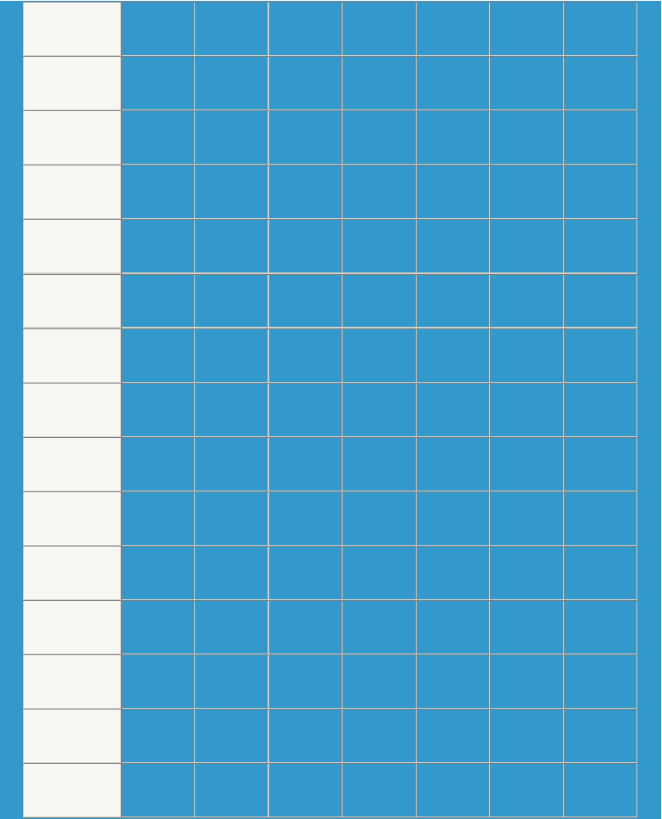

50 | 160 | 125 | 100 | 3 | 16 | 18 | 4-M16
65 | 180 | 145 | 120 | 3 | 18 | 18 | 4-M16
80 | 195 | 160 | 135 | 3 | 20 | 18 | 8-M16
100 | 215 | 180 | 155 | 3 | 20 | 18 | 8-M16
125 | 245 | 210 | 185 | 3 | 22 | 18 | 8-M16
150 | 280 | 240 | 210 | 3 | 24 | 23 | 8-M20
200 | 335 | 295 | 265 | 3 | 26 | 23 | 12-M20
250 | 405 | 355 | 320 | 3 | 30 | 25 | 12-M22
300 | 460 | 410 | 375 | 4 | 30 | 25 | 12-M22
350 | 520 | 470 | 435 | 4 | 34 | 25 | 16-M22
400 | 580 | 525 | 485 | 4 | 36 | 30 | 16-M27
450 | 640 | 585 | 545 | 4 | 40 | 30 | 20-M27
500 | 705 | 650 | 608 | 4 | 44 | 34 | 20-M30
600 | 840 | 770 | 718 | 5 | 48 | 41 | 24-M36
700 | 910 | 840 | 788 | 5 | 50 | 41 | 24-M36

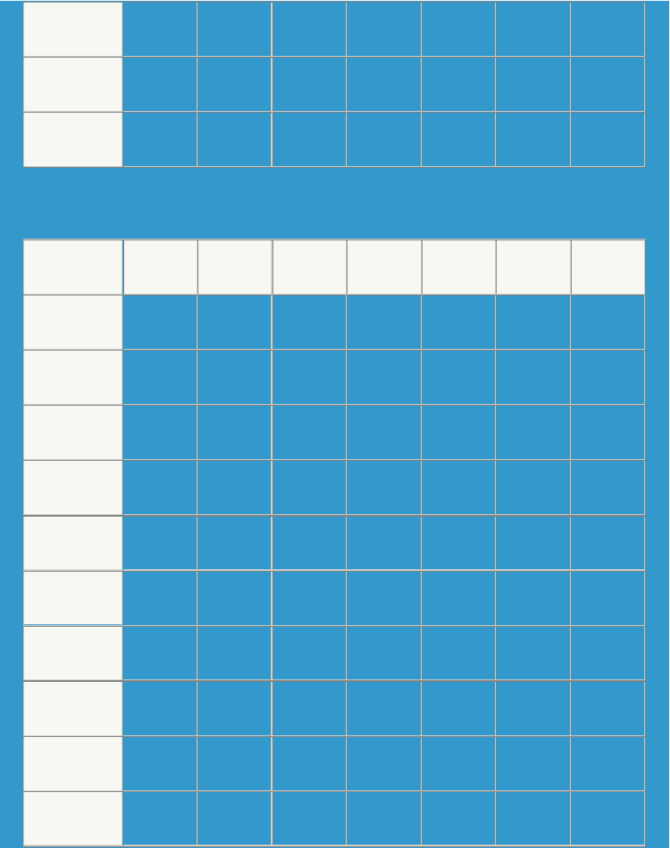

800 | 1020 | 950 | 898 | 5 | 52 | 41 | 24-M36
900 | 1120 | 1050 | 998 | 5 | 54 | 41 | 28-M36
1000 | 1255 | 1170 | 1110 | 5 | 56 | 48 | 28-M42
的尺寸
口径 DN | A | B | C | E | H | D | 螺栓
50 | 160 | 125 | 100 | 3 | 20 | 18 | 4-M16
65 | 180 | 145 | 120 | 3 | 22 | 18 | 8-M16
80 | 195 | 160 | 135 | 3 | 22 | 18 | 8-M16
100 | 230 | 190 | 160 | 3 | 24 | 23 | 8-M20
125 | 270 | 220 | 188 | 3 | 28 | 25 | 8-M22
150 | 300 | 250 | 218 | 3 | 30 | 25 | 8-M22
200 | 360 | 310 | 278 | 3 | 34 | 25 | 12-M22
250 | 425 | 370 | 332 | 3 | 36 | 30 | 12-M27
300 | 485 | 430 | 390 | 4 | 40 | 30 | 12-M27
350 | 550 | 490 | 448 | 4 | 44 | 34 | 16-M30

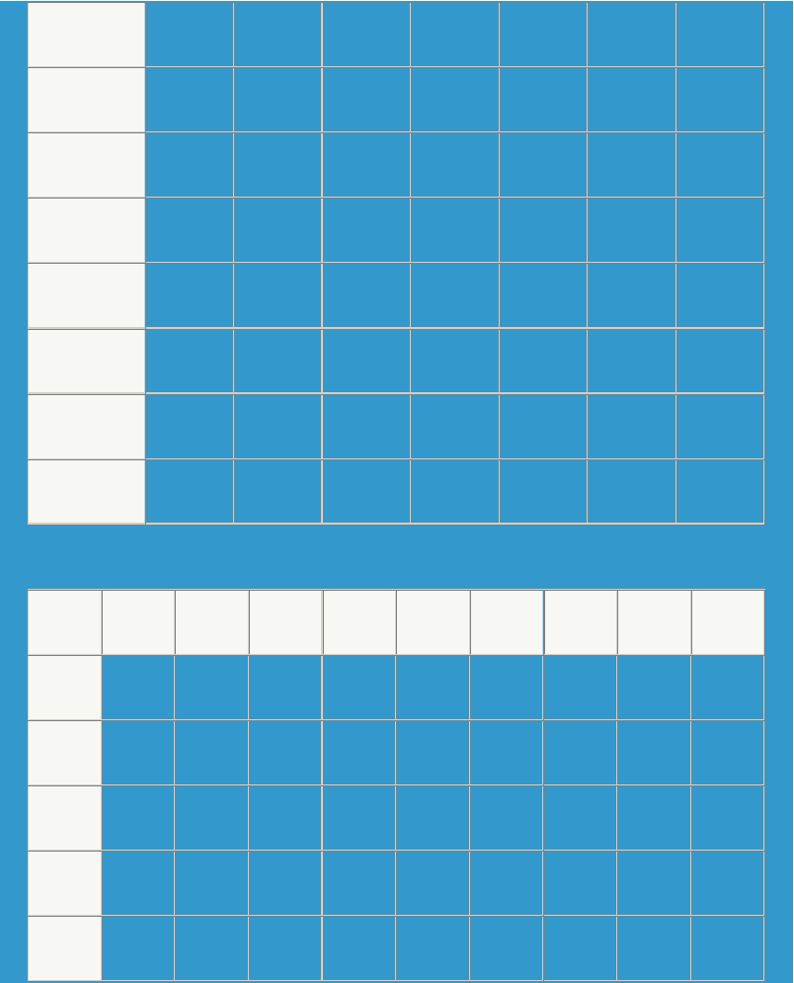

400 | 610 |  | 550 | 505 | 4 |  | 48 |  | 34 |  | 16-M30
450 | 660 |  | 600 | 555 | 4 |  | 50 |  | 34 |  | 20-M30
500 | 730 |  | 660 | 610 | 4 |  | 52 |  | 41 |  | 20-M36
600 | 840 |  | 770 | 718 | 5 |  | 56 |  | 41 |  | 20-M36
700 | 955 |  | 875 | 815 | 5 |  | 60 |  | 48 |  | 24-M42
800 | 1070 |  | 990 | 930 | 5 |  | 64 |  | 48 |  | 24-M42
900 | 1180 |  | 1090 | 1025 | 5 |  | 66 |  | 54 |  | 28-M48
1000 | 1305 |  | 1210 | 1140 | 5 |  | 68 |  | 58 |  | 28-M52
的尺寸
口径 DN | A | B | C | G | E | F |  | H |  | D |  | 螺栓
50 | 160 | 125 | 100 | 88 | 3 | 4 |  | 20 |  | 18 |  | 4-M16
65 | 180 | 145 | 120 | 110 | 3 | 4 |  | 22 |  | 18 |  | 4-M16
80 | 195 | 160 | 135 | 121 | 3 | 4 |  | 22 |  | 18 |  | 8-M16
100 | 230 | 190 | 160 | 150 | 3 |  |  | 24 |  | 23 |  | 8-M20
125 | 270 | 220 | 188 | 175 | 3 |  |  | 28 |  | 25 |  | 8-M22

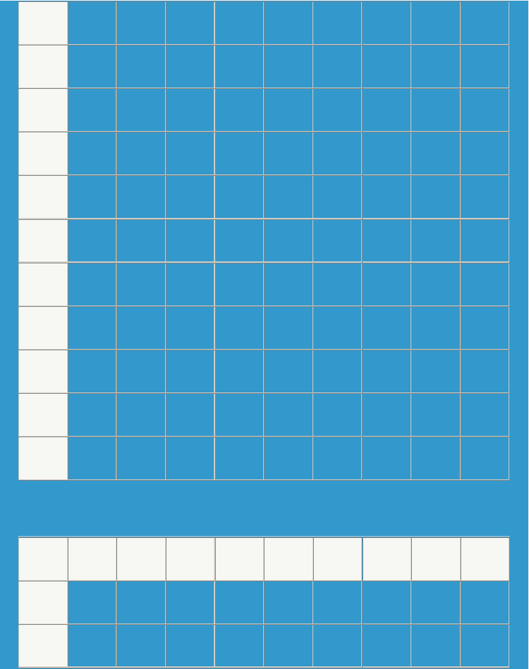

150 | 300 | 250 | 218 | 204 | 3 |  | 30 | 25 | 8-M22
200 | 375 | 320 | 282 | 260 | 3 |  | 38 | 30 | 12-M27
250 | 445 | 385 | 345 | 313 | 3 |  | 42 | 34 | 12-M30
300 | 510 | 450 | 408 | 364 | 4 |  | 46 | 34 | 16-M30
350 | 570 | 510 | 465 | 422 | 4 | 5 | 52 | 34 | 16-M30
400 | 655 | 585 | 535 | 474 | 4 | 5 | 58 | 41 | 16-M36
450 | 680 | 610 | 560 | 524 | 4 | 5 | 60 | 41 | 20-M36
500 | 755 | 670 | 612 | 576 | 4 | 5 | 62 | 48 | 20-M42
600 | 890 | 795 | 730 | 678 | 5 | 6 | 62 | 54 | 20-M48
700 | 995 | 900 | 825 | 768 | 5 | 6 | 68 | 54 | 24-M48
800 | 1135 | 1030 | 960 | 876 | 5 | 6 | 76 | 58 | 24-M52
的尺寸
口径 DN | A | B | C | G | E | F | H | D | 螺栓
50 | 175 | 135 | 105 | 88 | 3 | 4 | 26 | 23 | 4-M20
65 | 200 | 160 | 130 | 110 | 3 | 4 | 28 | 23 | 4-M20

以上内容仅为本文档的试下载部分，为可阅读页数的一半内容。如要下载或阅读全文，请访问：https://d.book118.com/818123064065006045

