2018 学年第一学期期末考试七年级英语学科试卷
Part 1 Listening（第一部分 听力）
I. Listen to the sentence and choose the right picture.（根据你听到的内容，选出相应的图画）
A.
B.
C.
D.
E.
F.
1. ________
2. ________ 3. ________ 4. ________
5. _______
Ⅱ. Listen to the dialogue and choose the best answer to the question you hear（. 根据你听到的对
话和问题，选出最恰当的答案）
6. A. He is in Beijing.
C. He lives in London.
B. He is in Nanjing.
D. He lives in Shanghai.
C. On foot.
7. A. By bus.
B. By bike.
B. $45.
D. By train.
D. $180.
8. A. $40.
C. $90.
9. A. In a school library.
C. In a restaurant.
10 A. The rain.
B. In a big store.
D. In a classroom.
C. The weather.
B. The date.
D. The umbrella.
11. A. The green one.
12. A. 15.
B. The white one.
B. 16.
C. The blue one.
C. 19.
D. The red one.
D. 20.
13. A. She will visit Granny Li.
C. She will relax at a bar.
B. She will phone Granny tomorrow.
D. She will stay at home.
Ⅲ. Listen to the passage and tell whether the following statements are true or false.（判断下列
句子是否符合你听到的短文内容，符合的用“T”表示，不符合的用“F”表示）
14. A boy was going to the house of his friend.
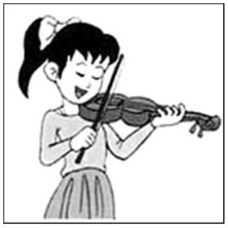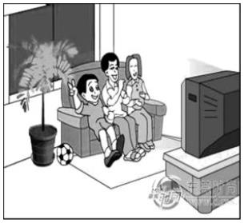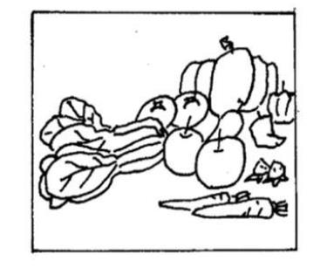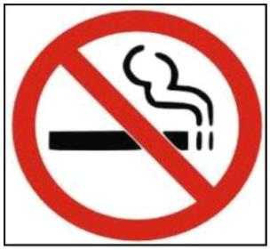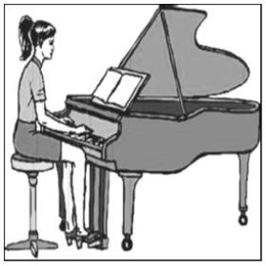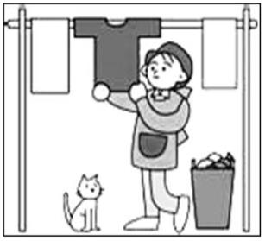

15. As the boy went along the road, he saw a box of good apples at the side of the road.
16. The boy didn’t want the apples because he was full.
17. The boy waited for some time, and went over the big river.
18. The boy went to the rich man’s house, but the rich man was not at home.
19. The boy was glad to eat the apples that he threw that morning.
Ⅳ. Listen to the passage and fill in the blanks with the words you hear.（听短文，填入所缺单
词）
20. Our school will organize all the students to visit the Happy Valley next ________.
21. All the students should meet at the school gate at _______am.
22. If you are late, you’ll have to stay in the school ___________.
23. You should wear your __________ and sports shoes that day.
24. In the park, you can ______ every place and take photos freely.
25. We will ________ at 5:00 pm.
Part 2 Vocabulary and Grammar（第二部分 词汇与语法）
V. Choose the best answer.（选择最恰当的答案）
1.Which of the following underlined parts is different in pronunciation?
A. forward
B. enjoy
C. coin
D. noise
2.My sister is _____ engineer. She doesn’t wear _____ uniform at work.
A. an, an
3.There is a shop _____ the bottom of the mountain
A. on B. for
B. an, a
C. a, a
C. in
D. a, the
D. at
4.All of us are looking forward _______ Shanghai Disneyland.
A. to visit
B. for visiting
C. to visiting
D. for visit
5.The ______ news made all the students very ________.
A. excited, exciting
C. exciting, exciting
B. excited, excited
D. exciting, excited


6.I’m going to play _____computer games and do _____exercise.
A. fewer, more B. less, more C. fewer, less
7.All passengers_____ go through safety check before they take a plane.
A. may B. can C. must
D. less, fewer
D. need
8.You______ worry about your lessons. Be careful next time and you will get a good mark.
A. don’t need to
9.He’d like _____ some English songs at the party.
A. singing B. to singing
B. not need
C. needn’t to
D. don’t need
C. to sing
D. sings
10. I went to Luxun Park last week.
—
—______________
A. So do I.
B. Neither do I.
C. So did I.
D. Neither did I.
D. for
11.We didn’t finish off all the food we ordered, _______ we took the rest home.
A. as B. so C. or
12.If he ____ next week, he will attend my birthday party.
A. will come B. come C. comes
13.May _____ hot dogs and apple pie from America yesterday.
A. sells B. selling C. sell
14.They _______ the rest of the money on books and clothes.
D. coming
D. sold
A. cost
B. paid
C. spent
D. took
15.--My sister has got a bad cold yesterday.
--___________.
A. You’d better go to see the doctor.
C. I’m sorry to hear that.
B. That’s all right.
D. What’s the matter with you?
VI. Complete the following passage with the words or phrases in the box. Each can be only be
used once.（将下列单词或词语填入空格，每词限填一次)
A. enjoy
B. little
C. running

D. enough
E. never
F. work
In a big city, everyone is in a hurry in the early morning. People are ____16____ to the stations, buses and cars.
They usually have ____17____ time for breakfast. People work busily all day. At six o’clock in the evening, people
go home after work. Most of the offices are closed, but some shops are still open. Many people have to ____18____
at night in a big city. For examples, the doctors and nurses are as busy as they are in the day. In the evening, some
people are going to have fun. Some are going to the cinemas. Some are going to the concerts. You can ____19____
music there day and night you can always find people working and playing. A big city ____20____ sleeps.
VII.
Complete the sentences with the given words in their proper forms.（用括号中所给单词的适当形式完成下列
句子）
21. When I go to different places, I like to visit different ________there. (church)
22. Our family will have a big party to celebrate my son’s ________ birthday. (eight)
23. ______ is always important to people. (healthy)
24. We put a lot of _________ on the Christmas tree. (decorate)
25. We can exercise ________ (regular) to stay healthy.
26. __________, I didn’t get hurt when I fell off my bike. (luck)
27. Tom ran into the river to _______ his wife. (safe)
VIII.
Rewrite the following sentences as required.（按要求改写句子，每空格限填一词）
28. Jack used to have a cup of tea after dinner.（改为否定句)
Jack _______ _______ to have a cup of tea after dinner.
29. My grandparents have never tried shopping on the Internet.（改为反意疑问句）
My grandparents have never tried shopping on the Internet, ______ ______?
30. Mr. Robert will be back in two weeks.（对划线部分提问）
_______ _______ will Mr. Robert be back?
31. I spend two hours doing my homework every day.（保持原意不变)

It _______ ________ two hours to do my homework every day.
32. new neighbourhood, to, convenient, in, go shopping, it, is, your（连词成句）
__________________________________________________________?
Part III Reading and Writing（阅读与写作）
IX. Reading comprehension.（阅读理解）
People have seen the colorful shared bikes (共享单车) in the city streets around China for two years. People
can rent (租用) them with a smart phone app and then park anywhere they choose. To relieve (减少) traffic jams
and air pollution, many cities have introduced bike-sharing services. But sometimes, dreams are not so perfect.
It is true that it is convenient for people to go out by shared bike. As shared bikes become more popular,
problems showed up. According to news reports, users treated shared bikes badly. After people used the bikes,
some of them just threw them onto streets and even into the ditches (水沟). Some people stole the bikes or locked
them up in chains (链条). A month ago, the police fined a man in Shanghai 1,000 yuan, because he stole a shared
bike.
Besides, the damage to the QR codes (二维码) on the bikes has brought huge losses to bike-sharing companies,
like Mobike (摩拜单车). If the QR code is bad, people cannot use the bike anymore. It can take several hundred
yuan for the company workers to find a lost bike and repair it. Mobike has 100 credit scores for each user. Once
the score drops to below 80, bike rental (租金) will go up five yuan per 30 minutes.
However punishment may not be the best way to stop shared bikes from being stolen or damaged.
,
Bike-sharing services will work better only if people follow the rules and show respect for the bikes.
33. People can easily rent a shared bike with _________.
A. a map
B. a card
C. a bike key
D. a smart phone app
34. Why did a man in shanghai get fined 1000 yuan?
A. He threw the bike onto street.
B. He stole a shared bike.
D. He found a lost bike.
C. He damaged the QR codes on the bike.
35. Many problems appeared after people used the bikes. Some people ________.
Which one is NOT mentioned (提到)?
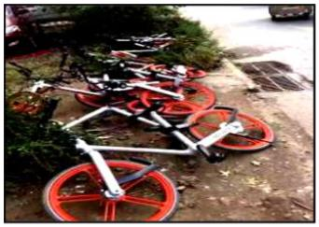

A. damaged the QR codes.
B. stole the shared bikes.
C. sold the shared bikes online.
D. threw the bikes onto streets or into ditches.
36. The underlines word “credit” in the last second paragraph refers to（指的是）_____.
A. 信用 B. 免费单 C. 兑换券 D. 积分
37. What can we infer (猜测) from the passage?
A. It is unnecessary to have shared bike in the city.
B. The best way to relieve traffic jam to is have more undergrounds.
C. If people follow the rules, the bike-sharing services will work better.
D. Punishment can stop shared bikes from being stolen or damaged.
Read the passage and choose the proper word to complete the passage.（阅读文章, 选择恰当的词完成短文,
用 A、 B、 C 或 D 表示, 填入括号内）
Mr. White is a member of his office. He is strong and can easily deal with all kinds of matters, so he’s always
paid more than his workmates. Of course he’s often ____38____ and has no time to do the housework. His wife
knows him well and does all at home. However, their daughter was hurt in a traffic accident last month and has to
be in hospital. Now Mrs. White has to ____39____ her there and she can’t go home. Mr. White often eats
something in the restaurant. As he ____40____ does some cleaning, the rooms are all disorderly (零乱不堪的).
Yesterday morning, before Mr. White got up, the telephone rang. He sat up to answer it. His friend told him to
____41____ an important telephone number down. But he couldn’t find either a pen or a piece of paper. He found
there was much dust on the table and wrote the number on it. But soon he ____42____ it and went to work. Two
hours later his wife came back and looked for a sweater for her daughter. Her husband came in while she was
cleaning the table. He couldn’t find the number on the table and called out angrily, “Who let you clean the table?”
38. A. tired
B. bored
B. play with
B. never
B. put
C. busy
D. lazy
39. A. look after
40. A. sometimes
41. A. write
C. think of
C. almost
C. look
D. live on
D. often
D. turn
42. A. thought
B. found
C. realized
D. forgot
Read the following passage and fill in the blanks with proper words（. 在下列短文内填入恰当的词, 使其内容
通顺, 每空格限填一词, 首字母已给）
We all know that it is important to get exercise. But how can we get enough exercise and have fun as well?

The a____43____ is: team sports! Team sports are great. When we’re playing, our friends will encourage us if
we are doing a good job, and there will be friends to give us useful a___44___ on how to play the sport better.
Many times, we get to meet and make some new friends!
We play team sports for f___45___ and good health. We play team sports to learn about the team spirit.
However, some teams try hard to w___46___ every game and become very competitive. If we are on such a team,
we will have too much pressure. And we may even get hurt.
Sometimes it can be hard to find a team that works for us. But we can always start one! Start a team
w___47___ some of our best friends and find out what kind of sports we like. It could be swimming, basketball,
dancing, or something else.
And while we’re playing team sports, we should remember to play safe, too! We need to l___48___ to our
parents and teachers before we have fun!
Answer the questions.（根据短文内容回答下列问题）
Life in the 22nd century will be different from that in the 21st century, because many changes will take place.
The population is growing fast. There will be more and more people in the world and most of them will live longer
than before. Computers will be much smaller and more useful, and there will be at least one in every home. And
computer studies will be one of the most important subjects at school.
People will work fewer hours than they did in the 21st century, and they will have more free time for sports,
watching TV and traveling. Traveling will be much easier. And more people will go to other countries for holidays.
There will be changes in our food, too. More land will be used for building new towns and houses. Then there
will be less room for cows and sheep, so meat will be more expensive. Maybe no one will eat it every day; instead
they eat more vegetables and fruit. In this way people will be healthier.
Work in the future will be different, too. Robots will do dangerous and hard work. Because of this, many
people will not have enough work to do. This will be a problem.
49. Why will life in the 22nd century be different from that in the 21st century?
Because ____________________________________.
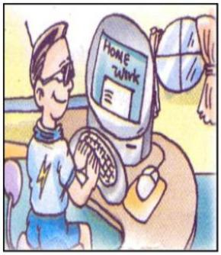

50. Computers will be much smaller and more useful, won’t they?
____________________________.
51. Will people work more hours than they did in the 21st century?
____________________________.
52. What will more land be used for?
More land will be used for ________________________________.
53. Who will do dangerous and hard work?
___________________________________.
54. According to the underlined sentences in the last paragraph, can you think of one more problem in the future?
__________________________________________________.
X. Writing.（写作）
55.Write at least 50 words on the topic ‘A change to my bad habit '.
（请以《我的坏习惯的改变》”为
题写一篇不少于 50 个词的短文，要求意思明确、内容连贯，标点符号不计字数）
（注意：作文中不得出现考生的中文姓名及其他相关信息，否则不予评分。）
The following questions are provided as a reference（以下问题可供参考）
1.
2.
What bad habit did you have in the past?
How did you change your bad habit? (List at least two ways)
A change to my bad habit

2018 学年第一学期期末考试七年级英语学科试卷
Part 1 Listening（第一部分 听力）
I. Listen to the sentence and choose the right picture.（根据你听到的内容，选出相应的图画）
A.
B.
C.
D.
E.
F.
1. ________
2. ________ 3. ________ 4. ________
5. _______
Ⅱ. Listen to the dialogue and choose the best answer to the question you hear（. 根据你听到的对
话和问题，选出最恰当的答案）
6. A. He is in Beijing.
C. He lives in London.
B. He is in Nanjing.
D. He lives in Shanghai.
C. On foot.
7. A. By bus.
B. By bike.
B. $45.
D. By train.
D. $180.
8. A. $40.
C. $90.
9. A. In a school library.
C In a restaurant.
B. In a big store.
D. In a classroom.
10. A. The rain.
11. A. The green one.
12. A. 15.
B. The date.
B. The white one.
B. 16.
C. The weather.
C. The blue one.
C. 19.
D. The umbrella.
D. The red one.
D. 20.
13. A. She will visit Granny Li.
C. She will relax at a bar.
B. She will phone Granny tomorrow.
D. She will stay at home.
Ⅲ. Listen to the passage and tell whether the following statements are true or false.（判断下列
句子是否符合你听到的短文内容，符合的用“T”表示，不符合的用“F”表示）
14. A boy was going to the house of his friend.

15. As the boy went along the road, he saw a box of good apples at the side of the road.
16. The boy didn’t want the apples because he was full.
17. The boy waited for some time, and went over the big river.
18. The boy went to the rich man’s house, but the rich man was not at home.
19. The boy was glad to eat the apples that he threw that morning.
Ⅳ. Listen to the passage and fill in the blanks with the words you hear.（听短文，填入所缺单
词）
20. Our school will organize all the students to visit the Happy Valley next ________.
21. All the students should meet at the school gate at _______am.
22. If you are late, you’ll have to stay in the school ___________.
23. You should wear your __________ and sports shoes that day.
24. In the park you can ______ every place and take photos freely.
,
25. We will ________ at 5:00 pm.
Part 2 Vocabulary and Grammar（第二部分 词汇与语法）
V. Choose the best answer.（选择最恰当的答案）
1.Which of the following underlined parts is different in pronunciation?
A. forward
B. enjoy
C. coin
D. noise
A
【答案】
【解析】
【详解】句意：下列划线部分哪个发音不同？
考查语音辨析。forward/ ˈfɔːwəd /向前；enjoy/ ɪnˈdʒɔɪ /享受；coin/ kɔɪn /硬币；noise/ nɔɪz /噪音。根据所给单
词划线字母 o 的读音，可知后面三项发音相同，故选 A。
2.My sister is _____ engineer. She doesn’t wear _____ uniform at work.
A. an, an
【答案】
【解析】
B. an, a
C. a, a
D. a, the
B

【详解】句意：我姐姐是个工程师。她上班不穿制服。
考查冠词辨析。不定冠词 a/an 修饰单数名词，表泛指，a 用在以辅音音素开头的单词前面，an 用在以元音
音素开头的单词前面；定冠词 the 表特指。engineer 以元音音素开头，需用不定冠词 an 表泛指；而 uniform
以辅音音素开头，需用不定冠词 a；根据句意语法，故选 B。
3.There is a shop _____ the bottom of the mountain.
A. on
B. for
C. in
D. at
D
【答案】
【解析】
【详解】句意：在山脚下有一家商店。
考查介词辨析。at 用于指较小的地方，而 in 用于指较大的地方；on 指在某物的表面；for 表目的或原因。
the bottom of the mountain 山脚下，是小地点，需用 at；根据句意语法，故选 D。
4.All of us are looking forward _______ Shanghai Disneyland.
A. to visit
B. for visiting
C. to visiting
D. for visit
C
【答案】
【解析】
【详解】句意：我们都很期待参观上海迪斯尼乐园。
考查固定短语和动词形式辨析。look forward to 期待，固定短语，可排除 BD 两项。介词 to 后接动名词短语，
visit（参观）是原形动词，可排除。根据句意结构，故选 C。
5.The ______ news made all the students very ________.
A. excited, exciting
C. exciting, exciting
B. excited, excited
D. exciting, excited
D
【答案】
【解析】
【详解】句意：这个令人兴奋的消息使所有的学生都很兴奋。
考查形容词辨析。exciting 令人兴奋的，用于物；excited 兴奋的，形容人。news（消息）属于物，需用 exciting
做定语；the students（学生）是人，需用 excited 形容。make sb. +adj.表示让某人处于某种状态，根据句
意结构，故选 D。

6.I’m going to play _____computer games and do _____exercise.
A. fewer, more B. less, more C. fewer, less
D. less, fewer
A
【答案】
【解析】
【详解】句意：我要少玩电脑游戏，多做运动。
考查比较级辨析。fewer 和 less 都表示“较少的”，但前者修饰复数名词，后者修饰不可数名词；games 是
复数形式，不可用 less 修饰，前空可排除 BD 两项。more 更多的，是 many 和 much 的比较级，可修饰复数
名词或不可数名词。根据句意可知，本句是“比较级+ and +比较级”结构，要“少游戏多运动”，exercise
（锻炼）需用 more 修饰，故选 A。
7.All passengers_____ go through safety check before they take a plane.
A may
B. can
C. must
D. need
C
【答案】
【解析】
【详解】句意：所有乘客在乘坐飞机前必须经过安全检查。
考查情态动词辨析。may 可以，表许可或请求；can 能，表能力或许可；must 必须，指一定；need 需要，
指有必要。根据句意语境可知，安检强调“必须，一定”，故选 C。
8.You______ worry about your lessons. Be careful next time and you will get a good mark.
A. don’t need to
B. not need
C. needn’t to
D. don’t need
A
【答案】
【解析】
【详解】句意：你不必担心你的功课。下次小心点，你会取得好成绩的。
考查动词 need 用法辨析。need 用作情态动词时常和不带 to 的不定式一起作谓语，否定式是将 not 置于其后，
并有其否定的缩写形式 needn't，在疑问和否定句中不加助动词；可知 BCD 三项表达错误。用作行为动词时，
need 是一个普通的及物动词，用在肯定、否定和疑问句中均可，接不定式时要带 to。本句 need 用作及物动
词，根据句意结构，故选 A。
9.He’d like _____ some English songs at the party
A. singing
B. to singing
C. to sing
D. sings

以上内容仅为本文档的试下载部分，为可阅读页数的一半内容。如要下载或阅读全文，请访问：https://d.book118.com/827022121046006031

