开心版小学五年级下册英语教案导学案教学设计最新版

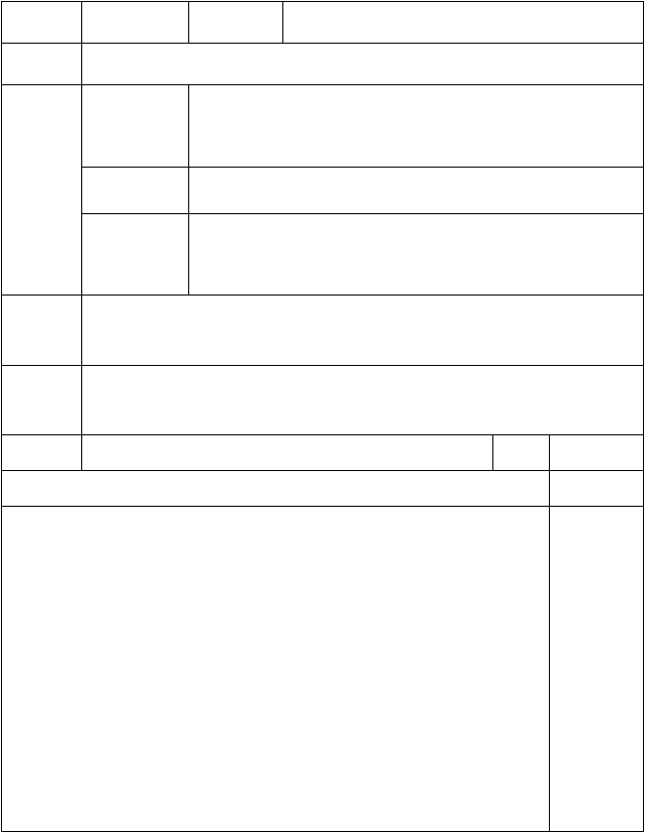
年级：五年级主备教师
科目：英语辅备教师
编号： 1

课 题

知识与技能
教学
目 过程与方法
标 情感态度

和价值观
Unit 1 Making Plans
- 学会 Vocabulary 的 8 个动词短语。
- 学习 Target，学习表示将来打算的句型。
- 学会歌曲 Are you going to write a letter?

通过对话来进行新词组的教学以及句型的学习。

让学生学会制定计划，珍惜时间。

教学重点 学生能听、说、认读和写出短语 take a test， play games， get a haircut， see the doctor，shop for clothes ，have a party， write a letter ，meet some
friends。

教学难点
听、说、认读和写句子:What are you going to do today?
以及用 I’m going to……回答。Are you going to ……?
Yes/No, I’m going to…….

教具准备 教学卡片，PPT

Free talk

教 学 过 程
课时 1
备 注


T: Hello, boys and girls. What day is it today/ tomorrow? T: How about the day after tomorrow?

Presentation (Page 9)
    - T：Next month we are going to take a test.（板书 take a test）
    - T：Do you want to play games？（Ss：Yes.）（板书 play games）
    - T： Oh ， look at my hair ， it’s long. I am going to get a haircut.（板书 get a haircut）
    - T：Gogo is sick. He is going to see the doctor.（板书 see the doctor）
    - T：What are you going to do on Saturday？Are you going

第 1 页 共 62 页


to shop for clothes or have a party?
（板书 shop for clothes 和 have a party 并让学生作出回答。）
    - T: Jenny is going to write a letter to her grandfather and Tony is going to meet some friends.
（板书 write a letter 和 meet some friends.）

Target (Page 9)
    - T ： As I say ， Jenny is going to write a letter to her grandfather. Let’s try to read the Target.
    - T teaches the Ss to read, and explains the meaning.
    - Ss read after the tape.
    - Ss read together.

Chant activity (Page 14)
    - Ask the Ss to listen to the song：Are you going to write a letter?
    - Ss follow the tape to sing the song.
    - After practicing several times，Ss sing together.
    - Ss finish the lyrics and T check the answers.

Homework
    - Copy the vocabularies.
    - Read the Target.

Unit 1 Making Plans

板 I’m going to…… take a test，
书
get a haircut，
设
play games，
see the doctor，

计 shop for clothes ， have a party，
write a letter ， meet some friends
教学反思

第 2 页 共 62 页

开心版五年级下册英语教案导学案教学设计最新版

年级：五年级
科目：英语 编号： 2

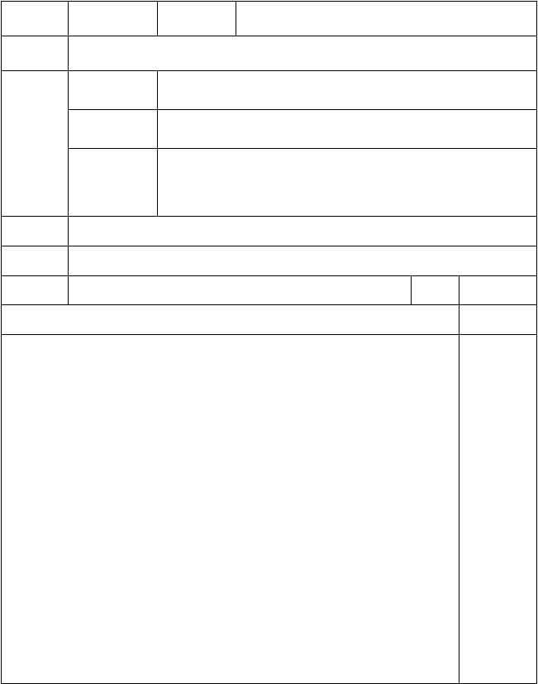
主备教师课 题
辅备教师

Unit 1 Making Plans

知识与技能
教
学 过程与方法
目
标 情感态度
和价值观
1. 学会 Story 的对话。

通过让学生带着问题阅读课文来进行学习。

1.让学生学会计划，珍惜时间。

教学重点
教学难点
Story 的对话。
bored，cook some food，have a vacation 等生词。

教具准备

I.Warm-up
PPT

教 学 过 程
课时 2
备 注

1、Greetings.
2、Chant: Are you going to write a letter?

Presentation (Page 8)
1、Look and answer:
① Show some questions on the screen.
  - Is Jenny going to get a haircut?
  - Is Jenny going to shop for clothes?
  - Is Jenny going to cook some food?
  - What is Gogo going to do?
② Teach the phrase “cook some food”.
③ Have the students look at the Story.
④ Choose the volunteers to answer the questions.
2 、 Have the students look at the Story once again. 3、Explain the important points:
① Teach “bored” and make an example: Gogo is .Have the students choose the best answer for the sentence from “bore,

第 3 页 共 62 页


bored and boring”.
② Teach the phrase “have a vacation” and have the students read one by one.
- Have the students follow the teacher to read the Story.
- Act out the Story.

Practice 1 (Page 10)
- Ask the Ss to read the questions first.
- Ask the Ss to use“He/She is going to ……”and “They are going to ……”to tell about each picture.
- Listen to the tape and check the answer. 4.Listen again， this time ，repeat.

Practice 2 (Page 10)
- T：Today is Friday. What are you going to do tonight? Ss：I’m going to …….
- Ss practice in groups.

Homework
- Read the Story.
- Do the Activity of P11 after class.

Unit 1 Making Plans
bored，
板
书 cook some food，
设 have a vacation
计

教学反思

第 4 页 共 62 页

开心版五年级下册英语教案导学案教学设计最新版

年级：五年级
科目：英语 编号： 3

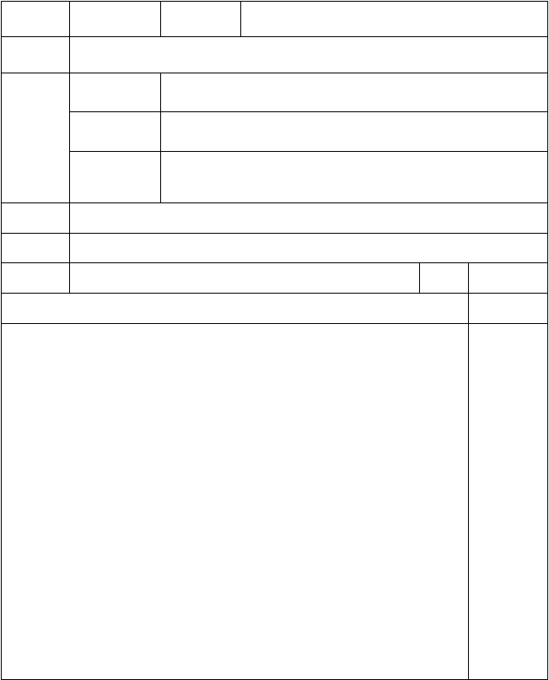
主备教师课 题
辅备教师

Unit 1 Making Plans

知识与技能
教
学 过程与方法目
标 情感态度和价值观
学会阅读的技巧。

让学生通过带着问题阅读，学会做阅读题的方法。

- 懂得尊敬长辈。 2.了解不同文化的学生平常的生活。

教学重点教学难点教具准备

Warm up
Reading and writing.
Seniors’ Center 等词以及阅读后面的习题。PPT
教 学 过 程

课时 3
备 注

1. Free talk ：T：What are you going to do？
S1: I’m going to…….

Presentation (Page 12)
（Reading and writing）
- T：Turn to Page 12, let’s look at these questions：
  - Where are the students going?
  - What are they going to do?
  - What is Xiaoming doing in the Seniors’ Center? Now reading with these questions. I’ll give you ten minutes.
- T：Times up. Who can answer Q1？
S1：They’re going to a Seniors’ Center. T： Good. Who can answer Q2？
S2：They’re going to sing, dance, and tell stories. T： Perfect. Who can answer Q3？
S3：He is taking photos.
T：Very good！

第 5 页 共 62 页


- T translates the passage to let the Ss know more about the story.

（More reading and writing）(Page 16)
- T：Look at the pictures，there are three students from different countries. Now reading with questions in Part 2. I’ll give you ten minutes.
- T：Times up. Where is John from?
S1：UK.
T： Good. What is May going to sell this weekend? S2：Sell cookies.
T： Perfect. What is Colin going to do this weekend? S3：He is going to take the animals to a show.
T：Very good！
3.T translates the passage to let the Ss know more about the passages.

Practice
    - Finish the Part 3 and Part 4 in P13 and P17.
    - Check the answers together.

Homework
1.Ask the Ss to prepare a show for their family. 2.Write a short passage about your weekend.

Unit 1 Making Plans
板 P13.（1）They’re going to a Seniors’ Center.
书 （2）They’re going to sing, dance, and tell stories.
设 （3）He is taking photos.
P17. （1）UK.
计 （2）Sell cookies.
（3）He is going to take the animals to a show.

第 6 页 共 62 页


教
学反思

开心版五年级下册英语教案导学案教学设计最新版

年级：五年级
科目：英语 编号： 4

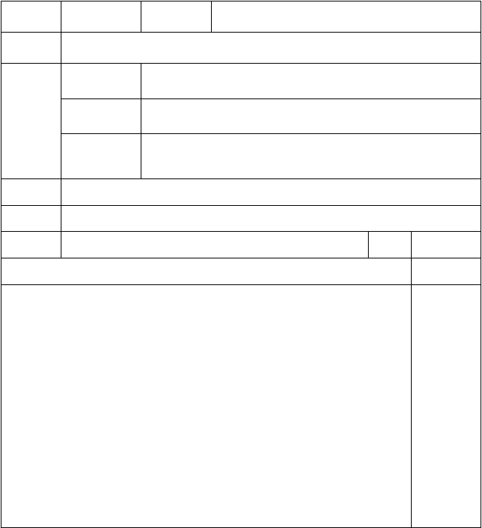
主备教师课 题
知识与技能
教
学 过程与方法目
标 情感态度
和价值观
辅备教师

Unit 1 Making Plans
- 学会 / ɔ p /与/ɔ ŋ/ 的发音。
- 会读单词 shop，stop，hop，song， long， strong。通过自编小短文，引出新词，学习发音。

训练学生的语音。

教学重点
教学难点
单词 shop，stop，hop，song， long， strong。
/ ɔ p /与/ɔ ŋ/ 的发音。

教具准备
PPT

教 学 过 程
课时 4
备 注

Warm-up
    - Free talk ：T：What are you going to do？
S1: I’m going to…….

Presentation (Page 15)
    - T： There’s a shop near the bus stop. Let’s hop.
（板书 shop, stop, hop 并且在 op 下面划线）
T： Look at these three words. What sound can you hear in the three words？
Ss: / ɔ p /.
T: Yes, repeat. O-P, / ɔ p /. ( Ss: O-P, / ɔ p /.)
    - T：My hair isn’t long and I am strong and I like to sing songs.

第 7 页 共 62 页

（板书 long，strong，song 并且在 ong 下面划线）
T： Look at these three words. What sound can you hear in the three words？
Ss: /ɔ ŋ/.
T: Yes, repeat. O-N-G, /ɔ ŋ/. (Ss: O-N-G, /ɔ ŋ/. )

    - Ss follow the tape to read all the words.
    - Ss read together.

Listen and read. (Page 15)
    - T: There is a fox ,he is hungry. He sees a rooster in the tree.
He wants to eat the rooster. Let’s read it together to see what happened.
    - T teaches Ss to read the story, and explains what the passage means.
    - Ss follow the tape to read it twice.
    - Ss read it together.

Conclusion
T： Today we have learned O-P, / ɔ p / and O-N-G, /ɔ ŋ/.
Please find more words with / ɔ p / and /ɔ ŋ/.

Homework
- Read the words.
- Find more words with / ɔ p / and /ɔ ŋ/.

Unit 1 Making Plans
板

书 shop，stop，hop，
设 song， long， strong
计
O-P, / ɔ p / O-N-G, /ɔ ŋ/.



第 8 页 共 62 页

教
学反思

开心版五年级下册英语教案导学案教学设计最新版

年级：五年级
科目：英语 编号： 5


主备教师课 题

教学
辅备教师

Unit 2 Vacation Plans
1. 学会 Vocabulary 的四个交通方式、两种住处以及两种娱乐的短语。
知识与技能 2. 学习 Target。
3. 学会歌曲 We’re going……

目 过程与方法标
情感态度

和价值观
通过介绍周末计划，引出新词组。

让学生学会选择合适的交通工具。

教学重点教学难点
学生能听、说、认读和写出短语 by ship ,by plane, by bus, by train , stay in a hotel, stay with my aunt and uncle, go camping, go sightseeing。
听、说、认读和写句子:How are you going to get to ……?
We’re going to go by……. Where are you going to stay?
We’re going to stay …….

教具准备
PPT

教 学 过 程
课时 1
备 注

第 9 页 共 62 页


Free talk
T: What are you going to do this weekend？ S1: I’m going to…….

Presentation (Page 19)
  - T：Tony is going to go to Shanghai by ship this weekend.
He’s going to stay in a hotel in Shanghai.
（板书 by ship 和 stay in a hotel）
  - T： I am going to go to Beijing by plane this weekend.
I am going to stay with my aunt and uncle in Beijing.
（板书 by plane 和 stay with my aunt and uncle）
  - T：Jenny is going to go to Huangshan by bus this weekend. She’s going to go camping there.
（板书 by bus 和 go camping）

  - T：Gogo is going to go to Tianjin by train this weekend. He’s going to go sightseeing there.
（板书 by train 和 go sightseeing）

Target (Page 19)
  - T：How are you going to get to Guangzhou? Ss：We’re going to go by bus.
T：Where are you going to stay? Ss: We’re going to stay in a hotel.
  - T teaches the Ss to read, and explain the meaning.
  - Ss read after the tape.
  - Ss read together.

Chant activity (Page 24)
- Ask the Ss to listen to the song：We’re going...
- Ss follow the tape to sing the song.
- After practicing several times，Ss sing together.
- Ss finish the lyrics and T check the answers.

Homework
  - Copy the vocabularies.
  - Read the Target.

第 10 页 共 62 页


Unit 2 Vacation Plans
板
书设
计
by ship ,
stay in a hotel,
by plane,
stay with my aunt and uncle,
by bus,
go camping,
by train ,
go sightseeing
教
学反思

开心版五年级下册英语教案导学案教学设计最新版

年级：五年级
科目：英语 编号： 6


主备教师
辅备教师
课 题
Unit 2 Vacation Plans
知识与技能
1. 学会 Story 的对话。
教
学目标
过程与方法
通过提问引出新学。
情感态度
和价值观
让学生学会表达自己喜欢的地方以及学会选择去某地
的交通方式。
教学重点
Story 的对话。
教学难点 Tibet ，for vacation，mountains，bears and the wolves 等生词。
教具准备
PPT
课时
2
教
学
过
程
备 注

第 11 页 共 62 页


Warm-up
1、Greetings.
2、Chant: We’regoing...

Presentation (Page 18)
- T：Gogo isgoing to TibetforvacationwithTony and Jenny. Do you thinkthereare beaches inTibet？
S1 ：No. There are mountains.
T：How are they going toget there? （发出飞机声响） S2 ： They’regoing by plane.
T：Can they go camping?
S3 ：No. It’tsoo coldforcamping. T：Does Gogo liketo go camping ？ S4 ：Yes.
T： Where are they going tostay? Ss: They’regoing tostayina hotel.
- Ss followthe teachertoread the Story.
- Ss read together.

IIIP.ractice 1 (Page 20)
- Ask the Ss toread the questionsfirst.
- Ask the Ss to use“He/She isgoing there by ……”to tellabout questionsA-B.
- Listento the questionsA-B and check the answers.
- Ask the Ss to use“Heisgoing to ……”to tellabout questions C-D.
- Listento the questionsC-D and check the answers.

Practice 2 (Page 20)
3. T ： May Day is coming. Gogo is going to Hong Kong for vacation.How ishe going toget to Hong Kong ？
Ss ：He isgoing by bus.
2. Ss practiceingroups.

Homework
  - Read the Story.
  - Do the Activitoyf P21 afterclass.

第 12 页 共 62 页


板
书
设计
Unit 2 Vacation Plans
Tibet ，for vacation mountains，bears and the wolves
教
学
反思

开心版五年级下册英语教案导学案教学设计最新版

年级：五年级
科目：英语 编号： 7


主备教师
辅备教师
课 题
Unit 2 Vacation Plans
知识与技能
学会阅读的技巧。
教
学目标
过程与方法
让学生通过带着问题阅读，学会做阅读题的方法。
情感态度
和价值观
学会为旅游做出计划。

第 13 页 共 62 页

教学重点教学难点教具准备

Warm up
Reading and writing.

Seniors’ Center 等词以及阅读后面的习题。PPT
教 学 过 程

课时 3
备 注

1. Free talk ：T：How are you going to get to ……? Ss：We’re going to go by …….

Presentation
（Reading and writing）(Page 22)
- T：Turn to Page 22, let’s go camping.
First, fill in the blanks with a-e in page 23. I’ll give you ten minutes. Begin.
T：Times up. The whole class tells me the correct answers.
Ss: E, a, b,d,c. T: That’s right.
- T translates the passage to let the Ss know more about it.

（More reading and writing）(Page 26)
  - T：Robert Wilson and Denise Wilson are going to Beijing next year. They like riding bikes, so they want to see the cycling events. Now reading with questions in Part 2. I’ll give you ten minutes.

  - T：Times up. Where are the Wilsons going? S1：They are going to Beijing.
T： Good. Why do they want to go?
S2 ： They like riding bikes, so they want to see the cycling events.
T： Perfect. Where are they going to stay?
S3：They are going to stay in a hotel near the Olympic Park. T：Very good！
3.T translates the conversations to let the Ss know more about it.

Practice
  - Finish the rest exercise in P23 and P27.
  - Check the answers together.
第 14 页 共 62 页


IV. Homework
1. Make a plan for camping .
Unit 2 Vacation Plans
板
书
设计
P23. e, a, b, d, c
P27. （1）S1：They are going to Beijing.
- They like riding bikes, so they want to see the cycling events.
- They are going to stay in a hotel near the Olympic Park.
教
学
反思

开心版五年级下册英语教案导学案教学设计最新版

年级：五年级
科目：英语 编号： 8


主备教师
辅备教师
课 题
Unit 2 Vacation Plans
知识与技能
1. 学 会 / a
/的发音。
教
学目标
过程与方法
2. 会读单词 eyes ,cry ,fly ,my ,dry ,why。
通过自编小短文，引出新词，学习发音。
情感态度
和价值观
训练学生的语音。
第 15 页 共 62 页

教学重点教学难点教具准备
单词 eyes ,cry ,fly ,my ,dry ,why。
/ aɪ /的发音。PPT
教 学 过 程

课时 4
备 注



Warm-up
  - Free talk ：
T：Where are they going to stay when you go to……? S：I am going to stay …….

Presentation (Page 25)
  - T：Fly, fly, fly a kite.
So high in the sky.
Why, why, why do you cry? My kite is not in the sky.
Dry, dry, dry your eyes. The kite is now flying high!
（板书 eyes ,cry ,fly ,my ,dry ,why 并且在 y 下面划线）
T： Look at these words. What sound can you hear in the six words？
Ss: / aɪ /.
T: Yes, repeat. Y, / aɪ /. ( Ss: Y, / aɪ /.)

  - Ss follow the tape to read all the words.
  - Ss read in groups.
  - Ss read together.

Listen and chant. (Page 25)
  - T: Now I will divided you into three groups to chant. The first group chants the first paragraph :
Fly, fly, fly a kite. So high in the sky.
The second group chants the second paragraph: Why, why, why do you cry? My kite is not in the sky. The third group chants the third paragraph:
Dry, dry, dry your eyes. The kite is now flying high! Let’s have a race. Ready ? Go !
第 16 页 共 62 页


- Ss chant in groups.
- Ss read it together.
IV. Conclusion
T： Today we have learned Y sounds / aɪ /.
Please find more words with y sounds / aɪ /.
V. Homework
- Read the words.
- Find more words with y sounds / aɪ /.
板
书
设计
Unit 2 Vacation Plans
eyes ,cry ,fly , my , dry ,why
y → / aɪ
/
教
学
反思

开心版五年级下册英语教案导学案教学设计最新版

年级：五年级
科目：英语 编号： 9


主备教师
辅备教师
课 题

教学目标
知识与技能
Unit 3 On Vacation
- 学会 Vocabulary 的 8 个动词短语。
- 学习 Target，复习 Unit 1 句型。
- 学会歌曲 What are you going to do?
过程与方法
通过介绍假期计划，引出新词组。

第 17 页 共 62 页

情感态度

和价值观

让学生学会为自己的假期做出计划。

教学重点 学生能听、说、认读和写出短语 have a picnic， visit relatives，
help Dad， take photos，play with friends，
make models， surf the Internet，read books 。

教学难点

教具准备

PPT
听、说、认读和写句子：What are you going to do during the vacation? I’m going to…….
课时 1

Free talk
教 学 过 程 备 注


T: What are you going to do this weekend？ S1: I’m going to…….

Presentation (Page 29)
  - T：Next week is a vacation, I’m going to go to Beijing. I’m going to visit relatives and play with friends.. First , We are going to have a picnic in the park, and I’m going to take photos.
Then, I’m going to make models with my cousin.
After that , I’m going to read books and surf the Internet . When I’m free, I’m going to help Dad. I’m going to have a good time! What are you going to do on vacation?
（板书并教学划线的短语）

Target (Page 29)
  - T：What are you going to do during the vacation?
（做出打字动作）
S1：I’m going to surf the Internet.
T：What are you going to do ?（做出看书动作） S2：I’m going to read some books.
  - Listen to the tape.
  - Ss read after the tape.
  - Ss read together.

Song activity (Page 34)
1.Ask the Ss to listen to the song： What are you going to do?
第 18 页 共 62 页

- Ss follow the tape to sing the song.
- After practicing several times，Ss sing together.
- Ss finish the lyrics and T check the answers.
- Homework
  - Copy the vocabularies.
  - Read the Target.
  - Do the Activity in Page 31.
Unit 3 On Vacation
板
书
设计
What are you going to do during the vacation?
I’m going to …….
have a picnic， visit relatives， help Dad， take photos，
play with friends，make models，
surf the Internet，read books
教
学
反思

开心版五年级下册英语教案导学案教学设计最新版

年级：五年级
科目：英语 编号： 10


主备教师
辅备教师
课 题
教学目标
知识与技能
Unit 3 On Vacation
- 完成 Activity 的习题。
- 学会 Story 的对话。
过程与方法
通过游戏复习上节所学，并且通过提问引出新学。

第 19 页 共 62 页

教学重点
情感态度

和价值观
Story 的对话。

让学生学会对假期设定计划及安排。

教学难点
next week, the Great Wall of China, do tai chi 等生词。

教具准备

Warm-up
PPT

教 学 过 程
课时 2
备 注


  - Sing the song：What are you going to do?
  - Check the answers of Activity in Page 31. T：Look at the picture, what is Jenny going to do? S1: She is going to swim.
……

Presentation (Page 28)
- Using a hat and a bag to lead in: It’s a vacation.
- Guessing game ：Review the phrases and sentence patterns
- （1） Show a picture of Bob. Bob is going to have a vacation.
（ 2 ） Then learn new words: next week, the Great Wall of China, do tai chi.
（3） Read the sentence after teaching the new words.
- Gogo is going to have a vacation too.（T play the video. ）
Have students answer questions:
What is Gogo going to do during the vacation ? What is Gogo going to do there?

- Students read after the teacher. Then have students answer the question:
What is Jenny going to do during the vacation?
- Students open the book and read together.
- Students role play in pairs, then role play together.

Practice 1 (Page 30)
- Ask the Ss to read the questions first.
- Ask the Ss to use“I’m going to ……” to tell about each pictures.
- Listen to the questions A-D.
第 20 页 共 62 页


4.Check the answers.
IV. Practice 2 (Page 30)
4. T：Next week is vacation. What are you going to do? S1: I’m going to …….
2. Ss practice in groups.
- Homework
  - Read the Story.
板
书
设计
Unit 3 On Vacation
next week, the Great Wall of China, do tai chi
教
学反
思

开心版五年级下册英语教案导学案教学设计最新版

年级：五年级
科目：英语 编号： 11


主备教师
辅备教师
课 题
Unit 3 On Vacation
教
学目
知识与技能
学会阅读的技巧。
过程与方法
让学生通过带着问题阅读，学会做阅读题的方法。

第 21 页 共 62 页


标 情感态度和价值观

学会写明信片。

教学重点教学难点教具准备

Warm up
Reading and writing.
明信片的格式。
PPT

教 学 过 程

课时 3
备 注

  - Free talk ：
T：What are you going to do during the vacation? S1：I’m going to …….

Presentation
（Reading and writing）(Page 32)
- T：Turn to Page 32, here’s a postcard.
Now reading with questions in Part 2. I’ll give you ten minutes.
- T：Times up. Is the postcard to Dagang? S1：Yes, it is.
T： Good job. What is Kevin going to do tomorrow? S2：He is going to visit his grandma and grandpa.
T： Perfect. What is Kevin going to do the day after tomorrow? S3 ： He is going to take some photos with his grandma and grandpa.
T：Very good！
- T translates the passage to let the Ss know more about it.

（More reading and writing）(Page 36)
  - T：Look at the picture ,the boy is Jeff who is from Toronto, a big city in Canada. Now reading with questions in Part 2.
I’ll give you ten minutes.
  - T：Times up. How long is summer holiday in Canada?
S1：Summer holiday is nine weeks long.
T： Good. When is spring holiday in Canada? S2：In March.
T： Perfect. What does Jeff like to do during summer holiday?

第 22 页 共 62 页


S3：He likes to travel with his parents.
T：Very good！
3.T translates the passage to let the Ss know more about it.
- Practice
  - Finish the Part 3 in P33 and P37.
  - Check the answers together.
IV. Homework
1. Write a postcard to your desk mate .
Unit 3 On Vacation
板
书
设计
P33.
2.(1)Yes, it is.
- He is going to visit his grandma and grandpa.
- He is going to take some photos with his grandma and grandpa.
P37.
2.(1) Summer holiday is nine weeks long. (2)In March.
(3)He likes to travel with his parents.
教
学
反思

开心版五年级下册英语教案导学案教学设计最新版

年级：五年级
科目：英语 编号： 12


主备教师
辅备教师
课 题
教学目
知识与技能
Unit 3 On Vacation
- 学会 / f /以及/ tr /的发音。
- 会读单词 phone， photo ，elephant，train， tree， travel。

第 23 页 共 62 页

标
过程与方法
情感态度和价值观
通过自编句子，引出新词，学习发音。

训练学生的语音。

教学重点
教学难点
单词 phone， photo ，elephant，train， tree， travel。
/ f /以及/ tr /的发音。

教具准备
PPT

教 学 过 程
课时 4
备 注



Warm-up
      - Free talk ：
T：What are you going to do during the vacation? S1：I’m going to …….

Presentation (Page 25)
      - T：An elephant takes photos with his phone！
（板书 phone， photo ，elephant 并且在 ph 下面划线）
T： Look at these words.
What sound can you hear in the three words？ Ss: / f /.
T: Yes, repeat. P-H, / f /. ( Ss: P-H, / f /.)
      - I travel by train，seeing many trees outside the window.
（板书 train， tree， travel 并且在 tr 下面划线）
T： Look at these words.
What sound can you hear in the three words？ Ss: / tr /.
T: Yes, repeat. T-R, / tr /. ( Ss: T-R, / tr /.)

      - Ss follow the tape to read all the words.
      - Ss read in groups.
      - Ss read together.

Listen and chant. (Page 35)
      - T: Let’s read the lyrics together.
      - Ss chant with the tape.
      - Ss chant in groups.
第 24 页 共 62 页


4.Ss read it together.
IV. Conclusion
T： Today we have learned P-H sounds / f / and T-R sounds / tr /.
Please find more words with ph and tr.
V. Homework
- Read the words.
- Find more words with ph and tr.
板
书设
计
Unit 3 On Vacation
phone， photo ，elephant，
ph
→ / f/
train， tree， travel 。
tr → / tr /
教
学
反思

开心版五年级下册英语教案导学案教学设计最新版

年级：五年级
科目：英语 编号： 13


主备教师
辅备教师
课 题
Review 1

第 25 页 共 62 页

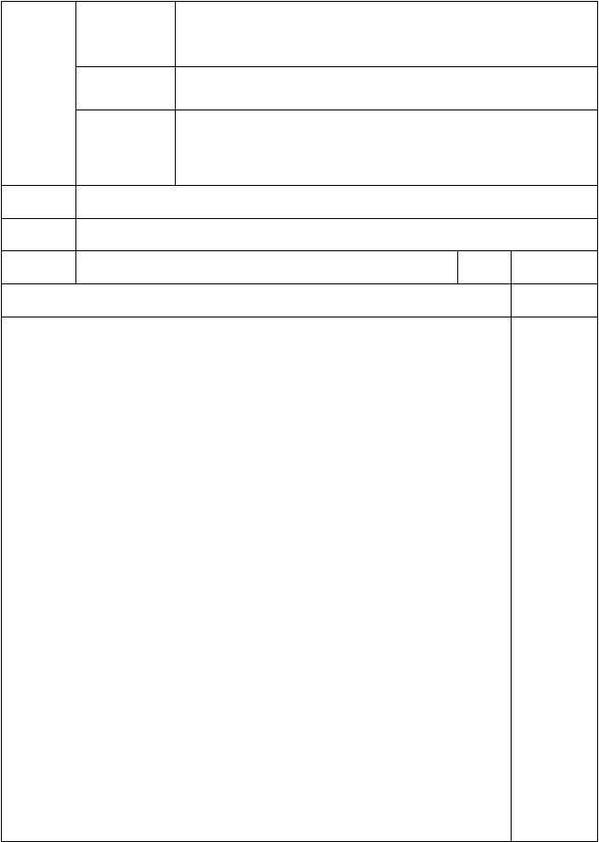
        - 复习 Unit1～3 的Vocabulary，Target和sounds and
知识与技能 words.
教 2. Activities 1～4
学 过程与方法 通过评讲练习，复习 Unit1～3 所学。目
标 情感态度

教学重点

和价值观
Activities 1～4
学生通过练习掌握做题方法。

教学难点 Activity3 以及各题的做题方法。教具准备 PPT
教 学 过 程
课时 1
备 注

Review
  - Review the Vocabulary of Unit1～3. 2.Review the Target of Unit1～3.
3.Review the sound and words of Unit1～3.

Activity 1 ：Listen，read and circle. (Page 38)
  - Ss read the sentence from A～E. 2.Listen to the tape.
- T: I’m going by ……？ [Ss: plane.] T: Now, circle the correct answers.
- Using the same way to finish them
.

Activity 2 ：Look ,listen， and write. (Page 38)
  - Ask the Ss to look at the pictures first.
  - Ask the Ss to tell about the each picture. T： What’s he/she going to do ?
Ss: He/She is going to…….

  - Listen to the tape，fill in the blanks.
  - Listen again，check the answers.

Activity 3 ：Read and write. (Page 39)
  - Ask the Ss to read the questions first.
  - Find a key word in the questions ，and find the answers in

第 26 页 共 62 页


the passages with the key word.
  - T explains the meaning of the passages，and tell them where to find the answers.
  - T ： What is Mary going to do tomorrow? （ Key word ： tomorrow）
(Ss: Have a vacation.)
T: What is Mary going to do with her cousin? （ Key word ： cousin）
(Ss: Make some model cars.)
  - Using the same way to do passage B.

Activity 4 ：Listen，read and circle. (Page 39)
  - Ask the Ss to tell about the sounds of ph，y，and op in the words photo，by，and shop.
  - Ask them to circle the other words with the same sounds.
  - Check the answers together.

Homework
- Copy the Vocabulary of Unit1～3
- Read the Story and the Target of Unit1～3

Review 1
板 P39 3. Key word：
书 A.1. tomorrow
设 A.2. cousin
B.1. Where
计 B.2. How
B.3. stay
教学反思

开心版五年级下册英语教案导学案教学设计最新版

年级：五年级
科目：英语 编号： 14

主备教师
辅备教师

第 27 页 共 62 页

以上内容仅为本文档的试下载部分，为可阅读页数的一半内容。如要下载或阅读全文，请访问：https://d.book118.com/868061123017006037

