重庆实验外国语学校2023-2024学年九年级上学期期末英语试卷（解析版）
Ⅱ.语法选择。 根据短文内容，从A、B、C三个选项中选出一个语法正确的答案，并把答题卡上对应题目的答案标号涂黑。
16．（10分）Dear Mr.Hunt，
I'm （1） student in CQFLS.I like English，but I'm not good at speaking or reading.I even （2） a C for my exam yesterday.Could you tell （3） what to do？
Ana
Dear Anna，
It's normal to have difficulty （4） learning foreign languages.Here are some （5） .
Firstly，pronunciation is as （6） as grammar.It is helpful for you to watch some English movies and try to follow the speakers.
Secondly，try reading simple stories first.The book Little Prince is a good choice.It （7） in French but was translated into many languages.The story is short and fun with some simple grammar，making it easy to understand.
Lastly，it is a good idea （8） an E﹣dictionary.When you use E﹣dictionaries，you can see （9） they become so popular.Because they save a lot of time!If you look up words quickly，you （10） it easier to read.
Mr.Hunt
（1） | A.a | B.an | C.the
（2） | A.get | B.gets | C.got
（3） | A.I | B.me | C.my
（4） | A.in | B.on | C.at
（5） | A.suggestion | B.suggestions' | C.suggestions
（6） | A.important | B.more important | C.the most important
（7） | A.wrote | B.was writing | C.was written

（8） | A.using | B.to use | C.use
（9） | A.because | B.when | C.why
（10） | A.will find | B.found | C.find
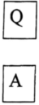
Ⅲ.完形填空。（每小题1.5分，共15分）根据短文内容，从A、B、C、D四个选项中选出一个能填入相应空格内的最佳答案，并把答题卡上对应题目的答案标号涂黑。
17．（15分）Once upon a time，there was a family with 8 children living in a village.Two of the children，both boys（1） very much，but the family was so poor that it was impossible to send both of them to study at an art college at the same time.
After many discussions，the two boys finally （2） a plan.They would toss（抛） a coin.The loser would go down into the mines（矿井）and，pay for his brother's college tuition（学费）.Then（3） his study，he would pay for the other to study at the college.
One of the brothers，Durer，won the toss and his brother Jack went down into the mines.Durer studied with all his heart and his paintings were much （4） than those of his teacher's.He was beginning to make a lot of money for his paintings.
Durer returned （5） studying for 4 years.It was Jack's turn to go to the art college.However，when Jack was told the good news，he said （6） ，"The four years in the mines does too much to my hands.It is too late，（7） I can't even hold a cup now."
To show his great love and respect for his brother，Durer drew Jack's （8） with palms（手掌） together and thin fingers towards the sky.He called his drawing The Praying（析祷） Hands
The next time you see a copy of that touching work，take a second look and let （9） remind you：No one ever succeeded （10） .
（1） | A.swimming | B.painting | C.singing | D.dancing

（2） | A.worked out | B.looked for | C.talked about | D.brought back
（3） | A.began | B.finished | C.kept | D.failed
（4） | A.cheaper | B.older | C.bigger | D.better
（5） | A.after | B.before | C.by | D.during
（6） | A.proudly | B.happily | C.sadly | D.secretly
（7） | A.because | B.so | C.but | D.although
（8） | A.eyes | B.hands | C.face | D.head
（9） | A.him | B.them | C.us | D.it
（10） | A.forever | B.alone | C.fast | D.suddenly
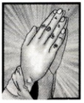
Ⅳ.阅读理解。 （共35分）阅读下列材料，从A、B、C、D四个选项中选出最佳答案，并把答题卡上对应题目的答案标号涂黑。
18．（3分）
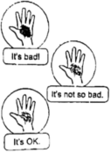 | Get a burn and don't know what to do？Here are some tips for you!First，stay calm and turn off the stove（炉灶）.This way，it won't start a fire.Next，check your burn.  If it's bad，go to the hospital at once!If it's not so bad，cool it under running water until you feel better.Then，put on some burn cream and cover it with a bandage.If it's OK，you should also cool it with running water and clean it.Then，make sure to keep it clean so it can get better faster.
（1）This passage is for someone who has .
A.a cold
B.a headache
C.a dirty hand
D.a burn
（2）According to the passage，when a person gets a burn，he should first.
A.check his burn
B.turn off the stove
C.go to the hospital
D.put a bandage on it
（3）Tracy's hand gets burned but it's not so bad.What is the right order for dealing with the burn？
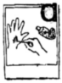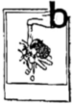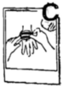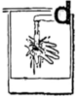
A.badc
B.bdac
C.dabc
D.dbac
19．（8分）Once there was a girl named Mathilde.She was pretty and attractive，loving beautiful clothes and shining diamonds.Unluckily，she married a clerk and lived a poor life.
Scene One
Husband：Darling!Good news!The Minister of Public Instruction（教育部长） invited you and me to the party on Monday evening，January 18th.
Mathilde：What do you wish me to do with that？
Husband：My dear，I thought you would be glad.You never go out，and this is such fine chance.Everyone wants to go
Mathilde：But I don't know what to put on.
Husband：Well，how about the dress you go to the theater in？It looks fine.Oh，what's the matter？Why do you look so sad？
Mathilde：I have no gowns（礼服）.Therefore，I can't go to the party.Give your invitation to someone who has beautiful gowns.
Husband：How much could a suitable gown cost？
Mathilde：I have no idea，but I think I could manage it with 400 francs（法郎）.
Husband：Well.I will give you 400 francs.Try to have a pretty gown.
Mathilde：Oh darling!I love you!But it still annoys me not to have a piece of jewelry （珠宝）.With nothing to put on，I shall look poor.I would rather not go at all.
Husband：What about asking your friend，Madame Forestier，to lend you some jewelry？
Mathilde：Sounds good!I've never thought of it.
Scene Two
The next day，Mathilde went to her friend Forestier and told her about her trouble.
Mathilde：My dear Forestier，I will go to a party and I want to borrow some jewelry from you.
Forestier：No problem.Choose whatever you like in the box，my friend.
Mathilde：Could you lend me this diamond necklace？
Forestier：Sure，you will look great wearing it!
Mathilde：Thank you very much，my dear!
Scene Three
The night of the party arrived.Mathilde was a success.She was prettier than any other woman at the party.

（1）The Minister of Public Instruction would hold a party on .
A.Monday afternoon
B.Tuesday evening
C.Jan.19th
D.Jan.18th
（2）Mathilde was sad because she didn't have a/an .
A.invitation
B.gown
C.chance
D.friend
（3）What can we know about Mathilde？
A.She lived a poor but happy life.
B.She didn't care about what she wore.
C.Her husband loved her very much.
D.Her friend Forestier was mean to her.
（4）The passage above may be from a/an .
A.play
B.poem
C.interview
D.advertisement
20．（8分）Dark green military overcoats recently became popular after some young people posted videos of wearing them on college campus and on the street.The overcoats，which were worn by soldiers in the past，now became a symbol of fashion and a new trend（流行趋势）.
According to Taobao，monthly sales of the coats at many stores have reached 10，000 to 30（客服） said that people had paid little attention to the coats in the past few years，while this winter a large number of people were buying and asking about them.
Behind the trend is the change in young people's shopping habits.
Compared with other generations（一代），they are more rational than before.They have chosen not to follow others blindly but stick to their own choices.They'll choose what suits them best.Whether it's an overcoat or a jacket，it's just a warm piece of clothing for winter.Young people often say，"it is not that we cannot afford down jackets （羽绒服）（经济实用的） military overcoats."
This kind of self﹣enjoyment also shows another side of the young generation.According to a survey，by 2022，China's"post﹣1990"and"post﹣2000"generations have become a new group in shopping with a population of nearly 320 million.Over 70 percent say they buy things mainly to enjoy themselves and improve happiness.They pay for what is good for their feelings and experience.

（1）According to the passage， wore the military overcoats in the past.
A.students
B.teachers
C.soldiers
D.officers
（2）The writer uses the numbers in Paragraph 2 to show .
A.the increase of Taobao users
B.the popularity of military overcoats
C.the reason of a new trend
D.the development of online shopping
（3）According to Paragraph 4，what will a "rational" person do when shopping？
A.Shop freely.
B.Follow blindly.
C.Act bravely.
D.Think carefully.
（4）The purpose（意图） of writing this passage is to .
A.introduce a new clothing trend among young people
B.show a change in young people's shopping habits
C.call on more people to wear the military overcoats
D.tell people the importance of not following others blindly

21．（8分）"Welcome to our new 'classroom'!"said Chen Dong，one of the three astronauts of the Shenzhou XIV mission.
They were giving a science class 400 kilometers above Earth on October 12.It was the third space class and it was held in the Wentian lab module（实验舱）.The two classes before were held in the Tianhe core module（核心舱）.
What does the new"classroom"look like？Chen，together with Liu Yang and Cai Xuzhe，showed us around."The beds in the Tianhe module are placed horizontally（横着），"said Liu.That means astronauts in the Wentian lab module need to sleep standing up!But as Liu explained，people don't feel any difference because there's no gravity（重力）
The astronauts also showed their "space farm"，where lettuce，wheat（拟南芥） and rice are
grown."Take a picture!" "Send the picture!"Through a voice﹣controlled camera，Chen already sent a picture of the thale cress to scientists on Earth.Then he used scissors to cut a sample（样本），"said Chen.Scientists will study how the environment of space affects the growth of plants.
"Can you see the water drops coming from the leaves？This is called "guttation" （植物吐水现象），"said Liu，holding the well﹣grown rice.In space
"We hope in the near future，we can harvest（丰收） the food grown on our own，we can harvest food on the moon or even Mars!"

（1）Where was the third space class held？
A.On Mars.
B.In the Wentian lab module.
C.On Earth.
D.In the Tianhe core module.
（2）How did Astronaut Liu sleep in the module？
A.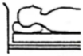
B.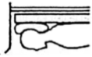
C.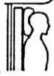
D.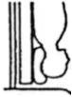
（3）What can we infer from the passage？
A."Guttation"can be clearly seen from leaves of rice in space.
B.It's easy to grow lettuce，wheat，and rice in Shenzhou XIV.
C.People may try to grow food on other planets in the future.
D.Astronaut Chen sent pictures of thale cress to children on Earth.
（4）Which may be the best title for the passage？
A.The Future of Space Science
B.The Life of Three Astronauts
C.A Journey into the Space
D.A Space Class in Shenzhou XIV
22．（8分）①Many stick puppets（木偶），dressed in traditional costumes，have fun on stage.They are able to change their facial expressions and perform difficult movements along with the music.The people who control the puppets are below them and use three rods（杆子）
②This is the art form of stick puppet plays popular in Xiaoyi（孝义），Shanxi Province.They were introduced to Xiaoyi during the Song dynasty，and became the most popular during the Ming and Qing dynasties.Traditionally
③Wang Maowei，40，is a master of performing the beautiful art form on stage.
④Since his parents used to work with the Xiaoyi Shadow Puppetry and Puppet Troupe（戏班），he fell in love with the art form as a teenager.He decided to be a puppet performer and "make it a lifelong career（事业）".
⑤When he was 17，he went to Xi'an，to learn puppet﹣making from a master.After spending seven years there
⑥"Traditional art in modern times is a challenge for performers."Says Wang， "Don't stay in the same old way.It's important to keep up with the times."So▲.First，unlike the traditional puppets，Wang uses one rod instead of three to make the puppets work.A special tool is put inside the puppet heads﹣the nose，combining traditional skills with modern technology.His puppets can perform bianlian，or face﹣changing，to attract more young people，his troupe now uses background music instead of local operas when performing the plays.This makes it easier for the audience to understand.

（1）The stick puppets cannot in a puppet play.
A.w ear traditional costumes
B.perform difficult movements
C.change their facial expressions
D.move hands and heads by themselves
（2）What does "it" refer to（指） in Paragraph 4？
A.Joining the local troupe.
B.Performing the stick puppet play.
C.Learning from a puppet﹣making master.
D.Letting more people know about the art.
（3）Which sentence can be put in the ▲？
A.many people think he is truly a puppet making master
B.he has done something new to the traditional art form
C.the plays are great for spreading the Chinese culture
D.he has made the puppets different from the old times
（4）Which group of words are the most suitable for the mind﹣map？
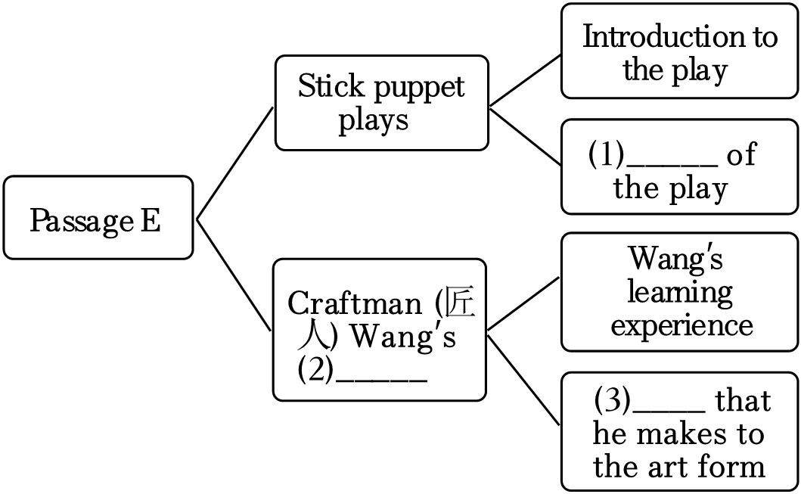
A.Birthplace；story；Examples
B.History；love；Changes
C.History；story；Changes
D.Birthplace；love；Examples
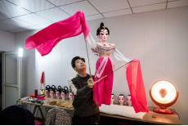
V.口语应用。 阅读下面对话，从方框内7个选项中选择5个恰当的句子完成此对话，并把答题卡上对应题目的答案标号涂黑。
23．（5分）A：Welcome to our store. （1）
B：I'd like to buy a smart TV.
A：We have different kinds of smart TVs here.You can have a look first.
B：This one looks very nice. （2）
A：It's made in China.You know China is getting better at making hi﹣tech products.
B：It's wonderful. （3）
A：It's 8，699 yuan.
B： （4） Do you have a cheaper one？
A：Of course.What about this one？It's on sale，only 4，199 yuan.
B：The price is OK. （5） Please deliver it to my home as soon as possible.
A：No problem!

A.Is it expensive？
B.What can I do for you？
C.I'm afraid I can't afford it.
D What's the price of it？
E.I will take it.
F.Where is it made？
G.I don't like it，either.
第Ⅱ卷（共65分）Ⅵ.任务型阅读。（共9分）阅读下文并回答问题。
24．（9分）One night I was sitting in my kitchen half﹣listening as my 15﹣year﹣old son Tommy fought against his younger brother Kevin.Later，Kevin went upstairs with a sad look
on his face.Clearly，he lost the fight.However
About 20 minutes later，as I was walking upstairs，I heard Kevin crying in his room.
I knocked on the door and asked，"Kevin，do you want to talk？"
There was no answer.I tried again.Still，nothing happened.
So，I took a piece of paper and wrote，"If you don't want to talk（使滑动） it under the door.
I sat on the floor outside his door and waited for an hour.Finally，a note slipped out.As I read it，I couldn't help crying.It said，Tommy thinks I am too weak and doesn't want to play basketball with me.You and Dad are never around even to notice me."
He was right about my part.Feeling sorry for him，I wrote back，" ."
I could hear him crying softly.Half an hour later，a note with"Thanks" came out.I wrote back，"For what？"
He returned，"Loving me."
Since then，I have tried my best to care about my family members.When one of us notices that someone is unhappy，we'll smile and say

（1）Did Kevin win the fight against Tommy？

（2）How did Kevin's mother communicate with him？

（3）According to Kevin's note，what did he think of himself and his family？

（4）What may Kevin's mother write back to him？Please finish the note.

Ⅶ.首字母填空。（每空1分，共5分）
25．（1分）It is i to make fun of someone's appearance.
26．（1分）—Which do you p ，tea or coffee？
一I like tea better.
27．（1分）Mother thinks ice﹣cream is unhealthy so she s eats it.
28．（1分）Don't make a d in a hurry!Think twice，or you may regret it.
29．（1分）We all went to the park e Tom.He was ill at home.
Ⅷ.用所给词的正确形式填空。（每空1分，共5分） 用所给单词的正确形式填空，一空一词。
30．（1分）My parents always say they are （pride） of me.
31．（1分）In order to study better，we should manage our time （wise）.
32．（1分）He thought it was hard （deal） with the problem.
33．（1分）We each are （suppose） to take action to protect the environment.
34．（1分）Eric learned to play the guitar by （practice） day by day.
Ⅸ.完成句子。（每空1分，共10分）根据所给提示，完成句子。每空一词，含缩略词。
35．（2分）Nancy has already finished her work.（改为否定句）
Nancy finished her work .
36．（2分）Joseph used to go swimming in summer.（对划线部分提问）
What Joseph use to in summer？
37．（2分）My sister will spend twenty minutes walking to school.（改为同义句）
will my sister twenty minutes to walk to school.
38．（2分）青少年应该被允许挑选自己的衣服。
Teenagers should to choose their own clothes.
39．（2分）你不尝试就不能成功。（完成译句）
you try，you will not be to succeed.
X.短文填空。（每空2分，共16分）根据下面短文内容及部分首字母提示，在短文的空格处填上一个最恰当的词，使短文完整、通顺。请将完整的单词填写在答题卡上对应的位置。
40．（16分）When talking about their personalities，people often say they are extroverts（外向型） or introverts（内向型）（1） world while extroverts get joy by communicating with other people.
The tests called MBTJ are getting （2） with young people these days.More and more young people take the tests to know their own personalities better.Results can tell us something about ourselves and we need to treat them properly.However，some people fail to do that.For example，they make an excuse（借口）（3） they hope to keep distance（距离） from others.But being introverts should （4） be an excuse to be rude.
Tammy，a teacher in a high school shares one of her （5）s about people who use "being introverts" as an excuse.One day，she wanted to communicate with her students and asked them some questions face to face.Some students chose to answer while others went away （6） saying anything.In Tammy's mind，some of them are truly shy but others are just considering （7） as those who are "too cool" to answer the questions. "This kind of behavior makes me sad and even doubt myself，" she said.
These students may push away or hurt people who really care about them.
Avoiding social situations will not help them in the long term.No matter if we are introverts or extroverts，we all need to communicate with others instead of （8） away from them.
xI.书面表达。（满分20分）
41．（20分）新年的钟声已经敲响。看，你的朋友们已经立下2024年的flag。新的一年，你想做什么样的自己呢？你有什么期待和计划吗？请谈谈你的新年计划以及实现方式。
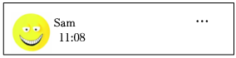
Happy new year!!! 
I will spend more time reading books in 2024!
How about you？ 
Abbey…get active…
Joe：…eat well.
：…take up a new hobby.…

参考要点：
（1）总的期许；
（2）新年计划（学习：健康；交友……）及实现方式；
（3）……
要求：
（1）80﹣120词；
（2）文中不能出现自己的姓名和所在学校的名称。

2024 has come!It's time to make New Year's resolutions!_________

参考答案与试题解析
Ⅱ.语法选择。 根据短文内容，从A、B、C三个选项中选出一个语法正确的答案，并把答题卡上对应题目的答案标号涂黑。
16．（10分）Dear Mr.Hunt，
I'm （1） A student in CQFLS.I like English，but I'm not good at speaking or reading.I even （2） C a C for my exam yesterday.Could you tell （3） B what to do？
Ana
Dear Anna，
It's normal to have difficulty （4） A learning foreign languages.Here are some （5） C .
Firstly，pronunciation is as （6） A as grammar.It is helpful for you to watch some English movies and try to follow the speakers.
Secondly，try reading simple stories first.The book Little Prince is a good choice.It （7） C in French but was translated into many languages.The story is short and fun with some simple grammar，making it easy to understand.
Lastly，it is a good idea （8） B an E﹣dictionary.When you use E﹣dictionaries，you can see （9） C they become so popular.Because they save a lot of time!If you look up words quickly，you （10） A it easier to read.
Mr.Hunt
（1） | A.a | B.an | C.the
（2） | A.get | B.gets | C.got
（3） | A.I | B.me | C.my
（4） | A.in | B.on | C.at
（5） | A.suggestion | B.suggestions' | C.suggestions
（6） | A.important | B.more important | C.the most important
（7） | A.wrote | B.was writing | C.was written
（8） | A.using | B.to use | C.use

（9） | A.because | B.when | C.why
（10） | A.will find | B.found | C.find
【分析】这封信主要是Anna向Mr.Hunt请教如何提高英语口语和阅读能力。Mr.Hunt给出了一些建议，包括观看英语电影，阅读简单的故事书，以及使用电子词典来帮助提高英语水平。
【解答】（1）考查冠词。句意：我是CQFLS的一名学生，用于以辅音音素开头的单词前表示泛指，用于以元音音素开头的单词前表示泛指，表示特指，表泛指，故选A。
（2）考查动词。句意：我昨天的考试甚至得了C，A原形，C过去式，动词要用过去式。
（3）考查代词。句意：你能告诉我该怎么办吗，主格，宾格，根据tell是动词，故选B。
（4）考查介词。句意：学习外语有困难是正常的，B在上面，根据 have difficulty in doing sth做某事有困难，故选A。
（5）考查名词。句意：以下是一些建议，单数，C建议，根据are可知要用名词复数。
（6）考查形容词。句意：首先。A重要的，C最重要的，中间要用形容词原形。
（7）考查动词。句意：它是用法语写的。A写，B正在写，被动语态，要用被动语态。
（8）考查动词。句意：最后。use使用，B不定式，根据句型"It's+adj+to sth"做某事是怎样的"。
（9）考查连词。句意：当你使用电子词典时。A因为，C为什么!（因为它们节省了很多时间，你可以看到它们为什么如此受欢迎。
（10）考查动词。句意：如果你快速查单词。find发现，B过去式，根据if引导的条件状语从句，所以主句用一般将来时。
【点评】根据短文大意和语境选择合适的单词，并用其正确的形式填入空白处，使补全后的短文意思通顺，语法正确，结构完整，注意单词的适当形式。
Ⅲ.完形填空。（每小题1.5分，共15分）根据短文内容，从A、B、C、D四个选项中选出一个能填入相应空格内的最佳答案，并把答题卡上对应题目的答案标号涂黑。
17．（15分）Once upon a time，there was a family with 8 children living in a village.Two of the
以上内容仅为本文档的试下载部分，为可阅读页数的一半内容。如要下载或阅读全文，请访问：https://d.book118.com/878116064016006027

