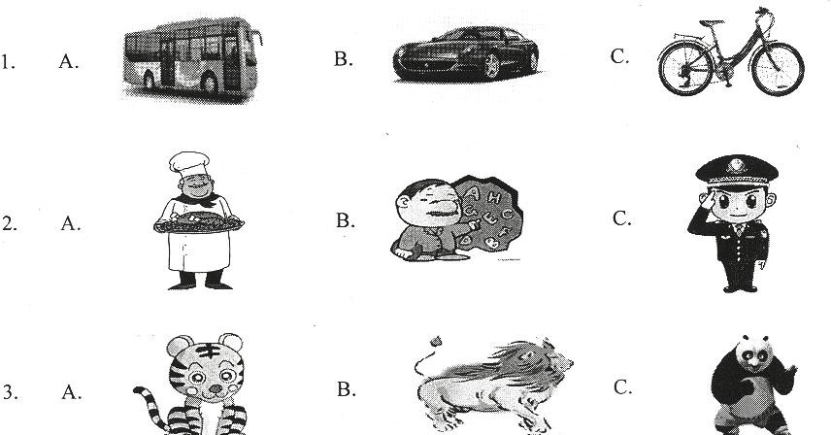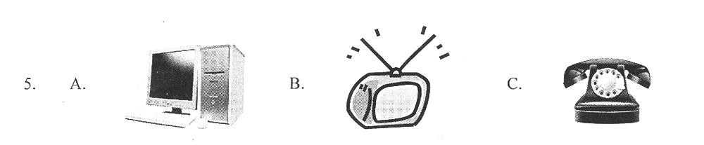机密★
1 / 23

2018 年云南省初中学业水平考试英语 试卷卷
(全卷四个部分，共 8 页；满分 100 分，考试用时 120 分钟>

注意事项:

1.本卷为试卷卷。考生必须在答题卡上解题作答。答案应书写在答题卡的相应位置上，在试卷卷、草稿纸上作答无效。b5E2RGbCAP 2.考试结束后，请将试卷卷和答题卡一并交回。
第一部分听力(共四节，满分 25 分>

做题时，先将答案标在试卷卷的相应位置，听力测试结束后， 请将试卷卷上的答案转涂到答题卡上。
第一节听句子，从题中所给的A, B, C 三个选项中选出与所听句子内容相关的图画。每个句子听两遍。(共 5 小题；每小题 1 分，满分 5 分>p1EanqFDPw

第二节听句子，从题中所给的A、B、C 三个选项中选出与所听句子内容相符的正确答语。每个句子听两遍。〔共 5 小题；每小
题 1 分，满分 5 分〕DXDiTa9E3d

- A. What a pity!

- A. Congratulations!
B. It’s my pleasure.
B. Just so-so.
C. That’s right.

C. Good luck.

- A. Three years ago.
B. In three years. C.For three years.

- A. All right.
B. Sorry to hear
that
C. Never tried.

- A. Good idea.
B. Well done. C.It doesn’t matter.

第三节听对话，从题中所给的A、B、C 三个选项中选出能回答问题的正确选项。每段对话听两遍，(共 5 小题；每小题 1 分， 满分 5 分>RTCrpUDGiT
听第一段对话，回答第 11、12 小题。

- What kind of noodles would the woman like?

  - Potato noodles.

  - Beef noodles.

  - Egg noodles.

- What’s the woman’s phone number?

A. 436-1789.

B. 463-1798.

C. 463-1789.

听第二段对话，回答第 13~ 15 小题。

- What are the two speakers doing now?

  - They’re talking on the phone.

  - They’re visiting Beijing.

  - They are visiting the hospital.

- Who is Maria going to travel with?

  - Mike.

  - Mike’s grandma.

  - Her parents.

15. What | will Mike do during his | summer | vacation?
A. Study | in England.
B.Travel | to Beijing.

C. Look after his grandma.

第四节听短文，从题中所给的A、 B、 C 三个选项中选出能完成下列信息表格的正确选项。短文听两遍。〔共 5 小题；每小题 2 分， 满分 10 分>5PCzVD7HxA

Speaker Place Time
Experiences
Information about a talk Mr. Black, a famous 16
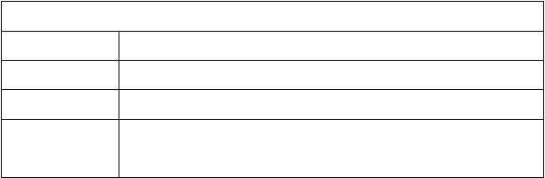
17
18 on Saturday evening
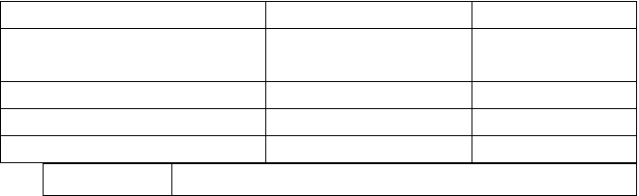
travelled through 19 different countries

- A.  - A. | actor  in the library | B. student  B. in the hall | C. writer  C. at a university
18. A. | at 7:15 | B. at 7:30 | C. at 7:45
19. A. | Three | B. five | C. seven
20. A. | England | B. Africa | C. China
 | About all | his experiences in | 20

第二部分 英语知识运用(共三节，满分 30 分>

第一节词语释义(共 5 小题；每小题 1 分，满分 5 分>

从题中所给的A、 B、 C、 D 四个选项中选出与句中划线部分意义最接近的解释，并将所选答案涂到答题卡的相应位置上。jLBHrnAILg
- I hope I’ll travel all over the world one day.

  - the next day B. in the

futurexHAQX74J0X

C. at that time D. the

whole dayLDAYtRyKfE

- Jack takes after his father. They’re both tall and strong.Zzz6ZB2Ltk
  - looks like B. waits for C. takes care of

D. feels excited aboutdvzfvkwMI1

- It’s reported that a person throws away 50kg of food every year. We should save food.rqyn14ZNXI
  - cooks B. takes C. eats D. wastesEmxvxOtOco
- —You’ll have a free trip to Hong Kong!

—Really? That’s music to my ears. I can’t wait!

  - That’s good news. B. That’s beautiful music.SixE2yXPq5
C. Have a good time. D. I’m afraid not.6ewMyirQFL
- The news about the missing plane broke many people’s hearts. We hope the passengers can come back home safely.kavU42VRUs
  - lost many people’s lives B. cheered many people upy6v3ALoS89

C. made many people sad D. surprised many peopleM2ub6vSTnP
第二节 单项填空(共 15 小题；每小题 1 分，满分 15 分>

从题中所给的A、B、 C、 D 四个选项中选出能填入空白处的正确选项，并将所选答案涂到答题卡的相应位置上。0YujCfmUCw
- —Eric, you look so cool with your sunglasses.

—
  - Not really

  - It’s not C. Nothing true much

D. Thank you

- My favorite is summer. I can swim with my

friends.eUts8ZQVRd
  - month B. day C. season D. weekend

- —Excuse me. Could you tell me the way
the

nearest supermarket?sQsAEJkW5T

—Go down the street and turn left. Then you’ll see it.GMsIasNXkA
  - to B. of C. in D. atTIrRGchYzg
- —May I take a look at your new iPad?

- Here you are.

  - I hope not B. Not at all

C. Of course D. No way7EqZcWLZNX

- If there
no buying and selling of animals, there

will be no killing in nature.lzq7IGf02E

  - is B. will be C. has

D. will havezvpgeqJ1hk

- —Oh, dear! Your room is untidy.

—Sorry, mom. I’ll .

  - set it up B. clean it up C. put it up

D. look it upNrpoJac3v1

- —What do you think of the Sochi Winter Olympic Games?1nowfTG4KI
- .They are exciting.

  - I love themB. I can’t stand them

C. Sounds terribleD. I don’t mind them 33.— sweet song it is!
—Yeah, it’s My Heart Will Go On sung by Celine Dion.fjnFLDa5Zo

A. How B. How a C. What a D. WhattfnNhnE6e5

- We
use mobile phones when the plane takes

offHbmVN777sL

  - may not B. shouldn’t C. needn’t D. mustn’tV7l4jRB8Hs
- China’s hot words, like tuhao, dama and lianghui,

in the western media(媒体>.83lcPA59W9

  - use widely B. is widely used C. uses widely

D. are widely usedmZkklkzaaP

36. —Kunming is really | a comfortable city | to live
in.AVktR43bpw
- .The weather  A. So it is B. So | is pleasant.  is it C. So it | does.D. So does
itORjBnOwcEd

- —To achieve a bright future, we should
study

hard
keep in good health.2MiJTy0dTT

—I agree with you.

  - not; but B. not only; but also C. neither; nor

D. either; orgIiSpiue7A

- —You look really tired. ?

—I didn’t sleep well last night. I had a headache.

  - How about you B. What should I douEh0U1Yfmh
C. What’s the matter D. How are you feeling nowIAg9qLsgBX
- Keep on. Don’t stop. The you climb, the

you will see.WwghWvVhPE

  - highest; farthestB. highly; farther

C. high; far D. higher;

fartherasfpsfpi4k

- —Do you know
in America?

—Sure. It’s the third Sunday of June.

  - when Father’s Day is B. how is Father’s DayooeyYZTjj1
C. when is Father’s Day D. how Father’s Day isBkeGuInkxI

第三节 完形填空(共 10 小题；每小题 1 分，满分 10 分>

从题中所给的A、 B、C、D 四个选项中选出能填入空白处的正确选项，并将所选答案涂到答题卡的相应位置上。PgdO0sRlMo

There was once a little monkey in the forest. He liked to41 everyone. He jumped from tree to tree, called all the other42 bad names and threw bananas or stones at them.3cdXwckm15
One day he saw a baby elephant near the river. “Hey, baby elephant, you are so 43 , and you’ll never catch me.” said the monkey.h8c52WOngM
“44 do you have to laugh at me?” the baby elephant asked. “I 45 make trouble or make anyone upset.”v4bdyGious
“It’s so fun.” said the monkey.

The monkey46, jumping from tree to tree. Then he saw a turtle(乌龟>47 with his mouth open. The monkey thought it would be a lot of fun putting his finger 48 the turtle’s mouth. He did so, 49 the turtle shut his mouth just at

以上内容仅为本文档的试下载部分，为可阅读页数的一半内容。如要下载或阅读全文，请访问：https://d.book118.com/885014312212011120

