2010 年秋季全国基础教育英。语水平检测（习思水平检测） 三级测试题
第一部分 听力理解（共３０分）

第一节 听录音并排序。（共 5 小题，每小题 1.5 分，计 7.5 分）
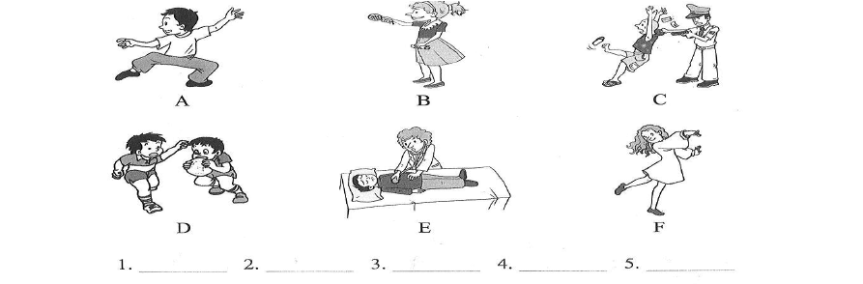
你将听到五段关于学生对理想中工作的描述。请根据描述的先后顺序，重新排列下面图片的顺序，并将图片下的字母标在试卷的相应位置。（提示：六幅图片中有一幅是多余的。）

第二节 听录音并选择图片。（共 6 小题，每小题 1.5 分，计 9 分）
你将听到六组不同场景的对话，每组对话后有一个小题。请从题中所给的 A、B、C 三幅图片中，选出能回答问题的最佳选项，并标在试卷的相应位置。
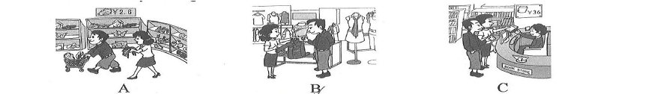
- Where are they talking?

- What kind of weather does the girl like?

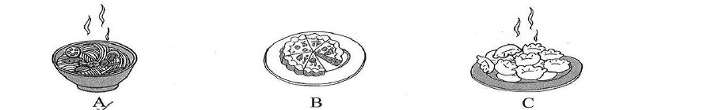
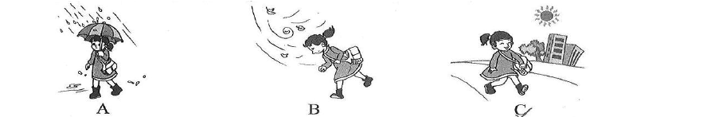
- What does the woman want to eat?


- What's the man's favorite music?


- Why is the boy late for school?

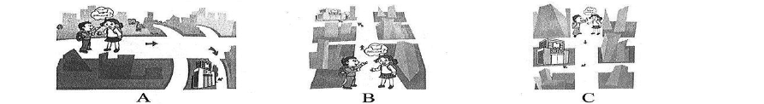
- Where is the bookstore?

第三节 听录音并选择最佳选项。（共 5 题，每小题 1.5 分，计 7.5 分）
你将听到两段对话，每段对话后后有几个小题。请从题中所给的A、B、C 三个选项中，选出能回答问题的最佳选项，并标在试卷的相应位置。

听第一段对话，回答第 12 至 13 小题。
- What will the mother let the boy do first?
A. Play basketball. B. Do his homework C. Watch TV 13.Where are they talking?
A. At home B. In the school C. On the playground

听第二段对话，回答第 14 至 16 小题。
- According to the dialogue, the woman will probably spend on the gift.
A. 15 dollars B.20 dollars C. 25dollars 15.The woman thinks a book is .
A. too cheap B. a little boring C. not special 16.The woman finally decided to buy a .
A. CD B. sweater C. basketball

第四节 听录音并记录信息。（共 6 小题，每小题 1 分，计 6 分）
你将听到一段有关学校课外活动的对话。请根据对话内容，完成下面的速记卡，并将主要活动信息填写在题号后的横线上。
Day Monday Tuesday Wednesday Thursday Friday Saturday
Sunday
My School Life
Activity
(17)
(18)
(19)
(20)
(21)
(22)
having a rest at home

第二部分 语言知识运用（共 15 分）

第五节 选择填空。（共 10 题，每小题 1 分，计 10 分）
请阅读下面的对话，并从题中所有的 A、B、C 三个选项中, 选出可以填入空白处的最佳选项。23.—Would you like to take a taxi home?
—Sorry, I haven't got any money. I've my wallet at home.
A. left B. forgot C. missed

- —Could I use your dictionary? — .

  - No, not at all
  - Yes, please
  - missed

- —Are you going to bring ? —Yes. I want to take some photos.

  - your camera
  - some books
  - a tent

- — are you going on vacation?
—I'm going to Harbin first, then to Manzhouli.
  - How B. Where C. When 27.—This pair of trousers is too long for me.
—Well, let me show you a pair. What about this one?
- lower B. smaller C. shorter

- —When did you in Paris? —Last night.

  - reach
- —My bike is broken.
  - have to
  - arrive
—So you walk to school?
- may C. can
- get

- —Would you like bowl of rice? —No, thanks. I've had one, and I'm full now.
  - other B. another C. one

- —Lily, why not go skating with us this Saturday?
—Sorry. I must go to visit my grandma because she is ill.
  - So B. And C. But

- —What your friend ? —He's kind and we all like him.

  - does; like
  - is; like
  - does; look like

第六节 选词填空。（共 5 小题，每小题 1 分，计 5 分）
下面是一篇关于 Mike 和他的爱车之间的一个小故事。阅读后，请从 Word Bank 中选择恰当的词语，并用其正确形式填空。（提示：Word Bank 给出的六个词语中有一个是多余的。）

Word Bank
happy / car / make / like / beautiful / sit

Mike works in a factory. He (33) a lot of money every month. Mike loves

- and he likes small red cars best. He likes driving very fast. Last month, Mike
bought a small red car. He often takes his wife out in this car, and his wife always says,
"But, Mike, why did you buy such a small car? We are almost (35) on the ground."
Then Mike laughs. He is very (36) .He likes being very close to the ground.
Last week he came out of the factory and went to his car. There was a small boy near
it .He was looking at the (37) red car. Then he looked up at Mike. In the eyes of
以上内容仅为本文档的试下载部分，为可阅读页数的一半内容。如要下载或阅读全文，请访问：https://d.book118.com/886133032151010032

