情景交流
参赛学生现场抽取一个题目，根据题目要求，与同队参赛教师扮演同一角色，与主试官进行 一对一现场交流，交替回答现场主考试官的问题。
本环节无现场备赛
比赛时长：5 分钟
分值：10 分





No.1

SAFETY STARTS WITH YoU
7 TIPS TO KEEP YOU SAFE AT WORK


Shorteuts
Wear Vour PPE
When on the job,whether
Whenever applicable,
wear all required
personal protection
you're operating tools and
machinery or sitting
equipment (PPE)
recommended
behind a desk,follow
all training and
instructions.
for your job,from face
masks to hard hats and
everything in between.
Procedures exist to
help keep you safe.

sitting for Long Pertods of Time

If your job requires long
Be Awere of Your
Surrouindings
Take a few seconds to familiarize yourself with your work environment every shift.The more aware you are of your tasks,your workstation ergonomics,and the space you'll be operating in,the less likely you are to feel
periods of sitting (typing.
driving long distances,
customer service,
etc.),correct posture
is a must to help
prevent back,
neck,and even
hip pain.

fatigued or encounter
a potential hazard
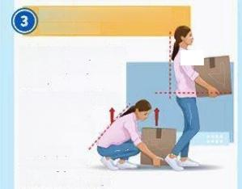
te Lrting Sterts with

RpaR Unsete Coneitons
If you see something, say something! Make your supervisor aware of any unsafe conditions you see
that may potentially be
hazardous to you,your
fellow team members,
and patrons.Keep your work
area and emergency exits clear
at all times to help reduce the likelihood of accidents.


Ereaks
Fatigue can be a
contributing factor to
accidents and injuries,
so make sure to take
regular breaks
throughout your day as
permitted by
your employer.

Your Head
Think before you lift
§171 BILLION
Total Annual Workplace Injury Cost
216
Lost Days Of Work Annually
EVERY
7 SECONDS
Thereis a Workplaceinjury
any heavy object at
work.
Keep the load close
to your waist,
adopt a stable
position
and avoid
bending your
back when lifting.

Task: Suppose you are a trainer from HSE Department and are answering questions
from a newly recruited worker,who is inquiring about safety measures at work.
Explain and clarify any doubts.
Contestants-student &teacher:A HSE safety trainer
Question Master:A new worker
No.of Questions: 6-10

No.2

April 20
谷 雨

联合国
中文日

CHINESE
LANGUAGE
DAY 2023

Opening Ceremony
Time: 6:15 pm-7:45 pm,April 20
Venue:Secretariate Building between Curved Wall and South Wall Lobby
Signature Events at UNHQ
Symposium:Sustainable Future Through Sci-Fi Lens
文学与可持续未来
World-renowned sci-fi writer and Hugo Award winner Mr.Liu Cixin will join UN officials via video link and share views
on sustainable development and the protection of mother earth.
Time:9 am to 10:30 am,April 20
Venue:Conference Rm.7+UN Web TV
Chinese Calligraphy Lecture &Exhibition:All Things Governed by the Laws of Nature
古今书法，道法自然
Calligrapher and educator Mr.Cui Xuelu will give an interactive lecture on the history of Chinese characters and
calligraphy,elaborating on the concept of harmony between humanity and nature in Chinese calligraphy.
In addition,an exhibition of Cui's works will beheld.
Lecture Time:11:15 am-12:15 pm,April 20 Venue:Conference Rm.7+UN Web TV
Exhibition Date:April 17-21 Venue:Curved Wall Lobby
Chinese Painting and Calligraphy Exhibition:The Highest Virtue Resembles Water
上善若水
An exhibition of traditional Chinese paintings and calligraphy,under the theme of water and rabbit,will beheld.
The exhibition aims to celebrate the concept of water in traditional Chinese culture
and highlight the important role water plays in sustainable development.
Date:April 17-28
Venue:South Wall Area Lobby
Multi-media Exhibition:The Chinese Zodiac:In Praise of the Jade Rabbit
中国生肖：玉兔礼赞
Date:April 17-21
Venue: Albano Building Lobby

Events Around the World
The United Nations offices in Geneva,Vienna,as well as the Economic Commission for Africa and UN peacekeeping missions will host exhibitions,lectures,online campaigns to mark the day.

Chinese Wisdom for a Green World
中国智慧绿色发展
Organizer/Permanent Mission of the People's Republic of China to the United Nations
Co-organizerFCoreignnAefairsrnfilcoonf thePeople'sSGovemment ohanxiProvince
Writers Association of Shanxi Province Beijing Contemporary Art Foundation
Task:Suppose you are a professional working at the UN Headquarter and are receiving a visitor who is interested in the Chinese Language Day activities.Explain
and clarify any doubts.
Contestants-student &teacher: A professional at the UN Headquarter
Question Master:A visitor
No.of Questions: 6-10

Celebrating
Infrastructure
Conference
and

No.3
Globas |  | The 2023 FIDIC(International Federation of Consulting Engineers)annual Global Infrastructure Conference will be held from 10 to 12 September 2023 in Singapore for the international construction industry to plan,develop and deliver strategies and solutions for economic and social prosperity and development.The conference theme is “Infrastructure -there is no time to lose:Sustainable global and local strategies to build a better world.”  Before the conference,the Federation Programme will be held from September 9h-102023 for members to network
discuss the implementation of FIDIC's Strategic Priorities and future plans.Further details are available below.

Friday,September 8,2023
9:00AM-5:30PM (SGT) | FIDIC Future Leaders Management Course -Day 1  Agenda to be confirmed in due course.
Saturday,September 9,2023
9:00AM-1:00PM (SGT) | FIDIC Directors and Secretaries (DNS)Meeting 2023  Open to Director and Secretaries of FIDIC Member Associations -Registration is required Raffles City Convention Centre -SKAI Suites (2,3,4)
9:00AM-5:30PM (SGT) | FIDIC Future Leaders Management Course -Day 2  Agenda to be confirmed in due course
2:00PM-4:00PM (SGT) | FIDIC Presidents Meeting 2023  Open to Presidents and elected leaders of FIDIC Member Associations -Registration is required. Raffles City Convention Centre -SKAI Suites (2,3,4)
7:00PM-9:00PM (SGT) | FIDIC Directors and Secretaries (DNS)Networking Dinner  Open to FIDIC Member Association reps and accompanying persons -Registration is required Optional event  Ticket price:$130 (excluding VAT)  Raffles City Convention Centre -SKAI Suites (2,3,4)
Sunday,September 10,2023
8:30AM-9:30AM(SGT) | FIDIC Past Presidents Council Meeting  Open to members of the FIDIC Past Presidents Council,Board members and senior Secretariat staff-Registration is required.  Raffles City Convention Centre -Clark Room
10:00AM-11:00AM (SGT) | FIDIC Regional Group Chairs Meeting  Open to chairs of the FIDIC Regional Groups (EFCA/FIDIC Europe,FIDIC Africa,FIDIC Asia Pacific,FIDIC North America,FIDIC Latin America),Board members and senior Secretariat  staff.-Registration is required  Raffles City Convention Centre -Clark Room
11:30AM-1:00PM(SGT) | FIDIC Committee Chairs Meeting  Open to FIDIC member association representatives,associate members,affiliates,committee members,staff working in member firms,regional group representatives,FIDIC Board members and Past Presidents,and any conference participant wishing to learn about FIDIC committee and council activities.-Registration is required.  Raffles City Convention Centre -Canning Room
1:30PM-3:30PM(SGT) | FIDIC Future Leaders Symposium  Open to all conference registrants -Registration is required  Raffles City Convention Centre -Canning Room

4:30PM-6:30PM(SGT) | FIDIC General Assembly Meeting 2023 (GAM)  The General Assembly Meeting (GAM)is open to FIDIC Member Association delegates only. Observers can attend upon registration(Past Presidents,MA staff,FIDIC Associates and Affiliates).  To be held partly in person and online -more details will be sent closer to the meeting Raffles City Convention Centre -Canning Room
Time Zone:(UTC+08:00)Singapore
Task: Suppose you are a secretary of the FIDIC.A member of the association intends
to participate in the FIDIC events.Explain and clarify any doubts.
Contestants-student &teacher:A secretary of the FIDIC
Question Master:A participant
No.of Questions: 6-10

No.4

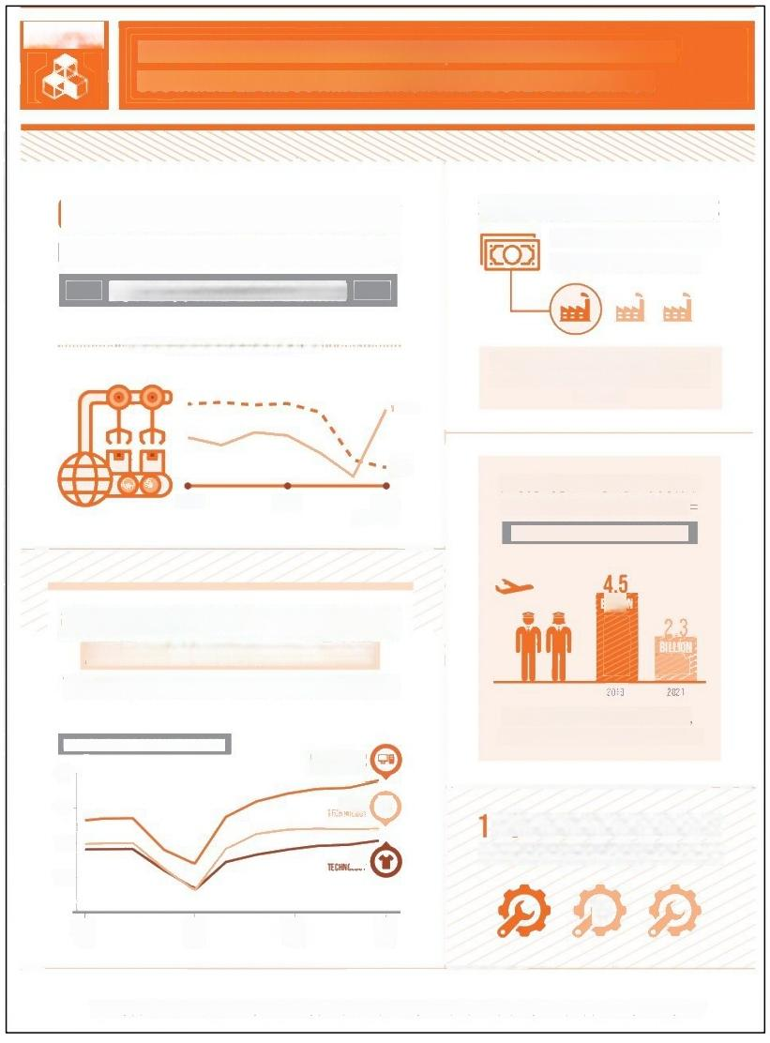
9
BUILD RESILIENT INFRASTRUCTURE,PROMOTE INCLUSIVE AND
SUSTAINABLE INDUSTRIALIZATION AND FOSTER INNOVATION

GLOBAL MANUFACTURING
HAS REBOUNDED FROM THE PANDEMIC
BUT LDCS ARE LEFT BEHIND

SMALL-SCALE INDUSTRIES
LACK ACCESS TO FINANCIAL
SUPPORT FOR RECOVERY

…… MANUFACTURING GROWTH ……

WOBLD

ONLY 1 IN 3 SMALL MANUFACTURERS
ARE BENEHITING FROM A LOAN OR UINE OF CREDIT
[2020-20211

2015

2018

LDcs
2021
[ESTMATED]

PASSENGER AIRLINE INDUSTRY
=IS STILL STRUGGLING T0 =

RECOUP CATASTROPHIC LOSSES

HIGHER-TECHNOLOGY INDUSTRIES
ARE FAR MORE RESILIENT IN CRISES
THAN THEIR LOWER-TECH COUNTERPARTS

MANUFACTURING PRODUCTIOMIMDEX
WEDLM-HEHNO
MSH TEEHMOLGY
130-

0

2.3 BILLION PASSENGERS IN 2021,
COMPARED WITH 4.5 BILLION IN 2019

120-

110-
100-

(

3 MANUFACTURING JOBS
ARE EGATIVELYIMPACIEO BY THE CRISIS

2019
[02]

2020
[02]

2021
[04]

THE SUSTAINABLE DEVELOPMENT GOALS REPORT 2022:UNSTATS.UN.ORG/SDGS/REPORT/2022/

Task: Suppose you are a UN professional attending an academic seminar and are
answering questions fiom a college student.Explain and clarify any doubts.
Contestants-student &teacher: A UN professional
Question Master: A college student
No.of Questions: 6-10

以上内容仅为本文档的试下载部分，为可阅读页数的一半内容。如要下载或阅读全文，请访问：https://d.book118.com/898117111033006032

