
标准实用

对划线部分提问/句型转换专项训练练习一：熟悉一下


1.This is a Japanese car. (改为否定句) This a Japanese car. 2.That's my cup. (改为一般疑问句) that cup?
- It is a nice jeep. (对划线部分提问) it?

- Wei Hua is in Row Three. ( 同 上) is Wei Hua in? 5.Is that a computer? (作否定回答) No, .
- It's a pear. (改为否定句) a pear.

- You can sit down. (改为一般疑问句) sit down?

- I am in Grade 2.(对划线部分提问) you in?

- Is that a cake?(作否定回答) , .

- is, what, three, one, and( 连 词 成 句) ?

- I think it is a bird. ( 改 为 否 定 句) I think it a bird.

- Han Mei isn't in today. (改为同义句) Han Mei isn't today.

- Li Lei is twelve. (对划线部分提问) is Li Lei?

- Her name is Li Lan. (改为一般疑问句) name Li Lan?

文案大全

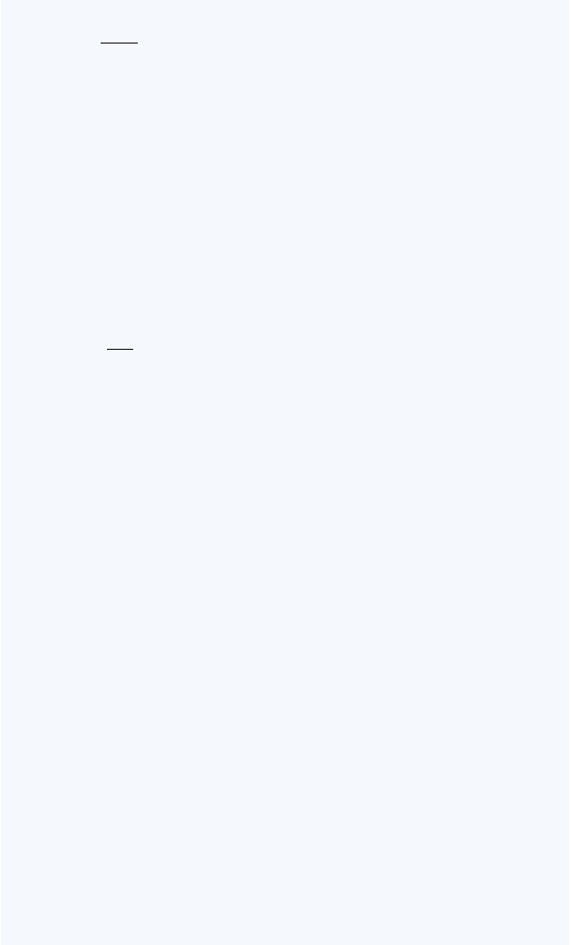
标准实用

- The cat is here. (对划线部分提问) the cat?

- It's a pencil-box. (改为复数句) are .

- That's OK. (改为同义句) That's .

- These are Chinese books. (改为否定句) These Chinese books.

- They are children. (改为单数句) He a .

- Those are hills. (对划线部分提问) ? (21-25 同义句)
- That isn't a new coat. That is coat.

- Lily is in Row Two. Lucy is in Row Two, too. Lily and Lucy are in row.

- Tom and Billy are twins. Tom is Billy's .

- My bike is here. My bike not .

- Every student is at school today. The students at school today.

- Jim Green is English. (用 American 构成选择疑问句)

?

- They are boxes. (改为否定句) .

文案大全


标准实用

- My brother can spell his name. (改为一般疑问句)

?

- We go to school at seven. ( 用 Emma 作 主 语 )

.

- My phone number is 6835702. (对划线部分提问)

?

答案

1. is not 2. Is, your 3. What is 4. What row 5. it isn't
6. It isn't 7. Can I 8. What grade are 9. No, it isn't 10. What's one and three
11. don't, is 12. at home 13. How old 14. Is her 15. Where is
16. They, pencil-boxes 17. all right 18. are not 19. is, child 20. What are those
21. an old 22. the same 23. twin brother 24. is, there 25. are all
- Is Jim Green English or American
- They aren't boxes
- Can your brother spell his name
- Emma goes to school at seven
- What's your phone number

文案大全

标准实用

练习二：四类专项练习

一、将下列句子改为复数形式：
  - There is a knife in the box. There in the box. 2.She's a woman doctor. They're .
3.Our teacher often tells us a story. Our often us . 4.The sheep is over there. The over there.
5.Please pass me a piece of bread. Please pass me some of .

二、下列句子改为否定句：
1.He does some reading every day. He reading every day.
2.I have to wash the dishes. I wash the dishes. 3.Tell him the news. him the news.
4.She has brothers and sisters. She has brothers sisters.

5.I think she is right. I she right.

三、下列句子改为一般疑问句：
- There is some fruit juice in the glass. fruit juice in the glass?

- He has to stay here. he to stay there?

- We do eye exercises every day. you eye exercises every day?

文案大全

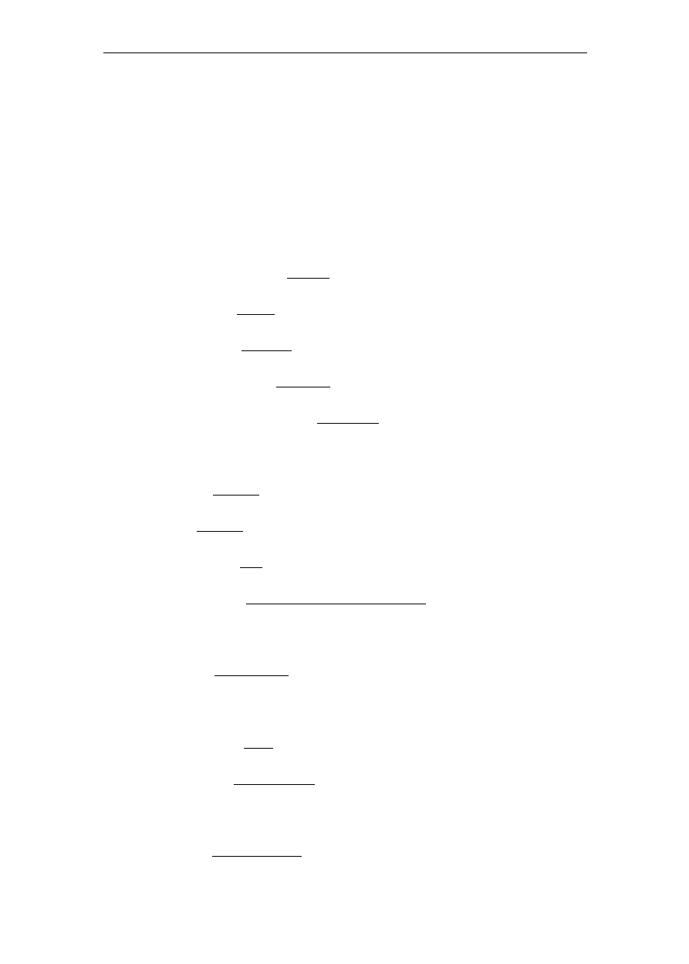
标准实用

- She has something to eat. she to eat?
5.I am good at singing and dancing. you good at singing

dancing?

四、对划线部分提问：
1.My mother goes to work by bike. your mother to work? 2.That is a map of France. map is that?
- The bag of rice is ten kilos. the bag of rice?
- I think Chinese food is very nice. do you Chinese food? 5.The students like their teacher very much.
do the students their teacher?

- His house is very big. his house ?

- There are six kites in the sky. in the sky?

- He lives in Room 306. he in?

- She looks worried because she can't find her dog.

she worried?
- It takes him half an hour to write the e-mail.

it him to write the e-mail?
- Classes begin at eight. classes ?
12.I want to buy three kilos of meat. do you want to buy?
- His uncle is a businessman. his uncle ?

文案大全

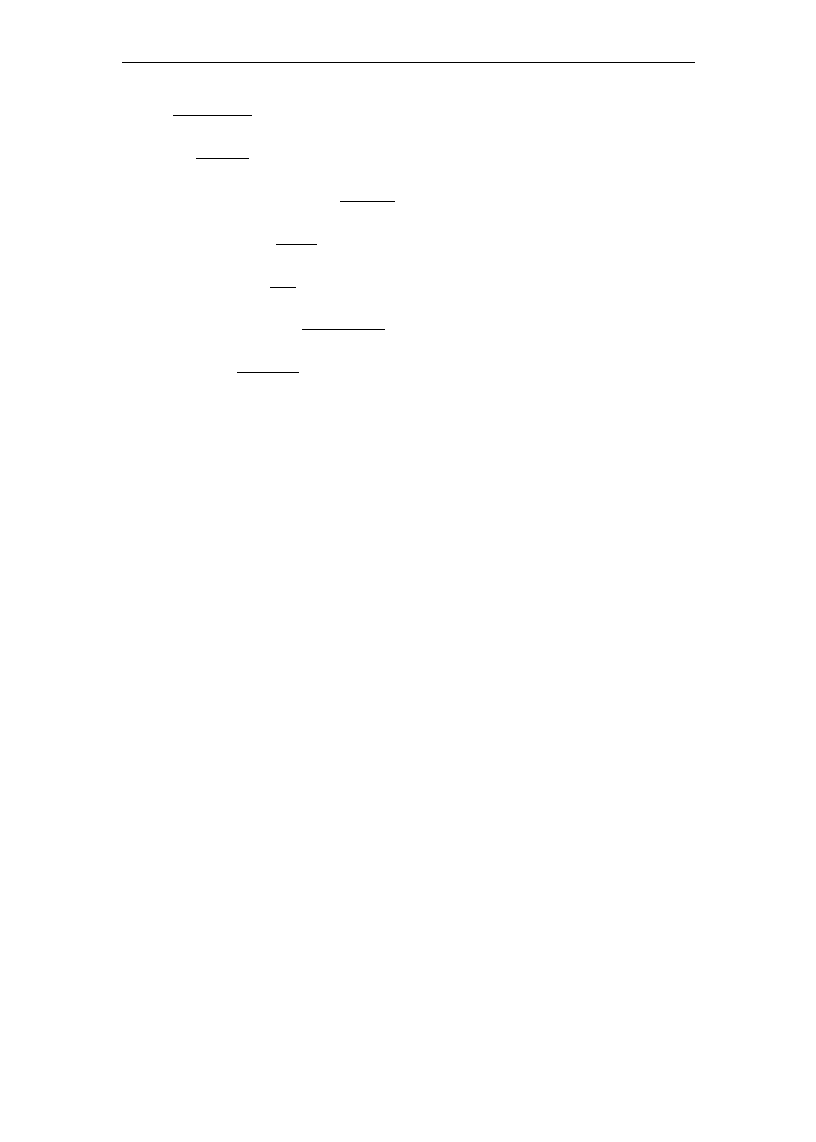
标准实用

- The orange dress is Kate's. is Kate's?

- It's Sunday today. is it today?

- The cats are running up the tree. are the cats ? 17.Jim's plane is broken. Jim's plane? 18.He would like five cakes. would he like ?
- They play football every Friday. they play football?

- The man in brown is Tom's father. is Tom's father?

参考答案：


一 、 1.are, some, knives 2.women doctors 3.teachers, tell, stories 4.sheep, are 5.pieces, bread
二 、 1.doesn't do any 2.don't have to 3.Don't tell 4.no,or 5.don't think, is
三、1.Is there any 2.Does, have 3.Do,do 4.Does have, anything 5.
Are,and

四 、 1.How does, go 2.What 3.How heavy is 4.What, think of 5.H ow, like 6.What is, like 7.What's 8.Which room does, live 9.Why doe s, look 10.How long does, take 11.What time do, begin 12.How mu ch meat 13.What does, do 14.Which dress 15.What day 16.Where,ru

文案大全

标准实用

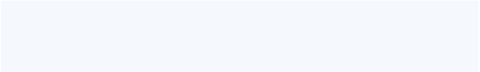
nning 17.What's wrong with 18.How
many
cakes 19.When
do 20.Wh
ich man

练习三：中大附模拟题之句型转换（探讨题）

按要求变换句子，每空只准填一个单词，缩写算一个单词，把答案写在答题卷相应的横线上。

- My book isn’t the same book as yours. 改( 为同一意思的句子)

My book yours.

- He is tall man. He wears a white shir合t.并(为一个句子)

He is a tall man
a white shirt.



- Mike bought some cakes yesterday afternoon. (对划线部分提问)

cakes Mike yesterday afternoon?

- I don’t live near to the post offic改e.为(同一意思的句子)

I live the post office.

文案大全


标准实用

- Their grandfathers are blowing some birthday candles. (改为否定句)

Their grandfathers blowing birthday candles.

- Our teacher is coming. Some flowers are in her hand. (合并为一个句子)

Our teacher is coming some flowers in her hand.

- October comes before November. (改为同一意思的句子)

November comes .

- They always go to bed at ten fifteen. (改为同一意思的句子) The always go to bed a .

- The girl will come to tea in my house tonight. (改为否定句)

The girl to tea in my house tonight.

- He felt angry when someone cut the trees. (对划线部分提问)

he angry?

文案大全


标准实用

练习四：每日一套题按要求转换句型，一空一词。（10 分）

  - He likes dolphins very much.（变一般疑问句）

he dolphins very much?

2.I like Tom because he is very friendly.（对划线部分提问）

do like Tom?

- The shy girl wants to see giraffes.（对划线部分提问）

does the shy girl want to see?

- Does your brother have lots of clever friends? （变陈述句）

brother lots of clever friends.

- Pandas are from China.（同义句转换）

Pandas China.

文案大全


标准实用

一个网上特例题：
If he studies hard, he will pass the exam. 对划线部分提问
高手解答：what will happen if he studies hard? 象这种对整个句子提问的题很少见的哦…
答案：1. Does, like 2.Why, you 3. What, animals 4. My, has 5.come, from

练习五：专项详细讲解 17 题
句型转换大体有两类考题：一类是不同句型间的转换，另一类是同义句或近义句之间的转换。在转换中需注意某些句型中要使用一些特定的词汇。具体做法如下：

一. 把下列句子转换为否定句
- There is some milk in the bottle . There milk in the bottle .

- They have already been to America .
They have been to America .

- Both of the twins are studying in No. 1 Middle School .

of the twins studying in No. 1 Middle School .

- All of the students are in the classroom .

文案大全


标准实用

of the students in the classroom .

- They have sports after school . They sports after school .

二. 把下面的句子转换为感叹句
- The computer is expensive .

expensive computer it is !

expensive computer is !

三. 对下列句子的划线部分提问
- My brother is tall . is your brother ?

- There is a little orange juice in the bottle .

orange juice is there in the bottle ?

- We have learned English for six years . have you learned English ?

- Li Lei goes to see his grandparents once a week .

文案大全

以上内容仅为本文档的试下载部分，为可阅读页数的一半内容。如要下载或阅读全文，请访问：https://d.book118.com/906014011041010052

