课 题 Unit 1 Feeling Sick. 主备教师 邓凤羽本课共 课时，这是第 1 课时。
- 教学目标：Vocabulary: headache, toothache, cold, fever, stomachache, take some medicine, see the dentist, stay in bed, earache, sore throat
- Sentences : What’s the matter with you? I have a stomachache.

教学重点：
Vocabulary: headache, toothache, cold, fever, stomachache, take some medicine, see the dentist, stay in bed, earache, sore throat
教学难点：
Vocabulary: headache, toothache, cold, fever, stomachache, take some medicine, see the dentist, stay in bed, earache, sore throat

教学准备：单词卡片
电子版教案 授课教师“二次备课”（手写）

Step 1. Greetings（1 minute）
T: Good morning, boys and girls. Glad to meet
教 you.
学 Step 2. Presentation (4minutes)
过 (1) Lead-in（展示洋娃娃,复习身体部位）
程
设 (2)Mary is unhappy today.（摆出布娃娃不
计 高兴的样子）Do you know why? Because she feel sick today. What’s the matter with her? She has a headache.

Step 3. Teaching words

  - headache（图片导入）

T: Headache, read after me, repeat.

Ss: Headache , headache, h-e-a-d-a-c-h-e, headache.


T: Show me a headache（.
生模仿动作]
手抱头作头痛状）[学


Ss: Yes, I did.

  - Let some of students do the actions , and others say the words.

For exemple:S1 shows a headache, and others say the word as quickly as possible.（要求学生动作夸张）

  - cold, fever, sore throat 4.review the words (5 minutes)
Let some of students do the actions , and others say the words.

Step 4 (8 minutes)

- One student show a fever, then teacher asked:
What’s the matter with you? I have a fever.

T: What’s the matter with you? S: I have a
fever.

- Look at the picture, and answer the questions.

T: What’s the matter with her/him? S1:She/He has …….

2. pair work:

A: What’s the matter with you? B: I have……

Step 5 (11 minutes)

1. performance : One student act a doctor, the other act a patient.


2. listen to the tape twice.
Step 6 homework(1 minutes)
1.copy the vocabulary
2.Read the words.
板书设计：
Unit 1
Feeling Sick.
headache, toothache, cold, fever, stomachache, take some
medicine, see the dentist, stay in bed, (earache, sore throat)
What’s the matter with you?
I have a stomachache.
教学反思：
Do the action to show the words .


课 题
Unit 1
Feeling Sick.
主备教师
邓凤羽
本课共
课时，这是第 2 课时。
教学目标：Sentences:（1） What’s the matter with you? I have a stomachache. You
should take some medicine. （2） What’s the matter with you? I have a cold. You should stay in bed.（3） What’s the matter with you? I hurt my foot. Be careful next time.
教学重难点：Vocabulary: headache, toothache, cold, fever, stomachache, take some
medicine, see the dentist, stay in bed, earache, sore throat
教学准备：单词卡片


教 电子版教案

Step 1. Greetings（1 minute）
- Show the pictures and review the words: headache, toothache, cold ,f ever, stomachache,
教 earache, sore throat
学
过 2. review the sentence:
程
设 T: What’s the matter with Gogo?
计

S: He has a …….

Step 2. Conversation.
  - T: What’s the matter with you?
T: If I want to help you , I can say, “you should see the doctor.” or “you should stay in bed.” repeat. “you should.”

Ss: You should . 2．Call one student show a stomachache,
T: What’s the matter with you?S1：I have a
stomachache.

T: You should take some medicine.(板书) 3．Call one student show a cold,
T: What’s the matter with you?S1：I have a cold.

T: You should stay in bed.(板书) 4.导入 Gogo 图片
T：What’s the matter with Gogo?

He hurt his foot.
授课教师“二次备课”（手写）


T: So, “Be careful next time.” Step 3.Practice
- Listen to the tape:P39 Practice1 And then check the answers
- Do the exercise: workbook P23 practice2.

And then check the answers

- listen to the tape: conversation, vocabulary, target

Step 4 . Homework:

作业设计：

板书设计：

Unit 1 Feeling Sick.
(1) What’s the matter with you?

I have a stomachache. You should take some medicine.
（2)What’s the matter with you?

I have a cold. You should stay in bed.


（3） What’s the matter with you?
I hurt my foot. Be careful next time.
教学反思：
What’s the matter with

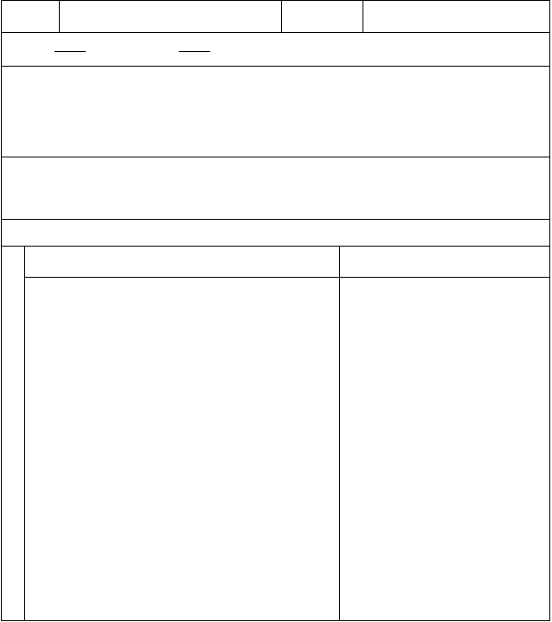
课 题
Unit 1
Feeling Sick.
主备教师
邓凤羽
本课共
课时，这是第 3 课时。
教学目标：1. Sounds and words: red, mess, head, bed, dress, bread
2.Can listen and chant: What a mess!
教学重难点：Sounds and words: red, mess, head, bed, dress, bread
教学准备：单词卡片
教 电子版教案
授课教师“二次备课”（手写）
Step1 (6 minutes)
1.call some of pairs to make the
教 dialogues and do the
学
过 performances.（头带饰物）
程
设 One act the doctor,and the other act
计 patient.
Step 2
(6 minutes)
1. do the exercise:students’ book
Practice2


And then check the answers

- students’ book:P41 activity (8 minutes)

- sounds and words (4 minutes)

red, mess, head ,bed, dress, bread 4.song activity ( 4 minutes)
5. Ask the students to go to different hospital and see the doctor.(14 minutes)

作业设计：

板书设计：

教学反思：




课 题
Unit2.Looking for a Hospital.
主备教师
邓凤羽
本课共
课时，这是第 1 课时。
教学目标：The students can listen,say，read and write the words.
教学重点：The four skilled words.
教学难点：How to use the words.
教学准备：单词卡片
教 电子版教案
授课教师“二次备课”（手写）


Step 1Warm up
Play a game with the Ss.
教
学 Step 2Presentation
过
程 1. Ask the Ss to look at the pictures ，
设 then study the words.
计
2. Lead the Ss to leard the sentences.
Step 3 Fun time
Play a game with the Ss.
Homework
Ask the Ss to read and write the words.
作业设计：


板书设计：
教学反思：

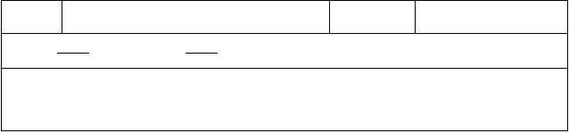
课 题
Unit2.Looking for a Hospital.
主备教师
邓凤羽
本课共
课时，这是第 2 课时。
教学目标：The students can listen,say，read the conversation.


教学重点：The sentences.

教学难点：
Asking and givinging directions.

教学准备：单词卡片
教 电子版教案 授课教师“二次备课”（手写）

Step 1Warm up
Review the words and the sentences

教 with the Ss.
学 Step 2Presentation
过

程 1.Ask and answer.
设

计 2.Study the conversation with Ss.
Step 3 Practice

Ask the Ss to listen to the tape， then read and check
Homework

Ask the Ss to read the conversation three times．


作业设计：

板书设计：

教学反思：

课 题 Unit2.Looking for a Hospital.
本课共 课时，这是第 3 课时。
主备教师 邓凤羽

教学目标：
The students can listen,say，read the sound and the words.

教学重点：
The sounds.
教学难点：
How to pronounce‘or’.

教学准备：单词卡片教 电子版教案

授课教师“二次备课”（手写）



Step 1Warm up

Ask and answer.
教
学 Step 2Presentation
过
程 1. Study the sounds and the words with
设 the Ss.
计
2.Teach the Ss to chant. Step 3 Practice
A march ：Who is the best？ Homework
Ask the Ss to read the sound and the words.


作业设计：
板书设计：
教学反思：

课 题 Unit3.StayingHealthy. 主备教师 邓凤羽本课共 课时，这是第 1 课时。
教学目标：知识目标：使学生能听、说、读单词。
情感态度：使学生有兴趣说英语，敢于开口，积极参与。
学习策略：对所学的内容能联系实际，能尽量用英语交流，培养学生的团结合作、关心他人的良好品质。
教学重点：
使学生能掌握句型和单词， 并能灵活运用。

教学难点：
对比和运用句型。

教学准备：单词卡片教 电子版教案

授课教师“二次备课”（手写）


教
学 Step 1Warm up
过
程 Ask the students to play a game.
设
计
Step 2Presentation
1、Let the Ss look at the picture to study “too much”.

2、Use the same ways to study the other words.
Step 3Practice
A march ：Who is the be？st

Homework

Ask the Ss to read and write the words.


作业设计：

板书设计：

教学反思：


课 题 Unit3. Staying Healthy. 主备教师 邓凤羽本课共 课时，这是第 2 课时。
教学目标：
The students can listen,say，read the conversation.

教学重点：
The sentences.
教学难点：
Talking about healthy and well-being.

教学准备：单词卡片
教 电子版教案 授课教师“二次备课”（手写）

Step 1Warm up
Review the words and the sentences

教 with the Ss.
学
过
程 Step 2Presentation

设 1.Ask and answer.
计

2.Study the conversation with Ss.
Step 3 Practice

Ask the Ss to listen to the tape， then read and check .
Homework

Ask the Ss to read the conversation four times.


作业设计：
板书设计：
教学反思：

课 题 Unit3. Staying Healthy. 主备教师 邓凤羽本课共 课时，这是第 3 课时。
教学目标：
The students can listen,say，read the sound and the words.

教学重点：
The sound.
教学难点：

How to pronounce‘st ，sk’.
教学准备：单词卡片教 电子版教案

授课教师“二次备课”（手写）



Step 1Warm up
Ask and answer.
教
学 Step 2Presentation
过 1.Study the sound and the words with the
程 Ss.
设
计 2.Teach the Ss to chant.
Step 3 Practice

1.Ask the Ss to listen to the tape， then read and check .
2.A march ：Who is the best？ Homework
Ask the Ss to read the sound and the words.


作业设计：

板书设计：

教学反思：

以上内容仅为本文档的试下载部分，为可阅读页数的一半内容。如要下载或阅读全文，请访问：https://d.book118.com/915200142030011111

