某机械设备的启动控制程序设计的计算机控制技术的实现

班 |  | 级：12 级机控一班
学 |  | 号：120101010077
姓 |  | 名：邸伟峰
课 | 程 | 名 称：16/32 位微机原理、汇编语言及接口技术
指 | 导 | 教 师：李艳文

2015 年 5 月

目录
- 项目题目描述及要求 2
- 工程背景及需要解决的问题 2
- 项目模拟方案： 3
  - 所用到的实验设备 3
  - 系统电路图和接线图 3
  - 实验线路连接 5
- 控制程序 6
  - 程序框图 6
  - 详细程序 6
- 实验效果图 34
- 项目结论 37
- 参考文献 37
8 感言 38

16/32 位微机原理、汇编语言及接口技术
邸伟峰

（燕山大学 机械工程学院）

摘要：某大型机械设备在启动时，需要检测气源设备、液压设备 、安全阀门和安全装备是否正常，通过设计一个汇编语言程序并构建其硬件电路来判断四项检测项目是否正常， 实现机械开机自检，防止因机床不正常启动而引发的事故。并用显示器显示各个环节的 检测信息，便于查找故障及维修。利用微机芯片 8086，并行接口 8255 以及显示屏模拟实现上述功能。
关键词 ： 启动控制 检测显示 汇编语言
前言： 机械设备的启动是工业生产中一个很常见的现象，而大型设备的启动需要在其
它设备条件具备的情况下才可以进行的，如果这些条件无法满足，就很难保证机械的正 常启动，甚至可能会造成意外的事故。因此，做好对其它设备条件检测、将检测结果送 到启动设备、判断控制设备的启停等工作至关重要！而这就需要一个好的启动控制程序， 对检测结果进行判断，控制设备的启动，若检测出现异常，则应报警、停车，并显示出 异常项目，以便后期的检查和维修。

项目题目描述及要求
某大型机械加工设备，启动过程需要检测以下装置：1、给设备供气的气源压力是否正常；2、液压系统的压力是否正常；3、安全门是否关闭；4、安全的装备中的光电传感器工作是否正常。全部正常后气动设备的主电机开始工作。要求用显示器显示各个环节的检测信息，以方便用户查找设备无法正常启动的原因。

工程背景及需要解决的问题
随着二十一世纪工业的迅速发展，工业生产早已走向自动化、智能化、集成化，各种集成的全自动机械设备随处可见，而机械设备的启动控制则是任何机械设备中一个必经的环境，大型机械设备的启动需要很多其他设备条件具备，否则无法正常启动设备，甚至可能会造成意外的事故。因此，在设备启动前，应该对其它设备是否具备条件进行检测，并将将检测结果送到启动设备，以控制设备的启停。而借助计算机虚拟程序控制，可以高效准确的解决这些问题。这就需要一个简单快捷的启动控制程序以及简易的硬件设施及连线，来对检测结果进行判断，控制设备的启动， 并能准确显示出异常项目，以便后期的检查和维修。

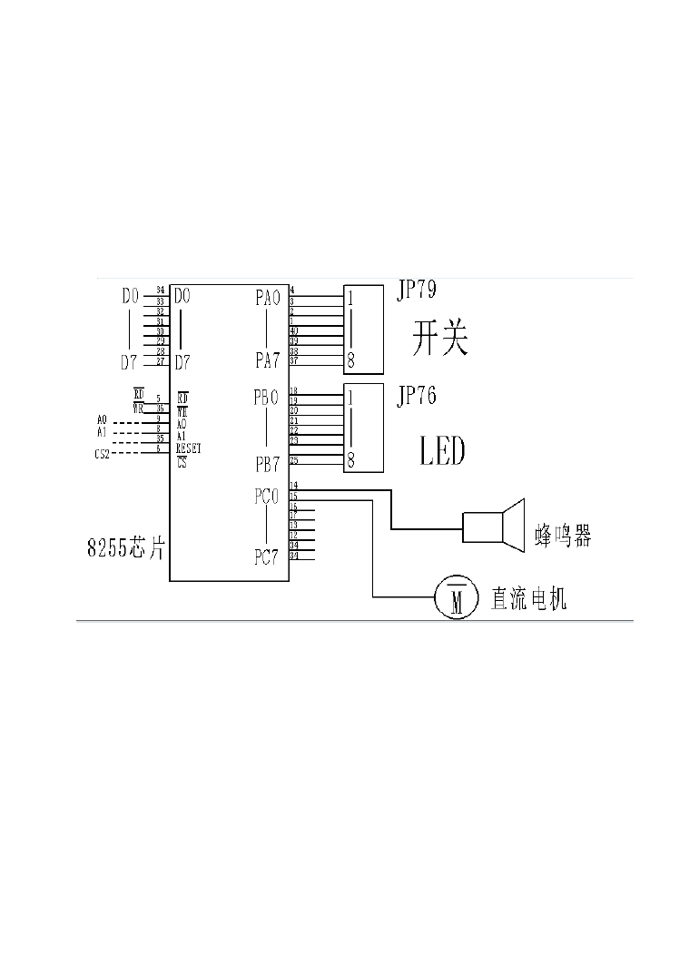
项目模拟方案：

所用到的实验设备
1）8255 芯片
2）12864J 液晶显示屏 12864J
    - 直动电机
    - 蜂鸣器
5) LED 灯、开关 4 个

系统电路图和接线图

8255 芯片、LED 灯、开关，直流电机以及蜂鸣器连线

3

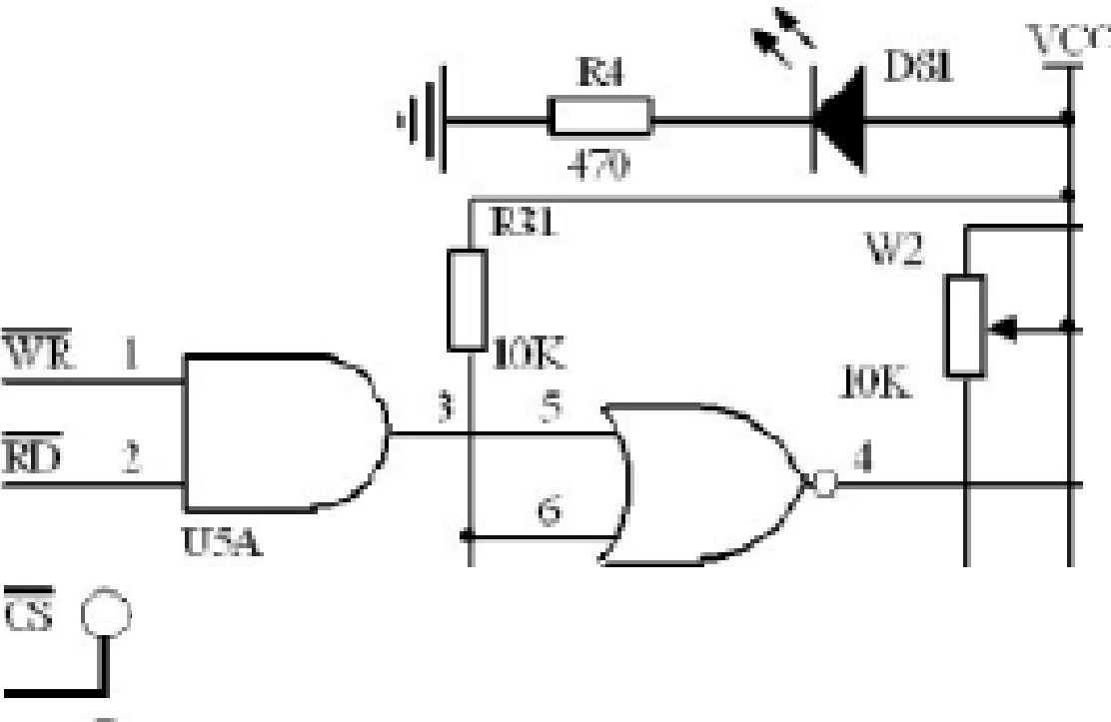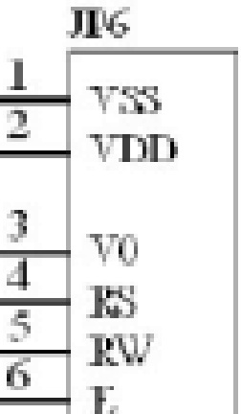CS1 , 3B
A1 E -... .....
AO
邸
叩 皿DEZ. DB3
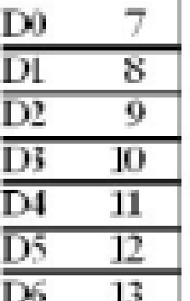
卫iB-1
D
，虚
区 二工］即
且

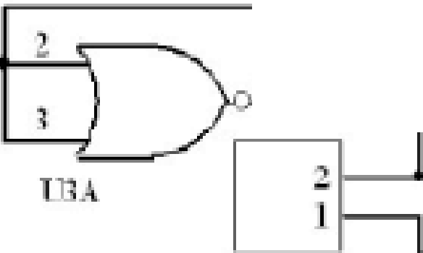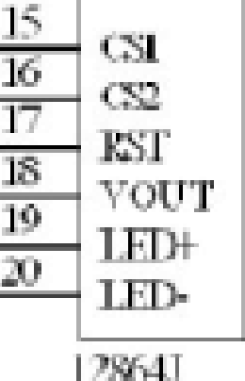·俨
司 2
立
几贮l
!

液晶显示屏 1286打 的接线1

4

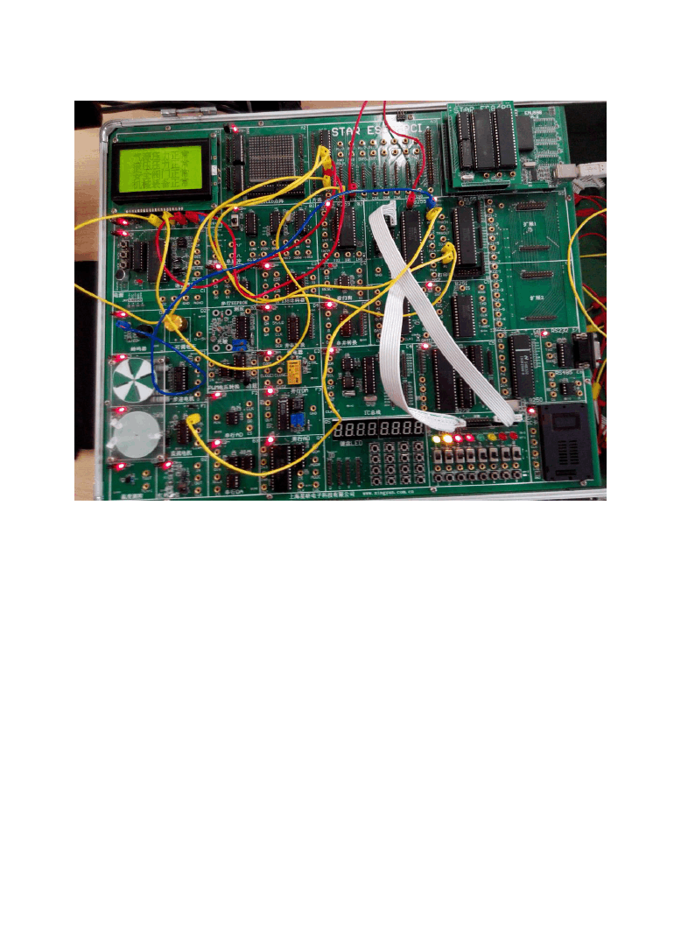
实验线路连接

5

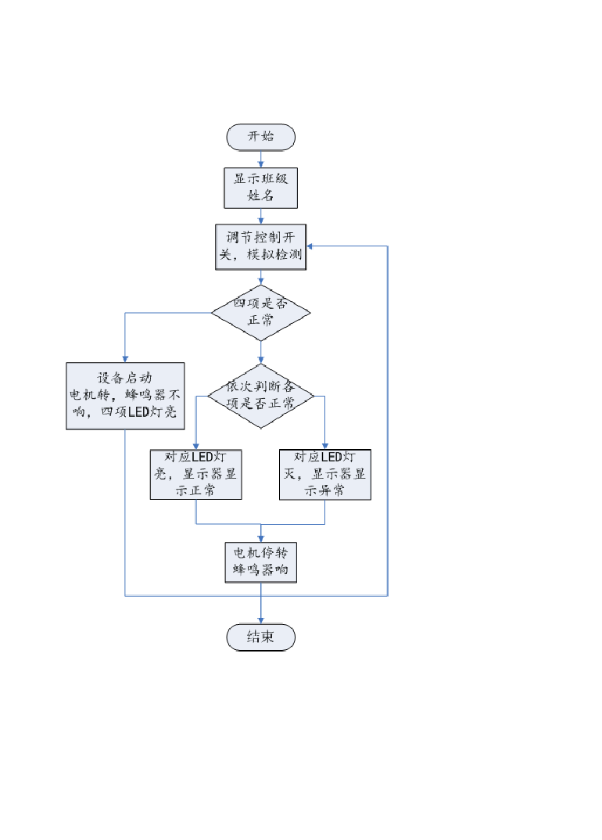
控制程序

程序框图

  - 详细程序
.MODEL TINY
WR_COM_AD_L EQU 0F004H ;写左半屏指令地址WR_COM_AD_R EQU 0F000H ;写右半屏指令地址WR_DATA_AD_L EQU 0F006H ;写左半屏数据地址WR_DATA_AD_R EQU 0F002H ;写右半屏数据地址
6

RD_BUSY_AD EQU 0F001H ;查忙地址RD_DATA_AD EQU 0F003H ;读数据地址
- EQU 0B8H ;起始显示行基址
- EQU 040H ;起始显示列基址FIRSTLINE EQU 0C0H ;起始显示行
.STACK 100
.DATA FENG DB 5
; 机
LINE1_1 DB 08H, 08H,0C8H,0FFH, 48H, 88H, 08H, 00H DB 0FEH, 02H, 02H, 02H,0FEH, 00H, 00H, 00H
DB 04H, 03H, 00H,0FFH, 00H, 41H, 30H, 0CH DB 03H, 00H, 00H, 00H, 3FH, 40H, 78H, 00H

; 控
LINE1_2 DB 08H, 08H, 08H,0FFH, 88H, 48H, 00H, 98H DB 48H, 28H, 0AH, 2CH, 48H,0D8H, 08H, 00H
DB 02H, 42H, 81H, 7FH, 00H, 00H, 40H, 42H DB 42H, 42H, 7EH, 42H, 42H, 42H, 40H, 00H

; 一
LINE1_3 DB 00H, 80H, 80H, 80H, 80H, 80H, 80H, 80H DB 80H, 80H, 80H, 80H, 80H,0C0H, 80H, 00H
DB 00H, 00H, 00H, 00H, 00H, 00H, 00H, 00H DB 00H, 00H, 00H, 00H, 00H, 00H, 00H, 00H

; 班
LINE1_4 DB 42H, 42H,0FEH, 42H, 42H,0E0H, 00H,0FFH DB 00H, 42H, 42H,0FEH, 42H, 42H, 42H, 00H
DB 10H, 10H, 0FH, 88H, 49H, 20H, 18H, 07H DB 20H, 20H, 20H, 3FH, 20H, 20H, 20H, 00H

; 邸
LINE2_1 DB 00H,0FCH, 44H, 44H,0FCH, 42H, 63H, 42H DB 00H, 00H,0FEH, 42H,0B2H, 0EH, 00H, 00H
DB 00H, 7FH, 20H, 10H, 23H, 4CH, 10H, 20H DB 38H, 00H,0FFH, 10H, 20H, 11H, 0EH, 00H

; 伟
LINE2_2 DB 80H, 40H, 20H,0F8H, 07H, 48H, 48H, 48H DB 48H,0FFH, 48H, 48H, 68H, 4CH, 08H, 00H
DB 00H, 00H, 00H,0FFH, 02H, 02H, 02H, 02H DB 02H,0FFH, 02H, 12H, 22H, 1FH, 02H, 00H

; 峰
LINE2_3 DB 00H,0F0H, 00H,0FFH, 00H,0F0H, 90H, 88H DB 4FH, 54H,0A4H, 54H, 4CH,0C4H, 40H, 00H
DB 00H, 1FH, 10H, 0FH, 08H, 1FH, 00H, 14H DB 15H, 15H,0FFH, 15H, 15H, 14H, 00H, 00H

;气
YU11_1 DB 40H, 20H, 58H, 47H, 54H, 54H, 54H, 54H DB 54H, 54H,0D4H, 14H, 06H, 04H, 00H, 00H
DB 00H, 00H, 00H, 00H, 00H, 00H, 00H, 00H DB 00H, 00H, 1FH, 20H, 40H, 80H, 70H, 00H
;源
YU11_2 DB 10H, 22H, 64H, 0CH, 80H,0FEH, 02H,0E2H DB 0A2H,0B2H,0AEH,0A2H,0A2H,0F3H, 22H, 00H
DB 04H, 04H,0FEH, 41H, 30H, 0FH, 20H, 13H DB 5AH, 82H, 7EH, 02H, 0AH, 13H, 30H, 00H
;压
YU11_3 DB 00H, 00H,0FEH, 02H, 82H, 82H, 82H, 82H DB 0FEH, 82H, 82H, 82H,0C3H, 82H, 00H, 00H
DB 40H, 30H, 0FH, 40H, 40H, 40H, 40H, 40H DB 7FH, 40H, 42H, 44H, 4CH, 60H, 40H, 00H
;力
YU11_4 DB 00H, 10H, 10H, 10H, 10H, 10H,0FFH, 10H DB 10H, 10H, 10H, 10H,0F8H, 10H, 00H, 00H
DB 00H, 80H, 80H, 80H, 60H, 18H, 07H, 00H DB 20H, 40H, 80H, 40H, 3FH, 00H, 00H, 00H
;正
YU11_5 DB 00H, 02H, 02H,0C2H, 02H, 02H, 02H,0FEH DB 82H, 82H, 82H,0C2H, 83H, 02H, 00H, 00H
DB 40H, 40H, 40H, 7FH, 40H, 40H, 40H, 7FH DB 40H, 40H, 40H, 40H, 40H, 60H, 40H, 00H

;常
YU11_6 DB 20H, 18H, 08H, 0AH,0ECH,0A8H,0A8H,0AFH DB 0A8H,0A8H,0ECH, 0AH, 08H, 28H, 18H, 00H
DB 00H, 00H, 00H, 3EH, 02H, 02H, 02H,0FFH DB 02H, 22H, 42H, 3FH, 02H, 00H, 00H, 00H
;气
YU12_1 DB 40H, 20H, 58H, 47H, 54H, 54H, 54H, 54H DB 54H, 54H,0D4H, 14H, 06H, 04H, 00H, 00H
DB 00H, 00H, 00H, 00H, 00H, 00H, 00H, 00H DB 00H, 00H, 1FH, 20H, 40H, 80H, 70H, 00H
;源
YU12_2 DB 10H, 22H, 64H, 0CH, 80H,0FEH, 02H,0E2H DB 0A2H,0B2H,0AEH,0A2H,0A2H,0F3H, 22H, 00H
DB 04H, 04H,0FEH, 41H, 30H, 0FH, 20H, 13H DB 5AH, 82H, 7EH, 02H, 0AH, 13H, 30H, 00H
;压
YU12_3 DB 00H, 00H,0FEH, 02H, 82H, 82H, 82H, 82H DB 0FEH, 82H, 82H, 82H,0C3H, 82H, 00H, 00H
DB 40H, 30H, 0FH, 40H, 40H, 40H, 40H, 40H DB 7FH, 40H, 42H, 44H, 4CH, 60H, 40H, 00H
;力
YU12_4 DB 00H, 10H, 10H, 10H, 10H, 10H,0FFH, 10H DB 10H, 10H, 10H, 10H,0F8H, 10H, 00H, 00H
DB 00H, 80H, 80H, 80H, 60H, 18H, 07H, 00H DB 20H, 40H, 80H, 40H, 3FH, 00H, 00H, 00H
;异
YU12_5 DB 00H, 00H, 7EH, 92H, 92H, 92H, 92H, 92H DB 92H, 92H, 92H, 9FH, 82H,0E0H, 00H, 00H
DB 04H, 04H, 84H, 44H, 3FH, 04H, 04H, 04H DB 04H, 04H,0FFH, 04H, 04H, 06H, 04H, 00H
;常
YU12_6 DB 20H, 18H, 08H, 0AH,0ECH,0A8H,0A8H,0AFH DB 0A8H,0A8H,0ECH, 0AH, 08H, 28H, 18H, 00H
DB 00H, 00H, 00H, 3EH, 02H, 02H, 02H,0FFH DB 02H, 22H, 42H, 3FH, 02H, 00H, 00H, 00H
;液
YU21_1 DB 10H, 22H, 64H, 0CH, 80H, 04H,0C4H, 34H DB 05H,0C6H,0BCH, 24H, 24H,0E6H, 04H, 00H

DB 04H, 04H,0FEH, 01H, 02H, 01H,0FFH, 42H DB 21H, 16H, 08H, 15H, 23H, 60H, 20H, 00H
;压
YU21_2 DB 00H, 00H,0FEH, 02H, 82H, 82H, 82H, 82H DB 0FEH, 82H, 82H, 82H,0C3H, 82H, 00H, 00H
DB 40H, 30H, 0FH, 40H, 40H, 40H, 40H, 40H DB 7FH, 40H, 42H, 44H, 4CH, 60H, 40H, 00H
;压
YU21_3 DB 00H, 00H,0FEH, 02H, 82H, 82H, 82H, 82H DB 0FEH, 82H, 82H, 82H,0C3H, 82H, 00H, 00H
DB 40H, 30H, 0FH, 40H, 40H, 40H, 40H, 40H DB 7FH, 40H, 42H, 44H, 4CH, 60H, 40H, 00H
;力
YU21_4 DB 00H, 10H, 10H, 10H, 10H, 10H,0FFH, 10H DB 10H, 10H, 10H, 10H,0F8H, 10H, 00H, 00H
DB 00H, 80H, 80H, 80H, 60H, 18H, 07H, 00H DB 20H, 40H, 80H, 40H, 3FH, 00H, 00H, 00H
;正
YU21_5 DB 00H, 02H, 02H,0C2H, 02H, 02H, 02H,0FEH DB 82H, 82H, 82H,0C2H, 83H, 02H, 00H, 00H
DB 40H, 40H, 40H, 7FH, 40H, 40H, 40H, 7FH DB 40H, 40H, 40H, 40H, 40H, 60H, 40H, 00H
;常
YU21_6 DB 20H, 18H, 08H, 0AH,0ECH,0A8H,0A8H,0AFH DB 0A8H,0A8H,0ECH, 0AH, 08H, 28H, 18H, 00H
DB 00H, 00H, 00H, 3EH, 02H, 02H, 02H,0FFH DB 02H, 22H, 42H, 3FH, 02H, 00H, 00H, 00H
;液
YU22_1 DB 10H, 22H, 64H, 0CH, 80H, 04H,0C4H, 34H DB 05H,0C6H,0BCH, 24H, 24H,0E6H, 04H, 00H
DB 04H, 04H,0FEH, 01H, 02H, 01H,0FFH, 42H DB 21H, 16H, 08H, 15H, 23H, 60H, 20H, 00H
;压
YU22_2 DB 00H, 00H,0FEH, 02H, 82H, 82H, 82H, 82H DB 0FEH, 82H, 82H, 82H,0C3H, 82H, 00H, 00H
DB 40H, 30H, 0FH, 40H, 40H, 40H, 40H, 40H DB 7FH, 40H, 42H, 44H, 4CH, 60H, 40H, 00H
;压

YU22_3 DB 00H, 00H,0FEH, 02H, 82H, 82H, 82H, 82H DB 0FEH, 82H, 82H, 82H,0C3H, 82H, 00H, 00H
DB 40H, 30H, 0FH, 40H, 40H, 40H, 40H, 40H DB 7FH, 40H, 42H, 44H, 4CH, 60H, 40H, 00H
;力
YU22_4 DB 00H, 10H, 10H, 10H, 10H, 10H,0FFH, 10H DB 10H, 10H, 10H, 10H,0F8H, 10H, 00H, 00H
DB 00H, 80H, 80H, 80H, 60H, 18H, 07H, 00H DB 20H, 40H, 80H, 40H, 3FH, 00H, 00H, 00H
;异
YU22_5 DB 00H, 00H, 7EH, 92H, 92H, 92H, 92H, 92H DB 92H, 92H, 92H, 9FH, 82H,0E0H, 00H, 00H
DB 04H, 04H, 84H, 44H, 3FH, 04H, 04H, 04H DB 04H, 04H,0FFH, 04H, 04H, 06H, 04H, 00H
;常
YU22_6 DB 20H, 18H, 08H, 0AH,0ECH,0A8H,0A8H,0AFH DB 0A8H,0A8H,0ECH, 0AH, 08H, 28H, 18H, 00H
DB 00H, 00H, 00H, 3EH, 02H, 02H, 02H,0FFH DB 02H, 22H, 42H, 3FH, 02H, 00H, 00H, 00H
;安
YU31_1 DB 90H, 8CH, 84H, 84H, 84H, 84H,0F5H, 86H DB 84H, 84H, 84H, 84H, 84H,0D4H, 8CH, 00H
DB 00H, 00H, 80H, 84H, 46H, 49H, 28H, 10H DB 10H, 28H, 47H,0C0H, 00H, 00H, 00H, 00H
;全
YU31_2 DB 80H, 80H, 40H, 20H, 50H, 48H, 44H,0C3H DB 44H, 68H, 50H, 20H, 40H,0C0H, 40H, 00H
DB 00H, 40H, 40H, 40H, 44H, 44H, 44H, 7FH DB 44H, 46H, 44H, 40H, 60H, 40H, 00H, 00H
;阀
YU31_3 DB 00H,0F8H, 01H, 86H,0E0H, 9AH, 82H,0FAH DB 42H, 4AH, 52H, 42H, 02H,0FFH, 02H, 00H
DB 00H,0FFH, 01H, 00H, 7FH, 00H, 10H, 09H DB 06H, 1AH, 21H, 30H, 80H,0FFH, 00H, 00H
;门
YU31_4 DB 00H,0FCH, 01H, 02H, 06H, 00H, 02H, 02H DB 02H, 02H, 02H, 02H, 02H,0FFH, 02H, 00H
DB 00H,0FFH, 00H, 00H, 00H, 00H, 00H, 00H

DB 00H, 00H, 00H, 40H, 80H, 7FH, 00H, 00H
;正
YU31_5 DB 00H, 02H, 02H,0C2H, 02H, 02H, 02H,0FEH DB 82H, 82H, 82H,0C2H, 83H, 02H, 00H, 00H
DB 40H, 40H, 40H, 7FH, 40H, 40H, 40H, 7FH DB 40H, 40H, 40H, 40H, 40H, 60H, 40H, 00H
;常
YU31_6 DB 20H, 18H, 08H, 0AH,0ECH,0A8H,0A8H,0AFH DB 0A8H,0A8H,0ECH, 0AH, 08H, 28H, 18H, 00H
DB 00H, 00H, 00H, 3EH, 02H, 02H, 02H,0FFH DB 02H, 22H, 42H, 3FH, 02H, 00H, 00H, 00H
;安
YU32_1 DB 90H, 8CH, 84H, 84H, 84H, 84H,0F5H, 86H DB 84H, 84H, 84H, 84H, 84H,0D4H, 8CH, 00H
DB 00H, 00H, 80H, 84H, 46H, 49H, 28H, 10H DB 10H, 28H, 47H,0C0H, 00H, 00H, 00H, 00H
;全
YU32_2 DB 80H, 80H, 40H, 20H, 50H, 48H, 44H,0C3H DB 44H, 68H, 50H, 20H, 40H,0C0H, 40H, 00H
DB 00H, 40H, 40H, 40H, 44H, 44H, 44H, 7FH DB 44H, 46H, 44H, 40H, 60H, 40H, 00H, 00H
;阀
YU32_3 DB 00H,0F8H, 01H, 86H,0E0H, 9AH, 82H,0FAH DB 42H, 4AH, 52H, 42H, 02H,0FFH, 02H, 00H
DB 00H,0FFH, 01H, 00H, 7FH, 00H, 10H, 09H DB 06H, 1AH, 21H, 30H, 80H,0FFH, 00H, 00H
;门
YU32_4 DB 00H,0FCH, 01H, 02H, 06H, 00H, 02H, 02H DB 02H, 02H, 02H, 02H, 02H,0FFH, 02H, 00H
DB 00H,0FFH, 00H, 00H, 00H, 00H, 00H, 00H DB 00H, 00H, 00H, 40H, 80H, 7FH, 00H, 00H
;异
YU32_5 DB 00H, 00H, 7EH, 92H, 92H, 92H, 92H, 92H DB 92H, 92H, 92H, 9FH, 82H,0E0H, 00H, 00H
DB 04H, 04H, 84H, 44H, 3FH, 04H, 04H, 04H DB 04H, 04H,0FFH, 04H, 04H, 06H, 04H, 00H
;常
YU32_6 DB 20H, 18H, 08H, 0AH,0ECH,0A8H,0A8H,0AFH

DB 0A8H,0A8H,0ECH, 0AH, 08H, 28H, 18H, 00H DB 00H, 00H, 00H, 3EH, 02H, 02H, 02H,0FFH DB 02H, 22H, 42H, 3FH, 02H, 00H, 00H, 00H
;机
YU41_1 DB 10H, 10H,0D0H,0FFH, 90H, 10H, 00H,0FCH DB 04H, 04H, 04H,0FEH, 04H, 00H, 00H, 00H
DB 04H, 03H, 00H,0FFH, 80H, 41H, 20H, 1FH DB 00H, 00H, 00H, 3FH, 40H, 40H, 70H, 00H
;械
YU41_2 DB 10H, 10H,0D0H,0FFH, 90H, 18H,0E8H, 08H DB 0E8H, 08H,0FFH, 08H, 0AH, 8CH, 08H, 00H
DB 04H, 03H, 00H,0FFH, 20H, 11H, 8FH, 81H DB 5FH, 21H, 17H, 38H, 46H, 81H,0E0H, 00H
;装
YU41_3 DB 00H, 42H, 24H, 10H,0FFH, 00H, 44H,0A4H DB 24H, 3FH, 24H, 34H, 26H, 84H, 00H, 00H
DB 01H, 21H, 21H, 11H, 09H,0FDH, 43H, 21H DB 0DH, 11H, 29H, 25H, 43H,0C1H, 41H, 00H
;备
YU41_4 DB 00H, 00H, 90H, 88H, 44H, 4BH, 32H, 12H DB 32H, 4AH, 46H, 82H, 80H, 80H, 80H, 00H
DB 01H, 01H, 00H,0FFH, 49H, 49H, 49H, 7FH DB 49H, 49H, 49H,0FFH, 00H, 01H, 00H, 00H
;正
YU41_5 DB 00H, 02H, 02H,0C2H, 02H, 02H, 02H,0FEH DB 82H, 82H, 82H,0C2H, 83H, 02H, 00H, 00H
DB 40H, 40H, 40H, 7FH, 40H, 40H, 40H, 7FH DB 40H, 40H, 40H, 40H, 40H, 60H, 40H, 00H
;常
YU41_6 DB 20H, 18H, 08H, 0AH,0ECH,0A8H,0A8H,0AFH DB 0A8H,0A8H,0ECH, 0AH, 08H, 28H, 18H, 00H
DB 00H, 00H, 00H, 3EH, 02H, 02H, 02H,0FFH DB 02H, 22H, 42H, 3FH, 02H, 00H, 00H, 00H
;机
YU42_1 DB 10H, 10H,0D0H,0FFH, 90H, 10H, 00H,0FCH DB 04H, 04H, 04H,0FEH, 04H, 00H, 00H, 00H
DB 04H, 03H, 00H,0FFH, 80H, 41H, 20H, 1FH DB 00H, 00H, 00H, 3FH, 40H, 40H, 70H, 00H

;械
YU42_2 DB 10H, 10H,0D0H,0FFH, 90H, 18H,0E8H, 08H DB 0E8H, 08H,0FFH, 08H, 0AH, 8CH, 08H, 00H
DB 04H, 03H, 00H,0FFH, 20H, 11H, 8FH, 81H DB 5FH, 21H, 17H, 38H, 46H, 81H,0E0H, 00H
;装

YU42_3 DB 00H, 42H, 24H, 10H,0FFH, 00H, 44H,0A4H DB 24H, 3FH, 24H, 34H, 26H, 84H, 00H, 00H
DB 01H, 21H, 21H, 11H, 09H,0FDH, 43H, 21H DB 0DH, 11H, 29H, 25H, 43H,0C1H, 41H, 00H
;备
YU42_4 DB 00H, 00H, 90H, 88H, 44H, 4BH, 32H, 12H DB 32H, 4AH, 46H, 82H, 80H, 80H, 80H, 00H
DB 01H, 01H, 00H,0FFH, 49H, 49H, 49H, 7FH DB 49H, 49H, 49H,0FFH, 00H, 01H, 00H, 00H
;异
YU42_5 DB 00H, 00H, 7EH, 92H, 92H, 92H, 92H, 92H DB 92H, 92H, 92H, 9FH, 82H,0E0H, 00H, 00H
DB 04H, 04H, 84H, 44H, 3FH, 04H, 04H, 04H DB 04H, 04H,0FFH, 04H, 04H, 06H, 04H, 00H
;常
YU42_6 DB 20H, 18H, 08H, 0AH,0ECH,0A8H,0A8H,0AFH DB 0A8H,0A8H,0ECH, 0AH, 08H, 28H, 18H, 00H
DB 00H, 00H, 00H, 3EH, 02H, 02H, 02H,0FFH DB 02H, 22H, 42H, 3FH, 02H, 00H, 00H, 00H
.CODE
.STARTUP
CHUSHI:CALL LCD_INIT ;液晶初始化CALL DELAYTIME
CALL DISLINE0 ;第 2 行显示"机控一班" CALL DELAYTIME
CALL DISLINE00 ;第 3 行显示"邸伟峰" CALL DELAYTIME
DEC FENG JNZ CHUSHI

DU:MOV DX,0E003H ;写入 8255 的方式控制字

MOV AL,10010000B OUT DX,AL
WEI: MOV DX,0E000H ;从开关读出代码IN AL,DX
MOV DX,0E001H ;让发光二极管亮OUT DX,AL
CMP AL, 11110000B ;若是满足条件跳转JZ GO
MOV BH,AL MOV BL,BH
AND BL,00000001B CMP BL,00000001B JZ BAOJING1
CALL DISLINE1 ;第 1 行显示"气源压力正常" CALL DELAYTIME
JMP JIANCE2
BAOJING1:CALL DISLINE2 ;第 1 行显示气源压力异常CALL DELAYTIME
JIANCE2:MOV BL,BH
AND BL,00000010B CMP BL,00000010B JZ BAOJING2
CALL DISLINE3 ;第 2 行显示液压系统压力正常CALL DELAYTIME
JMP JIANCE3
BAOJING2:CALL DISLINE4 ;第 2 行显示液压系统压异子" CALL DELAYTIME

JIANCE3: MOV BL,BH
AND BL,00000100B CMP BL,00000100B JZ BAOJING3
CALL DISLINE5 ;第 3 行显示安全门关闭CALL DELAYTIME
JMP JIANCE4
BAOJING3:CALL DISLINE6 ;第 3 行显示安全门未关CALL DELAYTIME

JIANCE4:MOV BL,BH
AND BL,00001000B CMP BL,00001000B JZ BAOJING4
CALL DISLINE7 ;第 4 行显示光电传感器正常CALL DELAYTIME
JMP JIANCE5
BAOJING4:CALL DISLINE8 ;第 4 行显示光电传感器异常CALL DELAYTIME
JIANCE5:MOV DX,0E002H C 端口输出，控制电机停，蜂鸣器响MOV AL,00000000H
OUT DX,AL JMP WEI
GO:MOV DX,0E002H C 端口输出，控制电机转，蜂鸣器不响MOV AL,11111111B
OUT DX,AL
CALL DISLINE1 ;第 1 行显示"气源压力正常" CALL DELAYTIME
CALL DISLINE3 ;第 2 行显示液压系统压力正常CALL DELAYTIME
CALL DISLINE5 ;第 3 行显示安全门关闭CALL DELAYTIME
CALL DISLINE7 ;第 4 行显示光电传感器正常CALL DELAYTIME
CALL DENG JMP DU
.EXIT DENG PROC MOV CX,5
LI: LOOP LI RET
DENG ENDP
;延时程序
DELAYTIME PROC NEAR MOV CX,0
LOOP $
RET

DELAYTIME ENDP
;第 2 行显"机控一班" DISLINE0 PROC NEAR
LEA SI,LINE1_1
MOV AL,2 ;A-起始显示行地址，第 2 行MOV AH,32 ;B-起始显示列地址，第 32 列，以下同
CALL WORDDISL ;左半屏，显示一个字子程序LEA SI,LINE1_2
MOV AL,2 MOV AH,48
CALL WORDDISL LEA SI,LINE1_3 MOV AL,2
MOV AH,0
CALL WORDDISR ;右半屏，显示一个字子程序LEA SI,LINE1_4
MOV AL,2
MOV AH,16
CALL WORDDISR RET
DISLINE0 ENDP
;第 3 行显示"邸伟峰"
DISLINE00 PROC NEAR LEA SI,LINE2_1
MOV AL,4 ;A-起始显示行地址，第 6 行
MOV AH,32 ;B-起始显示列地址，第 32 列，以下同CALL WORDDISL ;左半屏，显示一个字子程序
LEA SI,LINE2_2 MOV AL,4
MOV AH,48
CALL WORDDISL LEA SI,LINE2_3 MOV AL,4
MOV AH,0
CALL WORDDISR ;右半屏，显示一个字子程序RET
DISLINE00 ENDP
;第 1 行显示"气源压力正常"子程序

DISLINE1 PROC LEA SI,YU11_1 MOV AL,0
MOV AH,16 CALL WORDDISL LEA SI,YU11_2 MOV AL,0
MOV AH,32 CALL WORDDISL LEA SI,YU11_3 MOV AL,0
MOV AH,48 CALL WORDDISL LEA SI,YU11_4 MOV AL,0
MOV AH,0

CALL WORDDISR LEA SI,YU11_5 MOV AL,0

以上内容仅为本文档的试下载部分，为可阅读页数的一半内容。如要下载或阅读全文，请访问：https://d.book118.com/927116104122006025

