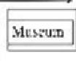

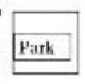
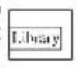
Long Strect
Brids Sireet

2023～2024学年度上期九年级期末质量检测 英 语
考试时间120分钟，满分150分
注意事项：
1.答题前，考生务必在答题卡上将自己的姓名、座位号和准考证号用0.5毫米黑色签
字笔填写清楚。
2.选择题使用2B 铅笔填涂在答题卡上对应题目标号的位置上，如需改动，用橡皮擦 擦干净后再填涂其它答案；非选择题用0.5毫米黑色签字笔在答题卡的对应区域内作答，
超出答题区域答题的答案无效；在草稿纸上、试卷上答题无效。
3.考试结束后由监考老师将答题卡收回。

A卷(共100分)
第一部分听力(共30小题；计30分)
一、听句子，根据所听到的内容选择正确答语。每小题念两遍。 (共5小题；每小题1
分，计5分)
1.A.I see. B.Good idea! C.Never mind!
2.A.It's very dark. B.He is brave. C.So he did.
3.A.Of course. B.Not at all C.I'm busy now
4.A.I agree B.No problem. C.That's all right.
5.A.Thank you B.I think so. C.That's great

二、听句子，选择与你所听到的句子意思相符合的图片。每小题念两遍。 (共5小题；
每小题1分，计5分)
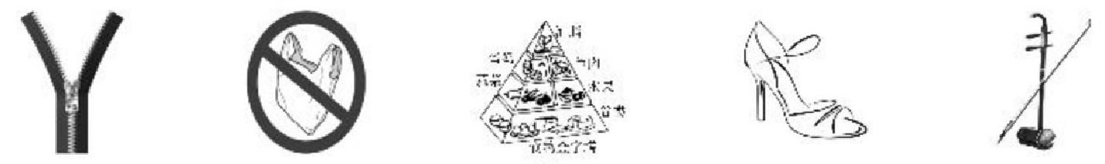
A B C D E
6. 7. 8. 9 10.

三、听对话，根据对话内容及问题选择正确答案。每小题念两遍。 (共10小题；每小题

1分，计10分)
11.A.Gray
12.A.On Wednesday
13.A.Rock.
14.A.New clothes.
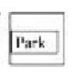
15.A. Streel
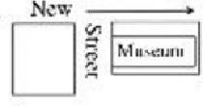


B.White.
B.On Thursday
B.Wood.
B.Red cups

B. |     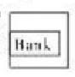  Long Streer  Ney  Lihrary | Bridge Strcet | 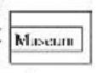  Streel  Park

C.Light blue.
C.On Friday.
C.Clay
C.Handmade Cards.

Strecr
C. New
Bank

九年级英语试题第1 页 (共12 页)

16.A.Once a week. B.Five times a week. C.Every day
17.A.Six. B.Sixteen. C.Eighteen
18.A.In a meat shop. B.In a restaurant. C.In a vegetable shop.
19.A.It's lost. B.It's stolen. C.It's dead
20.A.He was shopping
B.He was watching a movie.
C.He was having a singing competition.

四 、听短文，根据短文内容选择正确答案。短文念两遍。 (共5小题；每小题1分，计5分)
21.What subjects does Ye Liangping teach?
①Chinese. ②History ③English.
A.①② B.①③ C.②③
22.Why does Ye Lianping teach here?
A.Because he wants to make a living.
B.Because he is too old to work far away.
C.Because he wants to help the left-behind children.
23.What can we know about Ye Liangping?
A.Ye is the only teacher in the village.
B.Ye has taught there for about 30 years.
C.Ye lives with his wife and his own children
24.What happens to Yang Hongyan?
A.She works in a hospital.
B.She helps more than 2,000 children.
C.She stops poor children from dropping out of school.
25.What does Ye think of his job?
A.Not tired. B.Hopeful. C.Tired but meaningful.

五、 听短文，根据短文内容完成表格中所缺信息。短文念三遍。 (共5小题；每小题1
分，计5分)
26
What it is | It's a new subject students have 27 the  classroom.
28 they can 28 | *Doing things with hands.  *29 with others.  *Caring about nature,others and themselves.
How it works | *Teachers and students make a(n) 30  what to grow  *They grow them in the garden | on

Conclusion | It's as important as any other subject

九年级英语试题第2 页 ( 共 1 2 页 )

第二部分基础知识运用(共30小题；计40分)
六、 选择填空 (共15小题；计20分)
A. 从以下各题的A、B、C 三个选项中选择正确答案。 ( 共10小题；每小题1分，计10分)
31.—Where did you get umbrella?It's so beautiful.
—I bought it on the Internet.
A.a B.an C.the
32.—Are the keys yours,Tony?
—No,they're not .They might be Lily's.
A.mine B.yours C.hers
33.In the Wolong Panda Reserve,visitors to get closer to pandas.
A.allow B.are allowed C.are allowing

34.Alex,you are 15 years old now.You should do for yourself.Mom can't do
anything for you.
A.anything B.nothing C.something
35.—I'm so sorry to take away your exercise book .
—It doesn't matter.I know you didn't mean to.
A.by hand B.by accident C.by mistake
36.In a basketball game,it's important for the players to play together and the best in
each other.
A.work out B.bring out C.make up
37.—I'm not sure if I can learn English well.
—— .All things are difficult before they are easy.
A.I hope so B.It takes time C.It's a piece of cake
38.Lucy jumped high with after hearing she won the first prize.
A.fear B.patience C.excitement
39.—Song of Autumn by Liu Yuxi describes autumn in a different way.
—I agree.Most poets describe autumn to a feeling of sadness,but in his eyes
autumn is full of life and hope.
A.express B.expect C.explain
40.—Could you please tell me ?
—Sure.The bookstore closes at 9:00 p.m.today.
A.where I can buy a dictionary
B.how I can get to the bookstore
C.if I can buy a dictionary in the bookstore now

九年级英语试题第3 页 ( 共 1 2 页 )

B. 补全对话根据对话内容，从方框中选出适当的选项补全对话。 ( 共5小题；每小题2
分，计10分)
A:Excuse me,I am a reporter for a magazine. 41
B:Of course,please.
A:Where are you from?
B: 42
A:What do you think of Chengdu?
B:I like the city very much. 43 It seems that I have a sore throat now.
A:You can try some hot water with honey.That will make you feel better.
B:Thanks for your advice,I'll have a try!
A: 44
B:Surely not.The Spring festival is coming.I want to experience it myself!
A:Great!Thank you for answering my questions. 45
B:Thank you

A.Have a great time!
B.I come from Russia.
C.May I ask you some questions?
D.But I'm not used to the spicy food here.
E.Would you mind telling me why you come here?

七、完形填空阅读下面两篇短文，根据短文内容，从A 、B 、C 三个选项中选出可以填 入空白处的正确答案。 (共15小题；共计20分。A 篇每小题2分，计10分； B 篇
每小题1分，计10分)
A
The Double Ninth Festival falls on the ninth day of the ninth month in the Chinese lunar calendar. 46 ,people drink chrysanthemum wine(菊花酒)on that day.There are lots of
stories about this festival.Here is one of them.
Once upon a time,a young farmer lived with his 47 mother.He worried about his mother's illness but all medicines48 to bring back her eyesight.One night,he dreamed of a goddess who told him to find a white chrysanthemum far away.She said the flower would
49 on the ninth day of the ninth month and could cure(治愈)his mother's eyes.
He got it and planted it in his backyard.A few days later,the plant 50 more white
flowers.Finally,his mother could | see clearly.
46.A.Gradually | B.Importantly | C.Traditionally
47.A.blind | B.deaf | C.mad

48.A.failed | B.helped | C.refused
49.A.come up | B.come out | C.come on
50.A.created | B.gave | C.produced

九年级英语试题第4 页 ( 共 1 2 页 )

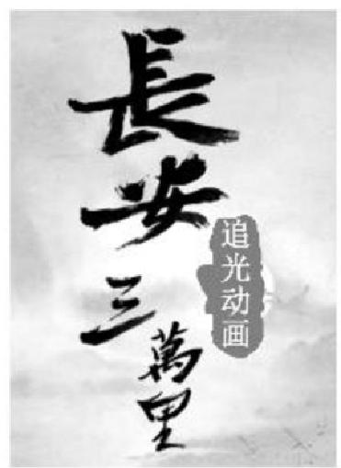
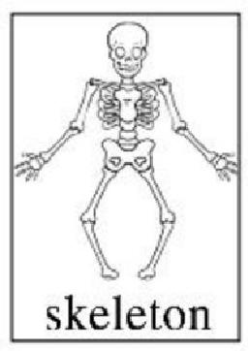

B
Have you ever seen the latest movie Chang An?With its beautiful art,the 51 movie takes us back to the Tang Dynasty.The stories of Li Bai and Gao Shi come to life before our eyes.Li is a talented poet, while Gao is a 52 man.Gao stammers (口吃)when he is young. He also has problems with 53 .When he sees words,there seems
to be a group of tadpoles(蝌蚪)swimming around on the paper.
Even so,I still like Gao.In the movie,a girl 54 a fight over
Gao.This makes him decide to work harder.Unluckily,he doesn't make
55 to the military examination(武考).Then he chooses to 56 the classic books for the keju.He doesn't succeed again,so he goes back home to 57 Gao's family gun. Finally,Gao becomes a great military leader.It shows that Gao is always 58 when facing
different problems.
From a young boy to an old man,Gao walks a 59 way between reality and dreams in his lifetime.Talents such as Li Bai are too few.The hard-working Gao Shi, 60 ,is the
common people's example to follow.

51.A.documentary
52.A.lazy
53.A.reading

54.A.has
55.A.him
56.A.write
57.A.practice
58.A.thankful
59.A.long
60.A.although

B.cartoon
B.smart
B.speaking
B.loses
B.it
B.read
B.break
B.hopeful
B.direct
B.unless

C.action

C.common
C.writing
C.wins
C.that
C.sell
C.catch

C.careful
C.smooth
C.however

第三部分阅读理解(共15小题；计30分)
八、阅读下面短文，根据短文内容判断句子正误。正确的涂“A”, 错误的涂“B”。 ( 共
5小题；每小题2分，计10分)
A giant panda's skeleton was found in the tomb of a Chinese emperor.It's the first time that a complete skeleton of the animal was found in an ancient
burial place.
The burial site is located near Xi'an.In late 2021,experts dug the remains of some animals around the tomb of Emperor Wen of Han.But only
recently they made sure that one of the skeletons is from a giant panda.

九年级英语试题第5 页 ( 共 1 2 页 )

China's giant pandas are divided into two kinds:Sichuan giant pandas and Qinling giant pandas.An expert says that the panda might belong to the Qinling giant panda.The kind has
larger and rounder face,and is different from the more common Sichuan giant panda.
“The appearance of a panda near Xi'an could also show that the weather in the area was warmer than it is today,allowing bamboo to grow there.However,it's also possible that the
animal was sent from the south as a gift,"experts add.
61.It's common to find complete skeletons of giant pandas in the ancient burial places.
62.The experts made sure that the skeleton was from a giant panda in 2021.
63.Sichuan giant pandas usually have smaller faces than Qinling giant pandas
64.From the passage we surely know it was warmer in the area near Xi'an than it is today.
65.We may read this article on a newspaper or a website.

九、 阅读下面两篇短文，根据短文内容选择正确答案。 ( 共10小题；每小题2分，计20分)
A
a |  | b
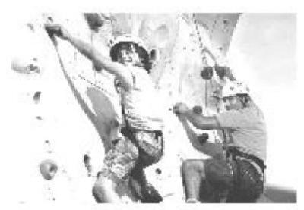 | Rock climbing  is a sport which  needs a good body,  enough energy and  the spirit of never | . | 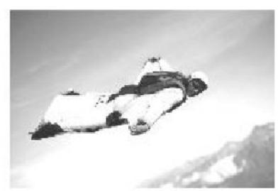 | Do you ever imagine flying through the sky like a bird?If  you're brave
giving up.It's said that rock climbing dates back to ancient China.A painting created in 200 BC shows ancient Chinese people taking up this sport.In the late 19th century,this  challenging sport became popular in Europe |  | . | enough,you can try Wingsuit Flying(翼  装飞行).Fliers in a special suit that was first developed in the 1930s usually start their trip in the air by jumping out of a  plane.

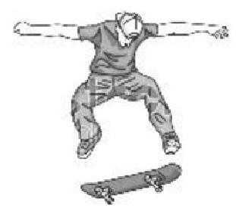  C  Skateboarding is popular among young people.Most skateboards are about 81cm long and  23cm wide. How do  people do this sport?A person rides on a  small board that is set on wheels.It sounds  easy,but in fact,it's really hard to keep one's  balance on it. | 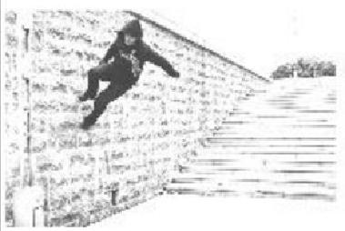  d  Parkour(跑 酷)is a way of  physical training  that develops one's ability to overcome difficulties.It was started in France by 15-year-old David Belle and quickly grew from there.While  some people consider it dangerous to  jump among buildings,active people  regard it as an exciting sport.

九年级英语试题第6 页 ( 共 1 2 页 )

以上内容仅为本文档的试下载部分，为可阅读页数的一半内容。如要下载或阅读全文，请访问：https://d.book118.com/936221225220010035

