雅思英语语法材料

第一章 谓语动词第一讲 时态

一、时态表格
（一）一般（现在、过去、将来、过去将来）

一般 | 现在 | 过去 | 将来 | 过去将来
 |  |  | 主 be + v-ing
 |  |  | 主 will/shall + v 原… | 主 would/should + v
肯定 | 主 is/are+… | 主 was/were+… | 主 is/are going to v：打算 | 原…
句式 | 主 v 原/v 单三+… | 主 v-ed+… | 一般现在（主将从现） | 主 was/were going
 |  |  | 主 be about to do sth 马上 | to+ v 原
 |  |  | 主will +be + doing sth 将要

时态“三字经”：
主
否定
句式
主 is/are not+…
主 was/were not…
主don’t/doesn’t + v 原
主 didn’t + v 原…
+…
主 be + not + v-ing
主 won’t/shall not + v 原主 is/are not going to+ v 原
Was/Were not
going to+ v 原
主
would/
should
疑问
句式
Is/Are 主+…?
Do/Does 主+v 原？
Was/were 主…?
Did 主+v 原?
Be 主 v-ing+…？
Will/Shall 主+v 原？ Is/Are 主+v 原？
not+ v 原+…/
Would/Should主v 原
+…？
Was/were 主 going to+v 原？
重复、习惯；状态，客
将来计划、明确安排；
意义
动作已经完成；描述一系列动作；
观；频度，次数；列车、
预测、尚未安排、可能；考 过去谈论将来
过去习惯
航班
虑打算、事实预测
标志
性的时间状语
频 度 副 词 ： always,
often, rarely, usually, sometimes, seldom; once/twice/three/four+ 次数； every evening/
day week/month/year
yesterday; last night/week/month
season / year; …ago; just now;
过
去
的
When, as soon as, after, before, until, as long as;
tomorrow…;
the next…
next…;
介
词 +
week/month/season/year/century
in+
表
示
将
来
的
week/month/season/year…
现在时，并不难；表重复，表习惯；表状态，表客观；有频度，有次数；看主语，定单三。

（二）（现在、过去、将来、过去将来）进行
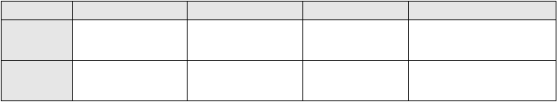
进行
现在
过去
肯定句式
主 is/are +v-ing
主 was/were +v-ing
将来
主 will/shall v-ing…
be
+
否定句式
主
主 is/are not +v-ing
was/were
not 主 won’t be +
+v-ing…
v-ing…
过去将来
主 would + v 原…
主 was/were going to+ v 原
主 Was/Were not going to+ v原主 wouldn’t+ v 原/

疑问句式 Is/Are 主+v-ing…?

Was/were 主+v-ing…?
Will 主 be + Would 主+v 原？

说话时正在发生的状
意义 态；目前正在进行的工
作
now; at the moment,

为过去某一动作提供场景
v-ing…？
将来进行着的动作； 纯粹的将来计划或 安排
Was/were 主 going to+v 原？

过去谈论将来进行着的动作

标志性的时间状语
currently, presently, at
when， while， as
present, this week
month/year
by this time
b that time; the next day
tomorrow…


（三）（现在、过去、将来、过去将来）完成

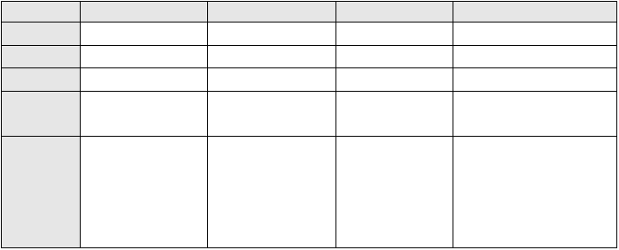
完成
肯定句式否定句式疑问句式
意义
现在 过去
主 has/have+v-ed… 主 had+v-ed…
主has/have not v-ed… 主 had not + v-ed…
Has/Have 主+v-ed…? Had 主+v-ed…?
过去动作持续到现在； 过去某时之前发生的
将来 过去将来
主 will have+ v-ed… 主 would have+ v-ed… 主+won’t have+ v-ed 主 wouldn’t have+ v-ed… Will 主 have+v-ed？ Would 主 have+ v-ed…?
将来某时之前完成 过去将来某时之前完成的动
过去动作影响到现在 动作 的动作 作
标志性的
时间状语
for+时间段， since+时
when, as soon as, by the
间点;
Ever, never, just,
already, yet; before,
till now,
time…,
sooner…
after;
no
than…,
Before, by+ 固定时 Before, by+固定时间; in+某段
间; in+某段时间 时间
hardly… when…

（四）（现在、过去、将来、过去将来）完成进行

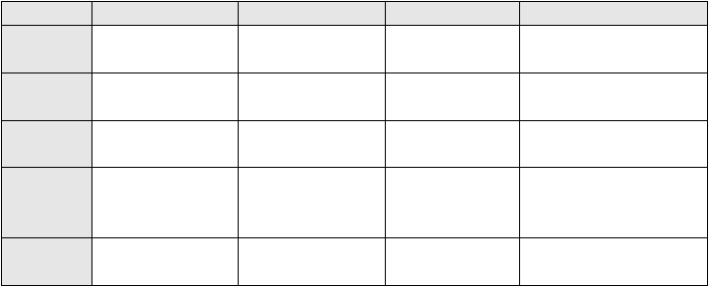
完成进行
现在
主 has/have
+v-ing…
过去
否定句式
主 has/have
+v-ing… Has/Have
+v-ing…?
not
been 主 had not been
将来
主 will have been
+v-ing…
主+won’t have been
+v-ing…
Will 主 have been + v-ing…？
将来某时之前某个
动作或状态存在了多久
过去将来
肯定句式
been
主 had been +v-ing…
主 would have+ been +v-ing…
主
wouldn’t
have
been
+v-ing…
+v-ing…
疑问句式
主
been
Had 主 been +v-ing…?
Would 主 have been +v-ing…?
意义
某种状态或动作持续
了多久
过去之前某一动作持
续的长短或动作本身
过去将来某时之前动作或状
态存在了多久
标志性的 for+时间段， since+时
时间状语 间点
for+时间段， since+时
间点
by the end of…
by the end of…

二、基本时态演练
Listening to the following conversation. (一) Task One: fill in the blanks.

- Interviewer: Your name? Peter: Peter . (1)
- Interviewer: (2) you work or (3) you a student?
Peter: I’m studying really hard for my exams this month —I’m doing math’s at university—but I also (4) my parents out. They own a (5) and I (6) there as a waiter in the evenings, so I (7) a lot of free time during the week.
My mom is always saying that I (8) enough in the restaurant! But I do manage to find some free time most days.
- Interviewer: Can you look at the (9) and tell me whether you do any of these things and if so, how (10)?
Peter: I love music and I’m learning to play the piano. I (11) really early and practice for an hour or so just about every day. I also play the guitar in a band with some other friends. We used to practice together at least (12) a week but these days we only manager to meet about once (13).
- Interviewer: What about the next thing on the list? - (14)?
Peter: Well, I used to play them all the time but now I’m too busy studying and I (15) miss them at all.
- Interviewer: Do you use a computer for other things?

Peter: I use the Internet just about (16) for my studies. And I also use it to

(17) my friends and my family. My cousin is living in Thailand at the moment and he (18) me regular emails to let me know how much fun he ’s having! He’s always visiting exciting places.
- Interviewer: Now, how about (19)?
Peter: Actually, I joined the local football team when I was at school and I still play
(20) provided I can get to training. I much prefer playing football to watch it on TV, though I do (21) watch a match if there’s a big final or something.
- Interviewer: What about going to watch live matches?
Peter: I’d love to be able to afford to go every week because I (22) my local team, but students don’t (23) have much money, you know! I can remember the
(24) I went to a live match. Oh, sorry, I can see my friends —I (25)
go now!

（二）Task Two
Read through the conversation and find out:
- Present simple sentences:
- Present continuous:
- Past simple sentences:

三、时态改错
- People should act according to what they are believing.
- In general, I think our government spent too much money on space travel.
- Nowadays, many people in my country have sent their children to single-sex schools.
- These days, more and more people traveling to very distant places for their holidays.
- I am hoping it is not too late to save the environment.
- The female hen laying on average 5 or 6 eggs per week.
- Younger drivers is more likely to be involved in a car accident.
- Most doctors are agreeing that the only way to lose weight is by doing more exercise.

第二讲 语态

一、被动语态的形式

现在过去将来
将来完成
一般
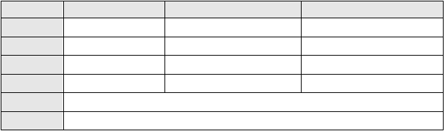
主 am/is/are + v-ed… 主 was/were +v-ed… 主 will be +v-ed… 主 would be +v-ed…
进行
主 am/is/are being +v-ed…
主 was/were being +v-ed…
×
×
完成
主 has/have been +v-ed …
主 had been +v-ed…
主 will have been +v-ed…
主 would have been +v-ed…

情态动词
不定式
主 can/could/may/might/shall/should/will/would/must/have to/ought to + be + v-ed…
…to be +v-ed…; to have been +v-ed

二、被动语态使用情景
（一）一般说来，当强调动作承受者，不必说出执行者或含糊不清的执行者时，多用被动 式
- I agree with the statement that there should be no government restriction on creative artists who express themselves in the way they do and that they must be given freedom for the same. (IELTS 4, Band 7, p167)
- There is almost everything good in what is given to us through the media world which is made up of artists. (同上)
- In conclusion, I strongly agree with that children should be taught to cooperate rather than
compete. (IELTS 5, Band 6, p167)
- It was opened in the year 1863, and it is already 140 years old. (IELTS 5, Band 7, p168)

（二）在描述事件和客观事实的时候，被动语态用得更多
- The use of electricity in England is indispensed with. (IELTS 4, Band 6, p164)
- Demand for electricity in England during typical days in winter and summer is illustrated in the graph. (同上)
- The use of average English home is shown in the pie chart. (同上)

（三）主语是泛指很多人或者大部分人这个方面
- A more dramatic rise is predicted between 2030 and 2040 in Japan, by which it is thought that the proportion of elderly people will be similar in the three countries. (IELTS 5, model answer, p162)

- It can be argued that…
It is advised/believed/universally accepted/generally recognized that… It is said/reported/estimated that…

（四）当上下文已经说明了动作执行者时：
A law was introduced to help protect people in this situation.

（五）动作的执行者并不重要时：
In the factory, the shoes are cleaned and packed into boxes ready for sale.

（六）需要体现动作的执行者时，加 by-短语：
A lot of waste materials could be recycled by large manufacturers.

三、剑指考试
- To enrich vocabulary, we should read more authentic materials.
可以改为：（1）
（2）
（3）
- It is important for nations all over the world to work hard together to control the environmental pollution.
可以改为：
- I am not sure whether all the college graduates can find jobs after graduation.
可以改为：

用适当的动词形式完成下列句子：
- My home (locate) in the western part of the city.
- These funds can (give) to the poorer people to help them.
- We (not tell) that the rules had changed.
- Children need to (teach) the correct way to behave in public.

句子改错：
- The house was sell for over a million dollars.

- The class has allowed to eat in the staff dining room during the renovations.
- The potatoes carry along a conveyor belt to a room where they wash and peel.
- The teacher told to take her class out of the school if the fire bell rang.
- Smoking don’t allow in any part of the aeroplane.
- The museum was being renovating when we were there, so we could not visit it.
- Bus tickets can buy at any newsagents.
- New employees have instructed not to operate the photocopier until they are trained.

把下面的句子改成被动语态，并决定是否需要带 by-短语
（1）A factory worker checks each box for quality.

- The government does not permit children under 16 to work.

- The washing machine is washing your clothes at the moment.

（4）A mechanic will repair your car this afternoon.

- The agent has sold our house at last.

- Something tore the back of my coat.

- The employer pay off the staff more for working at the weekend.

- Burning tires give off highly toxic chemicals.

第三讲 虚拟语气

请欣赏下列一首诗歌：
If you were a teardrop in my eye,
For fear of losing you, I would never cry.
And if the golden sun should cease to shine its light,
Just one smile from you would make my whole world bright.

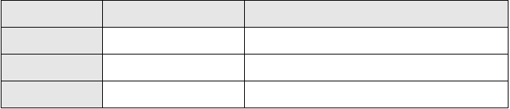一、虚拟语气基本句型
虚拟时间
if 从句谓语形式
主句谓语形式
与现在事实相反
did/ were
would (should, could, might) do
与过去事实相反
had done/ had been
would (should, could, might) have done/ been
与将来事实相反
did/were to/should + do
would (should, could, might) do
- 与现在事实相反
- If she were sick, she could stay at home and have a rest today.
- If you watched more and talked less, we would both enjoy our film.

与过去事实相反
- If they had studied earlier, they would have passed the IELTS.
- Helen would have graduated with her class if she had been able to meet all the requirements in time.

与将来事实相反
- If it snowed tomorrow, I would go skiing.
- If it should snow tomorrow, I would go to make a snowman in front of our dormitory.
- If you were to see your tutor, what would you tell him?

错综的虚拟语气
- If I were you, I wouldn’t have told that to her. （时间错综：从句现在，主句过去）
- Had I taken my umbrella with me in the morning, I should not be wet now. (时间错综：从句过去，主句现在)

虚拟语气的倒装
可以把条件句中的 if 省略掉，同时把 should, were, had 等助动词提前，构成倒装句。请把下面的句子变成倒装虚拟条件句
- （现在） If there were no air, there would be no life around the earth.

- （过去） If he had been older, he might have understood this question.

- （将来） If this were to happen again, you would be punished severely.

(4)（将来＋现在） If you should have any questions, feel free to call me.

二、虚拟语气——特殊名词性从句（从句动词用 should + v 原形）
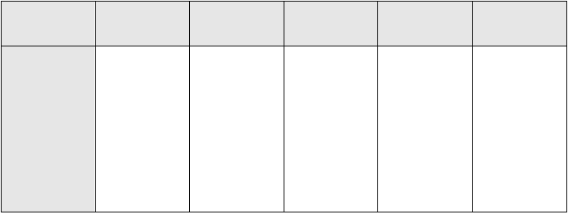1、（动词后面接宾语从句）
词义
Jian（坚持、建
议、推荐）
决（定）
要（求）
命（令）
其他
词汇
advise 建议
argue 主张insist 坚持maintain 主张recommend 建议propose 提议suggest 建议prefer 提出
urge 敦促
decree 裁 决
determine 决 意
resolve 决 意
ask 要求
desire 要求demand 要求plead 请求pray 恳求request 请求beg 恳求
command 命 令 agree 同意
direct 命令 arrange 安排
order 命令 intend 打算
stipulate 规定
rule 裁决
2、名词后面接表语从句或者同位语从句

Jian advice 建议recommendation suggestion 建议
proposal 建议
motion 提议
Jue
decision 决定建 议 resolution 决定
determination 决定
Yao demand 要求pray 请求
requirement 要求
propose 要求
desire 要求preference 提出要求command 要求
Ming order 命令command 命令
necessity 必要性

三、剑指考试——虚拟的语气，真实的分数
1、听力中的虚拟语气
- Either way we would have been rewarded because we fell upon amazing, high meadows, huge gorges and wonderful snow-capped mountains. (IELTS 2, Listening)
- I suppose if we were to do it all again, we ’d probably hire donkeys along the way. (IELTS 2,
Listening)
- It is important that you know roles of the jobs. (IELTS 2, Listening)
- And if you had to give the new directors some specific advice when they set up the channel,

what advice would you give them? (IELTS 2, Listening)

2、写作中的虚拟语气
- If they could raise them to be considerate of others and to be social, responsible individuals, the whole community would benefit (IELTS 4, Writing)
- High quality nursery schools could be established that would support families more in terms of raising the next generation. (IELTS 4, Writing)
- In conclusion, I strongly agree with that children should be taught to cooperate rather than compete. (IELTS 5, writing)
- If this were not true, then we would be able to predict the behavior and character of a person from the moment they were born. (IELTS 5, writing)
- Without the natural talent, continuous training would be neither attractive nor productive, and without the training, the child would not learn how to exploit and develop their talent. (IELTS 7, Writing)
- If sufficient sky trains and underground train systems were built and effectively maintained in our major cities, then traffic on the roads would be dramatically reduced. (IELTS 8, Writing)
- Long-term traffic and pollution reductions would depend on educating the public to use public transport more, and on government using public money to construct and run efficient systems. (IELTS 8, Writing)

3、思考题：
Overall the table suggests that households of single adults and those with children were more likely to be living in poverty than those consisting of couples. (IELTS 5, Writing) 这句是不是虚拟语气？为什么

4、首先用虚拟语气填空，然后根据听力内容进行答案核对
- If I (buy) a second-hand car, I (not need) to take out this big bank loan.
- It probably (not be) so bad if the price of petrol (not double) last month.
- If I (wait) a bit before buying the car, I (manage) to save quite a bit by now.
- If only I (listen) to him, none of this (happen).
- If you (get) better with him, you (listen) to him.
- If I (take) his advice, I (own) a small fortune now.

第四讲 主谓一致

一、雅思中常见的不可数名词
advice, advertising, food, furniture, garbage, information, knowledge, money, shopping, time, traffic, travel 等

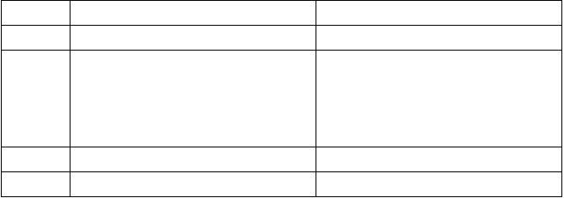可数名词与不可数名词对比：
量 可数名词 不可数名词
所有 All (of) All (of)
大量的 Lots of/plenty of/a lot of Lots of/plenty of/a lot of Many (of) Much (of)
Most (of) Most (of)
A large/considerable/substantial number of A large/considerable/substantial amount of
中量 Some (of)/a certain number of Some of/a certain amount of
几乎没有 No/not any/none of No/not any/none of

二、改错（每句话可能不止一个错误）
- My tutor was very helpful; he gave me one very good advice about how to study.
- I was surprised by the number of times it took us to reach the castle.
- You need a great deal of knowledges to become a doctor.
- The informations we were given by the tour guide were not very helpful.
- When we visited the park, we were upset to see so manage garbages left there.
- We arrived late because there were so many traffic on the road.
- I can’t wait to visit the market and do a few shopping.
- The furnitures in the hotel room were quite old but they were very comfortable.

三、剑指雅思
Listen and answer the question below
- Which three pieces of furniture are in the room?
a. bed; b. a bedside table; c. a desk; d. a lamp; e. a mirror; f. a wardrobe
- What does the desk look like?
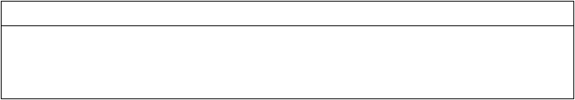Listen again and fill in the gaps in the advertisement. Write no more than one word or a number for each answer.
Accommodation for rent
Small, furnished 1 available. Sunny with a nice view of the .
Good
location close to two types of . Rent pounds per . Rent
includes and all other bills.

第二章 非谓语动词

第一讲 不定式

一、…verb + to do sth
agree, aim, appear, arrange, attempt, be able, be likely, claim, decide, deserve, fail, hope, learn, manage, offer, plan, promise, refuse, seem, tend, try

二、…verb + sb. + to do sth.
Advise, allow, encourage, force, get, persuade, remind, teach, tell, warn

三、…verb + to do sth/…verb + sb. + to do sth
Ask, choose, dare, expect, help, intend, need, prefer, prepare, want

四、Complete these sentences from the recording by using the verbs in brackets. Listen again and check your answers.
- I decided (do) an animal management course.
- I chose (study) at Fairfield College because it ’s got a good range of animals and everyone’s really friendly.
- The course is only three days a week, so I’ve already started (work) part-time at a pet shop.
- I prefer (take) time so I can get to know them.
- I don’t even mind (clean) them out.
- They have let us (treat) some minor problems, like removing splinters from paws.
- The make us (handle) all kinds of animals including spiders and snakes.
- I remember (feel) really scared.
- As long as you remember (do) it the way you have been taught, it’s fine.
- Before, if I heard him (bark), I just told him (be) quiet.
- I’d really like (work) in either a zoo or a safari park.

以上内容仅为本文档的试下载部分，为可阅读页数的一半内容。如要下载或阅读全文，请访问：https://d.book118.com/937012164050006053

