吉林省吉化一中2023-2024学年高三3月份第一次模拟考试英语试卷
考生请注意：
1．答题前请将考场、试室号、座位号、考生号、姓名写在试卷密封线内，不得在试卷上作任何标记。
2．第一部分选择题每小题选出答案后，需将答案写在试卷指定的括号内，第二部分非选择题答案写在试卷题目指定的位置上。
3．考生必须保证答题卡的整洁。考试结束后，请将本试卷和答题卡一并交回。

第一部分 （共20小题，每小题1.5分，满分30分）
1．People all think it strange that the boy should tell what’s written on the paper in another room without looking at it. It really ________ explanation.
A．prevents B．challenges C．interrupts D．confuses
2．---How’s your tour around the North Lake? Is it beautiful?
---It ________ be, but it is now heavily polluted.
A．will B．would C．should D．must
3．-- I have heard Mr. Morgan will be here at 4:00 pm. next Thursday.
-- No, he _______ at that time.
A．was boarding B．would be boarding
C．will be boarding D．is boarding
4．These new books are a very welcome _________ to the school library.
A．addition B．arrival C．attitude D．audience
5．I like such houses with beautiful gardens in front, but I don’t have enough money to buy .
A．it B．one C．that D．this
6．With economy increasing steadily, people ______ enjoy a life of higher quality.
A．should B．can C．may D．must
7．In order to make my composition clearer and smoother, my teacher asked me to _________ the unnecessary words and sentences.
A．leave alone B．leave behind
C．leave off D．leave out
8．Though he lacks experience, the arrangements are all _______ for the meeting next Thursday ahead of time.
A．in particular B．in place C．in preparation D．in time
9．---Has John ever broken his promise?
---No. For example, he said he would show me around his school, and .
A．so would he B．so did he
C．so he would D．so he did
10．— You've got your flat furnished, haven't you?
— Yes, I ______ some used furniture and it was a real bargain.
A．will buy B．have bought
C．had bought D．bought
11．—Are you doing your homework？
—No, I’m writing a short play．It _____ at the Christmas party．
A．will be put on B．will put on
C．puts on D．is put on
12．The pilot asked all the passengers on board to remain________as the plane was making a landing.
A．seat B．seating
C．seated D．to be seating
13．He’s as a “bellyacher”—he’s always complaining about something.
A．who is known B．whom is known
C．what is known D．which is known
14．––Cathy is not coming to your birthday party tonight.
––But she ______!
A．promised B．promises
C．will promise D．had promised
15．I really don’t know _________ she gets by on such a modest salary.
A．what B．why
C．how D．that
16．---Let's walk to that village together.
---__________. How can we two girls do that in the dark？
A．I agree with you. B．That's a good point.
C．You must be joking！ D．That's not your opinion！
17．Mike is looking for another job because he feels that nothing he does his boss.
A．serves B．satisfies
C．promises D．supports
18．—How I wish I had worked harder when I was in that company.
—If you had, you _________ a department manager now.
A．are B．would be
C．would have been D．were
19．一Excuse me，sir．You can’t enter 0ffice without permission．
一But the manager is expecting me．
A．the；a B．an；the C．the；不填 D．不填；不填
20．____ up early in the morning to have a walk, I am sure, you are likely to feel active all day．
A．Get B．Having got C．Getting D．To get
第二部分 阅读理解（满分40分）阅读下列短文，从每题所给的A、B、C、D四个选项中，选出最佳选项。
21．（6分）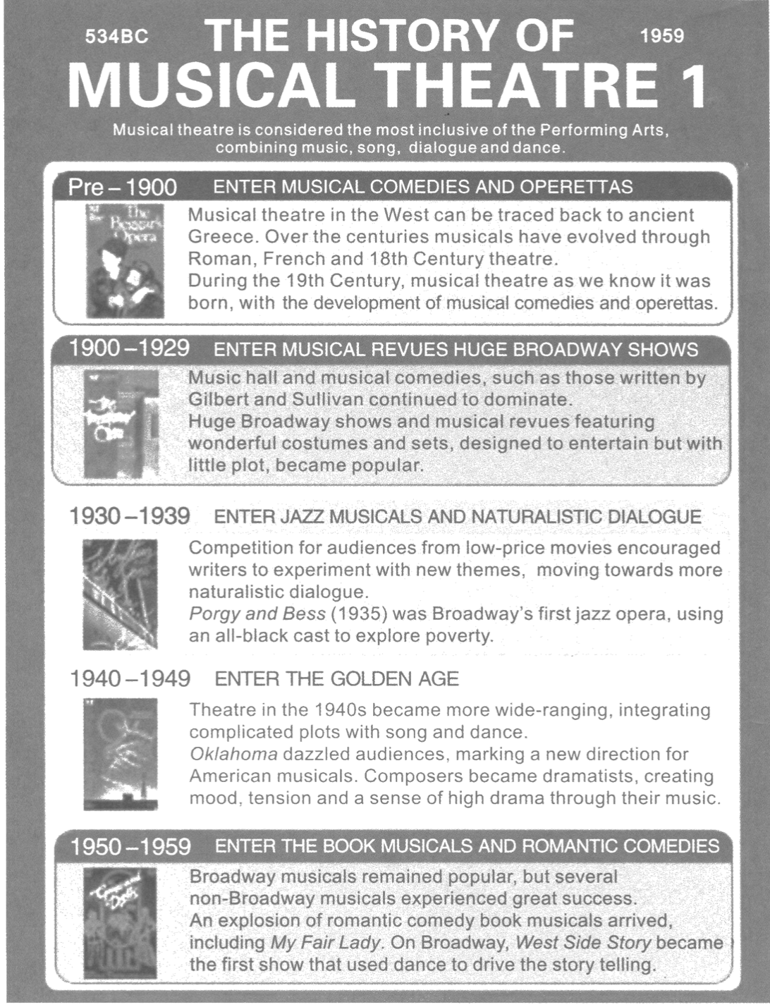
1、What caused musicals to move in a new direction during the 1930's?
A．The development of new musical instruments.
B．The audience s demand for more realistic art forms.
C．The rising popularity of other types of entertainment.
D．The greater acceptance of black performers by white audiences.
2、In which period did musical theatre become more complex and dramatic?
A．Pre - 1900. B．1900- 1929.
C．1940- 1949. D．1950- 1959.
3、What can be reasonably inferred about the musical West Side Story?
A．It told its story in a new way.
B．It was based on a true story.
C．It was a non-Broadway show.
D．It was not very successful at first.
22．（8分） The School has become aware that many students are being prevented from doing their work because of other students playing games and watching movies. We're sorry it's come to this，but we don't have enough resources to support everything，and our educational mission comes first.
●NO RECREATIONAL ACTIVITIES，SUCH AS GAMES AND MOVIES，ARE ALLOWED IN ANY OF THE LABS 8：30 AM TO 4：30 PM WEEKDAYS.
Work on course-related game development is excepted. Note that it is usually very obvious whether game activity is recreational.
●MULTIPLE LOGINS AT THE SAME TIME ON THE SAME USER ACCOUNT ARE FORBIDDEN.
If you have a course-related need for an exception to this rule，please contact the tech staff （supportatsignscs. carleton. ca）.
For our general policy on lab usage，please see scs. carleton. ca/ labpolicy. Note that it includes：
●NO FOOD（except dry snacks and bottled drinks）
●NO PROPPING DOORS OPEN
1、Why does the writer write this announcement?
A．To emphasize the must-be-obeyed rules in the lab.
B．To ask the students to pay for what they've done.
C．To remind students to bring something.
D．To criticize bad-behaving students.
2、According to the announcement, what is the most important thing for students to do in class?
A．Playing computer games. B．Watching movies.
C．Completing the learning tasks. D．Finishing all assignments before class.
3、According to the announcement, students have to contact the tech staff when______.
A．they want to log in the website
B．they need to repair their computers
C．they forget their password to enter the account
D．they want to share one user account at the same time
4、Which food could NOT be brought into the lab?
A．Biscuits. B．An apple.
C．A bottle of water. D．Bread.
23．（8分）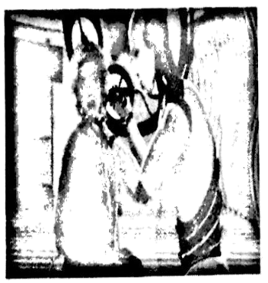
For all the technological wonders of modem medicine, health care-with its fax machines and clipboards(写字板)—is out of date. This outdated era is slowly drawing to a close as the industry catches up with the artificial-intelligence ( AI) revolution.
Eric Topol, an expert in heart disease and enthusiast for digital medicine, thinks AI will be particularly useful for such tasks as examining images, observing heart traces for abnormalities or turning doctors' words into patient records. It will be able to use masses of data to work out the best treatments, and improve workflows in hospitals. In short, AI is set to save time, lives and money.
The fear some people have is that AI will be used to deepen the assembly-line culture of modem medicine. If it gives a “ gift of time” to doctors, they argue that this bonus should be used to extend consultations, rather than simply speeding through them more efficiently.
That is a fine idea, but as health swallows an ever-bigger share of national wealth, greater efficiency is exactly what is needed, at least so far as governments and insurers are concerned. Otherwise, rich societies may fail to cope with the needs of ageing and growing populations. An extra five minutes spent chatting with a patient is costly as well as valuable. The AI revolution will also enable managerial accountants to adjust and evaluate every aspect of treatment. The autonomy of the doctor will surely be weakened, especially, perhaps, in public-health systems which are duty-bound to cut unnecessary costs.
The Hippocratic Oath(誓言) holds that there is an art to medicine as well as a science, and that “warmth, sympathy and understanding may outweigh the surgeon's knife or the chemist's drug”. There's lots of sense in it: the patients of sympathetic physicians have been shown to recover better. Yet as the supply of human carers fails to satisfy the demand for health care, the future may involve consultations on smartphones and measurements monitored by chatbots. The considerately warmed stethoscope ( 听诊器) ,placed gently on a patient's back, may become a relic of the past.
1、What's Dr Topol's attitude toward AI's coming into medicine?
A．Concerned. B．Doubtful. C．Optimistic. D．Cautious.
2、What does the author of the text attach more importance to?
A．Medical costs. B．National wealth.
C．Longer consultation. D．Greater efficiency.
3、Why is the Hippocratic Oath mentioned?
A．To prove the bright future of AI.
B．To show the advantage of a human doctor.
C．To explain medical equipment is more important.
D．To argue a human doctor performs as well as a robot.
4、What may be the best title for the text?
A．Health care and AI B．AI and its applications
C．Doctors and Patients D．Dr Topol and digital medicine
24．（8分） It’s not common that a grandmother aged 89 is crowned Queen of Icebergs in north America, but when it does happen it’s quite the sight.
On a recent trip to Iceland, Judith Streng became that grandma after her son attempted to take a photograph of her sitting on an ice structure that looks like a throne (宝座) at Diamond Beach in Jokul. Shortly after Streng sat down to pose, the piece of ice broke off and floated into the water.
“I thought it was safe. One girl had been on it and then two girls at the same time, and it was very secure with them. When I got on it, it started to shake and a wave was coming in. A very large wave came in and made the throne kind of shake, and I could tell that I was slipping off,” Streng told ABC News.
Streng’s story went hot after her 24-year-old granddaughter Catherine tweeted a text message exchange she had with her father about the incident. “My grandmother almost got lost at sea in Iceland today!”
Catherine, who teaches English in Seoul, South Korea, explained via Twitter that her father described the scene vividly. He has a PhD in English, and described the event in the following words, “She climbed to the throne after a wave had pulled back and left it briefly exposed on the beach. Then a wave washed in and removed the ice throne,
rocking it from side to side. When the wave left, it lifted the throne and carried her out into the sea with the tide.”
Luckily for the Streng family, Randy, a licensed boat captain from Florida with knowledge of water rescue strategies witnessed the whole thing, and was able to save the day.
1、Where was the grandma when her son was taking a picture for her?
A．On a crown. B．In an iceboat.
C．At a throne beach. D．On an iceberg.
2、How did Catherine spread this accident?
A．By drawing a vivid picture.
B．By exchanging tweeter account.
C．By talking with her father in Seoul.
D．By posting the text message exchange with her father.
3、Who saved the grandmother?
A．Catherine. B．Streng.
C．Randy. D．Judith.
4、What can be a suitable title for the text?
A．Taking Pictures Must be Very Dangerous
B．A Grandma Floated out to the Sea on an Iceberg
C．An Optimistic Family Who Love Iceberg
D．The Licensed Boat Captain Went Hot Slowly
25．（10分）Spain Environmental Project
Full Description
Greenheart Travel? Casita Verde (Green House) is an incredible eco-center situated in a beautiful valley near the village of San Jose, Ibiza. This great Mediterranean island is renowned for its rich culture and incredible scenery. Casita Verde is considered an experiential eco-education center, and showcases the best practices for sustainable living and alternative energies. The center includes almost 14 acres of working farm land created to demonstrate ecological development powered by wind and sun energy.
How You Will Make a Difference:
—Maintain and improve the farm facilities
—Install an alternative energy system
—Promote environmental awareness among visitors
—Cook delicious, organic meals for visitors
—Learn farming that emphasizes the use of renewable natural resources and the enrichment of local ecosystem
Assist with Sunday community visit/meals
Dates: Flexible dates available
Duration: 1 to 12 weeks
Cost Details: fee includes: housing, fool, medical insurance, in-country staff support, pre-departure orienta-tion, in-country orientation, 24-hour emergency contact
A Great Opportunity for: Teens/Professionals
Skills Needed/Experience
Participants should have an active interest in environmental studies/ecology, and strong desire to contribute to the international effort to protect the environment. Those who are interested in it must have extensive hands-on conservation experience and be willing to live rustically（淳朴地）in an alternative community. Some knowledge of Spanish is helpful but not required.
1、What do we know about Casita Verde?
A．It covers about 14 acres in size.
B．It is powered by renewable resources.
C．It is the center of a beautiful valley.
D．It develops its unique culture.
2、What can you do in Casita Verde?
A．Teach visitors how to grow organic plants.
B．Help the local promote environmental awareness.
C．Prepare organic meals for visitors on Sunday.
D．Make research into an alternative energy system.
3、Who are the intended readers of the text?
A．Travelers. B．Famers.
C．Workers. D．Volunteers.
第三部分 语言知识运用（共两节）第一节（每小题1.5分，满分30分）阅读下面短文，从短文后各题所给的A、B、C和D四个选项中，选出可以填入空白处的最佳选项．
26．（30分）"How was school, Ben?" I asked my 1 after he began kindergarten(幼儿园) this year. "The work is too 2 and there's not enough time to play." he replied with a deep 3 .
I couldn't help but remember Ben's mother. my daughter, Jane, and her 4 to the first day of school. When Julie 5 home that afternoon. I asked her the same question . She also replied with a long, 6 face but her answer was a little different as she announced . " I didn't learn to 7 today."
What a disappointment for a little girl who thought she would 8 know how to read her little books after the first day of school. I had to explain to her that she would 9 learn to read but didn't happen quite that fast.
My 10 went back to my school days again I could almost 11 the chalk dust in the air. I suppose few schools still use chalk and blackboards. They have probably been 12 with newer equipment and large computer screens
On the first day of school, the expectation was s 13 that I would be up early in the morning and 14 long before it was time to leave for school We 15 about 6 blocks to school 16 new shoes that felt tight and carried our small supplies inside a cigar box from one of the local stores. The stores must have saved cigar boxes just to give to us children .We 17 them from year to year until they fell apart.
The first day of school was a new beginning, although there might be 18 on the first day. The doors of knowledge had been opened and we 19 great learning adventures. It is an 20 in our lives that most of us remember. It's a big step for a small child toward leaving babyhood and so "there isn't enough time to play".
1、A．son B．grandson C．brother D．cousin
2、A．short B．loose C．hard D．long
3、A．cheer B．expression C．concern D．sigh
4、A．attention B．approach C．reaction D．access
5、A．returned B．left C．headed D．escaped
6、A．cheerful B．friendly C．sad D．familiar
7、A．write B．read C．listen D．speak
8、A．widely B．magically C．perfectly D．commonly
9、A．eventually B．originally C．occasionally D．constantly
10、A．idea B．view C．mind D．sight
11、A．smell B．imagine C．taste D．reach
12、A．decorated B．replaced C．exchanged D．equipped
13、A．small B．great C．faint D．slight
14、A．anxious B．nervous C．curious D．ready
15、A．walked B．drove C．ran D．rode
16、A．on B．in C．by D．with
17、A．saved B．used C．protected D．hid
18、A．excitement B．anxiety C．disappointment D．sorrow
19、A．expected B．promised C．demanded D．appreciated
20、A．matter B．affair C．fact D．event
第二节（每小题1.5分，满分15分）阅读下面材料，在空白处填入1个适当的单词或括号内单词的正确形式。
27．（15分）The World Health Organization (WHO) 1． (include) game addiction in the latest International Classification of Diseases on Nov. 28,2017.
It is the first time for WHO to include the addiction in the global information standard. 2．the standards have not been officially published, game addiction is already a social issue that involves an3．(increase) number of adolescents and even adults.
“All addictive behaviors can 4．(consider)as addiction diseases from a professional perspective,” said Huang Yueqin, director of the Institute of Mental Health, Peking University Sixth Hospital. Yuan Yonggui, director of Zhongda Hospital’s psychiatry department, said that game addiction is similar 5．certain mental disorders caused by damage to the area of the brain, 6． is responsible for the reward system.
A study by a university in the United Kingdom shows that game addiction might not be a chronic condition and it is the escape from reality 7． attracts addicts.Most games can be very rewarding, 8．(regard) of how they are played, and this is9．(especial) important for teenagers. Not only do they get a sense of control, but also a sense of 10． (achieve) and belonging.
第四部分 写作（共两节）第一节 短文改错（满分10分）
28．（10分）假定英语课上老师要求同桌之间交换修改作文，请你修改你同桌写的以下作文。文中共有10处语言错误，每句中最多有两处。每处错误仅涉及一个单同的增加、刪除或修改。
增加：在缺词处加一个漏字符号（∧），并在其下面写出该加的词。
删除：把多余的词用斜线（\）划掉。
修改：在错的词下划一横线，并在该词下面写出修改后的词。
注意：1、每处错误及其修改均仅限一词；
2、只允许修改10处，多者（从第11处起）不计分。
As a student, I have taken a great many of exams、 Whether I have been good prepared or not, I will keep calm and confidently、 That is because I know the purpose of exams is to find out the knowledges we can’t understand、 Therefore, there was a time when I was afraid of exams、 I was afraid that I couldn’t get high marks or fail the exam, I would be laughed at by others、 Later, my teacher, she realized my problem, had the face-to-face talk with me、 After I followed the advice giving by my teacher I finally overcame my fear、
第二节 书面表达（满分25分）
29．（25分）假定你是李华，你校学生会暑期将组织“丝绸之路”沿线国家考察活动，留学生也可参加。请你用英语给对此次活动感兴趣的留学生Jenkins写封电子邮件，告之相关内容：
1. 活动安排(参观、交流等)；
2. 报名条件(年龄、身体状况等）；
3. 报名方式。
注意：
1. 词数100左右；
2. 可以适当增加细节，使行文连贯。
________________________________________________________________________________________________________________________________________________________________________________________________________________________________________________________________________________________________________________________________________________________________________________________________________________________________________________________________________________________________________________________
参考答案

第一部分 （共20小题，每小题1.5分，满分30分）
1、B
2、A
3、C
4、A
5、B
6、B
7、D
8、B
9、D
10、D
11、A
12、C
13、C
14、A
15、C
16、C
17、B
18、B
19、C
20、C

第二部分 阅读理解（满分40分）阅读下列短文，从每题所给的A、B、C、D四个选项中，选出最佳选项。
21、1、C
2、C
3、A
22、1、A
2、C
3、D
4、B
23、1、C
2、D
3、B
4、A
24、1、D
2、D
3、C
4、B
25、Before leaving his job in Brooklyn, Brian Peter had one thing he wanted to do on his last day-say thank you to the city he loves. Peter decided to use the money he made for a day’s work, as well as the $17 per year he earned for his service, to give back to his community.
“I've got nothing but good things from the city and the citizens,” Peter said. “I take what I make in a day and add that $1136 that the police association was going to give me, and I’ll just add it up to $500 and get some gift cards for people.”
So after fourteen years’ serving as a police officer, Peter spent his last day doing that. Using his own money, Peter purchased five gift cards from Target and five gift cards from the grocery chain Cub Foods worth $ 50 each and handed them out to strangers in Brooklyn Center.
It took him about two hours to give away the cards and that he could put smiles on a lot of people’s faces, including one woman he stopped after noticing the condition of her car. “Her car was really old and really damaged. I saw her windshield wipers were stuck in the up position,” Peter recalled. “I explained what I was doing and gave her a gift card, and immediately, she lit up with a smile.”
Once people overcame the initial shock of what he was doing, Peter said he received a lot more hugs that day. Monique Drier, who stayed with Peter, said Peter has always wanted to give back and didn’t really want the attention. “He didn’t even have a going-away party,” Drier said.
Peter, who started his new job three days ago, said he still wanted to continue giving back to the community. “Community service is extremely important, and when you’re fortunate in life, you should give back to others who aren’t as fortunate as you,” Peter said. “That’s what makes the world go round.”
17、We can learn from the passage that Peter______.
A．decided to retire from his position as a police officer
B．was interested in making friends with some strangers
C．showed his kindness to strangers before leaving his job
D．earned ten dollars a year for his service as a police officer
5、The woman in a car is mentioned in the passage in order to show____.
A．how Peter’s gift card influenced her attitude
B．how Peter added happiness into others’ daily life
C．how Peter found others in trouble and helped them
D．how Peter received hugs from those who were grateful
18、How does Peter think the world can go round according to the passage?
A．By involving other in community service.
B．By sharing what we have with the unfortunate.
C．By giving rewards to those who help others.
D．By offering new jobs to unfortunate people.
16、What is the main idea of this passage?
A．A police officer knew how to cheer up people in trouble.
B．Peter spent his last day giving gift cards to strangers.
C．The best way to help a community can be learnt from Peter.
D．Peter returned what he earned in his work to the police station.
参考答案1、A
13、B
9、C
17、D5、D
18、B
16、A
13、A9、C
17、A
以上内容仅为本文档的试下载部分，为可阅读页数的一半内容。如要下载或阅读全文，请访问：https://d.book118.com/938041012032006047

