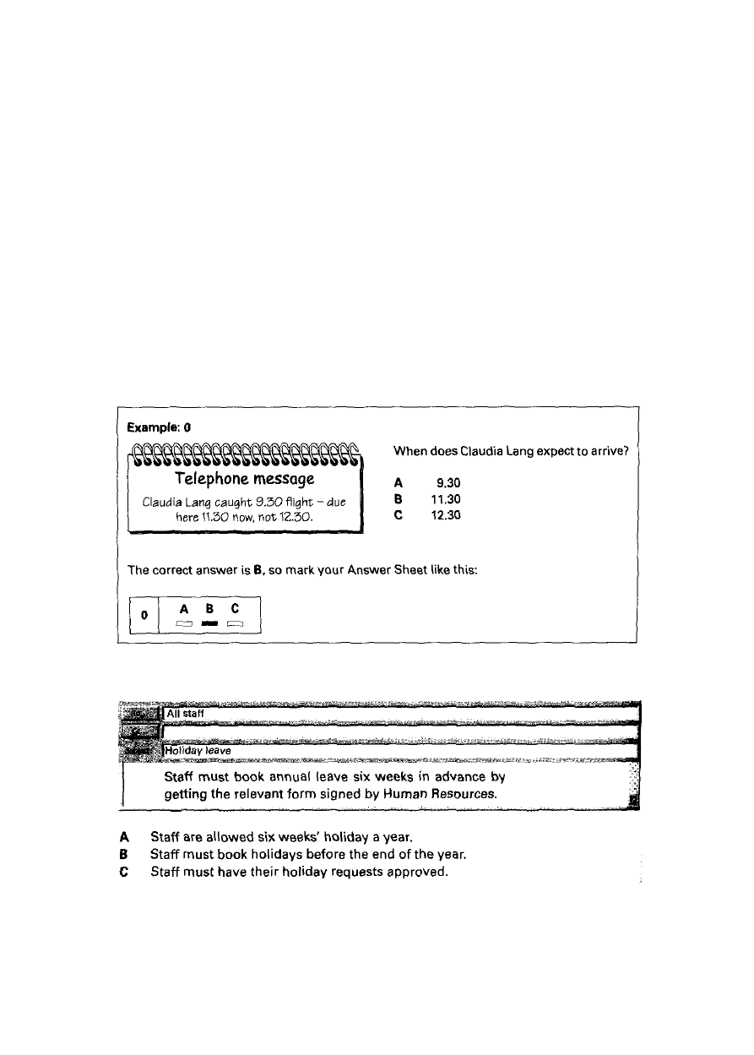
Test 1
READING AND WRITING 1 hour 30 minutes PART ONE
Questions 1-5
- Look at questions 1-5.
- In each question, which sentence is correct?
- For each question, mark one letter (A, B or C) on your Answer Sheet.

1

2


Inform臧 i on for customers
,, AH go 呻 trans ported by Fera Carriers a『 e insur 职 I, but our policy exclud 够damage due to poo·r peckag1n9 .

A Customers ·will not nee的 扭 ri ly· qu alify for compensation if goods are damagedm B C邸 tom ersshoul d arrange insurance against damage加i ore sending goods.
C Cust ome『s ar-e able to claim a refund if packaging is damaged.
3

MEMO
To: WciYu
From: Human Re叙儿 r” 巧迦 ： ］8 N 叩 ember Subject: 阿 nin g
We-can't 浊 y whether your肛ainingapplication will be accepted until we. canco呻 rm
that funds are a.vail able.

A Wei Vu should re-apply for his training cou 呻 at a Iat er date.
I There may not be enough money to pay for Wei Vu's course.
C Human Resources cannot 心 而 rm which l riJi nin g co u rs e W ei Yu shou ld take.
4


氏 terphoned from t沺 staIion- services to London aran:tt r叩 ningthis mor叩ng.
汕 sting put off to 3 pm this 咖 rnoon.
知 e

．一二'·-`.五.
．一
...L. 巴-．- - l .

A T he 11 am meeting is po叩 oned because Peter's train wascanc ell ed .
a p咖 wi.U ar r ive at the 11 am meeting late because his.train ls delayed.
C The11 am me叭in g is resched u l的 切 cause Peter was lateand missedhistrain.
5

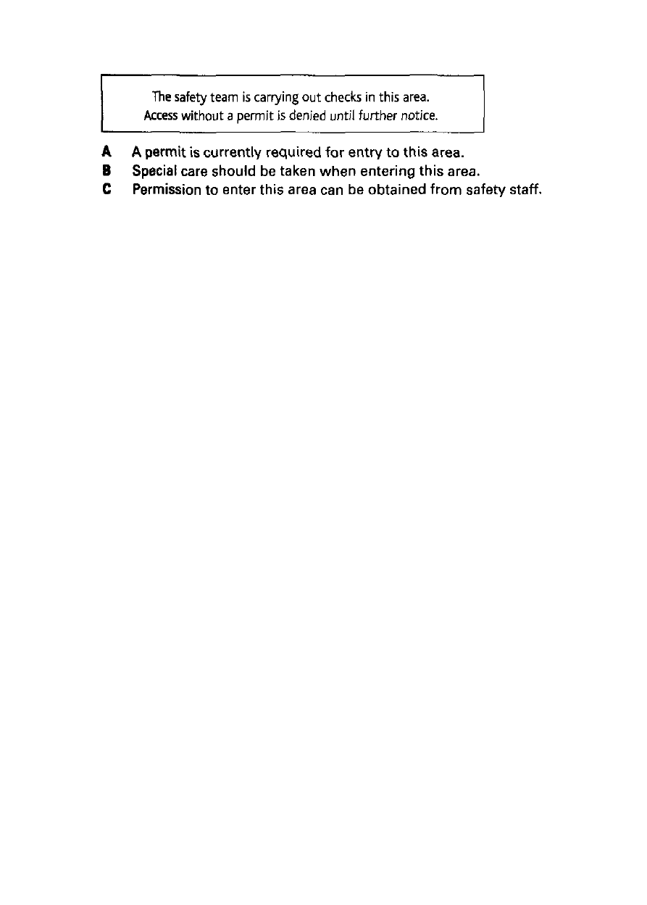

PART TWO
Questions 6-10
- Look at the advertisement below. It shows a list of workshops offered by a training company.
- For questions 6-10, decide which workshop (A-H) each person on the opposite page should attend.
- For each question, mark one letter (A-H) on your Answer Sheet.
- Do not use any letter more than once.

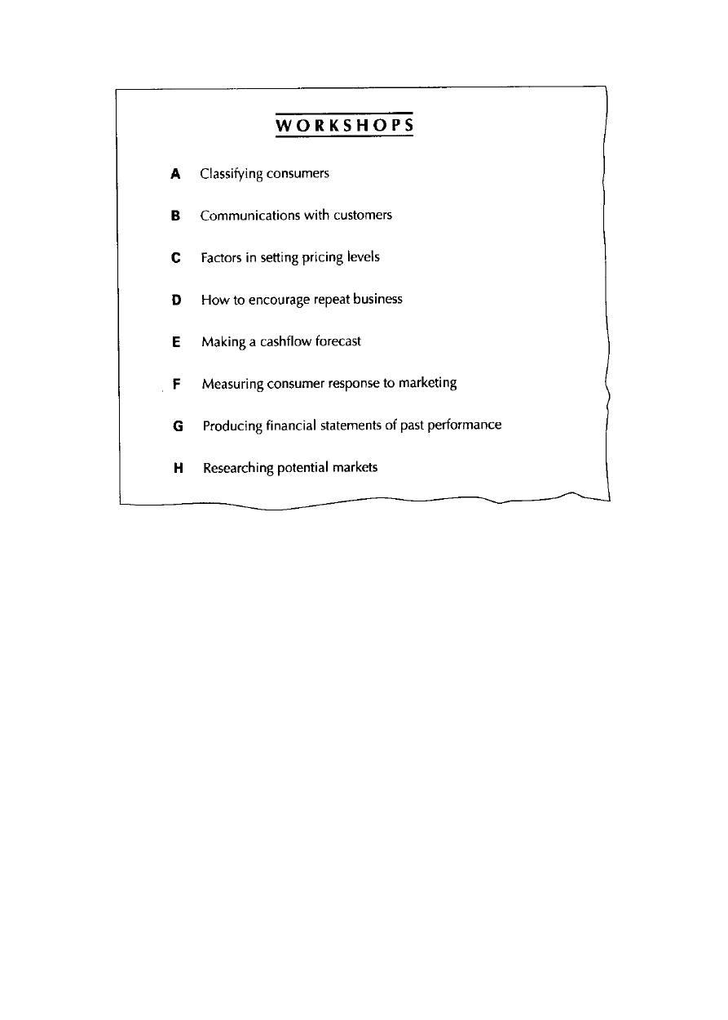

  - Julia Strekalova wants to know how to calculate the amount she can charge customers for her marketing consultancy services.
  - Roger Walker's company wants to give him responsibility for his firm's annual profit-and-loss account and balance sheet.
  - Paolo Longo needs to be able to assess the effect on sales following his company's recent product promotions.
  - Zhon Mei Feng's company wants her to learn to divide the market into groups, which it can target with different brands.

  - Valerija Georgievska needs a course on working out how much money her firm can expect to have available each month.
PART THREE
Questions 11-15
- Look at the chart below. It shows a company's turnover, operating profit and market share over a period of ten months.
- Which month does each sentence (11-15) on the opposite page describe?
- For each sentence, mark one letter (A-H) on your Answer Sheet.
- Do not use any letter more than once.

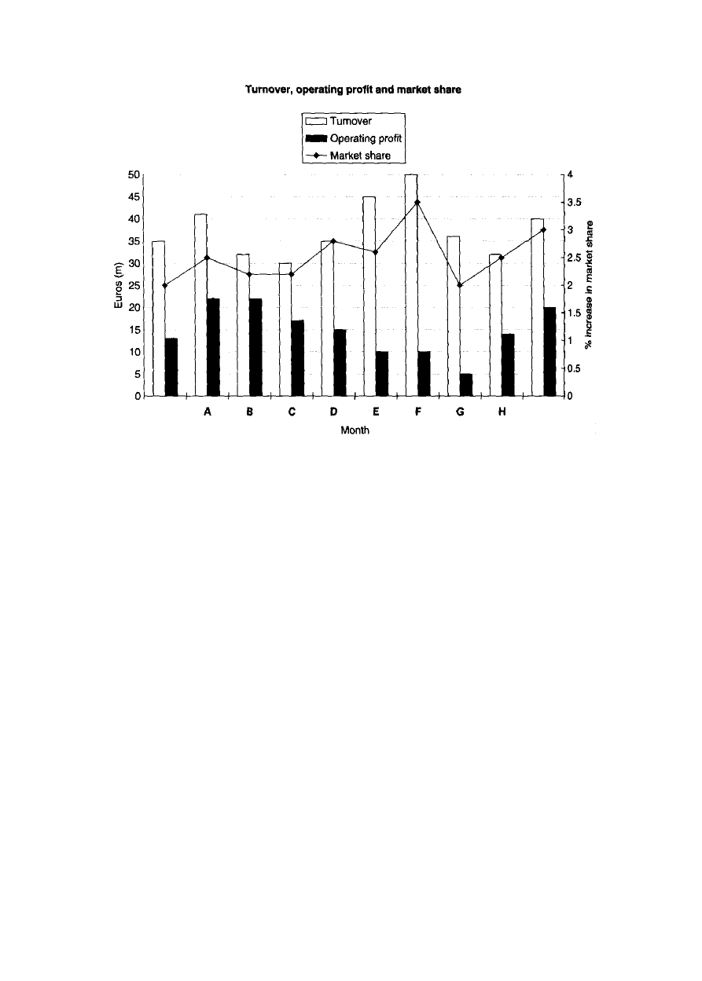

- Although operating profit dropped and market share experienced a decline,
there was an upturn in the level of turnover.
- Both turnover and market share showed an increase this month, while operating
profit suffered a decline.
- Despite the fact that market share fell and there was a decline in turnover,
operating profit was equal to that of the previous month.
- While turnover experienced a downturn, both operating profit and market share

showed signs of recovery.
- Although market share showed an improvement and turnover also increased,
this had no effect on the month's operating profit.
PART FOUR
Questions 16-22
- Read the job advertisement below.
- Are sentences 16-22 on the opposite page 'Right' or 'Wrong'? If there is not enough information to answer 'Right' or 'Wrong', choose 'Doesn't say'.
- For each sentence (16-22), mark one letter (A, B or C) on your Answer Sheet.

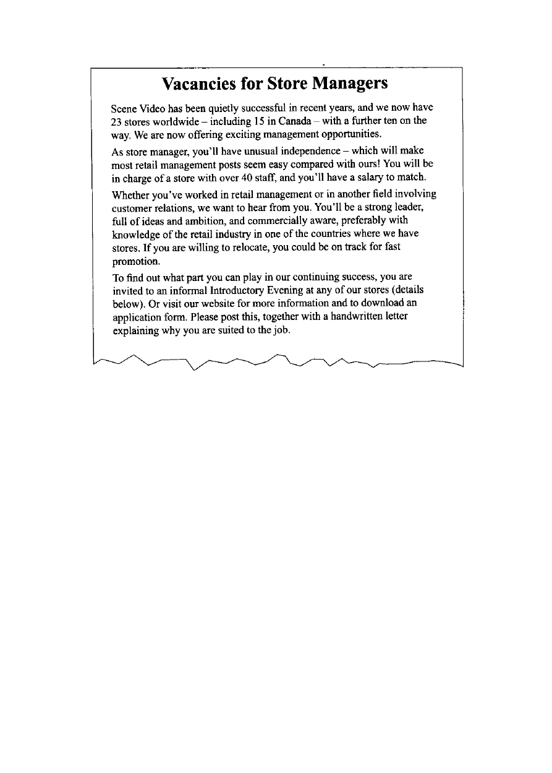

- Scene Video is planning to open more stores. A Right
- Wrong
- Doesn't say
- Scene Video believes its store managers have a harder job than other store
managers... A Right
- Wrong
- Doesn't say
- Scene Video's salaries are higher than for similar

positions in other retail businesses.
- Right
- Wrong
- Doesn't say
- It is essential for applicants to have experience as store managers.
- Right
- Wrong
- Doesn't say
- Most successful applicants will have to spend time working in different
countries.
A Right
- Wrong
- Doesn't say
- The Introductory Evenings are targeted at successful candidates.
- Right
- Wrong
- Doesn't say
- Application forms should be completed online.

- Right
- Wrong
- Doesn't say PART FIVE
Questions 23-28
- Read the article below about a successful business partnership.
- For each question (23-28) on the opposite page, choose the correct answer.
- Mark one letter (A, B or C) on your Answer Sheet.

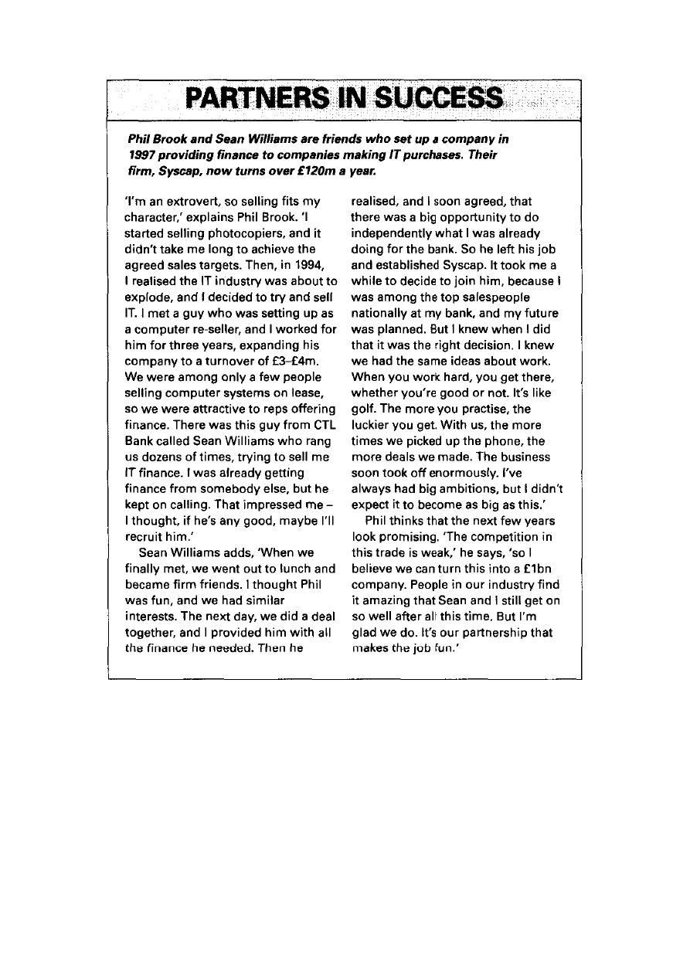

- Phil stopped selling photocopiers because he A was unable to meet the sales targets.
  - recognised an opportunity in another field.
  - became aware of their limited market potential.
- Why did Phil agree to meet Sean?

  - He liked the way Sean did not give up trying.
  - He thought they would have a lot of common interests.
  - He needed someone to provide IT finance for his clients.
- Why did Sean not join Phil immediately at Syscap?
- He had doubts about the profitability of the venture.
- He was unsure about giving up an established career.
- He was afraid that working together would damage their friendship.
- In what way does Sean believe that business is like golf?.
- You cannot achieve your goals without taking
risks.
- To do well, you need a combination of ability and ambition.
- If you do something enough times, you'll eventually be successful.
- Sean says he is surprised that
- he and Phil are still good friends.

- their company has been so successful.
- more people do not set up their own businesses. 28 What makes Phil confident about their company's future growth?
- the strength of the friendship they have
- being in a commercial field which is rapidly expanding
- having few serious challengers for their position in the marketplace
PART SIX
Questions 29-40
- Read the introduction to a company report below.
- Choose the correct word to fill each gap from A, B or C on the opposite page,
- For each question (29-40), mark one letter (A, B or C) on your Answer Sheet.

以上内容仅为本文档的试下载部分，为可阅读页数的一半内容。如要下载或阅读全文，请访问：https://d.book118.com/958067045117006033

