2023-2024学年山东省青岛市崂山区七年级（上）期末英语试卷
听力 1.听句子，选择最佳答语。每个句子读一遍。你将有10秒钟的时间完成有关小题和阅读下一小题。
1．（1分）A.He's at school.
B.He's my uncle.
C.He's twenty.
2．（1分）A.20 dollars.
B.In January.
C.Five people.
3．（1分）A.Soccer.
B.In the room.
C.On Friday.
4．（1分）A.Maths.
B.Red.
C.Socks.
5．（1分）A.Because it's boring.
B.Because it's difficult.
C.Because it's interesting.
II.听对话和问题，选择正确答案。对话和问题读两遍。你将有10秒钟的时间完成有关小题和阅读下一小题。
6．（1分） 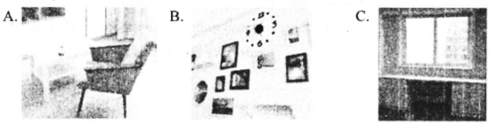
7．（1分）
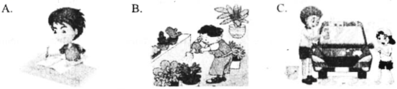
8．（1分）A.Bob.
B.Henry.
C.Tom.
9．（1分）A.On August 2nd.
B.On June 1st.
C.On June 2nd.
10．（1分）A.Talking about dogs.
B.Playing with dogs.
C.Watching a movie about dogs.
Ⅲ.听短文，完成下列任务。A.听第一遍短文，按照听到的顺序排序，你将有15秒钟的时间阅读下面的内容。
11．（5分）A.be happy to be a music teacher
B.tell us interesting stories
C.learn how to play the pipa
D.take their children to study
E.help students have a good life（生活）
（1）
（2）
（3）
（4）
（5）
B.再听这篇短文，根据短文内容，完成小题，你将有15秒钟的时间阅读下面的内容。短文将再读两遍。
12．（5分）（1）Mr.Li is .
A.5
B.18
C.79
（2）Mr.Li is good at .
A.sports
B.English
C.folk music（民族音乐）
（3）Mr.Li's students are .
A.of different ages （年龄）B.busy
C.all middle school students
（4）Jack thinks Mr.Li's lessons are .
A.interesting
B.boring
C.difficult
（5）The writer writes the passage （文章） to .
A.help us have fun
B.show us a nice teacher
C.let us learn folk music
笔试 IV.单项选择 从每小题所给的四个选项中选出最佳选项。
13．（1分）﹣﹣ Dad，do you know where Yunnan is？
﹣﹣ Yes，I can show you on the______.（ ）
A．bag B． clock
C．map D． dictionary
14．（1分）There are four people in my family.Kate is my sister.Jack and Jenny are our ________.（ ）
A．friends B．sons C．parents D．daughters
15．（1分）I____my radio.Can you help me to find it？（ ）
A． see B． spell C． lost D．found
16．（1分）﹣﹣ Let's____where to go tomorrow.
﹣﹣ How about going to the library？（ ）
A． come on B． thank for
C． help with D．think about
17．（1分）Mike's grandpa is 70，but he is very____.He plays ping﹣pong every afternoon.（ ）
A． tidy B． healthy C． happy D．kind
18．（1分）I can go shopping with you now.I'm____.（ ）
A．fat B．cool C． easy D． free
19．（1分）Our aunts are cooking in the room.Let's go to help____.（ ）
A．her B．him C．us D．them
20．（1分）I'm thirteen years old.My little sister is_____three.（ ）
A． only B． always C． often D． also
21．（1分）You can't see Lucy because she is ____ a tree.（ ）
A． under B． behind
C．near D．in front of
22．（1分）﹣ What do you think of the schoolbag？
﹣____（ ）
A． I'm fine. B． They're tidy.
C． It's nice. D． You're welcome.
V.完型填空阅读下面短文，从每小题所给的四个选项中选出可以填入空白处的最佳选项。
23．（10分）Fiona is a popular （受欢迎的） girl at school.She is kind to （1） .She asks all her classmates to come to her birthday party.She often gives gifts to them.She is （2） with so many friends，so she doesn't have much time with anyone.She feels very happy because no other girl has so many （3） at school.
But he feels unhappy on Friendship Day.It's a （4） for good friends.Everyone makes three gifts and gives them to their three good friends.No one gives gifts to Fiona!No one thinks Fiona is their good friend!She （5） .
Everyone comes to her.But they only stay for a short time and then leaves （离开）.That's what Fiona often do.Now she （6） these are not enough （足够） to make a good friend.
"Mom， （7） can I find good friends？" Fiona asks her mother at night.
"Oh，my dear，it's not（8） ，"answers her mother. "You can't make good friends with
just a smile （笑） or some good words.You should give them （9） and love.You must always be there with them，in good times and bad times."
"But I want to be everyone's good friend!" Fiona says.
"My dear，you're a lovely girl， （10） you can't be a good friend to everyone.It's enough to have two or three good friends." says her mother.

（1） | A.someone | B.everyone | C.something | D.everything
（2） | A.angry | B.free | C.famous | D.busy
（3） | A.time | B.teachers | C.parties | D.friends
（4） | A.subject | B.place | C.dinner | D.festival
（5） | A.sleeps | B.listens | C.finishes | D.cries（哭）
（6） | A.knows | B.asks | C.looks | D.spells
（7） | A.How | B.What | C.Why | D.Who
（8） | A.helpful | B.difficult | C.easy | D.happy
（9） | A.money | B.time | C.gifts | D.questions
（10） | A.so | B.and | C.but | D.because
VI.阅读理解 阅读短文，选出最佳答案。A、B篇为选择最佳答案，C篇为六选五。
24．（7.5分）
My school has a book sale every year.We can find many good books there.I have a very interesting book.Its price is 18 yuan，but I got it for only 10 yuan at the book sale last year.  Alice | I think Sports Day is a great thing for students.It's on April 30th.There are some fun games.We can run，jump and play ball games.Ping﹣pong is my favorite sport.I like to play it on that day.  Eric
Do you have a school trip？Well，I do.We have it last Friday of March.We can go to some nice places.It's relaxing.Ms.Green likes taking pictures of us on the trip. | English Day is in December in my school.We read English books and watch English films in the morning.In the afternoon，we have an English party.We can always have

John | fun.  Cindy
（1）Alice had the book for yuan at the book sale.
A.eight
B.ten
C.fifteen
D.eighteen
（2）Eric likes to at school on April 30th.
A.run
B.take photos
C.watch games
D.play ping﹣pong
（3）When is John's school trip？
A.
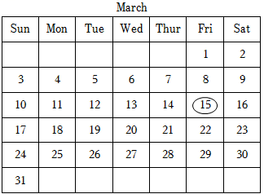
B.
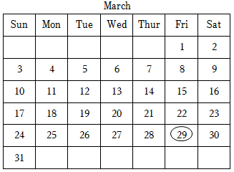
C
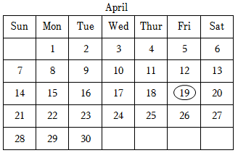
D.
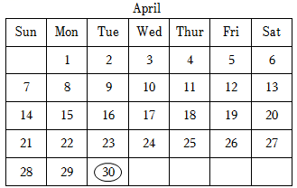
（4）What can Cindy do on English Day？
①Read English books.
②Watch English films.
③Play English card games.
④Have an English party.
A.①②③④
B.①③④
C.②③④
D.①②④
（5）The four students tell us their at school.
A.fun classes
B.good habits
C.fun activities （活动）
D.favorite sports




25．（7.5分）Do you know any people in wheelchairs（轮椅）？Do they love sea？Can they go to the beach？It must be very difficult for them.What should we do to help them？
Hundreds of beaches in Greece （希腊） finds a new way for those people to get into the water.It's named Seatrac.And people can use it for free.
Seatrac is a chair on a moving walkway（移动步道）.It can help wheelchair people get into the sea.When the people are in the sea，they can sit in the chair，look at the water or go for a
swim.When the people want to get out of the water，they use the remote control（遥控器）to bring the chair back to the walkway.
Ignatios Fotiou is one of the inventors（发明者） of Seatrac.He has a wheelchair friend.His friend liked the sea，but he he couldn't go to the beach.His friend felt grieved.Fotiou wanted to make something to help wheelchair people get into the water easily.So he worked hard with others and then came Seatrac.It is solar﹣powered（太阳能的），and can keep running if the electricity （电） goes out.
This summer，about 220 beaches used Seatrac.Thanks to Seatrac，people in wheelchairs now can get into the sea.

（1）The writer begins the passage by .
A.telling a story
B.giving examples （例子）
C.making a report （报告）
D.asking questions
（2）With the help of ，wheelchair people can go for a swim.
A.Seatrac
B.solar﹣powered
C.electricity
D.remote control
（3）The word "grieved" in Paragraph 4 means （意思是） .
A.healthy
B.sad
C.boring
D.happy
（4）Paragraph 4 talks about .
A.how to use Seatrac
B.why Fotiou invented Seatrac
C.how long it took Fotiou to invent SeatracD.where people can see Seatrac
（5）The writer writes the passage to .
A.let more people know Seatrac
B.tell more people to use Seatrac
C.tell wheelchair people to go to the beaches in Greece
D.show the friendship（友谊）between Fotiou and his wheelchair friend
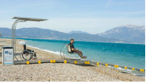
26．（5分）A：Good morning，Sally!How was your weekend？
B：Hi，Jim.It was great. （1） So we celebrated （庆祝）it together.
A：That's good.Did your family eat out？
B：No.My parents cooked at home. （2）
A：I see.Did you buy him a gift？
B：Sure. （3）
A：Wow!That's cool.
B：Yeah.He was happy when he saw it.What about you？ （4）
A：Yes.I took a one﹣day trip to a zoo.
B：Really？ （5）
A：I walked around and saw some animals.
B：Oh，nice.
A.It was near our school.
B.What did you do there？
C.Did you have a good weekend？
D.We just bought a birthday cake early.
E.My brother's birthday was on Sunday.
F.I bought a Bing Dwen Dwen key ring as a gift.


VII.综合运用 A.根据上下文和方框中的提示，完成句子，每词限用1次。
27．（7分）
be，we，watch，strawberry，use，on，hour
（1）Go and get me some ，please.
（2）The lunch in our school good yesterday.
（3）Our parents bought two picture books for .
（4）Tom often sports games on TV after dinner.
（5）Dictionaries are very .You can look up the new words in them.
（6）Our art festival is November 12th.I will dance with Jenny and Anna.
（7）We played tennis from two o'clock to four o'clock yesterday.We played for two .
B.阅读下面短文，按照句子结构的语法性和上下文连贯的要求，在空白处填入一个适当 的单词，或用括号中提示词的正确形式填空。
28．（8分）Cindy is a ten﹣year﹣old girl.She（1） （/lɪvz/） with her family.There is a pond （池塘） not far from her home.Cindy and her brother（2） （think） playing near the pond is very interesting.（3） they often visit it in their free time.There are trees and flowers near the pond.Cindy likes to take （4） （/ˈfəʊtəʊz/） and go fishing there.Her brother likes to do painting near it.
Last Sunday，Cindy（5） （go） to the pond.She met（6） old man.He told Cindy that the pond had a name a long time ago.There were（7） （许多）frogs in the pond，so people named it "Frog Pond".But later there weren't any frogs in the pond so people forgot （忘记） its（8） .

C.汉译英。
29．（2分）她的饮食习惯听起来很好。

30．（2分）Tom 正在向他老师请求帮助。

31．（2分）昨天他们进行了一次语文考试。

32．（2分）他们将要用很好的价格卖出所有的服装。

33．（2分）我们最喜欢的科目是艺术，因为它让人放松。

VIII.阅读表达
34．（10分）12﹣year﹣old Song Zihan is a student from Zhaozhuang Primary School in Shandong. Her days are full （充满） of study and soccer training（训练）.She doesn't have time to play.Song is one of the players in her school's girls' soccer team.
In 2019，the school made a girls' soccer team.Now there are nearly thirty girls in the soccer team.Song and her teammates often train after school or on holidays.They train five days a week at school.And they often have soccer games.On holidays，those young soccer players often train in the park or on the grass.They are hard﹣working. Hard work pays off（回报）.Their team is strong now.
These girls learn soccer skills，and learn teamwork，too.They have a real love for soccer.

根据短文内容填空，每空1词。
（1）From the sentence （句子）"Her days are full of study and soccer training.She doesn't have time to play."，we can see Song Zihan is .
（2）Zhaozhuang PrimarySchool is in .It made a girls' soccer team five years .The girls in the team love soccer.
（3）从文中找出能说明Song在学校努力训练的一句话。

（4）根据短文第二段内容用Where提出一个问题，并做出回答。

（5）将画线句子Hard work pays off，译为汉语。请用生活中常用的一句名言表达。

35．（10分）Romario Valentine is a boy.At the age of 12，people know him because of his book Protect Our Earth（保护地球）.He thinks people should learn to protect the earth from a young age.And a book can help children know how to protect the earth.But when he goes to the library to read such （这样） books，he finds the books aren't easy to read for children at his age.That is why Romario wants to write his book.He wants to help more children find a way to protect the earth.
Romario wants to talk about water and animals in the book.Then comes the most difficult part ﹣ putting his ideas on paper，making time to do a lot of things and balance（平衡） schoolwork and sports.It takes Romario a lot of time.But he makes it with the help of his parents.
The book came out in September last year.Children like it very much.A young child says， "This book is very fun.You can find some exciting experiments（实验）.You can learn what a child can do to protect the earth from it.It's very helpful."

根据短文内容，回答下列问题。
（1）What makes Romario have the idea （想法） to write his book？（不超过15词）

（2）What is the most difficult part for Romario when he writes the book？

（3）Who gives him help？

（4）写出划线词汇it指代的内容。

（5）写出本文的主旨大意。


IX.书面表达
36．（15分）如今越来越多的家长关注孩子的健康生活，请根据图片提供的两个方面，写一篇短文，阐述你对健康生活的理解和你的做法。字数在70字左右。
提示：不必描述图片，图片内容仅供参考，可自由发挥。
___________
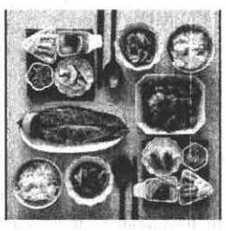
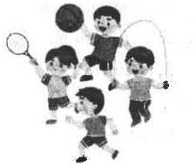
2023-2024学年山东省青岛市崂山区七年级（上）期末英语试卷
参考答案与试题解析
听力
略
笔试 IV.单项选择 从每小题所给的四个选项中选出最佳选项。
13．（1分）﹣﹣ Dad，do you know where Yunnan is？
﹣﹣ Yes，I can show you on the______.（ ）
A．bag B． clock
C．map D． dictionary
【分析】﹣﹣爸爸，你知道云南在哪里吗？
﹣﹣是的，我可以在地图上指给你看。
【解答】bag包；clock钟表；map地图；dictionary字典。根据Dad，do you know where Yunnan is？（爸爸，你知道云南在哪里吗？）和Yes，I can show you（是的，我可以指给你看）可知，应该是在地图上指给你看，因此选map。
故选：C。
【点评】做这类题，要注意分析题干信息，并结合语境答题。
14．（1分）There are four people in my family.Kate is my sister.Jack and Jenny are our ________.（ ）
A．friends B．sons C．parents D．daughters
【分析】我家有四口人。凯特是我妹妹。杰克和珍妮是我们的父母。
【解答】friends朋友；sons儿子；parents父母；daughters女儿。根据"There are four people in my family.Kate is my sister.Jack and Jenny are our...（我家有四口人。凯特是我妹妹。杰克和珍妮是我们的......）"可知家里一共有四口人，凯特是妹妹，所以杰克和珍妮是他们的父母。
故选：C。
【点评】做此类题，先分析选项，再结合句意和语法，正确作答。
15．（1分）I____my radio.Can you help me to find it？（ ）
A． see B． spell C． lost D．found
【分析】我的收音机丢了。你能帮我找到它吗？
【解答】see看见；spell拼写；lost丢失；found发现。根据Can you help me to find it？（你能帮我找到它吗？）可知，应该是丢失了收音机。
故选：C。
【点评】做这类题，要注意分析题干信息，并结合语境答题。
16．（1分）﹣﹣ Let's____where to go tomorrow.
﹣﹣ How about going to the library？（ ）
A． come on B． thank for
C． help with D．think about
【分析】—让我们想想明天该去哪里吧。
—去图书馆怎么样？
【解答】come on快点，加油；thank for感谢；help with帮助；think about考虑，想想，都是动词短语。根据后句句意"去图书馆怎么样"可知，前句句意为"让我们想想明天该去哪里吧"，要填"考虑，想想"，其它选项语意不通。
故选：D。
【点评】考查动词短语，要牢记动词短语的词义及用法，进行比较分析，选择正确答案。
17．（1分）Mike's grandpa is 70，but he is very____.He plays ping﹣pong every afternoon.（ ）
A． tidy B． healthy C． happy D．kind
【分析】麦克的爷爷70岁了，但是他是非常健康的。他每天下午打乒乓球。
【解答】A整洁的；B健康的；C快乐的；D善良的。根据He plays ping﹣pong every afternoon.（他每天下午打乒乓球。）可知是麦克的爷爷70岁了，但是他是非常健康的。
故选：B。
【点评】本题考查形容词辨析，要求学生熟悉常见的形容词含义及用法，再根据题干即可作出选择。
18．（1分）I can go shopping with you now.I'm____.（ ）
A．fat B．cool C． easy D． free
【分析】我现在可以和你一起去购物。我是空闲的。
【解答】A胖的；B凉爽的；C容易的；D空闲的。根据I can go shopping with you now.（我现在可以和你一起去购物。）可知是我是空闲的，选项D符合语境。
以上内容仅为本文档的试下载部分，为可阅读页数的一半内容。如要下载或阅读全文，请访问：https://d.book118.com/968035065122006040

