武汉市部分重点中学2021-2022学年度上学期期末联考
高二英语试卷
考试时间：120分钟 试卷满分：150分
第一部分 听力 (共两节，满分30分)
做题时，先将答案标在试卷上。录音内容结束后，你将有两分钟的时间将试卷上的答案转涂到答题卡上。
第一节 (共5小题；每小题1. 5分，满分7. 5分)
听下面5段对话，每段对话后有一个小题，从题中所给的A、B、C三个选项中选出最佳选项，并标在试卷的相应位置。听完每段对话后，你都有10秒钟的时间来回答有关小题和阅读下一小题。每段对话仅读一遍。
1. What drink did the woman order?
A. A Pepsi. B. A Coke. C. A beer.
2. How does the man probably feel toward the woman?
A. Angry. B. Disappointed. C. Grateful.
3. Why does the man have to pack carefully?
A. So nothing breaks. B. So they don’t forget anything. C. So the woman can clean easily.
4. What did the speakers see last night?
A. A little but noisy bird. B. A dark-colored bird. C. A bird that flew very quietly.
5. Why does the woman need directions?
A. She might be lost. B. She has lost track of her map. C. The museum is not on the map.
第二节 (共15小题；每小题1. 5分，满分22. 5分)
听下面5段对话或独白。每段对话或独白后有几个小题，从题中所给的A、B、C三个选项中选出最佳选项，并标在试卷的相应位置。
听第6段材料，回答第6、7题。
6. What’s special about the people riding bikes?
A. They are funny. B. They are all men. C. They have no clothes on.
7. Why does the woman want to go somewhere else?
A She’s too cold. B. She hates what she saw. C. She wants to get something to eat.
听第7段材料，回答第8至10题。
8. What does the woman want to do?
A. Rent a house. B. Get a loan. C. Get her credit report.
9. How many years of tax returns does the woman need?
A. 5. B. 3. C. 1.
10. What does the woman probably mean in the end?
A. She has a lot of information in her emails.
B. She can’t give the man more information.
C. The man is asking for too much information.
听第8段材料，回答第11至13题。
11. Where did the woman go last week?
A. To a concert. B. To a friend ‘s house. C. To a clothing store with Laura.
12. Why did the woman fall the second time?
A. She tripped on some steps.
B. Her foot got caught by her skirt.
C. She looked into the sky while walking.
13. How is the woman now?
A. Her nose doesn’t hurt. B. Her nose is broken. C. She has a headache.
听第9段材料，回答第14至16题。
14. Where are the speakers probably?
A. In the middle of a city. B. In a boat. C. On a hill.
15. What are the speakers looking at?
A. The ocean. B. The city lights. C. The stars.
16. Why was the man probably surprised?
A. A “bear” talked to him.
B. A lot of birds flew around him.
C. A wild animal was coming toward him.
听第10段材料，回答第17至20题。
17. Where does Mr. Smithson live?
A. In a country house.
B. In a luxury apartment.
C. On the second floor of an apartment building.
18. What was the photographer’s project about?
A. Neighbors at home. B. Angry neighbors. C. Residents in luxury buildings.
19. Why are the residents probably angry?
A. The photos are too private.
B. Their faces can’t be seen clearly.
C. They don’t receive any payment.
20. What will probably happen to Mr. Smithson?
A. He’ll be thrown in jail. B. He won’t get in trouble. C. He will have to pay a fine.
第二部分阅读理解 (共两节，满分50分)
第一节 (共15小题；每小题2. 5分，满分37. 5分)
阅读下列短文，从每题所给的A、B、C和D四个选项中，选出最佳选项。
A
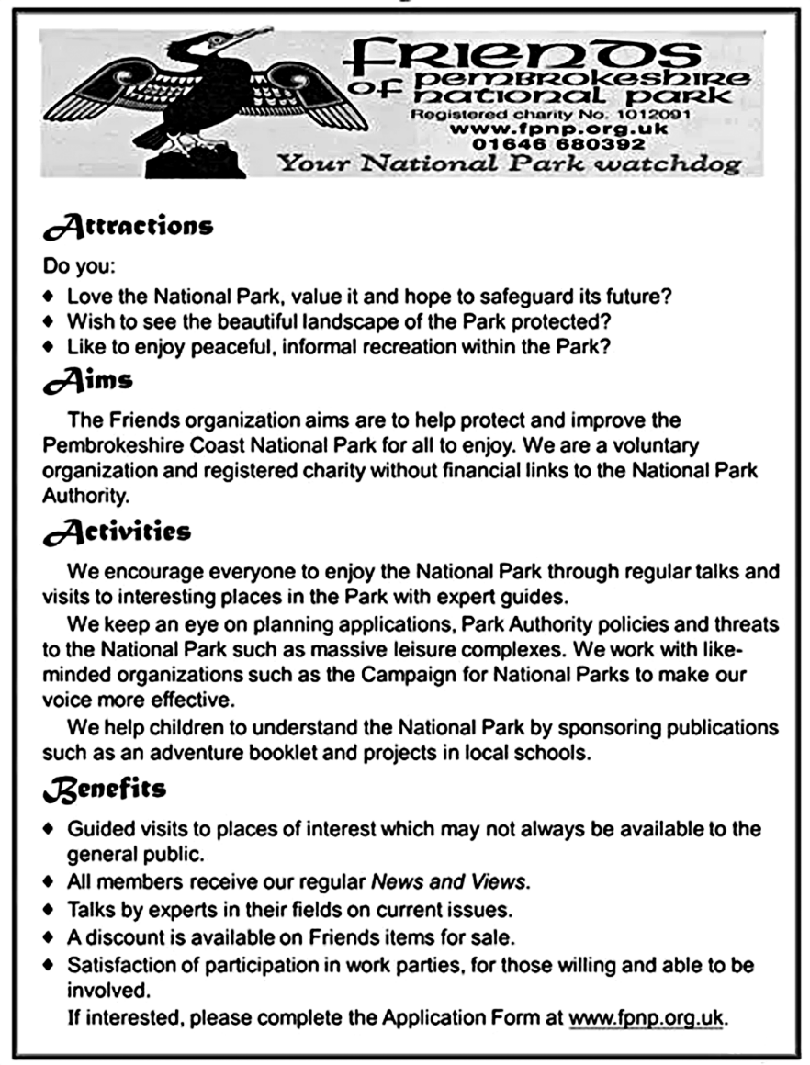
1. Which of the following is disapproved by the Friends organization?
A. To help fix up the Park for all to enjoy.
B. To block potential damages to the National Park.
C. To sponsor publications and projects in local schools.
D. To build large-sized complexes for public amusement.
2. What benefits can the members of Friends receive?
A. Having Friends’ goods free of charge.
B. Engaging in work parties if they want to.
C. Gaining access to visiting any scenic spot.
D. Delivering talks in their fields on current issues.
3. What is the purpose of this poster?
A. To raise more money for the Friends organization
B. To recruit managers for Pembroke shire National Park.
C. To appeal to more enthusiasts to join the Friends organization.
D To attract people to enjoy the landscape of Pembroke shire National Park.
【答案】1. D 2. B 3. C
【解析】
【分析】这是一篇应用文。文章是一则“朋友”组织的海报，介绍这一组织的特色、目的、活动以及好处。
【1题详解】
细节理解题。根据Activities部分中“We keep an eye planning applications, Park Authority policies and threats to the National Park such as massive leisure complexes.(我们密切关注规划申请、公园管理局的政策和对国家公园的威胁，如大规模的休闲中心)”可知，D选项“建造大型公共娱乐设施”是“朋友”组织不同意的。故选D。
【2题详解】
细节理解题。根据Benefits部分中“Satisfaction of participation in work parties, for those willing and able to be involved.(对于那些愿意和能够参与的人来说，可以参与工作聚会)”可知，如果“朋友”组织的成员愿意，可以参加工作聚会。故选B。
【3题详解】
推理判断题。根据最后一段“If interested, please complete the Application Form at www.fpnp.org.uk.(如有兴趣，请在www.fpnp.org.uk上填写申请表)”可推知，这张海报的目的是呼吁更多的热心人士加入“朋友”组织。故选C。
B
On Feb. 19, the same day Harper Lee passed away, the world lost another literary giant. He was 84-year-old Umberto Eco, an Italian writer, whose masterpiece The Name of the Rose won him international fame when it was published in 1980. The novel sold more than 10 million copies in about 30 languages and was made into a movie in 1986 starring British actor Sean Connery.
A USA Today obituary (讣告) thus describes: “Eco was an author of books ranging from novels to scholarly books to essay collections; Eco was enthusiastic about the obscure as well as ordinary daily life; As a scholar, critic and novelist, he also did research on the mysterious theory of semiotics-the study of signs and symbols in language and the technical languages of the Internet.
The Name of the Rose can be seen as a much more complicated version of US writer Dan Brown’s popular novel The Da Vinci Code. The book is set in a 14th century Italian Monastery (修道院) where monks are being murdered one by one in terrible manners. Two monks who travel to the monastery try to solve the murders. The book’s mystery develops around a complex-designed library and a lost Aristotle’s book on comedy.
Although the novel is full of Latin phrases and devotes many pages to analysis of Christian beliefs and ancient philosophy, it’s a fascinating detective thriller.
Eco also wrote some harsh literary criticism. He once wrote that “books always speak of other books, and every story tells a story that has already been told”.
4. What can we learn about The Name of the Rose?
A. It earned Harper Lee worldwide reputation.
B. It featured the main character Sean Connery.
C. It was translated into no more than 30 versions.
D. It had its film adaptation following the book’s publication.
5. From the USA Today obituary, which of the following can be inferred?
A. Eco not only wrote novels but also some dramas.
B. Eco was merely interested in ordinary daily life.
C. Eco was an expert in the Internet.
D. Eco was more than a novelist.
6 What does the book The Name of the Rose describe?
A. A story copied from the novel The Da Vinci Code.
B. Chain murdering in an Italian Monastery.
C. A long-lost ownerless book.
D. A complex-designed library.
7. What does the underlined quote said by Eco imply?
A. Stories are far from reality. B. Creativity is hard to come by.
C. Some books are well worth reading. D. Writers need to polish their language.
【答案】4. D 5. D 6. B 7. B
【解析】
【分析】本文是说明文。文章讲述意大利作家翁贝托·艾柯和他的代表作《玫瑰之名》。
【4题详解】
细节理解题。根据第一段的“He was 84-year-old Umberto Eco, an Italian writer, whose masterpiece The Name of the Rose won him international fame when it was published in 1980. The novel sold more than 10 million copies in about 30 languages and was made into a movie in 1986 starring British actor Sean Connery.( 他就是84岁高龄的意大利作家翁贝托·艾柯。1980年，艾柯的代表作《玫瑰之名》出版，为他赢得了国际声誉。这部小说被翻译成大约30种语言，销量超过1000万册。1986年，这部小说被拍成了电影，由英国演员肖恩·康纳利主演。)”可知：书是1980年出版，1986年拍摄成电影，因此可知这本书出版后，被改编成了电影。故选D。
【5题详解】
推理判断题。根据第二段的“Eco was an author of books ranging from novels to scholarly books to essay collections; Eco was enthusiastic about the obscure as well as ordinary daily life; As a scholar, critic and novelist, he also did research on the mysterious theory of semiotics (艾柯的作品从小说到学术著作，再到散文集；艾柯对平凡的日常生活充满激情；作为一名学者、批评家和小说家，他还研究了神秘的符号学理论)”可知，Eco既写小说，也写学术著作，也编撰散文集，Eco不仅仅是一个小说家，也是学者和批评家。故选D。
【6题详解】
细节理解题。根据第三段的“The book is set in a 14th century Italian Monastery (修道院) where monks are being murdered one by one in terrible manners.( 这本书以14世纪的意大利修道院为背景，那里的僧侣们一个接一个地被残忍地杀害。)”可知，The Name of the Rose描述的是l4世纪发生在意大利修道院的一起连环谋杀案。故选B。
【7题详解】
推理判断题。打引号的句子“books always speak of other books, and every story tells a story that has already been told”意为：书总是讲的其它书的内容，每一个故事总是讲的曾经被讲的故事。结合上文“Eco also wrote some harsh literary criticism.( 艾柯也写过一些严厉的文学批评。)”可得知，引号中的话是艾柯的批评，因此推断引号的话说明艾柯认为书和故事都是重复的内容，没有创造性，创造力很难获得。故选B。
C
Clutter is the disease of American writing. Our national tendency is to inflate and thereby sound important. But the secret of good writing is to strip every sentence to its cleanest components. Every word that serves no function, every long word that could be a short word, every adverb that carries the same meaning that’s already in the verb, every passive construction that leaves the reader unsure of who is doing what—these weaken the strength of a sentence.
Simplify, simplify. How can we achieve such freedom from clutter? The answer is to clear our heads of clutter. Clear thinking becomes clear writing; one can’t exist without the other. It’s impossible for a muddy thinker to write good English. He may get away with it for a paragraph or two, but soon the reader will be lost.
Writers must therefore constantly ask: what am I trying to say? Surprisingly often they don’t know. Then they must look at what they have written and ask: have I said it? Is it clear to someone coming across the subject for the first time? If it’s not, some fuzz has worked its way into the writing. The clear writer is someone clear-headed enough to see this stuff for what it is: fuzz.
I don’t mean that some people are born clear-headed and are therefore natural writers, while others are naturally fuzzy and will never write well. Thinking clearly is a conscious act that writers must force on themselves, as if they were working on any other project that requires logic.
Writing is hard work. A clear sentence is no accident. Very few sentences come out right the first time, or even the third time. Remember this in moments of despair. If you find that writing is hard, it’s because it is hard.
8. Which of the following contributes to good writing?
A. Avoiding using passive structures.
B. Leaving out words without a meaning.
C. Using short words instead of long ones whenever possible.
D. Choosing adverbs carrying the same meaning of the verbs.
9. What’s the relationship between clear thinking and clear writing?
A. Clear thinking equals clear writing.
B. Clear thinking reflects clear writing.
C. Clear writing may not rely on clear thinking.
D. Only clear thinking brings about clear writing.
10. What does the underlined word “fuzz” in paragraph 3 probably mean?
A. Something cloudy. B. Something difficult.
C. Something uninteresting. D. Something complicated.
11. What may be the best title for the text?
A. Bad writing and clutter B. Out of clutter find freedom
C. Simplify to achieve good writing D. Nobody is born to be a good writer
【答案】8. C 9. D 10. A 11. C
【解析】
【分析】这是一篇说明文。文章说明了当下文章冗繁的弊端，提出解决办法就是简化，以及如何才能做到简化。
【8题详解】
细节理解题。根据第一段中“Every word that serves no function, every long word that could be a short word, every adverb that carries the same meaning that’s already in the verb, every passive construction that leaves the reader unsure of who is doing what—these weaken the strength of a sentence.(每一个没有作用的词，每一个长词可能是一个短词，每一个副词的意思与动词相同，每一个让读者不确定谁在做什么的被动结构——这些都会削弱句子的力量)”可知，尽可能使用短词而不是长词有助于写作。故选C。
【9题详解】
细节理解题。根据第二段中“Clear thinking becomes clear writing; one can’t exist without the other.(清晰的思维变成清晰的写作；一个不能脱离另一个而存在)”可知，清晰的思维和清晰的写作之间的关系是只有清晰的思维才能带来清晰的写作。故选D。
【10题详解】
词句猜测题。根据划线词上文“Is it clear to someone coming across the subject for the first time? If it’s not, some”可知，写作时要问自己：文章对第一次接触这个主题的人来说清晰吗？如果不，说明文中有fuzz，即“不清晰的东西”。划线词意思是“不清晰的东西”。故选A。
【11题详解】
主旨大意题。根据第二段“Simplify, simplify. How can we achieve such freedom from clutter? The answer is to clear our heads of clutter. Clear thinking becomes clear writing; one can’t exist without the other. It’s impossible for a muddy thinker to write good English. He may get away with it for a paragraph or two, but soon the reader will be lost.(简化，简化。我们怎样才能从混乱中获得这样的自由呢？答案是清理我们头脑中的混乱。清晰的思维变成清晰的写作；一个不能脱离另一个而存在。一个头脑模糊的人是不可能用英语写出好文章的。读者也许能侥幸读完一两段，但很快就会迷失方向)”结合文章说明了当下文章冗繁的弊端，提出解决办法就是简化，以及如何才能做到简化。可知，C选项“简化以达到好的写作”最符合文章标题。故选C。
D
In the United States alone, over 100 million cell-phones are thrown away each year. Cell-phones are part of a growing mountain of electronic waste like computers and personal digital assistants. The electronic waste stream is
increasing three times faster than traditional garbage as a whole.
Electronic devices contain valuable metals such as gold and silver. A Swiss study reported that while the weight of electronic goods represented by precious metals was relatively small in comparison to total waste, the concentration (含量) of gold and other precious metals was higher in so-called e-waste than in naturally occurring minerals.
Electronic wastes also contain many poisonous metals. Even when the machines are recycled and the harmful metals removed, the recycling process is often carried out in poor countries which allow many poisonous substances to escape into the environment, or in practically uncontrolled ways which make more wastes generated.
Creating products out of raw materials creates much more waste material, up to 100 times more, than the material contained in the finished products. Consider again the cell-phone, and imagine the mines that produced those metals, the factories needed to make the box and packaging it came in. Many wastes produced in the producing process are harmful as well.
The U. S. Environmental Protection Agency notes that most waste is dangerous in that “the production, distribution, and use of products -as well as management of the resulting waste-all result in greenhouse gas release.” Individuals can reduce their contribution by creating less waste at the start -for instance, buying reusable products and recycling.
In many countries the concept of extended producer responsibility is being considered or has been put in place as an incentive(动机)for reducing waste. If producers are required to take back packaging they use to sell their products, would they reduce the packaging in the first place?
Governments’ incentive to require producers to take responsibility for the packaging they produce is usually based on money. Why, they ask, should cities or towns be responsible for paying to deal with the bubble wrap(气泡垫)that encased your television?
From the governments’ point of view, a primary goal of laws requiring extended producer responsibility is to transfer both the costs and the physical responsibility of waste management from the government and tax-payers back to the producers.
12. What do we know from the Swiss study?
A. Natural minerals contain more gold.
B. The weight of electronic goods was by no means small.
C. Precious metals account for a great proportion in e-waste.
D. The percentage of precious metals is small in electronic goods.
13. Which way is incorrect to reduce waste?
以上内容仅为本文档的试下载部分，为可阅读页数的一半内容。如要下载或阅读全文，请访问：https://d.book118.com/977201114143006025

