Unit 2 The universal language Section Ⅰ Welcome to the unit & Reading
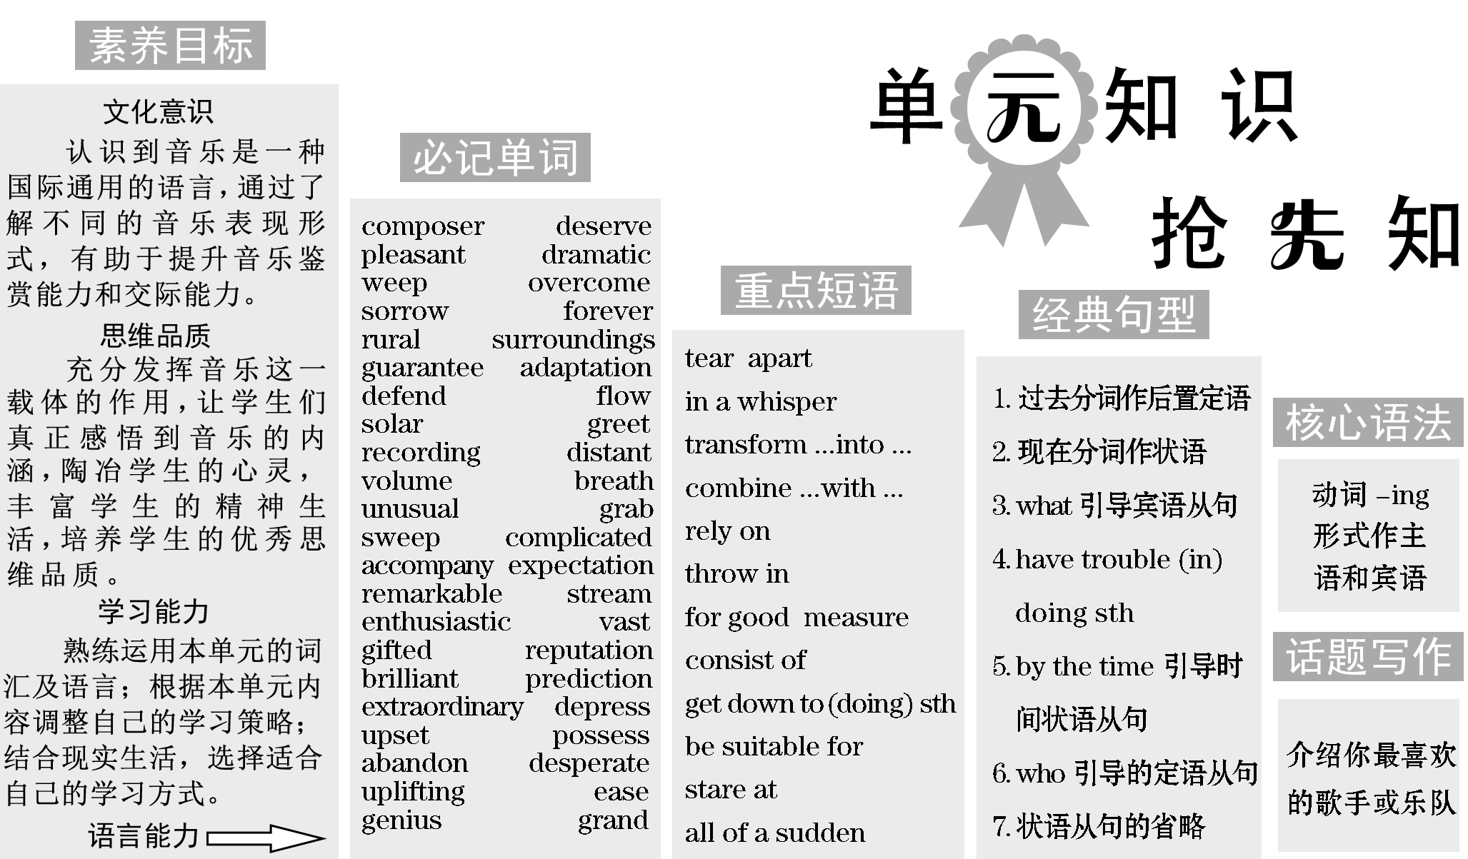
 | 音乐，是人们生活中不可缺少的一部分。什么是音乐？你喜欢什么样的音乐？

What is music?
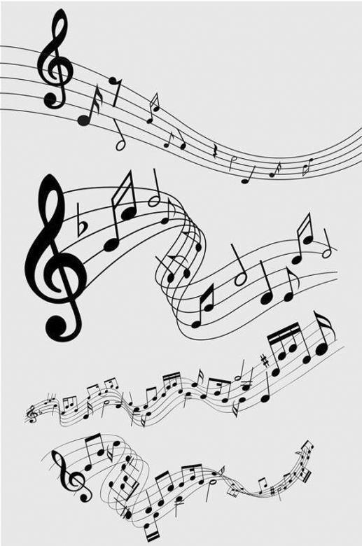Suppose you hit a wooden table with your hand.It makes a sound.Now suppose you hit a ball.It makes a sound.The second sound is called a tone.A tone is a single musical sound.Music is the art of organizing tones into meaningful patterns of sound.We might call it the language of tones.Sometimes the language of music speaks to us in tones sounding after one another in melody.Or the tones could be sounding together in harmony.
When tones hit with one another, it is not in harmony.But this hit is often full of meaning.What we call melody is given meaning by its rising or falling or moving straight ahead.It is also given meaning by its rhythm of beats and phrasing, its speed and how loud or soft it is at any moment.All of this sounds very technical. What music means to us often can not be put into words.We can feel that the music expresses joy or sorrow, pleasure, love, anger — all kinds of things and feelings that words alone could never do.
Music can also be enjoyed just for its beauty, and not for what it is saying.We can get pleasure from even a single tone of voice, violin, horn, or some other
instruments.
There are, of course, many forms of music，from the chant to the symphony, and many types of music, from folk music to opera.
[阅读理解]
阅读文章，回答下面的问题。
1．Do you like music? What kind of music do you like most?
Yes,_I_like_it_very_much.I_like_soft_(pop,_rock_and_roll,_etc.)_music_most.
2．According to the above passage, what kinds of expressions can we feel from the music?
We_can_feel_that_the_music_expresses_joy_or_sorrow,_pleasure,_love,_anger_—_all_kinds_of_things_and_feelings_that_words_alone_could_never_do.
[词汇积累]
1．tone n． 乐音
2．melody n. 旋律
3．harmony n. 协调
4．be full of 充满
5．technical adj. 专业的；学术的
6．instrument n. 乐器；器械

Section_Ⅰ  Welcome_to_the_unit_&_Reading



$\begin{matrix}[读文清障]\end{matrix}$
①performance n． 表演；表现
②compose vt.& vi. 作曲；组成；撰写；使镇静
composer n. 作曲家，作曲者
③deserve vt. 值得，应得
sb deserve(s) to do sth 某人值得做某事
sth deserve(s) doing＝sth deserve(s) to be done 某事值得被做
④twists and turns 迂回曲折
⑤tear apart 使(关系密切的人)分离，分开
⑥pleasant adj. 令人愉快的，可喜
的；友好的，和善的
⑦as if 好像
⑧whisper vi.& vt. 耳语，低语；私下说；沙沙作响
n. 低语；轻柔的声音；传言
whisper to sb 向某人耳语
in a whisper 低声地；耳语
⑨represent vt. 代表；象征
representative n. 代表；代理人
adj. 典型的；有代表性的
⑩dramatic adj. 激动人心的，引人注目的；突然的；戏剧的；夸张的
⑪force sb to do sth 强迫某人做某事
⑫weep vi.& vt. (wept，wept)
哭泣，流泪
⑬bitterly adv. 悲痛地；沉痛地
⑭loss n. 遗失；失去；丧失
at a loss 不知所措
⑮overcome vt. (overcame, overcome)
受到……的极大影响；克服，解决；战胜
⑯sorrow n. 悲伤，悲痛；伤心事
sorrowful adj. 悲伤的；令人痛苦的
⑰grave n. 坟墓；死亡，去世
adj. 严重的；严肃的
⑱transform vi.& vt. (使)变形，(使)改观，(使)转化
transform into 转换成为……
⑲fly away 飞走
⑳forever adv. 永远；长久地；老是
$\begin{matrix}[原文呈现]\end{matrix}$
Understanding culture through music
Hi Lucy，
So glad to get your email.I hope everything is fine with you.Last night, I watched a performance^{①} of Butterfly Lovers, a beautiful violin concerto composed^{②} by He Zhanhao and Chen Gang.[1] It's a piece that really deserves^{③} to be heard.
[1]句中composed by He Zhanhao and Chen Gang为过去分词作定语，修饰前面的名词a beautiful violin concerto。另外a beautiful violin concerto作Butterfly Lovers的同位语，起解释说明作用。
The music took me through the twists and turns^{④} of a classic story about a young couple torn apart^{⑤} by their families.[2] When the two lovers, Liang Shanbo and Zhu Yingtai, first meet, the music is light and pleasant^{⑥}， as if^{⑦} whispering^{⑧} to the audience.It is followed by a fast and cheerful section which represents^{⑨} their three happy years of school.[3] Then the music gets dramatic^{⑩} with heavier notes and that is when the lovers are separated because Zhu's father forces^{⑪} her to marry another man.Angry and sad, Liang falls sick and dies.[4] Zhu weeps^{⑫} bitterly^{⑬} over the loss^{⑭} of her love.Overcome^{⑮} with sorrow^{⑯}， she jumps into his grave^{⑰}. Finally, during the most exciting part, the music takes a softer turn and ends on a bittersweet note, telling us how the couple transform^{⑱} into butterflies and fly away^{⑲} to be together forever^{⑳}. [5] It is an amazing journey!
[2]本句中torn apart by their families作后置定语修饰前面的名词a young couple。
[3]本句为主从复合句。句中which引导定语从句，先行词为a fast and cheerful section, 先行词在从句作主语。
[4]本句为形容词作状语，形容词angry and sad修饰主语Liang。
[5]本句为主从复合句。telling为现在分词作状语。另外how the couple transform into butterflies and fly away to be together forever为how引导的从句，作tell的宾语。
$\begin{matrix}[译文参考]\end{matrix}$
通过音乐了解文化
你好，露西，
很高兴收到你的邮件，希望你一切都好。昨晚，我看了《梁祝》的演出，这是一首优美的小提琴协奏曲，由何占豪和陈钢创作。这首曲子确实值得一听。
这首乐曲带着我体验了一个跌宕起伏的经典故事，故事讲的是一对被双方家庭拆散的年轻情侣。当梁山伯和祝英台这对情侣初次见面时，音乐轻快悦耳，仿佛在向观众喃喃私语。紧接着是一个欢快的部分，代表着他们的三年快乐的学校生活。然后音乐变得扣人心弦，音调变重，这对恋人因为祝英台的父亲强迫她嫁给另一个男人而被拆散。悲愤之下，梁山伯生病去世。祝英台因失去所爱之人而痛哭。她悲痛欲绝，于是跳进了梁山伯的坟墓。最后，在最激动人心的部分，音乐转向柔和，以喜忧参半的音调结束，告诉我们这对情侣如何变成蝴蝶，并永远双宿双飞了。这真是一段奇妙的旅程！
combine vt.& vi. (使)融合；(使)结合，(使)混合；兼做；合并
combine ...and/with ... 把……和……结合
instrument n. 乐器；器械
unique adj. 独特的；独一无二的
be unique to 对……来说是特殊的，独特的
definitely adv. 确切地；肯定地, Butterfly Lovers combines Chinese and Western musical elements：it is played on Western instruments such as the violin, but more significantly, much of the music has its roots in Chinese Yue Opera. [6] This unique combination has made me realize that music is indeed a universal language.[7] You should definitely listen to Butterfly Lovers—I bet you'll like it!
All the best，
Alice
[6]本句为but连接的并列句。句子之间为转折关系。另外more significantly为but从句中的状语。
[7]本句为主从复合句。that music is indeed a universal language为realize的宾语从句。另外本句中make sb do sth意为“让某人做某事”。, 《梁祝》结合了中西方的音乐元素：它是用小提琴等西方乐器演奏的，但更重要的是，它的大部分音乐源于中国越剧。这种独特的融合让我意识到音乐确实是一门共通的语言。你一定要听《梁祝》——我确定你会喜欢的！
愿一切安好！
爱丽丝
$\begin{matrix}[读文清障]\end{matrix}$
as interesting as 和……一样有趣
rely on 依赖，依靠；信任
rely on sb to do sth 依赖某人做某事
introduce ...to ... 把……介绍/引进……
in the south of America
在美国南部
in the 1940s 在20世纪40
年代
blues n．(the blues) 布鲁斯音乐，蓝调；忧郁，悲伤
folk adj. 民间的，民俗的
n. 民间音乐；人们；各位；家人
folk music 民间音乐
tune n. 曲调，曲子
vt. 调音；调频道；调整
lyric n. 歌词；抒情诗
adj. 抒情的；吟唱的
deep in thought 陷入沉思
plenty of 许多；大量的
throw in 奉送，额外赠送
for good measure 作为额外增添
rural adj. 乡村的，农村的
like prep. 像
suggestive adj. 暗示的；引起联想的；提示的
surroundings n. 周围，环境
surrounding adj. 周边的，周围的
heaven n. 极乐之地
breeze n. 微风，和风
guarantee vt. 保证，担保；确保；为(产品)提供保修
n. 保证，担保；保修单
guarantee sb to do sth
保证做某事
under guarantee 在保修期内Dear Stephen，
Life here in Nashville is as interesting as I thought it would be.My host family
are big fans of country music, so I can always rely on them to introduce me to some great songs.I love learning about country music and I keep asking them questions about it all the time！[8]
[8]本句为动名词作宾语，其中learning about country music作love的宾语，asking them questions ...作keep的宾语。
It turns out that country music became popular right here in the south of America in the 1940s and then spread across the nation.It grew out of such music types as the blues and folk music, so the musicians use many similar instruments, such as the guitar.The tunes are easy to sing, and the lyrics often leave you deep in thought.[9] Most of the songs are about hardship and heartbreak, but also about hope — with plenty of humour thrown in for good measure.You can feel an emotional connection between you and the musicians.
[9]本句中the tunes are easy to sing为sth/sb be＋形容词＋to do结构，形容词后用to do的主动形式表示被动意思。
Country music shows the peaceful green fields and simple life of the countryside.Obviously I don't know what it's truly like to grow up in rural America, but the masters of country music, like John Denver, can make you feel like you're there.[10]The simple tunes and beautiful natural images are often very suggestive of countryside surroundings：
[10]本句中what it's truly like ...为what引导的宾语从句，like John Denver是举例子，来说明the masters of country music的。
Almost heaven， West Virginia
Blue Ridge Mountains, Shenandoah River
Life is old there, older than the trees
Younger than the mountains, growing like a breeze
(From “Take Me Home, Country Roads” by John Denver)
Why don't you try to listen to some great country music? I guarantee you'll enjoy it!
Best wishes，
Harry,亲爱的斯蒂芬，
纳什维尔的生活和我想的一样有趣。我的寄宿家庭一家人都是乡村音乐的狂热爱好者，所以我总是可以依赖他们介绍一些好歌曲给我听。我喜欢了解乡村音乐，而且我一直在问他们关于乡村音乐的问题！
原来乡村音乐流行于20世纪40年代的美国南部，然后风靡全国。它起源于蓝调和民间音乐等音乐类型，因此音乐家使用许多类似的乐器，如吉他。曲调很容易唱，歌词经常让你陷入沉思。大多数歌曲都是关于苦难和悲伤的，但也有关于希望的——额外增添了很多幽默成分。你可以感受到你和音乐家之间的情感联系。
乡村音乐展示了宁静的绿色田野和简单的乡村生活。显然我不知道在美国乡村长大是什么感觉，但乡村音乐大师，比如约翰·丹佛，会让你有身临其境的感觉。简单的曲调和美丽的自然画面常常让人联想起乡村的环境：
西弗吉尼亚州，天堂一般
蓝岭山脉，谢南多厄河
那里的生命久远，比树木还要古老
比群山还年轻，像微风一样自由成长
(选自约翰·丹佛的《乡村路带我回家》)
你为何不试着听一些美妙的乡村音乐呢？我保证你会喜欢的！
祝好！
哈利

Step One：Pre­reading
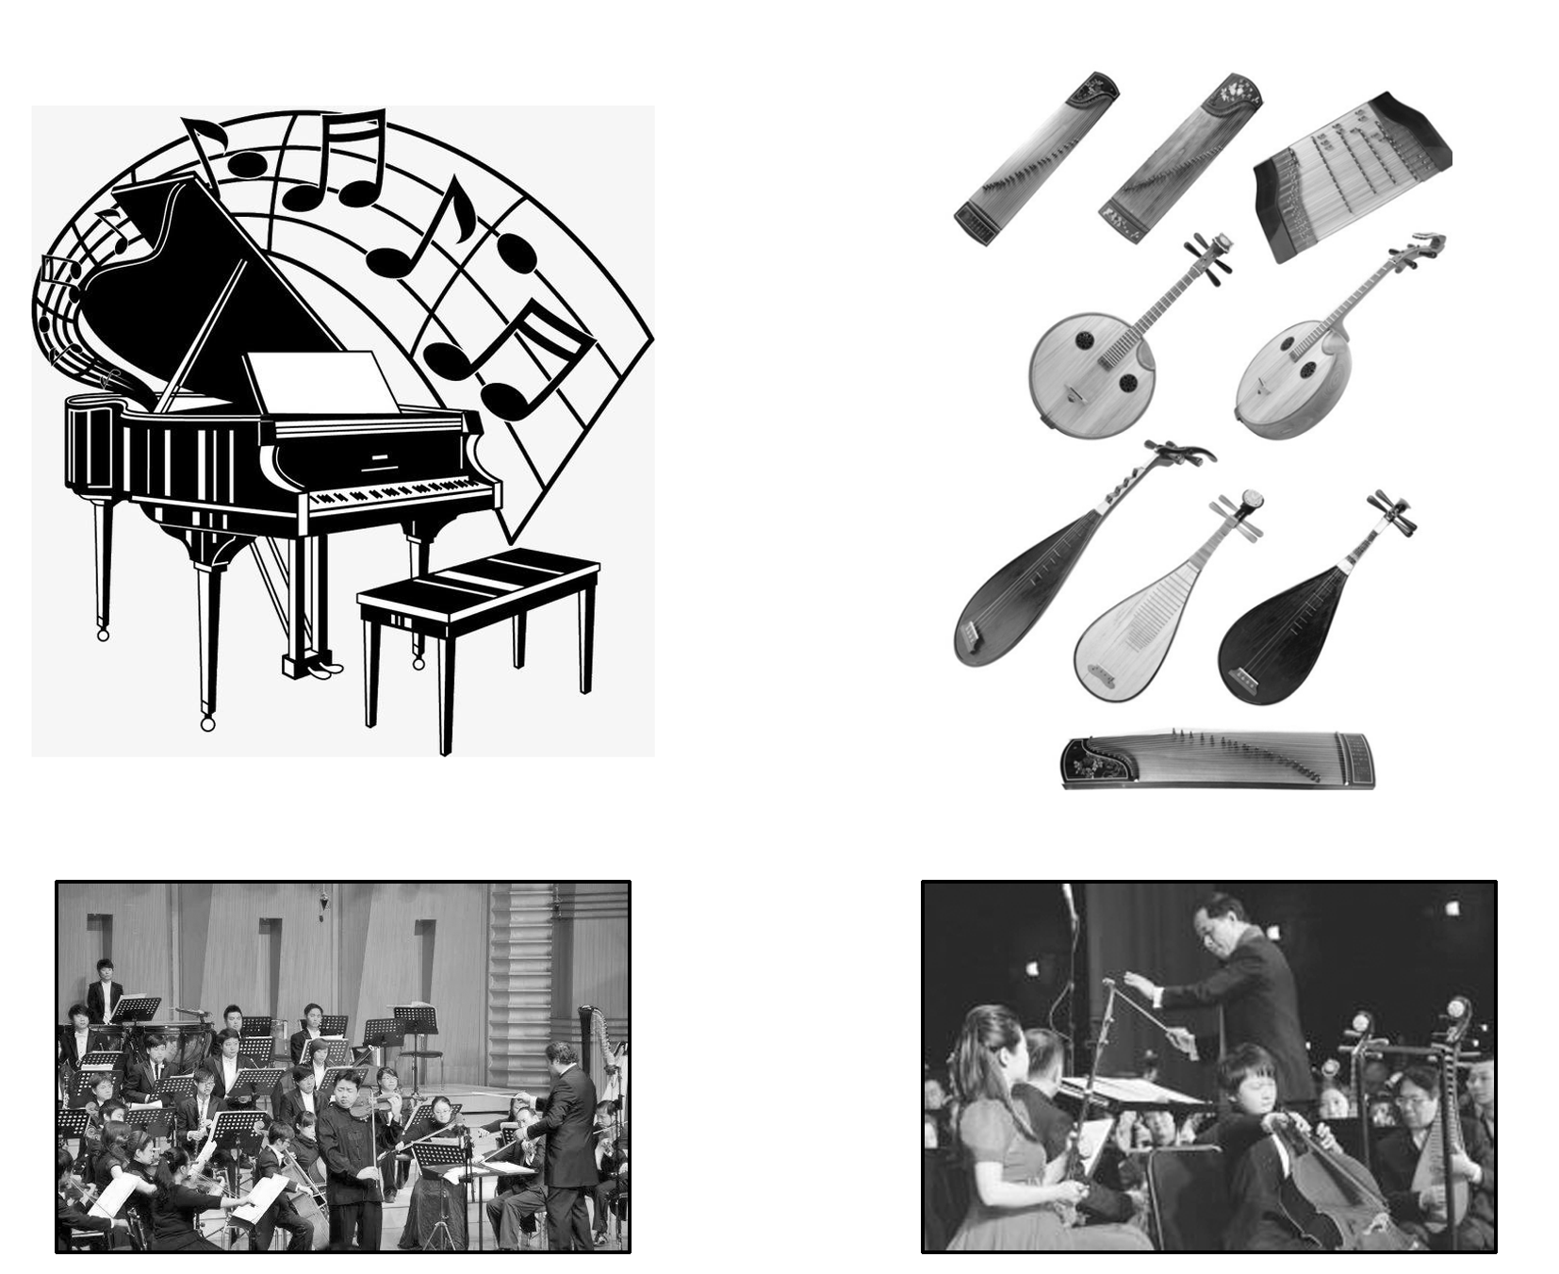
Have you watched or heard of the music performance Butterfly Lovers？What do you think of it?
Discuss in pairs and place a tick in the proper box：
□Yes, I have watched the music performance on TV.
□The love between Liang Shanbo and Zhu Yingtai makes us moved.
□The music of the performance is varied according to the plots of the story.
□It is a sad love story, which attracts many people.
□Through watching the music performance, I realize that music is a common language for everyone.
Step Two：While­reading
Ⅰ.Read for the main idea
Read the passage quickly and choose the best answer.
The emails mainly tell us ________.
A．the love in Butterfly Lovers is moving
B．country music is popular for most of people
C．music is the universal language; we can understand culture through it
D．the music in Butterfly Lovers differs with the plots of the performance
答案：C
Ⅱ.Read for details
Read the first email carefully and choose the best answer.
1．Which performance did the author watch last night?
A．Butterfly Lovers. B．The West Chamber.
C．Miss Saigon. D．Cats.
2．What kind of music is played when Liang Shanbo and Zhu Yingtao meet?
A．Sad and fast. B．Soft and bitter.
C．Light and Pleasant. D．Loud and Exciting.
3．About Butterfly Lovers，which of the following is TRUE?
A．Butterfly Lovers is a romantic love story with a happy ending.
B．Butterfly Lovers combines Chinese and Western musical elements.
C．Butterfly Lovers is performed by He Zhanhao and Chen Gang.
D．Butterfly Lovers is a musical performance which has the only one instrument.
答案：1～3 ACB
Read the second email carefully and judge the information right or wrong. If it is right, please fill “T” in the blank, if it is wrong, please fill “F” in the blank.
4．The host family are big fans of folk music, so I can rely on them to introduce some great songs.( )
5．Country music became popular in the north of America in the 1940s.( )
6．Country music's tunes are easy to sing, and the lyrics often leave people deep in thought.( )
7．Country music shows the simple life of the countryside, which makes you feel like you are there.( )
答案：4～7 FFTT
Ⅲ.Read for the structure
Read the emails again and fill in the blanks.
The first email
I'm glad to get your email.Last night， I watched a 1.performance of Butterfly Lovers， which 2.deserves to be heard.
↓
The music is a classic story about a young couple 3.torn apart by their families.When they meet， the music is light and pleasant； when they 4.are separated， the music gets 5.dramatic with heavier notes； when we hear the most exciting part of the performance， the music takes 6.a softer turn and when they 7.transform into butterflies， the music ends on a 8.bittersweet note.
↓
Butterfly Lovers 9.combines Chinese and Western musical elements.This unique combination has made me realize that music is indeed 10.a universal language.
The second email
The host family in Nashville are big fans of 11.country music， and I can learn about country music from them.
↓
Country music became popular in the south of America 12.in the 1940s and the musicians use many similar 13.instruments.Most of the songs are about hardship and heartbreak， but also about hope.,Country music shows the 14.peaceful green fields and simple life of the countryside.And the 15.masters of country music can make you feel like you are there.
↓
I recommend that you should listen to some great country music.
Step Three：Post­reading
Ⅰ.阅读课文内容，在空白处填入1个适当的单词或括号内单词的正确形式。
1．I am glad (1)to_receive (receive) your email.I hope everything is fine with
you.Last night, I watched Butterfly Lovers, a beautiful violin concerto (2)composed (compose) by He Zhanhao and Chen Gang.The music is a classic story about a young couple who (3)are_torn (tear) apart by their families.The music in this (4)performance (perform) varies according to the plots of the story.Butterfly Lovers combines Chinese and Western musical element.The unique (5)combination_ (combine) has made me realize that music is a universal language.
2．My host family in Nashville are big (1)fans (fan) of country music, they can introduce some great songs (2)to me.Country music became popular in (3)the 1940s, whose tunes are easy to sing.The songs of country music are about hardship, heartbreak and hope.And country music shows the simple life of the countryside.(4)Obviously (obvious), the masters of country music can make you feel like you are in the countryside.(5)So_I suggest that you should listen to some great country music.
Ⅱ.Discussion
1．According to what you know, list some benefits about listening to music.(Answers may vary.)
Listening_to_music_can_exercise_your_brain,_make_you_smarter_and_improve_your_intelligence./Listening_to_music_can_solve_your_anxiety,_make_you_relax,_and_even_make_you_manage_your_stress_more_effectively./Listening_to_music_can_improve_your_memory_and_help_you_solve_your_puzzle.
2．What do you think of learning English by listening to English music？(Answers may vary.)
Some_students_don't_believe_listening_to_English_music_can_help_us_learn_English.But_I_have_to_say_they_think_wrongly.Listening_to_English_songs_can_help_you_learn_the_language_better,_the_reasons_are_as_follows：
①Lyrics_are_not_easily_forgotten.
②Songs_give_you_perfect_pronunciation_models.
③When_you_start_paying_attention_to_the_lyrics,_your_listening_skills_naturally_improve.
④When_you_listen_to_English_music,_you_get_to_practice_your_grammar.
Ⅲ.长难句分析
1．Last night, I watched a performance of Butterfly Lovers, a beautiful violin concerto composed by He Zhanhao and Chen Gang.
[句式分析]
以上内容仅为本文档的试下载部分，为可阅读页数的一半内容。如要下载或阅读全文，请访问：https://d.book118.com/995141211111011034

